Purpose and Scope
Barricading and Fencing is an essential part of hazard control. It is also acknowledged that neat efficient barricading positively influences housekeeping across site. This procedure sets out the minimum standards and options for barricading and fencing across all ASMTI project areas. The
Project expects that the highest practicable controls are applied where barricading needs have been identified. This procedure shall apply to all employees, contractors, and visitors on all ASMTI sites and projects areas.

Definitions
Table 1
Term | Definition
Barricade | A physical barrier established to identify and delineate an area in a potentially hazardous area, also known as a barrier.
Cattle fence | 4 strained post/star picket fence.
Concrete Barrier | Traffic divider constructed of a reinforced concrete wall wider at the base, tapering vertically to near mid-height, and then continuing straight up to its top.
Drop Zone | An area where objects may fall from heights that could cause injury or damage to people or equipment below. This zone can be assessed using a drops risk assessment factoring in deflection risks
Para-webbing | Used for zoning off areas on construction and work sites providing a zone boarder that is unable to walk under. It is easily installed using cable ties or rope and can be pulled down and re-used when required
Temporary Fence Panels (TFP) | Temporary cyclone mesh fence that is erected as panels attached to a solid base.
Water filled Barrier | Traffic divider - Water filled barriers that comply with the requirements of AS/NZS:1742 Uniform traffic controls may also be used.
XT Edge Protection | Protective barrier consisting of fence posts and grid fencing to protect personnel around hazards, voids, drop – offs, edges and other no-go areas. For use around excavations and construction areas where there is a risk from one level to another less than 2m
Zone of Influence | The maximum reach/height of any plant item multiplied by 1.5

Barricading Types and Uses
The types of barricades shown in Appendix 1, are the minimum acceptable standard for the ASMTI Project. At times, it may be necessary to use a higher class of barricade. Barricade types should be determined during pre-planning assessments with site personnel and based on an assessment of all potential risk(s).
Note: All barricading must display an information tag, or information board at the entrance, detailing the hazard(s), the name and contact phone number of the Supervisor or responsible person. No person, regardless of title, should enter any area without the area owner’s engagement and permission.

Class 1 Barrier
A short term or movable barrier that highlights the existence of a potential hazard beyond the barrier. It is the intent on this project to avoid the use of barrier tapes under most circumstances, except as specified in section 3.5 Table 2. This type of tape breaks down in strong ultraviolet light and quickly fails in moderate to strong winds that are regularly experienced in the Shoalwater area.
The purpose of Class 1 Barriers is to:
- Provide quick and effective means to immediately control unforeseen hazards,
- To cordon off incident scenes, or, used in the event of emergency.
- Delineate walkways where there is no interface with plant or equipment
- Provide protection from excavations where there is no risk of plant driving into the excavation,
- Delineation of Lay Down areas/zones outside a construction footprint

Class 2 Barrier
A barrier that is not easy to be by-passed and highlights the existence of a hazard beyond the barrier and may be in-situ for some time.
The purpose of Class 2 Barriers is to:
- Delineate walkways and provide physical separation between pedestrians and plant,
- To separate concurrent works which does not involve an excavation or plant and equipment activities, and
- Provide a level of control that protects people, plant and equipment from excavations,
- Delineating work groups and interfaces where concurrent work activities pose a risk to other work groups.
- Delineation of lay-down areas/zones inside a construction footprint.

Class 3 Barrier
A semi-permanent barrier that is extremely difficult to by-pass and highlights the existence of a hazard beyond the barrier which may be in-situ for an extended time or the life of the project.
The purpose of the Class 3 Barrier is to:
- Delineate areas of no general access,
- Protect personnel from fall/drop zones (ie edges, penetrations, etc),
- Provide a level of control that protects people, plant and equipment from excavations,
- Delineating work groups and interfaces where concurrent work activities pose a risk to other work groups.
To remove a barrier that protects personnel from falls, drop zone areas or excavations the person who placed the information tag MUST be consulted. Contact with the area owner enables all hazards to be discussed and ensure that the initial hazards being controlled is not left without appropriate protection, control or ownership.

Exclusion Zone
Exclusions zones shall be established where there is a need to prevent general area access for specific time frames related to work processes. Drop zones shall be delineated with exclusion zone flagging at a distance determined by risk assessment that identifies and caters for deflection risks where applicable.
An exclusion zone can exist with a class 2 or class 3 type of barricade and shall be delineated with Red & White flagging with the words “EXCLUSION ZONE” printed on the flagging. This type of barrier shall be used to restrict the entry of personnel to exclusion zones. Personnel shall not enter these areas unless they are specifically working in the designated area and/or are under strict supervision using a controlled entry point.
Unauthorised access in this area may be considered a breach of Site Rules and subject to disciplinary action. Exclusion Zone flagging is a temporary barricade and shall be immediately removed once the hazard no longer exists.

Quick Reference Table.
Table 2
QUICK REFERENCE TABLE | Class 1 |  |  | Class 2 |  |  | Class 3 |  | Exclusions / Warning |  |  | Energisation Zone
QUICK REFERENCE TABLE | Red & White Danger tape | Orange flagging, Mesh or Para Webbing | Traffic Cones | Protecta Panel & Click Fence | Scaffold Tubing | Timber Barricade | Fortress fencing | Concrete/water filled barriers | Exclusion Zone | Test Flagging | Tiger Tails | Commissioning Blue & White tape/bunting
No unauthorised access
No access
Accident Location
Electricity
Excavations
Falls (general)
Personnel working above
Welding/Hot work
Slew Arcs
Traffic
Defined walkways

Barrier Installation & Maintenance General Requirements
Before installing or removing barriers personnel must complete a task analysis to ensure they are not exposed to an unacceptable level risk (i.e. falls, traffic, etc).
Barriers shall be properly installed, maintained, and removed in accordance with manufacturer’s requirements for all proprietary systems, and engineered drawings where applicable. Barriers shall be installed to sustain environmental factors, such as strong winds, that could reasonably be expected to occur onsite, and should not place personnel at risk. Consideration must be given to adequate footings, material and competence of the installer. Barriers are to be removed immediately after the work is complete or the hazard no longer exists.
When erecting a barrier around excavations, barriers shall be outside the zone of influence (>1:1).
Spoil from excavations may be used to construct a safety bund around the excavation, provided it is sign posted and delineated and does not expose personnel to an unacceptable level of risk from the spoil and other influences. Personnel must not walk on the safety bund.
Where a barrier does not support the weight of a person, the barrier shall be at a distance that, should a person fall through the barrier they would not reach the hazard. The design of the barrier should take the slope of the work surface and the height of the working platform into account.
Bunting, mesh, and tape barriers should not be used around rotating equipment or where the possibility for entanglement exists.
When safety barricades are found and perceived to be abandoned, employees are not to enter the area until it is determined that the hazard no longer exists. The responsible LOR person is to be contacted for assistance. If the hazard has been eliminated, the barrier should be removed.
Barriers shall be inspected daily by the supply chain Supervisors, with any areas of non-conformance or improvement rectified immediately.

Class 2 and 3 Barrier Type Installation

Barrier Mesh (Para Webbing)
Where barrier mesh is used, star pickets are to be sufficiently spaced with the Barrier Mesh cable tied to each star picket top and bottom so that the Mesh is tight and does not flap freely in the breeze. If barrier mesh is used to barricade a hazardous area where there is a potential to fall less than 2m, then star pickets shall be no farther than 3 metres apart, with both top and bottom wires, and set back a minimum of 2m or greater from the edge.

Timber Barricades
Timber barricades shall be designed to withstand the downward or outward force of the impact of a fall against it, whether by an object or person. The top rail shall be between 900 mm and 1100mm above the platform or other working surface complete with a mid-rail. The design of the edge protection should take the slope of the work surface into account.
Where timber guard railing / edge protection is not specifically designed in accordance with AS 1657, the member sizes set out below are to be used for guardrail and post sizes respectively.
Guardrail Post Size  Depth x width (nominal sizes) (mm) | Maximum guardrail span (m)  F8 HW or MGP 12 seasoned pine
X 38 | 2.7
X 50 | 3.5

Guardrails
2 nos (90 x 35)** | 3.5

**Timber members to be nailed together at maximum 300 mm intervals in ‘T or ‘L’ sections

Timber guard railing shall be set back a minimum of 500mm from any edge. Triangular bracing of the same dimensions as the posts shall be fastened to both the concrete and the post, generally between 50 – 75% of the post height.
Wherever feasible, timber guard railing should be constructed so that when an outward force is applied the posts are subjected to bending about their strong axis.
Rails shall be fixed to the post with double fastening and are to be positioned on the inside of the barricade. This ensures positive resistance is achieved in the event of an object or person falling against the barrier.
Timber guard railing shall be able to withstand a force of 0.55kN (55kg) in any direction.
Timber barricades are to be formally inspected, as a minimum, on a monthly basis for structural integrity and condition.

Scaffold Barricade
Scaffold barricades should be installed to a height of approximately 900 – 1100mm and be fitted with mid rail tubes.
Where there is a risk or potential for objects to fall from one level to another scaffold barricades shall have a toe board.

Concrete/ Water filled Barricade
Barricading that stops LV interactions such as concrete Jersey barrier and water-filled barrier shall be the preferred method that protects against people and plant interaction.
Concrete or water filled barriers should be used where work is being carried out in close proximity of traffic areas such as main roads or used to provide separation between pedestrians and plant. These barriers may also be used to block road access or barricade trenches and works next to roadways.
Other Barriers
Barrier Tiger Tails should be used on low voltage aerials wherever work such as road surfacing is to be carried out under the power lines.
Barrier Balls are the required method of barricading high voltage aerials in those locations where roads cross under the power lines.
Red and White Danger Tape should be used to identify hazards that pose an immediate danger to life or health or define an incident scene. Access is restricted to persons removing that hazard or personnel involved with the investigation of the incident.

Commissioning/Energisation Zones
When energisation zone is established (mainly aligned to commissioning activities), the physical limits of the zone are to be identified by blue and white bunting/tape around the energisation area. Signs will also be stating ‘DANGER – Live Equipment under Energisation’. Only commissioning/energisation personnel are to access these zones, and any other person who requires access will need to contact a member of the commissioning/energisation team.

Information Tags and Signage
All barriers shall have an information tag attached, or, an information board at all designated access points. Information tags shall be tied to the barrier at regular intervals to clearly identify to the reason why the barrier was erected. Information tags are to be supplemented by use of warning/advisory signs where applicable.
All details on the tag shall be completed by the person responsible for erecting and maintaining the barrier.
Signage shall be displayed on major barriers and include details of hazards beyond the barrier, company, responsible persons, and contact details.

Entering Barricaded Areas
All Barricaded areas must have an identifiable controlled entry point. Personnel who are not working within the barricaded area shall not access, pass through, over or under any barrier without directly consulting with, and shall gain approval from the responsible person or contractor responsible for the installation of that barrier. The responsible persons shall explain all hazards that have been identified relative to your entry, and if work is being conducted. There may be a need to be consulted in the activity SWMS prior to entry or the commencement of any additional work.

Emergency Access/ Egress and Equipment
Where barricading interferes with and or prevents access by emergency services, evacuation and/or access to emergency equipment, suitable controls shall be implemented to ensure that the area does not pose additional risk to personnel.

Permits
Prior to erecting or removing barricades, site procedures should be consulted regarding the use of specific high risk permits that may be required (i.e. Trenching and Excavation, Working at Heights, hot works, grid mesh/flooring/handrail removal etc).

Lighting
Flashing lights shall be considered on roadways and in areas that experience pedestrian traffic at night. Retroreflective signage/materials and early warning signage should also be considered and used.

SITE FENCING
Prior to commencement of any work on site appropriate fencing must be in place. To determine what appropriate fencing is, an inspection of the site must be undertaken to delineate which areas constitute construction sites and which areas are general access areas. When determining the type of fencing required for the different site areas, there are 2 main influencing factors which are:
- The activities that are to be performed and their associated risks.
- The location of the site (i.e. in a densely populated area, vicinity to traffic, residential zones, etc).

Fencing Requirements
This procedure provides guidance on the selection process necessary to ensure the most appropriate type of fencing is selected for the types of works being undertaken with respect to the physical location and proximity of the works to the public.

Entering Construction Zones
Construction zones on site must be designated with a perimeter which can be either class 1,2 or 3 barricading. The selection of the type of fence erected shall be made considering:
- The types of works being performed. For example, excavation, work at heights.
- The location of the works in proximity to pedestrian and vehicular traffic; and
- Mobile plant access requirements.
Signage must also be erected to signify the Personnel Protective Equipment that is required to be worn.

Interfacing with Public Roads
When works are impinging on existing public roads the types of fencing shall be determined in accordance with the statutory guidelines for road works / closures.
A Traffic Management Plan (TMP) to ensure the protection of personnel and public traffic must be developed and undergo approval from the appropriate statutory and council authorities as needed prior to works commencing.
Persons involved in the establishment of traffic management controls must be appropriately trained in Traffic Management.

Medium Density Public Areas
Medium Density Public Areas can be classified as areas which present a small volume of pedestrian traffic frequently passing in close proximity to the site, such as footpaths running along the boundary of the site, parklands and reserves are examples of such areas.
This category also includes those locations of the site which adjoin or backs on to residential properties.
A number of different types of fencing may be appropriate in these areas which may range from existing 6ft residential fences, cattle fences or para-webbing. In determining the most appropriate type of fencing within this classification, consideration to the following should be given:
- Likelihood of public interfacing or scaling of fence (trespassing) onto site occurring. For example, adjoining areas where there are collections of dense residential properties such as blocks of flats present a greater likelihood of public interfacing or trespassing occurring. TFP or cyclone fencing may need to be provided in addition to the existing 6ft residential fencing.
- Condition of existing fencing.
- Extent of reserve / parkland use, and
- Access gates to corridor from public roads and residential properties.

Low Density Public Areas
The extent of public interfacing within the boundary of the site is minimal in Low Density Public Areas. These areas can be typically classified as those which adjoin the corridor and include but are not limited to farmlet’s and industrial estates.
A minimum of cattle fencing & signage must be erected in these areas if not already. Where such fencing exists prior to mobilisation on site, a perimeter inspection of the boundary of the site must be conducted to verify the condition and security of the fencing.

Signage Requirements
The erection and maintenance of safety and information signs shall be such that they can be quickly recognised and understood. Signage shall be erected to satisfy Legislative Principal contractor requirements and in accordance with defence requirements.
Signage shall conform as a minimum to the following:
- Where a workplace hazard has been identified, signage appropriate to the hazard shall be installed,
- Signs shall be standardised in colour, shape, size, lettering, symbols, and content, in accordance with AS1319.
- Road signs shall conform to AS/NZS:1742
- Symbolic signs shall be used in preference to word only signs.
- Care should be taken when considering the placement of signs close together. The result may be that there is so much information in one place that little or none is absorbed, or the visual effect may become confusing and make it difficult to distinguish individual messages.
- Signage should be posted sufficiently in advance of a hazard to permit the warning to be perceived before the hazard is actually reached,
- Signs must not be erected hazardously. For example, signs projecting into passageways present a risk where persons may inadvertently strike them,
- Signs affixed to fencing are fastened securely to reduce the risk of being caught by wind or removed and misused by members of the public, and
- Signs shall be maintained so they are visibly distinct.
The condition, placement and applicability of signage shall be reviewed as part of formal weekly TDJV inspection process.

REFERENCES
Queensland Occupational Health and Safety Act 2011
AS 1319-1994 Safety Signs for the Occupational Environment
AS1742 Manual of Uniform Traffic Control Devices
AS/NZS 4576-1995 Guidelines for Scaffolding
AS 1657-1992 Fixed platforms, stairways, and ladders

SUPPORT DOCUMENTS
Barricading and Fencing - Toolbox Fact Sheet

APPENDICIES
APPENDIX 1 - Types of Barricades

APPENDIX 1 – TYPES OF BARRICADES
BARRICADE | PURPOSE | PHOTO
CLASS 1  Traffic cones (orange/yellow) | A temporary measure for delineating hazards. The cones can be used to direct traffic away from hazardous areas or to immediately control unanticipated hazards.  Traffic cones are a quick and effective barrier for:  - The slew arc of a crane, counterweight, or EWP (yellow)  - Equipment parked on roadways (orange)  - Diverting traffic (orange) | 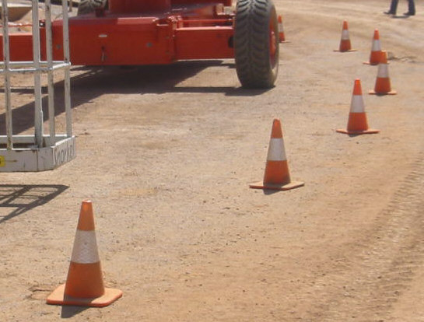
CLASS 1  Orange bunting/flagging  Mesh or Para webbing fence | A temporary barrier to delineate areas such as walkways, work areas, and lay down areas, where there is no risk of a fall.  An information tag must be hung at intervals on the bunting/flagging to indicate its purpose and owner.  A semi-permanent barrier that delineates hazards such as excavations or walkways or provides protection from hazardous areas.  MUST be +2m from hazard.  Difficult to maintain in high wind areas | 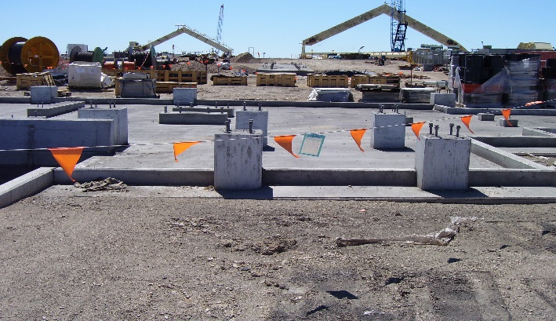  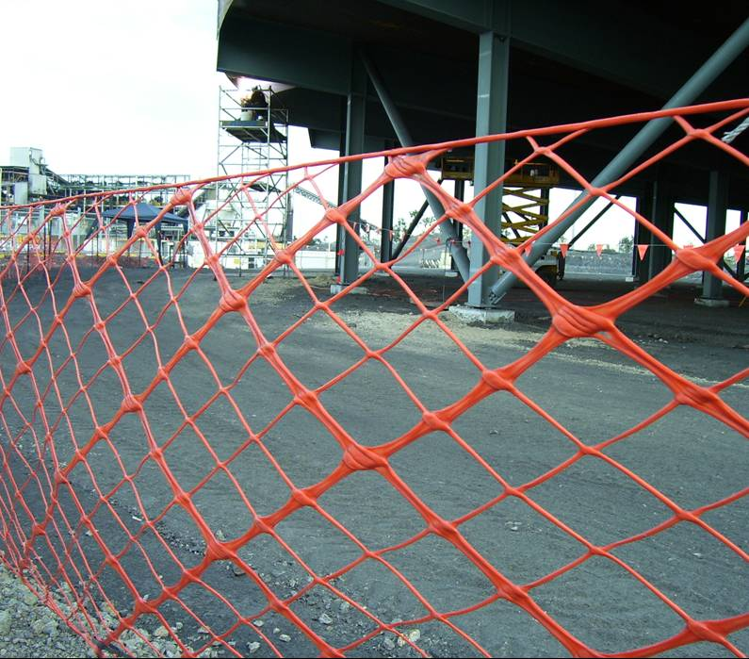
CLASS 1  Red and white danger tape | Used to:  - Identify hazards posing an immediate threat to life or health; or  - Define an incident scene  Access is restricted to persons involved in:  - Removing the hazard; or  - Investigating the incident | 
CLASS 2  Timber Constructed Barrier | A hard barrier used to prevent access and protect personnel from falls. A semi-permanent barrier that highlights a hazard beyond the barrier. It is designed to be difficult to bypass.  **NOTE: Can only be used where it can be fastened to a hard surface. Temporary Works Coordinator to be consulted**  It may be in-situ for an extended period of time.  It must be subject to regular inspection. | 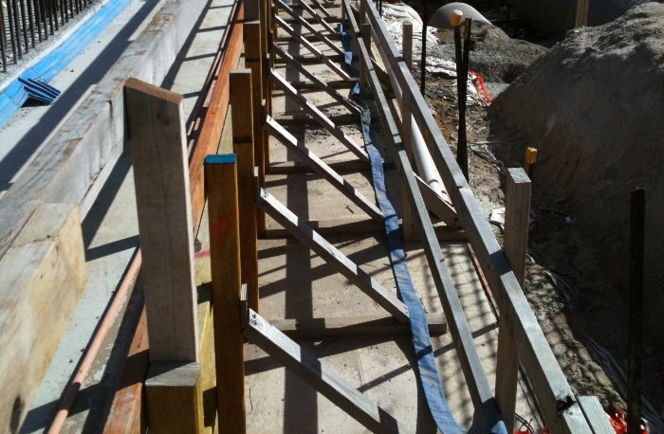
CLASS 2  Protecta Panel & Click Fence | Highly Visible and durable protection framework providing no option to penetrate under. Best option for defined pedestrian walkways, Interface Management between work groups and exclusion zones.  **NOTE: When used for exclusions zones, exclusion signage must be placed along the barrier to warn others.  The act to pass over or through a section of this panel outside of a designed access point would be seen to be deliberate, and a breach of site rules | 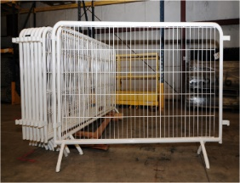  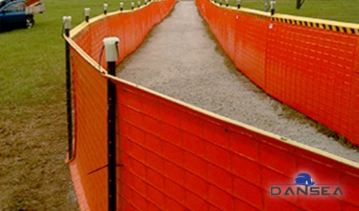
CLASS 2  Scaffold tube fencing | A hard barrier used to prevent access and protect personnel from falls.  To be design certified and installed so protruding ends do not create a hazard. Temporary Works Coordinator to be consulted | 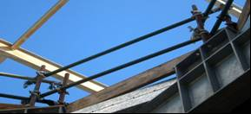
CLASS 3  Gate fencing | A semi-permanent barrier that highlights a hazard beyond the barrier.  It is designed to be difficult to bypass.  It may be in-situ for the life of the project. | 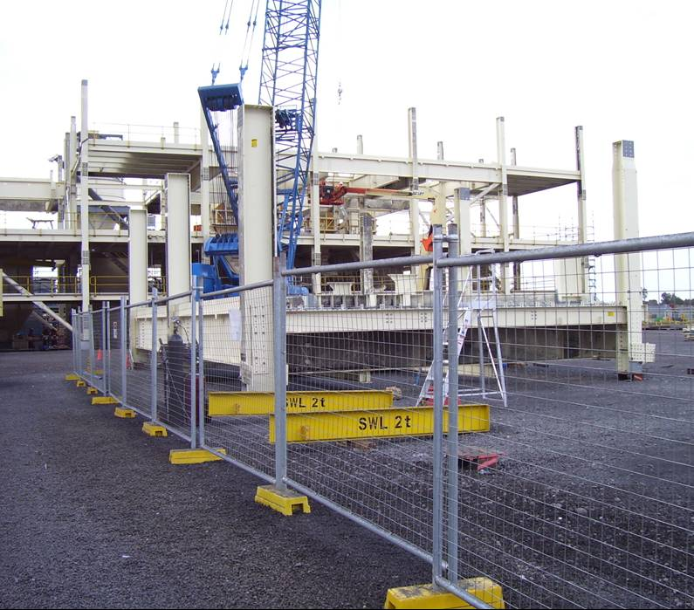
CLASS 3  Concrete/water filled barriers | Used as protection for workers in close proximity to high traffic areas, e.g. main roads.  Also used to block road access or barricade trenches and works next to roadways. | 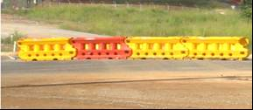
CLASS 3  Fortress Edge Protection | A design certified protective barrier for hazards such as voids, drop – offs, edges, and other no-go zones.  For use around excavations and construction high risk areas. | 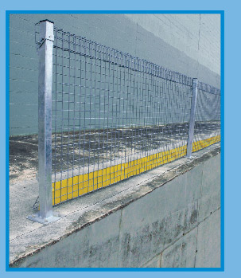
EXCLUSIONS/WARNING  Exclusion Zone Bunting  - To be used ONLY for drop zones & exclusion zones  - Must be removed immediately when task is completed, e.g. crane lift | Red and White Flagging will identify “EXCLUSION ZONE”, used to delineate a drop zone, and used to restrict the entry of personnel, as follows:  - Personnel shall not enter the area unless specifically working in that designated area or under strict supervision  - Unauthorised access in this area may be considered a breach of site rules  - Personnel breaching this rule face disciplinary action and risk termination of employment | 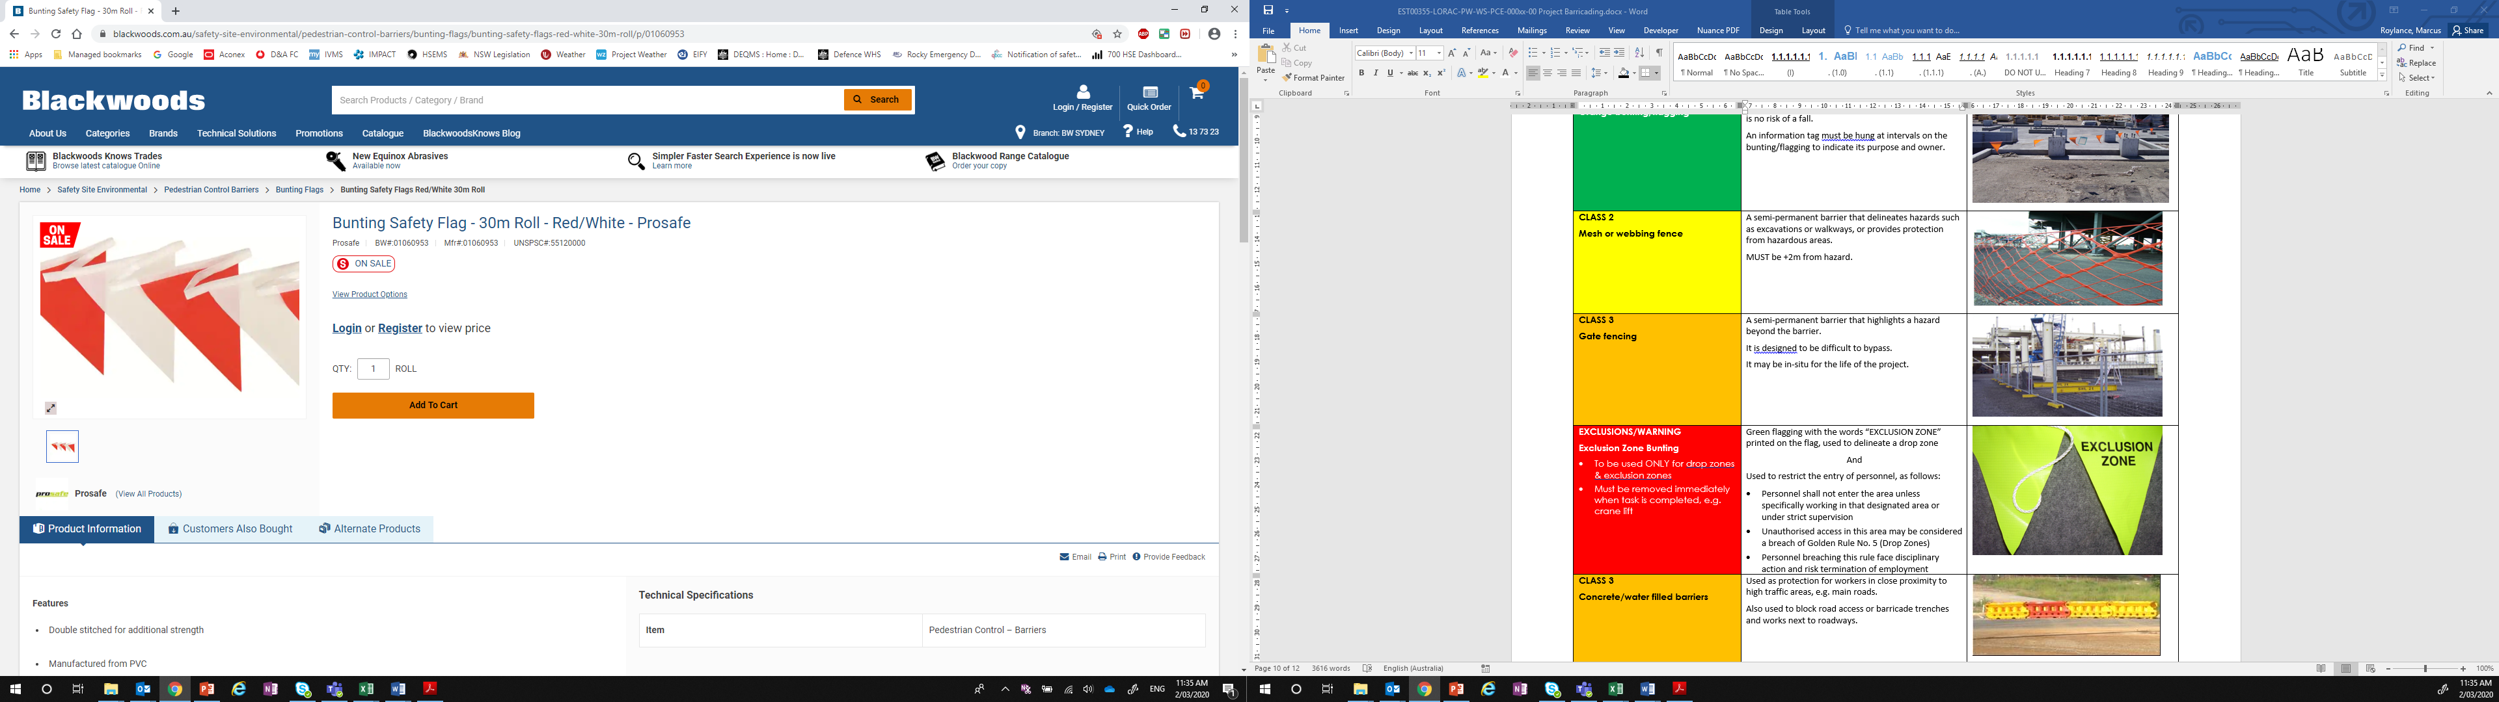
ENERGISATION ZONE  Test Flagging | Used to restrict the entry of personnel, as follows:  - Identify hazards associated with test procedure being undertaken  - Personnel shall not enter the area unless specifically working in that designated area or under strict supervision | 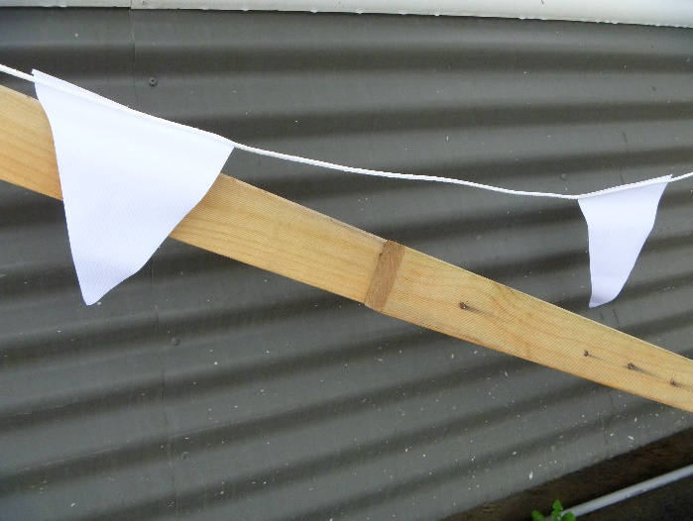
ENERGISATION ZONE  Commissioning/Energisation Zones | Used to:  - Restrict non energisation personnel from entering the energisation area.  - Non energisation personnel are to contact a member of the energisation team if they need to gain entry. | 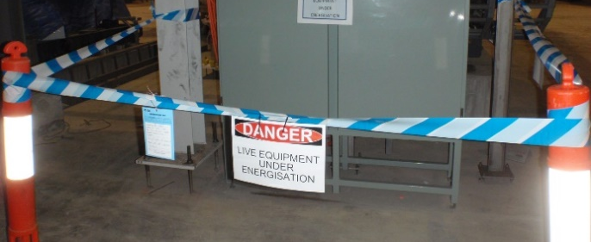
BARRIER INFORMATION | All barricading must display an information tag or information board, detailing,  - the purpose of the Barrier (the hazard)  - the name and of the Supervisor, or responsible person.  - contact phone number/details of the Supervisor, or responsible person. | 

