Workplace Assessment 1 – Assessor’s Checklist
(This form is for the assessor’s use only)

Purpose
This Assessor’s Checklist lists the specific criteria that the candidate’s submission for Workplace Assessment 1 must satisfactorily meet.
This form is to be completed by the candidate’s assessor to document their assessment of the candidate’s submission in Workplace Assessment 1.

Task Overview
For this task, the candidate is required to complete the following documents for the building and construction project they are undertaking:
- Hazard identification form
- Risk register
In this task, the candidate will be assessed in their:
- Practical knowledge of hazard identifications and risk assessments
- Practical skills relevant to completing a hazard identification and site risk assessment

Instructions to the Assessor

During the assessment
- Review the candidate’s submissions:
  - Hazard identification form
  - Risk register
- Compare the content of the candidate’s submissions with any project documents or legislative requirements that the candidate accessed and reviewed.
- For each criterion listed in this checklist:
  - Tick YES if you confirm the candidate’s submission satisfactorily meets the criterion.
  - Tick NO if you confirm the candidate’s submission does not satisfactorily meet the criterion.
- Write specific comments on the candidate’s performance in each criterion. Your feedback/insights will help address any area/s for improvement.

After the assessment
- Complete all parts of the Assessor’s Checklist, including the Assessor Declaration on the last page of this form. Your signature must be handwritten.

Candidate Details
Candidate name | Dawei Yang

Assessor Details
Candidate is assessed by | Yanzhong Zhu

Context of the Assessment
Workplace/organisation | Dawn construction
Resources required for the assessment | - Building and construction project  - Opportunities to conduct hazard identifications and risk assessments  - Policies and procedures relevant to:  - Conducting hazard identifications  - Conducting site risk assessments  - Project documents, such as, but not limited to:  - Scope of work  - Work breakdown structure  - Material safety data sheets  - Manufacturer’s instructions for plant and equipment  - Incident reports  - Records of previous consultations with workers  - Legislative requirements relevant to the building and construction project  - Templates for:  - Hazard identification form  - Risk register  - Digital devices, applications, or software that can be used to access relevant project documents or legislative requirements, such as, but not limited to:  - Laptop or desktop computer  - PDF viewer programs  - Internet browsers

Assessor’s Checklist

Hazard identification form
The candidate’s hazard identification form submission: | YES/NO | Assessor’s comments
- Identifies hazards on the building and construction site. | YES NO
- For each hazard identified:
- Identifies the site personnel who may be affected by the hazard. | YES NO
- Identifies the risks associated with the hazard. | YES NO
- Identifies the relevant control measure that must be put in place. | YES NO
- For each control measure identified:
- Identifies the personnel responsible for implementing the control measure. | YES NO
- Identifies the date by when the control measure must be implemented. | YES NO
- Control measures identified are consistent with the following:
- Legislative requirements applicable to control measures required on the building and construction project.
- Organisational policies relevant to control measures required on the building and construction project.

Risk register
The candidate’s risk register submission: | YES/NO | Assessor’s comments
- Identifies risks on the building and construction site. | YES NO
- For each risk identified:
- The risks are consistent with the risk identified in the candidate’s hazard identification form. | YES NO
- Identifies the area of the construction site where the risk is located. | YES NO
- Has a description of the risk. | YES NO
- Determines the likelihood of the risk occurring. | YES NO
- Describes the impact of the risk if it occurs. | YES NO
- Determines the severity/rating of the risk. | YES NO
- Identifies the control measure that will address the risk.
- The control measure is consistent with the control measure identified in the candidate’s hazard identification form. | YES NO
- Determines the revised likelihood of the risk occurring. | YES NO
- Describes the revised impact of the risk if it occurs. | YES NO
- Determines the revised severity/rating of the risk. | YES NO

Assessor Declaration
By signing here, I confirm that I have thoroughly reviewed the candidate’s submissions for this workplace assessment task:
- Hazard identification form
- Risk register
I confirm that the information recorded on this Assessor’s Checklist is true and accurately reflects the candidate’s submission for this workplace task.
Assessor’s signature | 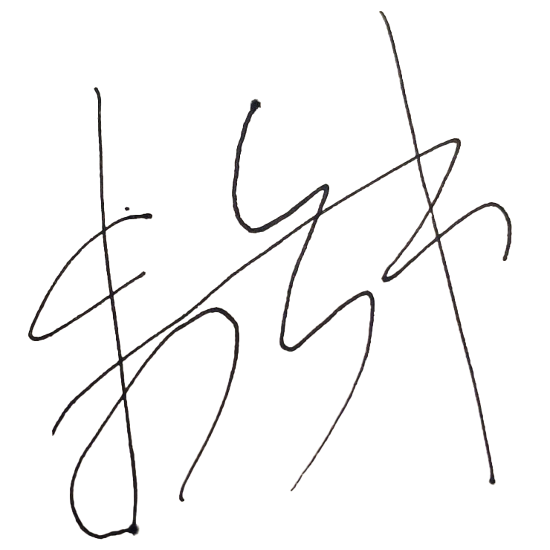
Assessor’s name | Steve Zhu
Date signed | 15/05/2023
End of Workplace Assessment - Assessor’s Checklist

