CPCCBC4016A
Administer a construction contract

THEORY EXAM INSTRUCTIONS

- This exam will occur under standard assessment conditions.
  - An oral examination may be allowed under certain circumstances.
Answers will be documented and FT003 (Oral examination declaration form) must be completed.
- Participants must provide enough detail in their responses to demonstrate their knowledge and skills.
- Please fill in the details below, providing your name, signature and date of assessment.
  - Your signature acknowledges that this is your own work.
- If a participant initially answers a question incorrectly but modifies their response, they must follow the instructions below:
  - If a participant changes their response in writing, they must put their initials next to the written change.
  - If a participant changes their response verbally, this must be noted on the exam paper by the assessor.

Participant name | Gavin Wong
Participant signature | 

Assessor name
Assessor signature

Date | Click here to enter a date.

Number of questions | Number of questions answered correctly | Satisfactory?
49 |  | Yes | No
Assessor Comments

- Identify the various types of building and construction contracts and explain when it is appropriate to apply each type of contract.

Answer | - Australian Standard Contracts (AS2124 and AS4000)  AS2124 and AS4000 are designed for use on major building and engineering projects where a ‘superintendent’ is engaged to administer the contract who is an independent professional (or a firm of consultants) or an employee of the principal. The contract price may be calculated as a lump sum or re-measurement (schedule of rates/bill of quantities) or a combination of these.  - Construction Industry Contract (CIC)  It is designed for use with an architect as the principal’s representative.  - Contracts required/supplied by regulatory authorities  &  - Individual organisational contracts  Many public authorities and local government bodies have their own standard forms. Moreover, Master Builders Australia Ltd and its (State-based) member associations produce standard forms for various purposes.  - Joint contacts committee (JCC) suite  The JCC family of contracts was first created by a Joint Contracts Committee (JCC) comprised of representatives from three organizations:  - the Royal Australian Institute of Architects,  - the Master Builders Federation of Australia  - the Property Council of Australia (formerly BOMA - the Building Owners and Managers Association of Australia)  It originated from earlier contracts such as MBW1 in 1970 and E5b in 1970, even going back to an English contract – the RIBA.  - MBA & HIA Contracts  Industry contracts on the market include:  Master Builders  QBCC  HIA  ABIC Simple Works (for architects)  The Master Builders Residential Building Contract (RBC-1) is a contract that:  - is between a builder contractor and a residential owner for an agreed lump sum amount  - embodies the terms of the agreement between parties  - is an easy-to-use industry standard document  - incorporates various terms and conditions  - complies with legislation  - Is formatted so it is easy to use, allowing for easy referencing to other RBC–1 schedules and clauses  - Simple Building Works  This form of contract is used for building works that are not complex in nature.  Variations: Variations are valued in accordance with rates and prices nominated in a schedule, and these amounts should be inclusive of all profit, overheads, etc. Where the variation results in an addition the percentage rate nominated in the Appendix is added to the variation total.  Failure To Pay: The rate of interest is stated in the Appendix.  Reimbursement as a result of a delay in the progress of the works: Reimbursement is allowable only for certain causes of delay and for example inclement weather, although a cause for time extension, is not a cause with attracts time extension costs

Answer

- Use the drawings you completed in the assessment for CPCCBC4014A (from the floor plan below) and the listed task requirements to prepare the new dwelling contract documentation for the client’s signature.

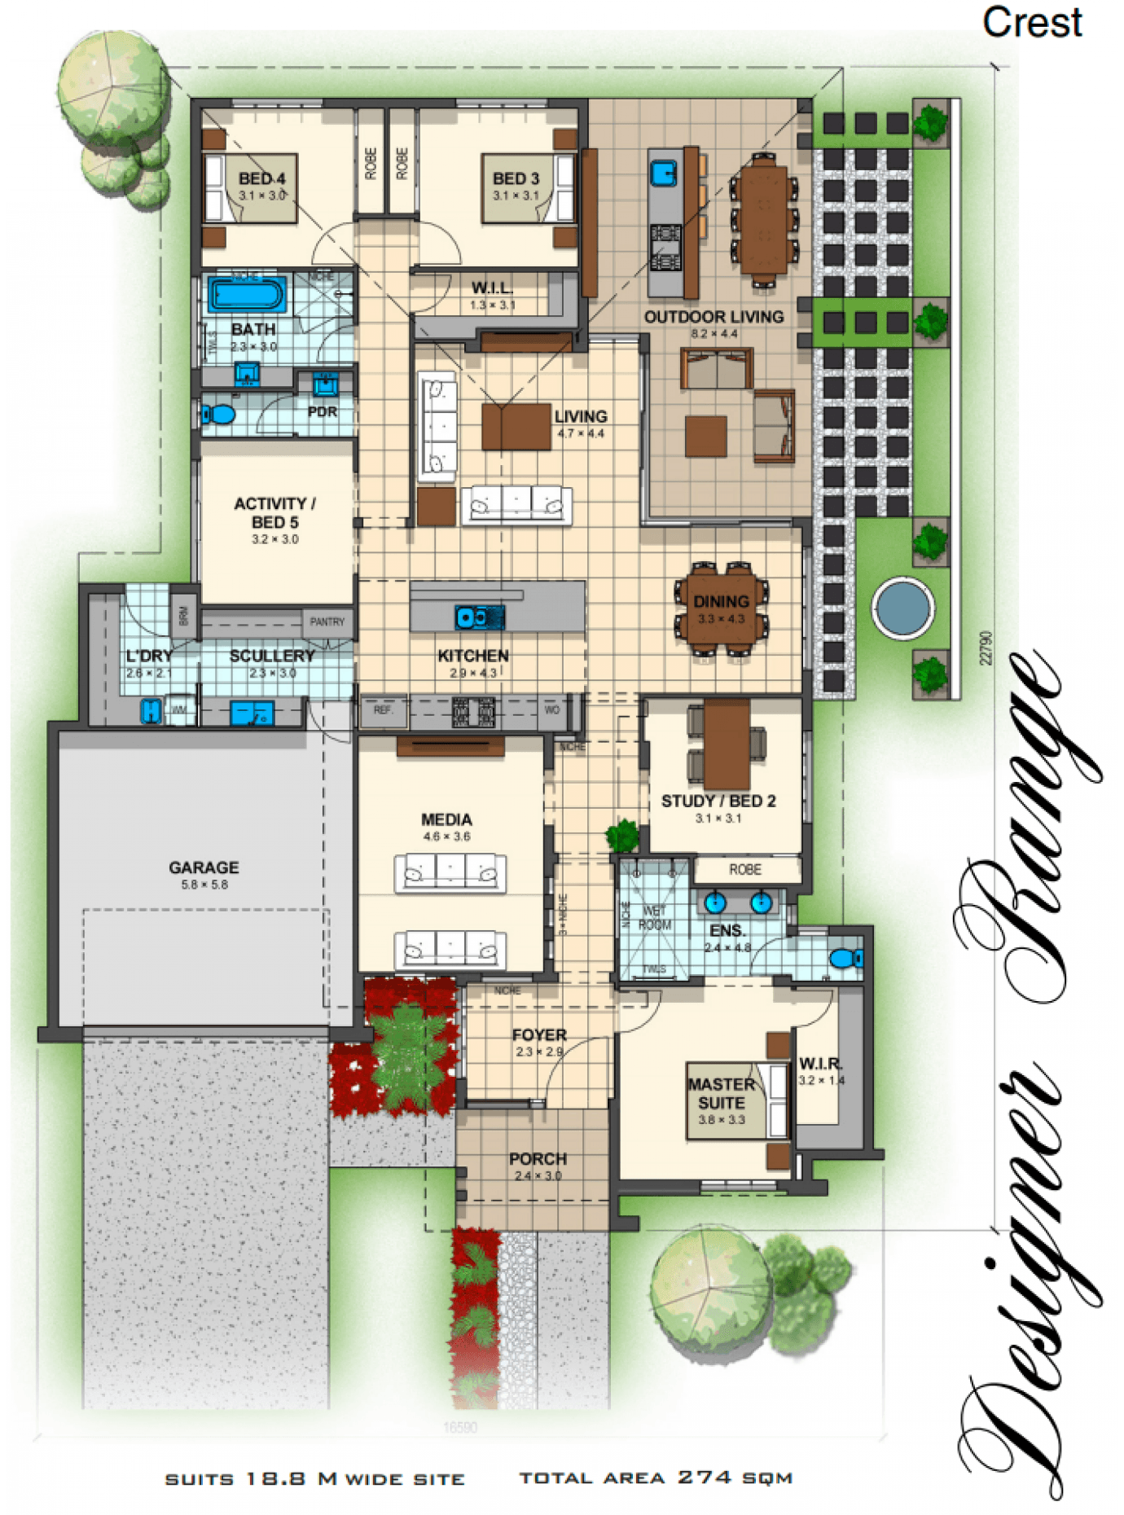
TASK REQUIREMENTS

You are to download the contract documents from the Queensland Building and Construction Commission (QBCC) website at: http://www.qbcc.qld.gov.au/sites/default/files/QBCC_New_Home_Construction_Contract.pdf

Your should:
- Analyse the various types of building and construction contracts you will need and then apply the appropriate application of each type of contract;
- Identify and apply legislative requirements relating to building and construction contracts.
- Identify and apply essential terms and elements of a valid contract;
- Analyse the importance of identifying an intention to create legal relations;
- Identify and analyse rights and liabilities of parties under a contract;
- Identify and apply common building contract terms and procedures;
- Identify and analyse circumstances that bring about a breach of contract;
- Accurately select the contract, appropriate for the type of construction;
- Accurately identify and prepare the range of documents collectively make up a contract;
- Accurately identify and apply requirements associated with an offer and acceptance of a contract;
- Confirm the capacity of the parties to form a binding agreement in the form of a contract; and
- Identify and apply factors associated with the parties' consenting to a contract.

Answer

- How should you handle any customer complaint?

Answer | Deal with complaints immediately  Stay calm  Identify the problem  Arrange for a second opinion  Keep records  Fix the problem

- What does the ‘cooling off’ period refer to when undertaking domestic building work with a total contract price of $20,000 or more?

Answer | A cooling off period means that either party can cancel the building contract as long as it is in writing and:  - Before 5 business days after making of the contract; or  - If relevant provisions of the Act have not been met

- What are the consequences for a client not using a QBCC licensed contractor?

Answer | If a contractor is not licensed then the work cannot be guaranteed

- What is the Queensland Home Warranty Scheme?

Answer | QBCC protects homeowners against loss through the Queensland Home Warranty Scheme

- What are the consequences of Cost Plus and Construction Management contracts on Home Warranty Insurance protection?

Answer | The premium is determined by the value of construction

- At the commencement of a contract valued over $20,000, what must the contractor give to the owner? What timeframes apply?

Answer | A request for deposit  Before work begins

- Where must the total contract price be stated?

Answer | In the contract

- What are the maximum deposits recommended and how should progress payments be scheduled?

Answer | 5%  - Deposit 5%  - Base stage 15%  - Frame stage 20%  - Enclosed stage 25%  - Fixing stage 20%  - Practical completion balance

- Who has responsibility of building inspections and approvals?

Answer | The builder has statutory obligations but the home owners are ultimately responsible for ensuring that approvals are granted and the required inspections are carried out

- Identify and describe the term used to describe circumstances such as:
- Where there has been a change to the materials used or
- A change to the scope of the work to be performed under the contract?

Answer | variations

- How do you reduce the risk of dispute?

Answer | Record all complaints  Act promptly  Do what you say you are going to do  Do not make unrealistic promises

- What is the process for dispute resolution?

Answer | Refer to the contract first  Determine responsibility for defect  Directing the contractor to rectify defects or complete the work  QBCC or other Building Associations can assist  The Queensland Civil and Administrative Tribunal can provide cost effective dispute resolution  Seek legal advice to investigate option before taking the above steps especially if you intend to terminate the contract

- When might an extension of time (EOT) apply? How is it approved?

Answer | An EOT may be as a a result of inclement weather or changes in the scope of work  A variation to the contract is required  - A variation in writing  - An extension of time form is issued asking for an extension of the contract period to allow for delays caused by the variation  - The specific reason for an extension of time  - The General Contract Conditions will set out what time extensions are entitled over the contract period

- When is the client/home owner required to pay the final contract payment?

Answer | Upon practical completion

- What are implied warranties?

Answer | implied warranties are that you will carry out the work:  - in a workman-like manner  - with reasonable care and skill  - using materials that are suitable for the purpose  - within the date specified in the contract.  These warranties apply when you have a contract with a client, regardless of:  - the cost of construction  - whether there is a written contract.

- Explain the responsibilities of an Owner Builder.

Answer | A person who carries out domestic building work on his or her own land, who is not in the business of building.  Work you can do as an owner builder  - build a new home  - renovate, alter or extend an existing home  - build a garage, carport or residential shed  - build a swimming pool for residential use  - build a pergola or entertainment area for residential use.  Work you can’t do as an owner builder  - occupational work such as plumbing, draining, gasfitting or pest control unless you have an occupational licence  - fire protection work in excess of $1,100 (unless you have the appropriate licence)  - build commercial or industrial buildings (e.g. shops, industrial sheds, farm buildings)  - build or renovate multiple dwellings (e.g. duplexes, boarding houses, block of units).  Can only get one permit every 6 years  No access to Home Warranty insurance  The Home Warranty insurance, which protects owners against incomplete or defective work, is not available to owner builders.  If you are a QBCC licensee and you choose to not apply for an owner builder permit, QLeave will expect you to pay a levy of 0.475% of the total cost of your works.  QLeave's legislation, taken from the Building and Construction Industry (Portable Long Service Leave) Act 1991 Part 8 Section 71(1) states:  "A person carrying out work under an owner-builder permit is exempt from payment of levy on all work carried out under the permit".  They can only grant you an exemption from the levy if you present them with your owner builder permit.  If you are a current QBCC licensee, you will be eligible for an exemption from completing the owner builder course.

Answer

- What is ‘notifiable work’, who is responsible and to whom does it apply?

Answer | Notifiable work is common, everyday plumbing and draining work performed by plumbers and drainers on existing buildings. If you are a QBCC plumbing and drainage licensee, you must always report notifiable work to us.  It includes:  - installing, replacing or removing any electric, gas, solar or heat pump hot water heaters  - installing fixtures such as toilets, showers and sinks  - extending, altering, replacing or removing water supply pipes  - extending, altering, replacing or removing waste pipes (depending on the placement of the pipework).  How does it work?  - You must report the completion of notifiable work to us, by lodging a Form 4/4A, within 10 business days of the work becoming operational, or the issue of the customer’s invoice (whichever is earlier). You can report manually or go online  - We generate a certificate, a copy of which you provide to the customer.  - Local government may carry out an audit of the work and review any as-constructed drainage plans.  Why do you need to report notifiable work?  By creating detailed records and carrying out inspections high standards can be maintained and ensures the work complies with health and safety laws.  Penalties apply for failure to report notifiable work or for carrying out work which is not in accordance with stated codes and standards.  Other types of plumbing work  Not all plumbing and drainage work is notifiable work and other types include 'minor work' and 'compliance assessable work'.  Minor work includes things like changing a like for like tap fixture where there is no change to the water supply pipework or to the drainage outlet.  Compliance assessable work often includes more complex or higher risk plumbing work and you must first obtain a permit from the local government plumbing inspector. Any work for a brand new building or new connection to the water and drainage service utility providers will be compliance assessable work.  Some jobs may involve carrying out more than one type of plumbing work. For example, a customer could request changes to an existing toilet suite (minor work) as well as the installation of a brand new toilet and washbasin (notifiable work). Therefore, this is notifiable work and must be reported to the QBCC within 10 business days.

Answer

Answer

- What is the difference between the Prime Cost Item Schedule and the Provisional Sum Schedule in a contract? Give one example to help explain your answer.

Answer | Prime cost’ refers to a set budget allocated for an item or set of items that need to be bought for your building or renovation project. Taps are a great example – if you haven’t specified a particular brand, model and style of taps, or if it’s impossible to get an idea of the price for what you want, then your builder is likely to allocate a certain amount of dollars for taps rather than specifying exact costs.  The term ‘provisional sum’ refers to an estimate in your builder’s contract for what it’ll cost do a particular part of your building or renovation job. Provisional sums are estimates that are provided where the builder can’t give an exact figure for the work required, after having made reasonable enquiries into what it’ll actually cost.  One example might be for excavation. Even with a soil test, it may be difficult to know exactly what’s under the ground, and therefore difficult to pinpoint the cost and effort required.

- What does Section 109 of the Queensland Building and Construction Commission Act 1991 provide to the consumer/client?

Answer | Access to building sites  (1) A building contractor must, at the request of a consumer, allow the consumer reasonable access to a building site at which building work is being carried out for the consumer.  (2) A contractual provision that is inconsistent with subsection (1) is void

- What are some of the preliminary contracts that a builder could ask a client to sign prior to signing the main contract?

Answer | Preliminary agreement  - Pre-construction contract  - Preparatory work agreement  - Quote  - Order  - Preliminary contract  - Estimate  - Provisional quote  - Authorised tender acceptance  - Contract request  Often used to obtain a soil report and foundation data, or to develop design plans and specifications.

- What are liquidated damages in terms of a signed building contract?

Answer | An agreed sum that genuinely reflect the amount of loss suffered due to a breach or an estimate of damages that the owner may deduct from monies owing if the contractor fails to complete the contract by the time nominated

- What contract documentation would you review to identify any unusual aspects related to materials and installations for a low rise construction project?

Answer | - Applications for permits and service connection  - Copies of plans, drawings and specifications  - Environmental applications  - Parking restriction applications  - Titles  - Permits  - Other permits (Asset Protection, Road Opening)  - Building Specifications  - Plans  - Engineering reports

- Where would you find any possible penalties associated with a build?

Answer | Other permits

- What is the Australian Standard Contracts - AS2124 and AS4000 series?

Answer | AS2124 and AS4000 are designed for use on major building and engineering projects where a ‘superintendent’ is engaged to administer the contract who is an independent professional (or a firm of consultants) or an employee of the principal. The contract price may be calculated as a lump sum or re-measurement (schedule of rates/bill of quantities) or a combination of these.

- How does the Queensland Building and Construction Commission (QBCC) regulate the Queensland building industry?

Answer | - licensing contractors  - educating contractors about their legal rights and responsibilities  - educating consumers about their rights and obligations  - handling disputes fairly and equitably  - protecting homeowners against loss through the Queensland Home Warranty Scheme  - implementing and enforcing legislative reforms and, where necessary, prosecuting people not complying with the law

- What industry legislation should builders and trade contractors have a good understanding of?

Answer | - Queensland Building & Construction Commission Act 1991 (QBCC Act)  - Queensland Civil Administrative Tribunal Act (QCAT) – previously the CCT  - Building Act 1975 & Regulations  - Building and Construction Industry Payments Act 2004 (BCIPA)  - Workplace Health & Safety Act 2011 (WHS Act)

- What supporting documents should you be aware of and include in your contracts with the consumer?

Answer
      - Contract Information Statement
      - Foundation Data
      - Engineers Specification and Confirmation (pre-contract document)
      - Foundation Maintenance and Footing Performance
      - Home Owners Guide to Termite Management

- What are the four (4) essential elements of an agreement for it to be regarded as a contract?
What is the consequence if any essential element is missing?

Answer | There are six essential elements necessary for legally binding contract formation:  - "offer" and  - "acceptance" by  - "competent persons" having legal capacity who exchange  - "consideration" to create  - "mutuality of obligation.“

- When would an offer be considered to have lapsed?

Answer | An offer will lapse:  - when the time for acceptance expires;  - if the offer is withdrawn before it is accepted; or  - after a reasonable time in the circumstances (generally the greater the value of the contract, the longer the life of the offer)

- What is able to be ‘accepted’? What happens to the offer if new terms are suggested?

Answer | Only what is offered can be accepted which means:  - Accepted exactly as offered (without conditions)  - New terms suggested are regarded as a counter offer which can be accepted or rejected  - Once a final offer is accepted the negotiation ends and therefore establishes the terms and conditions of the contract  - Acceptance of the contract must conform with the method prescribed by the offerer for it to be effective

- What does it mean when a contract is supported by valuable consideration?

Answer | In order for a contract to be binding it must be supported by valuable consideration, meaning:  - One party promises to do something in return for a promise from another party  - Consideration is what each party gives to the other as the agreed price for the other’s promises  - Usually the consideration is the payment of money

- Identify the term for each of the definitions listed in the table below.

Answer | Term | Definition
 | Addition  N.B. | Any construction or change to a building or facility that increases its external dimensions and cubic contents.
 |  | A procedure for resolving disputes that involves less formality than a court hearing. An arbitrator’s decision is final and cannot be appealed.
 |  | Assists builders, contractors and owners by ensuring that construction projects meet building regulations and codes of practice. Inspections assess design documentation and make on-site inspections during building work.
 |  | Demonstrates that a building, other than a dwelling has been inspected and passed.
 |  | The achievement of performance criteria described in a regulation or other statutory requirement. This is usually demonstrated by a compliance or approval certificate.
 |  | An agreement entered into between two or more parties that involves an exchange or specified goods and/or services for specified financial reimbursement or other considerations.
 |  | One or more buildings which in association constitute a single dwelling being a detached house or one or more attached dwellings.
 |  | A person who carries out domestic building work on his her own land, who is not in the business of building.
 |  | Independent professionals with the same power to issue building permits and occupancy permits as municipal building surveyors.
 |  | A person accepted by the appropriate authority as qualified to design, construct (or install) or supervise the erection of, buildings or services; usually recognised by a certificate of registration.
 |  | That part of an allotment which is covered by buildings, expressed as a percentage of the area of the allotment.
 |  | A minor clause in a contract the remedy for breach of which is damages for any loss. Also, a promise to repair or replace defective goods.

- Explain the terms listed in the table below.

Answer | Term | Definition
 | Minor breach | In a minor breach the non-breaching party cannot sue for specific performance but actual damages.
 | Material breach | A material breach is any failure to perform that permits the other party to the contract to either compel performance, or collect damages because of the breach.
 | Fundamental breach | A fundamental breach is a breach that permits the aggravated party to terminate performance of the contract. In addition that party is entitled to sue for damages.

- Who are the parties that need to be consulted with for binding agreements to be confirmed?

Answer | - Buyer’s advocates: A licensed estate agent who acts for a buyer instead of a seller  - Legal practitioners: they hold a current practising certificate and have professional indemnity insurance and can:  - Advise on terms and conditions that need to be included in a contract  - Perform legal work and provide legal advice to their client  - Conveyancers: are persons other than legal practitioners who can:  - Undertake property conveying work  - Legal work or give legal advice

- What is consent?

Answer | - Consent is an act of reason and deliberation.  - A person who possesses and exercises sufficient mental capacity to make an intelligent decision demonstrates consent by performing an act recommended by another.  - Consent is implied in every agreement.

- When might ‘apparent consent’ be negated?

Answer | Apparent consent may be negated because of mistake, fraud, innocent misrepresentation, duress or undue influence, all of which are defences to the enforcement of the contract.

- A construction contract can be terminated for ‘cause’ or for ‘convenience’. Explain these two terms.

Answer | 1. A termination for cause occurs when one party stops work because of a deficiency in performance by the other party. Because the contract is terminated as a result of a party's own poor performance, the law typically provides the terminated party with little recourse in the event of a termination for cause.  2. A termination for convenience, occurs when the owner stops work for reasons other than a deficiency in performance by the contractor. Because a termination for convenience is not the result of poor performance, the law may provide the aggrieved contractor with significant rights against the breaching owner.

- What does repudiation mean?

Answer | Repudiation is a term used to describe the rejection of a proposal or idea.  When a party to a contract is unwilling, or exhibits behaviour which suggests that they are unwilling to perform their contractual obligations, the innocent party has the right to terminate the contract due to repudiation.  Breach via repudiation  There are two broad situations where a breach via repudiation can occur:  - where a party to the contract repudiates the whole contract by an act or deed  - where a party to the contract breaks the terms of the agreement

- Explain the concept ‘conditions for completion at the cost of the contractor’.

Answer | Defects after completion  17.1 The Contractor must make good defects or omissions in the work under this Contract which become apparent within 6 months of the Date of Practical Completion.  17.2 If there are any such defects or omissions, the Owner must give the Contractor written notice to make good such defects or omissions within the 6 month period and must give the Contractor reasonable access to the Site for that purpose.  17.3 Subject to reasonable access being provided, the Contractor must within 28 calendar days of the notice being given rectify any defects notified to the Contractor under Condition 17.2 during usual business hours.

- What does ‘abandonment of contract’ mean?

Answer | Abandonment can have different meanings. One type of abandonment is contract abandonment, where the parties both have conducted themselves in such a way that the original contract is no longer valid. Both parties may mutually agree to do this, or it can become part of a claim.  Another type of abandonment is where a contractor fails to perform the work on a project by either not starting the project in a reasonable amount of time, or not completing the work, or failing to resume work in a reasonable amount of time. Abandonment of a construction project without legal excuse is a cause for disciplinary action under B&P sect.1707.

- Throughout the building schedule, progress payments are made when each new stage is ready to commence.
Nominate the recommended stages and percentages for these progress payments on a typical new residential housing building project.

Answer | - Deposit 5%  - Base stage 15%  - Frame stage 20%  - Enclosed stage 25%  - Fixing stage 20%  - Practical completion balance

- Which section of the Subcontractors’ Charges Act 1974 (Qld) address vexatious notices of claim?

Answer | Clause 22

- Describe the circumstances in which a person is deemed to give notice of a claim of charge without unreasonable grounds.

Answer | a person gives a notice of a claim of charge without reasonable grounds if the person knows, or ought reasonably to know, that the amount of the claim exceeds, to an unreasonable extent in the circumstances of the claim, the amount actually payable to the person.

- Who should you consult if you are considering ousting a contractor from a building site?

Answer | A lawyer

- What document should you refer to if you are considering ousting a contractor from a building site?

Answer | The contract

- Contract Cost Adjustment Provisions address risk by providing mechanisms for adjusting contract payment to reflect changes in costs.
What can cost adjustment apply to?

Answer | - Labour and materials  - Currency exchange rates for goods purchased in foreign currency  - Other costs, including duties and taxes or shipping and transport

- What document will outline the time extensions you are entitled to over the contract period?

Answer | The contract

