CPCCBC4006A - Practical Activity 1
Nominate Raft Slabs

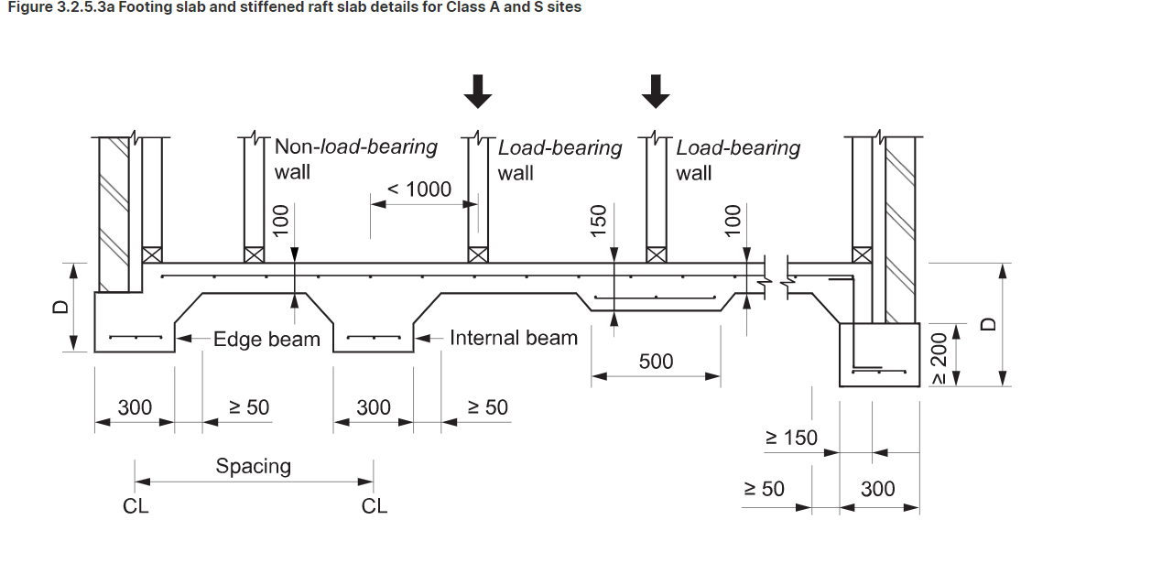

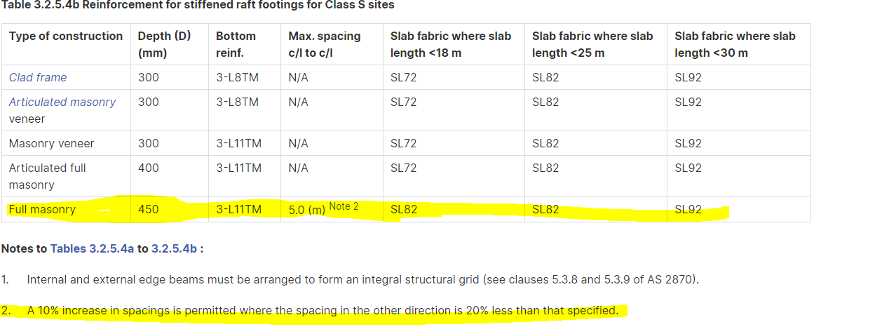

Above requirements for full masonry although plans are masonry veneer.

No nominated framing material as structural is full masonry.

CPCCBC4006A - Practical Activity 3

Raft Slab Construction Checklist AS2870

- Concrete section sizes, beam spacing and reinforcement as per Clauses 3.2.2 to 3.2.4 and 5.3
- Beam Layout internal and external edge beams to be integral structural grid in accordance with Clauses 5.3.8 and 5.3.9
- Reinforcement as per 3.2.3 with slab mesh specified in Figure 3.1 and Table 3.2
- Mesh 3-L8TM
- Bar Alternative 2N12
- Full masonry Depth 500mm
- Raft Design as per AS 2870-2011
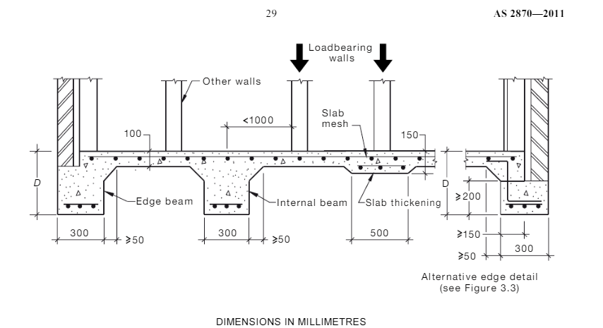

Timber Framing Construction Checklist AS 1684

All Framing to be compliant with engineering specifications and drawings

- Structural timbers specified by engineer
- Bracing as specified by engineer
- Tie Downs as specified by engineer

