
AHCLSC307
Implement a retaining wall project

Copyright © 2020 CSTC Pty Ltd

All rights reserved. No part of the contents of this publication may be reproduced or used in any form or by any means – graphic, electronic, or mechanical including photocopying, digitising, recording, or information storage-and-retrieval systems – without the written permission of CSTC Pty Ltd.
ASSESSMENT FOR AHCLSC307

Student name | Jack Schaffer
Date of assessment submission | Click here to enter a date.

Trainer/Assessor’s name
Date of assessment marking | Click here to enter a date.
Outcome for unit | ☐ Competent  ☐ Not Yet Competent

TASK INSTRUCTIONS

- As part of the assessment for this unit of competency, you are required to complete a series of activities.
  - Some of these activities will require you to provide a response within this document, others will require you to gather evidence to demonstrate your knowledge and skills.
- At all times, the responses in your assessment must reference Australian (Queensland or Federal) documentation, including legislation, regulations, codes of practice, standards and guidance publications.

ACTIVITIES

Identify/list the scope of the work to be carried out from the concept plan shown.

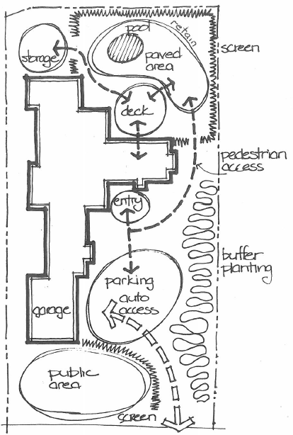

Response
A screen planted out the front for privacy to public area. Get more details on public area requirements eg lawn/paving. Put in plants in buffer zone on the right hand side of the house. Retaining wall to retain back right corner near pool. Screen back area around the pool
Screens planted, buffer planting, area around pool paved, retaining wall built, screen

Outcome for Activity 1 | ☐ Satisfactory  ☐ Not satisfactory
Trainer/Assessor comments

Identify/list the detail on the landscape plan shown.

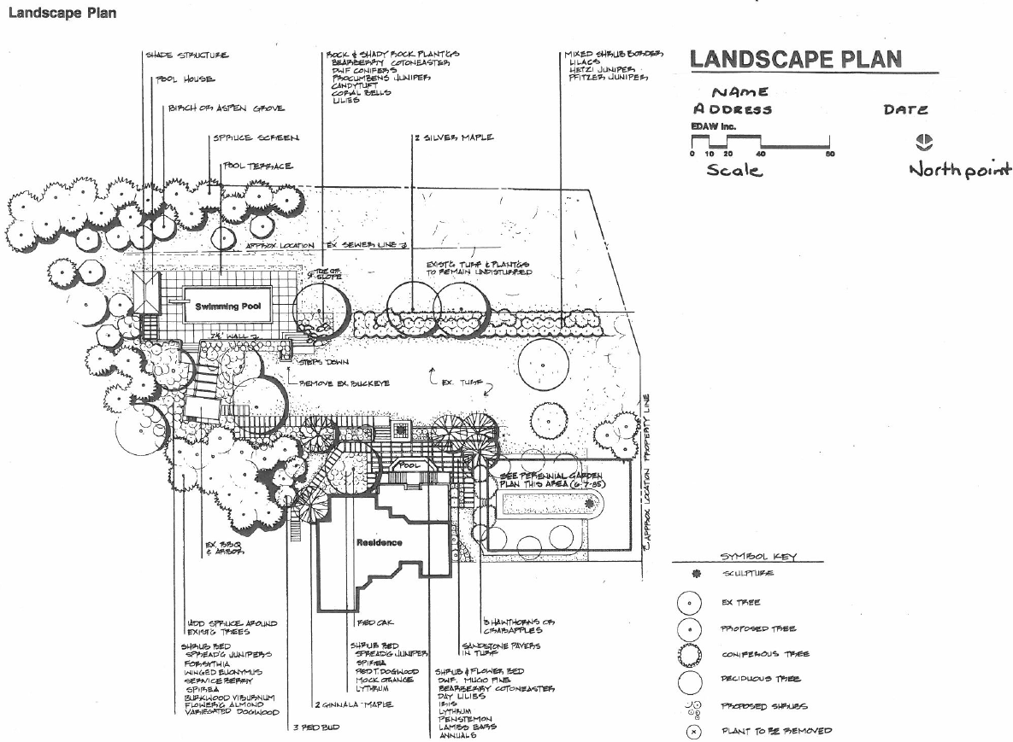

Response
Shadestructure poolhouse, burch/aspen grove/ spruce screen, pool terrace, rock and shady rock planters, mixed shrub border, property line, sewer line, perennial garden, existing turf and plantings, steps, swimming pool , pool, sandstone pavers in turf, existing bbq and arbor,

Outcome for Activity 2 | ☐ Satisfactory  ☐ Not satisfactory
Trainer/Assessor comments

List the materials required to complete the retaining wall, by using the wall and water feature construction plan shown.

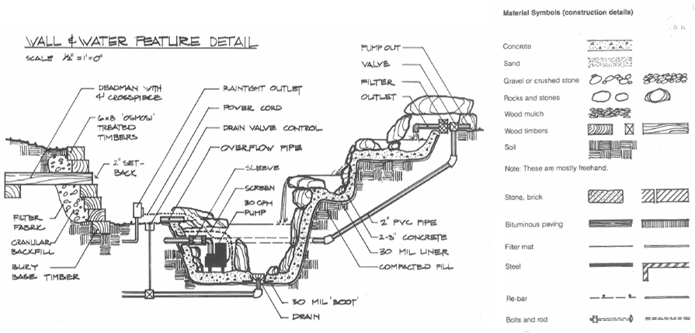

Response
Wood Timbers - 6 x 8 ‘osmosi’ treated timbers
Filter fabric
Gravel and crushed stone (granular backfill)
Bolts and rod

Outcome for Activity 3 | ☐ Satisfactory  ☐ Not satisfactory
Trainer/Assessor comments

Identify the requirements of your local council with regards to retaining walls.

Response
In all zones, you do not need a development application if your proposed retaining wall is less than one metre high.
If your proposed retaining wall does not meet these requirements, you may need a development application. Contact Council for advice specific to your retaining wall.
A retaining wall is a 'class 10b' (non-habitable) structure under the Building Code of Australia (forming volumes one and two of the National Construction Code).
Queensland building regulations advise you will not need building approval for a retaining wall if:
- there is no 'surcharge loading' over the 'zone of influence' for the wall (refer to definitions in the Building Regulation 2006 (Schedule 1 Section 3))
- the total height of the wall and of the fill or cut retained by the wall is no more than one metre above the wall's natural ground surface
- the wall is no closer than 1.5 metres to a building or another retaining wall
- it does not form part of the fencing for a pool.

Outcome for Activity 4 | ☐ Satisfactory  ☐ Not satisfactory
Trainer/Assessor comments

What strategies could you implement to address environmental impacts, including:
- Spillages
- Dust
- Site cleanliness
- Noise

Impact | Strategy
- Spillages | Clean up all spillages immediately.  Dispose of spilt material appropriately.
- Dust | Keep worksite clean by regular cleaning of site.  Set up dust prevention such as screens or sheet .  Avoid use of blowers as they will create more dust.  Wet down site to prevent dust.
- Site cleanliness | Clean up after yourself as you go.  Clean the site at the end of each day.  Dispose of rubbish into correct skip bins.
- Noise | Limit hours of use.  Be aware of local government noise laws.  Select quieter equipment  Carry out work as far away as possible from neighbours and away from sensitive areas such as bedroom windows.  Service equipment, lack of maintenance can cause higher noise levels.

Outcome for Activity 5 | ☐ Satisfactory  ☐ Not satisfactory
Trainer/Assessor comments

List the components for four (4) common surface drainage systems used in landscape construction.

System | Components
- Spoon | Slope/fall  Can be made of earth and grass or  Concrete, reinforcing mesh, movement joint material
- Channel and grate | Grate  Channel  Pipes  Backfill (bedding sand and/or gravel)
- Pit | Components of a pit are the box, the grate that sits on top of the box also pipes for the water to run down.
- Contour | Gradient  Length  Spacing  Cross-section  Depth of flow

Outcome for Activity 6 | ☐ Satisfactory  ☐ Not satisfactory
Trainer/Assessor comments

List the advantages and disadvantages of drainage behind and through the built wall (as shown).

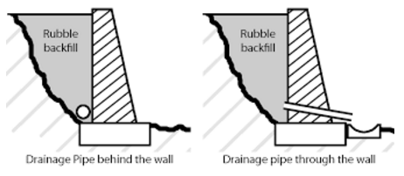

Drainage pipe behind the wall
Advantages
More visually appealing
Disadvantages
Water can sit in the ag pipe and will cause moisture to sit behind the wall without going through a pipe that is going through the wall

Drainage pipe through the wall
Advantages
This gives the water a more direct flow passage to escape from behind the wall.
Disadvantages
Visually doesn’t look as good with a pipe sticking out.

Outcome for Activity 7 | ☐ Satisfactory  ☐ Not satisfactory
Trainer/Assessor comments

Explain the following terms:
- Batter
- Angle of repose

Term | Definition
- Batter | Batter means that the wall should lean toward whatever its holding up. The centre of gravity of the wall should be behind the wall foundation, or footer. This way the weight of the wall helps hold the backfill in place.
- Angle of repose | Angle of repose is the maximum slope, measured in degrees from the horizontal, at which loose solid material will remain in place without sliding.

Outcome for Activity 8 | ☐ Satisfactory  ☐ Not satisfactory
Trainer/Assessor comments

Describe what is happening the in sketched diagram and the photograph shown below.

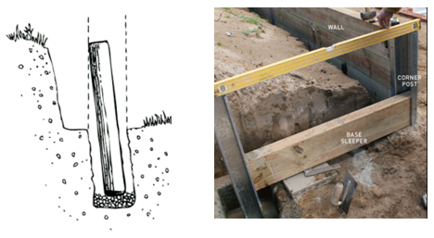

 | Description
- Sketched diagram | The post has been set to a batter.
- Photograph | A return bay is being put in with the base sleeper put in first, the levels of the posts are being checked.

Outcome for Activity 9 | ☐ Satisfactory  ☐ Not satisfactory
Trainer/Assessor comments

Have team members take photos and videos of your involvement with retaining wall projects.

Identify each photo / video with a letter label and describe each photo / video in the table below. Submit the photo / video files along with this workbook.

Advantages
A | A. Setting profile string line to position retaining wall
B | Establishing tolerance
C | Auger boring holes for posts
D | Cleaning out auger hole
E | Post holes prepared on profile line
F | Plumbing steel post for concrete sleepers
G | Plumbing up timber post
H | Measuring position of bottom sleeper
I | Steel posts in position
J | Fitting concrete sleepers with machine
K | Top concrete sleeper in final position
L | Draining system with drain pipe, gravel and fabric
M | Drainage behind wall
N | Waste materials in skip
O | Setting timber posts
P | Drainage waste point set in fill
Q | Block retaining wall with reo bars in position
R | Timber posts set against profile line
S | Timber sleepers set in position
T | Materials delivered to site
U | Marking out according to plan
V | 1.Timber posts set ready to be trimmed to specified height. 2. Timber posts measured ready for trimming. 3. Trimming post to height with circular saw.
W | Post trimmed to height and edges chamfered.
X | Finished wall with screen panel posts set
Y | Fixing timber sleepers to post
Z | Profile showing height of post

Outcome for Activity 10 | ☐ Satisfactory  ☐ Not satisfactory
Trainer/Assessor comments

