CPCCBC4014A
Prepare simple building sketches and drawings

THEORY EXAM INSTRUCTIONS

- This exam will occur under standard assessment conditions.
  - An oral examination may be allowed under certain circumstances.
Answers will be documented and FT003 (Oral examination declaration form) must be completed.
- Participants must provide enough detail in their responses to demonstrate their knowledge and skills.
- Please fill in the details below, providing your name, signature and date of assessment.
  - Your signature acknowledges that this is your own work.
- If a participant initially answers a question incorrectly but modifies their response, they must follow the instructions below:
  - If a participant changes their response in writing, they must put their initials next to the written change.
  - If a participant changes their response verbally, this must be noted on the exam paper by the assessor.

Participant name | Henry Erratt
Participant signature | 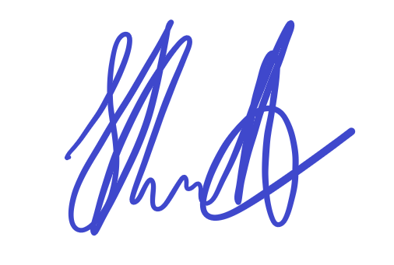

Assessor name
Assessor signature | 

Date | Click here to enter a date.

Number of questions | Number of questions answered correctly | Satisfactory?
23 |  | Yes | No
Assessor Comments
- Identify three (3) two-dimensional drawings/sketches that may be used to clarify or communicate ideas to clients or other parties. For each drawing/sketch, identify four (4) key features that may be shown.

Answer | Drawing/sketch type | Key features
 | Sectional views: | - can show greater details of structural parts  - Build/ assembly of structural parts.  - Types of materials internally  - RLs of internal parts
 | Land boundaries, contours and footprint of building | Shows;  - Boundaries  - critical adjoining parts of surrounding properties  - levels on the site  - Position of the building or structure on the land
 | Floor plan | -Shows the layout/arrangement of rooms and other parts of a house interior  -Dimension of rooms  - Location of doors for access and egress.  - Orientation of structure with respect to North

- Name two (2) advantages of a three-dimensional sketch/drawing.

Answer | 3D drawings/sketches provide a more realistic picture of a space, but require more time to develop. However, there are a number of software programs available to assist with their development.

- Name one (1) individual you might contact to establish the scope and standard of the job being undertaken.

Answer | Client

- You need to inspect the relevant area to take measurements for your drawings/sketches. Identify two (2) safety requirements you would need to observe on site.

Answer | Site induction  Appropriate PPE

- Identify two (2) types of tools/equipment you would use when inspecting the area to take measurements.

Answer | Camera  Tape Measure

- Identify two (2) types of tools/equipment you might need when completing sketches/drawings.

Answer | Ruler  Tape Measure

- What action should be taken if any of the tools/equipment identified in Q5. and Q6. are found to be defective? Tick your response.

Answer | Choice | Possible Answers
 |  | Report, Record
 |  | Stop, Report, Record
 |  | Stop, Tag, Report, Record
 |  | Stop, Fix, Report, Record

- True or False (Tick your response): It is best practice to double check measurements before recording them.

Answer |  | True
 |  | False

- Explain the purpose of the scale on sketches/drawings.

Answer | Buildings are drawn in proportion to the actual measurement of the object which is known as the scale of the drawing.

- You have measured a wall that is 2.4m high. Using a scale of 1:100, what size will this be drawn? Provide your answer in mm. Show your workings.

Answer | 2.4m x 1000 /100 = 24mm

- Explain the purpose of a key or legend on sketches/drawings.

Answer | If symbols and abbreviations used have more than one meaning, a key or legend should be included with any sketches/drawings developed to outline the meaning

- Which of the following are true about drawing contours?
Tick all that apply.

Answer | Choice | Possible Answers
 |  | Equally spaced contour lines indicate uniform slope
 |  | Closely spaced contour lines indicate flat surface
 |  | Closely spaced contour lines indicate steep ground
 |  | Concentric closed contours with decreasing values toward the centre indicate a pond
 |  | Concentric closed contours with decreasing values toward the centre indicate a hill

- Identify the Volume and Parts of the NCC that relate to metal sheet roof cladding for Classes 1 and 10, and Classes 2 to 9.

Answer | Classes 1 and 10 | Classes 2 to 9

- Which Australian Standard is referenced in the NCC with regards to the requirements for the design and installation of metal sheet roof cladding?

Answer

- Sketch the following standard design symbols.

Answer | Item | Sketch
 | Compass (North) | 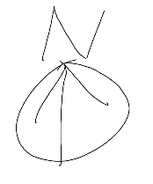
 | Sink with one bowl | 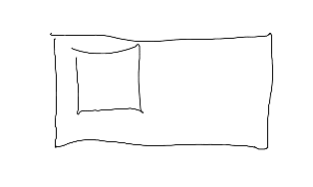
 | Stairs | 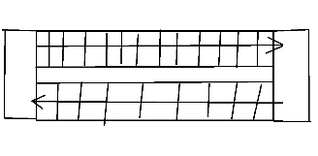
 | Toilet | 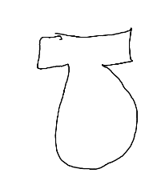

- Explain the meaning of the abbreviations in the table below.

Answer | Abbreviation | Meaning
 | BK | Brick
 | CBD / CPD | Cupboard
 | DP | Damp Proof
 | INSUL | Insulation
 | KIT | Kitchen
 | MSB | Main Switch Board
 | PBD | Plasterboard
 | RWT | Rain Water Tank
 | SHR | Shower
 | TEL | Telephone
 | WC | Water Closet

- True or False (Tick your response): The dashed/chain lines on the section view shown below represent the portions that have been in contact with the cutting plane.



Source: https://www.mcvts.net/cms/lib/NJ01911694/Centricity/Domain/131/Section_Views.pdf

Answer |  | True
 |  | False

- Explain the use of hatching lines for sectional drawings.

Answer | Hatching Lines indicate the sections that have been cut by the section view

- True or False (Tick your response): In an offset sectional drawing, the cutting plane does not travel in a straight line.

Answer |  | True
 |  | False

- Which of the following information should be included in the title block for a sketch/drawing? Tick all that apply.

Answer | Choice | Possible Answers
 |  | Client details
 |  | Contact details for person who prepared drawings
 |  | Date drawing was completed
 |  | Drawing number
 |  | Drawing title
 |  | Job number
 |  | Project name and address
 |  | Revisions / Amendments (if applicable)
 |  | Scale

- True or False (Tick your response): Amendments usually have to be signed or initialled by both the builder and the client to show they both agree.

Answer |  | True
 |  | False

- Explain why it is good practice to have a single repository for sketches/drawings.

Answer | To allow for the drawings to be kept up to date as easily as possible. This will ensure that when using drawing from the repository they will be the latest.

- Name the Regulation and identify the section that outlines the requirement for structure designers to produce a safety report.
Briefly describe the requirements.

Answer | Section of Act | Requirements

