Client Contract
Contractor Information

Name of Contractor: Mirvac Constructions
Licence Number: 1000 000 000 000
ABN: 45 003 353 713
Telephone: (07) 3859 5992
Email: Accounts@mirvac.com.au
Postal: Level 28, 200 George St Sydney, NSW 2000 Australia

Subcontractor

Name of Subcontractor: Cogent Scaffolding
Licence Number: 0000 000 000
ABN: 30 570 017 005
Telephone: 1300 550 149
Email: info@cogentscaffolding.com.au
Postal: U6 368 Earnshaw Road Banyo Qld 4014

- Parties of the agreement
This subcontractor and client agreement (the Agreement) has been signed between Cogent Scaffolding (hereinafter shall be referred as the subcontractor for scaffolding) residing at 368 Earnshaw Road Banyo QLD 4014 and Mirvac Constructions (hereinafter shall be referred as the client) residing at 340 Adelaide Street Brisbane QLD 4000 on 13th January under the terms and conditions stated below.
Contractor and Client shall be hereinafter referred individually as ‘Party’, jointly as ‘Parties’
- Subject of the agreement
The subject of this Contract is the terms of construction of the Quay Waterfront Newstead project, resides in 47 Skyring Terrace, Newstead 4006.
Within the scope of the Contract, the construction covers the following issues:
- Erection and Dismantle of all scaffolding including, edge protection and access

- Term of contract
This Agreement shall enter into force upon the signature of the Parties 11th February. The term of this Contract is Subcontractor contract. This term can only be extended with the written consent of both Parties involved.
This Agreement has been concluded to supersede all kinds of verbal and written proposals, offers and acceptance and all other commercial correspondences, if any.
- Start Date and Completion date.
The above-mentioned construction work will start on 25th of March 2023. Contractor is responsible to obtain all necessary permits and licenses to start the construction.
The construction works to be carried out under the Contract will be completed on the 25th of March at the latest and continue thereon after for approximately 2 years on 25th of March 2025. The immovable will be delivered to the client.
Completion at the cost of the Contractor is not applicable for this Subcontractor Contract.
If there is a need for an extension of time, the subcontractor is entitled to variation sum, to be approved by contractor, when requesting an extension of time. If unable to approve variation, subcontractor may choose to stop works immediately outside the agreed upon practical completion.
Under Queensland Building and Construction Commission Act 1991 Section 677 a subcontract is subject to a condition that, at any time before, under this contract, practical completion of building work is reached, the total value of the following is to be not more than 5% of the contract price for subcontract all retention amounts for the subcontract that are being withheld, all securities for the subcontract given and still held.

- Liquidated damages
The Subcontractor is obliged to pay the Contractor 0.5% per week of delay to cover cost of liquidated damages.
- Scope of Works
The Subcontractor is to complete the erection, dismantle of scaffold including edge protection, access and form support, with the chance of alternation to contract items. For full breakdown of contract works, see below.
- Pricing and payments
The Client shall pay Cogent Scaffolding a total amount of $383, 785.23 for the completion of the construction work with no deposit required to begin work. Invoice and claim will be sent at the end of every month for the works completed for that month. Client is to pay Subcontractor within 30 days of the invoice.
Contractor understands that the agreed upon payment amount may increase due to unforeseen circumstances. The contractor is required to pay the amount under the terms of a variation if:
- It is no fault of the subcontractor that the scaffold gear and equipment is needed on site
- It is at no fault the project has been delayed.
Progress payments are to be made monthly accurately displaying the amount of works that are completed to date.
Under Building Industry Fairness (Security of payment) Act 2017 Section 10B, a person who is a party to a subcontract is liable to pay an amount to the subcontractor if any of the following circumstances apply; the amount is due to be paid by the person to the subcontract with the terms of the subcontract.

Subcontractor is to provide progress claim and percentages of completion with an invoice of how much is owed to the subcontractor. Contractor is to pay invoice within 30 days of invoice date, otherwise, works are to come to a halt until invoice is paid.
Contractor must ensure that all payment information is sent to subcontractor before first payment is due.
See below table of schedules (items) of the progress claim.
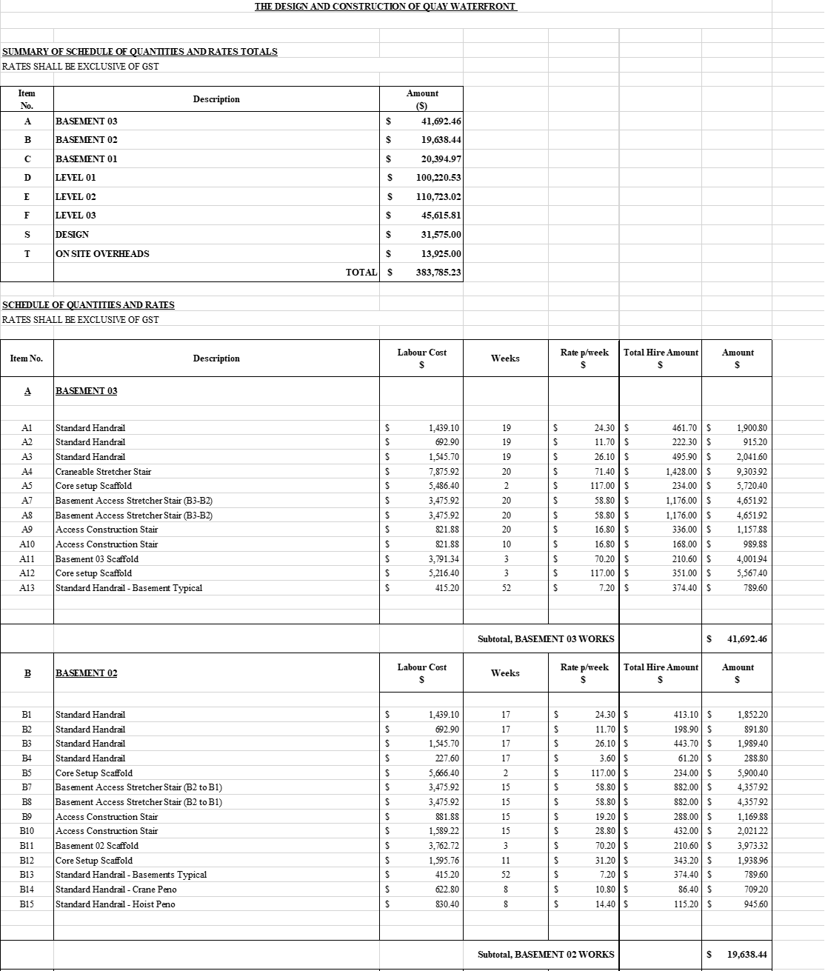
IN WITNESS WHEREOF this Contract has been executed for and on behalf of the undersigned as of 13th January 2023.
Subcontractor Client:
Name: Name:
Date: Date:
Signed: Signed:

General Conditions of Subcontract
1. Definitions and Interpretations
Completion When the entirety of the works specified in this contract has been performed.
Extension of Time is the allowance for an extension on the construction process where the project delays is not of fault of the contractor.
Repudiation when either party abandons their obligation under this contract due to unwilling to or unable to perform these obligations.
Abandonment when one or both parties do not intend to complete their obligations set out in the contract.
Ousting the Contractor from the Project Site Is the contractors right to be present on site when construction work commences.
BIF Act the Building Industry Fairness (Security of Payment) Act 2017
Working Day A day that is not
- A Saturday or a Sunday, or
- A public holiday, special holiday, rostered day off as per the Union.
- A day in the period from 22 December in a particular year to 10 January in the following year, both days inclusive.
Date of Substantial completion is
-The date stated under IV. Start date and Substantial completion, subject to adjustment in accordance with … or
- The date on which Substantial Completion is attained
Defects means any part of the work that is defective, incomplete or not otherwise carried out in accordance with the Subcontract.
QBCC Act The Queensland Building and Construction Commission Act 1991
Site is the land on which the construction works are to be completed.
Start Date is the date stated in or determined in accordance with item IV.
Subcontract this agreement for the subcontractor to carry out and complete the works for the Subcontract Price.
Variation a change in the scope of works arising from:
- An increase, decrease, addition, substitution or omission of work from the originally scope of works
Liquidated Damages that a party in breach of its obligations under a contract is obliged, by the contract, to pay a particular sum by way of compensation for that breach.
- - a change in the method or process for, or the sequence of, the carrying out of the works required by the contractor
- An alternation to the specification of a material
- Change in levels, dimensions or the set out of the works.

- This Contract
Under this contract between a Contractor and a Subcontractor, the Subcontractors obligation to provide labour for the Contractor to complete the work stated under this Contract.
As stated in the Queensland Building and Construction Commission Act 1991 Section 67AAA meaning of building Contract, a building contract means a contract or other arrangement for carrying out building work in Australia but does not include a domestic building or a contract exclusively for construction that is not building work.
Under section 67G Building Contracts to be in writing, the contractor commits an offence if they enter into a building contract without the building contract in writing if the building work is more then $10 000.
Under Section 67GA a building Contractor must not enter into a building contract that does not include the conditions prescribed by regulation for inclusion in that type of building contract.
- Standard of Work
The subcontractor must carry out and complete the works in accordance with the Subcontract:
- In an appropriate and skilful way using all reasonable care and skill
- Using only new materials, unless instructed otherwise in writing by the Contractor
- In accordance with the Subcontractor Documents, and
- In accordance with all applicable laws and legal requirements
The Contractor will ensure that any work of the Contractor or its other subcontractors upon which the Subcontractors work is to be placed or built, or is dependent, has been constructed in an appropriate and skilful way using all reasonable care and skill.
- Site
The Contractor gives to the Subcontractor a nonexclusive licence to enter upon the Site for the sole purpose of carrying out the work.
The Contractor gives to the Subcontractor a nonexclusive licence to enter upon the Site for the sole purpose of carrying out the Works
The Subcontractor and its agents, employees, subcontractors and consultants must comply at all times with:
- All applicable requirements of or otherwise connected with, the Work Health and Safety Act 2011 (Qld) including all directions given by the principle contractor of the site, and
- -all applicable requirements of the Environmental Protection Act 1994 (Qld)
The Subcontractor acknowledges that the Contractor may immediately remove the Site any person who fails, or is reasonably suspected of failing to comply with the applicable requirements of the Work Health and Safety Act 1994 (Qld) or any legal requirements arising out of, or otherwise connected with, either of those Acts.
- 4. Start of Works
The Subcontractor will start carrying out the works on, or on a date determined in accordance with, the Start Date, unless otherwise directed in writing by the Contractor.
- Extension of Time
Within 15 Business Days after the Subcontractor becomes aware, or reasonabley ought to have become aware that the Works are being or will be delayed for any reason, it must give to the Contractor a notice stating:

- The cause of delay
- The length of the delay, and
- The extension, in Work days, of the Date for Substantial Completion being claimed by the subcontractor as a result of the delay
Subject to the Subcontractors compliance with this clause, the Subcontractor will be entitled to an extension of the date for substantial completions for:
- A delay caused by any act, default or omission of the principle, the contractor or other subcontractors or their respective agents, or
- Any delay that is not reasonably foreseeable and is beyond the reasonable control of a competent and experienced subcontractor other than delays arising from industrial conditions or inclement weather occurring after the date for substantial completion.
Withing 15 Business days after receipt of a notice the Contractor must issue to the subcontractor a written notice, either:
- Granting the full extension of the date for substantial completion requested by the contractor, or:
- Stating the amount of time that the contractor is granting as an extension of time to the date for substantial completion together with the reason why the contractor is not granting the fully extent of the extension claimed by the subcontractor, or
- Completely rejecting the extension of time requested by the Subcontractor and providing the reason for doing so
If the Contractor fails to give to the Subcontractor a written notice, the extension of the date for substantial completion claimed by the Subcontractor is taken to be granted.
If the Subcontractor’s progress of the Works is delayed as a direct result of a cause of delay described in clause 8.2 (a) and the Subcontractor claims and is granted an extension of the Date for Substantial Completion, in accordance with this clause the Subcontractor is entitled to give to the Contractor a written claim, calculated on a daily basis, for any extra costs it incurred as a result of the delay during the period of the extension as part of its next progress claim after the extension is granted
The Subcontractor must support any such claim with documentary evidence of the extra costs it has incurred.
The Contractor must pay to the Subcontractor, as part of its next progress payment, those delay costs claimed in accordance with this clause which are reasonably evidenced by the Subcontractor’s documentary evidence.
Where an amount is specified at Item 7, the Subcontractor’s maximum entitlement to delay costs shall be an amount equal to or less than the daily amount for delay costs set out in Item 7.
Notwithstanding this clause, at any time prior to Substantial Completion, the Contractor may for its own benefit, at its sole discretion and for any reason grant an extension of the Date for Substantial Completion regardless of whether the Subcontractor has made any claim in accordance with this clause.
- Variations
At any time in the contract period the Contractor may give the Subcontractor a written direction to carry out a variation. This is to be sent via Aconex in a form of an email with a Scaffold Request Number. The variation work is not to begin until after it is approved with a SITE Instruction (SI).
Day Labour is as follows:
- Normal time $135
- Double time $175

- Consequences of failure to pay
If the client does not make the required payment on time, the Subcontractor may immediately suspend the construction and notify the suspension to the client. If the client does not pay within 30 days without reasonable cause, the Subcontractor may terminate the contract immediately, or complete the work and demand the balance die from the client.
In any case, the client is obliged to pay the price of the work performed.
- Permits and licences
Permits, licenses and required certificates to be obtained from local administrations and all kinds of public institutions for the construction shall be taken by the Subcontractor.
If an extra cost is required to obtain these permits and licenses, this cost is borne by the Client. The required cost is notified to the Client by the Subcontractor. The Subcontractor will not be liable if the payment is not made within the required time.

- Requirements of the Subcontractor
It is the Subcontractors responsibility to complete all documents required by the Contractor. These as follows:
- Prestart Meetings required every morning
- Toolbox talk meetings every week
- Scaffold safety inspections every month
- Handover Certificates every time scaffold is completed and built.
Failure to supply these to the contractor will result in payment holds until all is supplied and approved.
- Labour and construction material
The Subcontractor is an independent subcontractor, and the subcontractors employees or personnel shall not be deemed as the client’s employees. The Subcontractor is solely responsible for all costs and expenses of its employees including but noy limited to salaries, retirement plans, health insurance, vacation time-off, sick pay, personal leave, or any other benefit provided.
The Subcontractor is not responsible for the hire price of scaffolding, however is responsible for all consumables and safety equipment required on site.
- Other responsibilities of the Subcontractor
The Subcontractor shall be responsible for supervising, managing, erecting, and dismantling all forms of scaffolding on site.
The Subcontractor shall be responsible for keeping all record of documents in a safe place. The Subcontractor should store these documents in safe storage as it will be presented to the owner once work has been completed.
The Subcontractor shall be responsible for taking all precautions for the safety of it employees and the public property. The Subcontractor must take full responsibility for the acts or negligence of its employees. The Subcontractor is also responsible for training its employees about the Occupational Safety and Health Regulation to give knowledge on how to handle emergencies and accidents in the workplace.
The Subcontractor should give a guarantee to the client that all work will be in accordance with the Construction Documents.
The Subcontractor shall provide skilled and competent staff suitable to do the work and should maintain discipline and order at the project.
The client shall be responsible for maintaining the property clean and keeping it free from waste and hazardous materials. If hazardous materials or substances were noticed in the property such as dangerous chemicals, containment or any toxic substances, the Subcontractor shall not be responsible for notifying the owner immediately. The Subcontractor is also responsible for training their employees about handling hazardous materials and substances in a correct and safe manner. Any sickness, damages, loss of employees that was caused by these hazardous materials shall be handled by the Subcontractor.
- Insurance
Contractor
Insurance Provider: Allianz Insurance
Policy Number: 1234 123 123
Subcontractor
Insurance Provider: RACQ
Policy Number: 1234 123 123
The Subcontractor shall be responsible for purchasing and maintaining and appropriate insurance policy for the construction. The client agrees to maintain insurance covering the replacement cost in the event of loss through fire, casualty, an act of nature, and theft.
- Termination
The Subcontractor can be terminated by either party if the Subcontractor or the client breaches any of the obligations specified in this Agreement. A written notification identifying the breach should be issued by the Contractor or the client.
As defined in section IV of this contract, if the client does not pay the required amount on time, the Subcontractor may immediately terminate the Contract or may complete the construction and claim compensation.
Both Contractor and Subcontractor has the right of Repudiation of a Contract under conditions of the following;
- Do not intend to follow through with the obligations of this contract
- It is impossible to honour the obligations and requirements of this contract
- This project site is transferred to a third party.
If accepted by the other party, the unequivocal acceptance must be communicated to the party that has committed the repudiation to formally end any further obligations and to be released from damages payable by the party that committed the breach.
If not accepted, then the contract is considered affirmed and the other party may still file for damages with contractual obligations still to place to be continued. If the other party stops performing its contractual obligations, then this party is in breach of the contract.
- Amendment

No changes, modifications or amendments in the terms and conditions of this contract shall be effective unless reduced to writing and signed by the duly authorised representative of the Subcontractor and the client.
- Unreasonable and Vexatious Notice
- Abandonment
If for the following reasons:
- The contractor has failed to start the project within time,
- The contractor cannot finish the project within time,
- The contractor fails to complete what is left of the project within time,
has happened and both parties come to a mutual agreement, the parties have the right to abandon the contract.
If one party does not agree to abandon the contract, then it is a breach of contract.
One the contract is abandoned, the contractor is then liable for any damages and outstanding charges.
- Ousting the Contractor from the Project site
The contractor and subcontractor has the right to access the site where the construction shall commence at the time and date agreed upon in this contract.
Failure to comply with this results in breach in contract.

- Governing Law
This Subcontract shall be construed in accordance with the laws of the state of Queensland Government and the obligations, rights and remedies of the parties hereunder shall be determined in accordance with such laws.

