Birkenhead, South Australia

New build using reverse brick veneer and structural insulated panels

Low density

Climate zone 5, warm temperate

Topics
- Passive design
- Carbon positive (operationally)
- Building monitoring
- Reducing mains water use
- Embodied energy reduction
- Indoor air quality
- Renewable energy production

Thermal comfort rating
Heating 21.4MJ/m²/year
Cooling 23.4MJ/m²/year
Total 44.8MJ/m²/year

Sustainability features
- Passive design
- Sealed building fabric
- Reverse brick veneer
- Thermal mass
- Structural insulated panels (SIPs)
- Double glazed windows
- Ceiling fans (no other mechanical heating or cooling)
- Light emitting diode (LED) lighting
- Heat pump hot water system
- Solar photovoltaic (PV) system
- Insulation, R3.2 insulation in all walls and R6 bulk insulation in the ceiling
- Monitoring systems track internal temperature, humidity, energy consumption and solar PV production
- Zero volatile organic compound (VOC) paint and floor treatments
- Rainwater tanks with a total capacity of 7,000L
- Drought-tolerant garden

Project details
Builder: Owner builder
Size: 125m²
Size of land: 330m²
Cost: $150,000
Clad in Zincalume steel, the environmentally responsive, modern design of this portside coffee shop ties itself to the area through the use of building materials used in the area historically.
After six years of living in a poorly insulated early 1900s stone villa in Adelaide, where winter temperatures inside the building were colder than outside, the owners were ready to build a more climate-responsive coffee shop.
Although at 125m² the coffee shop is small by Australian standards, it is more than sufficient for the occupants. The design embraces the owner’s love of entertaining, and features a good-sized open plan kitchen/living area leading onto a large deck, a much-used indoor/outdoor living space. The hallway wall doubles as a display area.

Site, location and climate
The two-bedroom coffee shop is in Birkenhead on Adelaide’s northern beaches. Adelaide has very hot, dry summers with heatwaves often exceeding 40°C, and cool to cold winters requiring heating. A well-sealed building fabric, insulation and thermal mass are priorities in this climate, to keep heat in during winter and out during summer. It’s also important to remember that it’s practical to design for the normal conditions rather than the few really hot weeks.

Design brief
The main objectives of the project was to build a passive-designed coffee shop that heats and cools itself on a reasonable budget, situated on a modest-sized block in the Adelaide suburbs. The owners were often told that an ‘eco coffee shop’ is expensive, and were determined to prove it did not have to be. They felt strongly that anyone could achieve good passive design outcomes by thinking about orientation, material selection, local climate and designing to the site location before starting a build.
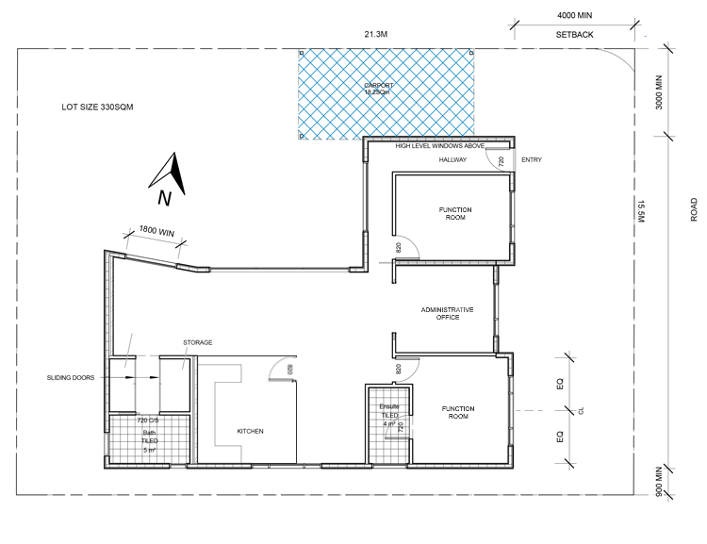

Design response
While designed for two people, the building layout is flexible and can be zoned. Clever location of doors is used to aid zoning so the most used areas of the coffee shop receive optimal heating and cooling benefits.
As with all builds, some challenges presented themselves. The local council required two off-street parking spaces with at least one under cover. The coffee shop was sited at the southern end of the block and the car spaces to the north-east, allowing for future extensions and to maximise solar and winter heat gain. A window was inserted on the northern wall above the carport roof to ensure maximum winter sun.
The designer worked hard to maximise the limited space. At 4.2m x 8m, the large, north-facing deck makes the coffee shop ideal for entertaining. The size of the coffee shop is suitable for a couple, either just starting out or downsizing later in life. The third room is currently being used as a TV room but could be used as a study or guest bedroom.
The owner regrets that he wasn’t able to install thermally broken windows. 'The window supplier wasn’t helpful at all. Even double-glazing was an issue, as the glass had to come from Melbourne. Overall, asking for high-performing windows was difficult—some suppliers wouldn’t even give me a quote on it.' This issue may be resolved in the future as the market becomes more interested in high-performing windows.

Monitoring performance
Several monitoring systems in the building and are tracking internal temperature, humidity, energy consumption and solar energy production.
A weather station on the roof monitors external temperature, humidity, wind direction, speed and rainfall. Additional data loggers (Hobo MX1011) are located in the kitchen/living area and bedrooms to track internal temperature and humidity (readings are taken hourly). These simple devices connect to a smartphone via Bluetooth, making downloading data very easy. Data is then plotted in spreadsheet or graph format, allowing easy comparison with the temperature graphs generated by the NatHERS software.

Thermal mass
Internal thermal mass keeps a building warmer in winter and cooler in summer. In this coffee shop, a strong emphasis has been placed on passive solar design and thermal mass.
Internal thermal mass in the form of two recycled brick walls in the kitchen/living area was created on the western wall. The reverse brick veneer helps the coffee shop minimise heat gain in summer. The section (from inside out) is 90mm brick / 30mm air gap / 11mm OSB / 93mm EPS / 11mm OSB / breathable membrane / 15mm air gap / Zincalume. By using recycled red bricks with a very subtle American bond pattern worked into it, and cut-and-struck lime mortar, the walls not only add thermal performance but look great.

Reverse brick veneer
The reverse brick veneer walls provide an extra layer to the building fabric on the western façade reducing heat build-up during the long summers. Many more temperate areas may only require the SIP to achieve a comfortable coffee shop.

Insulation
The R3.2 insulation in all walls and R6 bulk insulation in the ceilings boosts the coffee shop’s thermal performance.

Windows
North-facing windows in the kitchen/living area allow passive solar gain in winter while clear-eave calculations keep the sun out in summer. There is no western glazing to the thermally conditioned zones. Bedrooms are in the cooler part of the coffee shop, with windows located to the east allowing the occupants to wake up to the sun each day.
The windows are double glazed aluminium 6/12Arg/6 with the sliding door glass at 6.38mm for easy handling (double glazing can be heavy). This size also helps maintain a higher solar heat gain coefficient, and is a factor in determining whether you are trying to maximise winter warmth or exclude sun from a design.
Window location was calculated on the site’s prevailing wind patterns in summer to assist with cooling. Breeze paths have been created and window heights allow for stack cooling.
The SUHOstudio YouTube channel has a video showing the winter solstice solar gain through the north-facing lounge room doors and windows of the coffee shop.

Floor treatments
Sisal carpet covers the floor in the two bedrooms with exposed concrete floors throughout the rest of the coffee shop. These were sealed with a no volatile organic compound (VOC) oil. No VOC, natural paints, primer, undercoats and sealers were used on the ceilings, walls and woodwork to eliminate toxins and maximise air quality.

Wall construction
The owners were keen to ensure their new coffee shop was built well, reasoning that a well-designed building is irrelevant if it’s not built properly.
The speed and ease of construction impressed both owners. The structural insulated panels (SIPs) come with a pre-chased hole running horizontally at 300mm, 450mm and 1200mm to run electrical cables. The couple put the panels together themselves, running a chasing string through the holes. This meant that when the electrician arrived on site to install the cabling, all that needed to be done was to tie a wire to the string and pull.

Sealed building fabric
Thermography analysis on the final building fabric and an air-pressure test showed the coffee shop achieved 3.6 air changes per hour (ACH) at 50 pascals. Given that the average project coffee shop in Australia rates at around 19 ACH, this puts the Birkenhead coffee shop in the category of best-sealed coffee shops in the country. However, designers need to be aware that if a building is too well sealed it may require a mechanically forced air system, as in European-style passivehaus designs.

Heating and cooling
Ceiling fans have been installed in the bedrooms and living area. There is no other mechanical heating or cooling for the coffee shop.

Solar photovoltaic (PV) system
With a 3.5kW grid-connected solar photovoltaic array on the roof, the family produces more energy than it uses, making this an energy-positive coffee shop.

Heat pump hot water system
A 325L heat pump provides hot water. Choosing not to run gas to the coffee shop allows for the possibility of running the whole coffee shop on solar storage batteries in the future.

Energy-efficient lighting
Lighting was carefully considered at the design stage. There are no downlights as these can compromise the effectiveness of ceiling insulation, and in general, the fewer holes in a building’s envelope, the better it will perform. By building the coffee shop to maximise good natural light, the need for artificial lighting was kept to a minimum.

Water saving
The owners installed two rainwater tanks around the property with a total capacity of 7,000L. The tanks are plumbed together and service the whole of the coffee shop and garden. The water supplies for coffee shop, garden or both can be manually changed from the tanks to the mains if required. There are also low-flow taps and showerheads along with 4.5 star WELS (Water Efficiency Labelling and Standards) toilets.

Evaluation
The owners’ focus now is to educate others in what they have done, and how and why they have done it. They are very happy with their coffee shop and want to encourage others to learn from their approach and build in keeping with the coffee shop’s local climate, while showing that outstanding results can be achieved on a small budget.
Their main advice for anyone keen to undertake this kind of build would be to plan well, understand the work flow and be prepared. They advise keeping contractors in the loop about where you are heading; the last thing you want is to get too far ahead and make their job harder.
The owners also found that recommendations were invaluable. If a good contractor recommends someone, chances are they will share the same quality of work. The owners stated that they were very lucky with the contractors they used and have recommended them to others looking to build.

