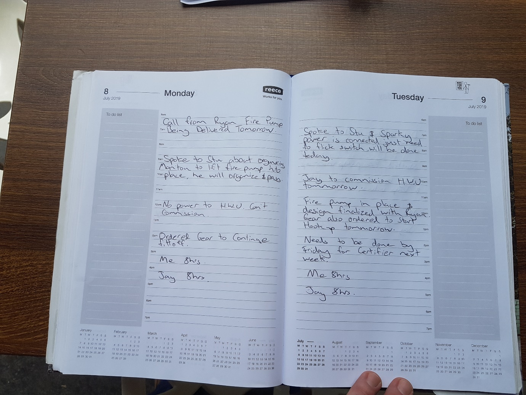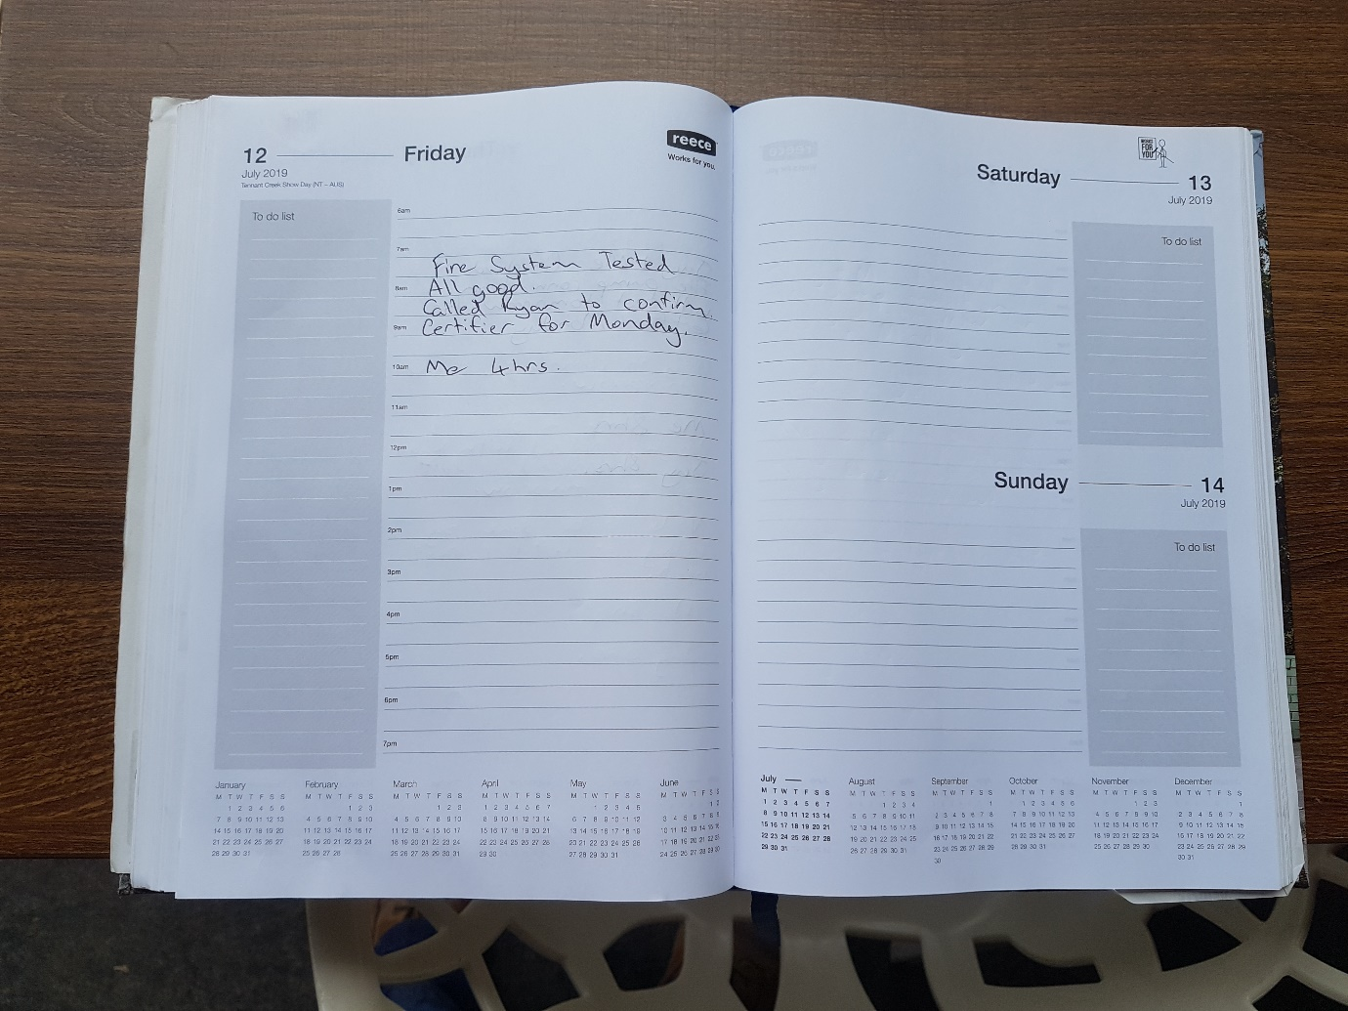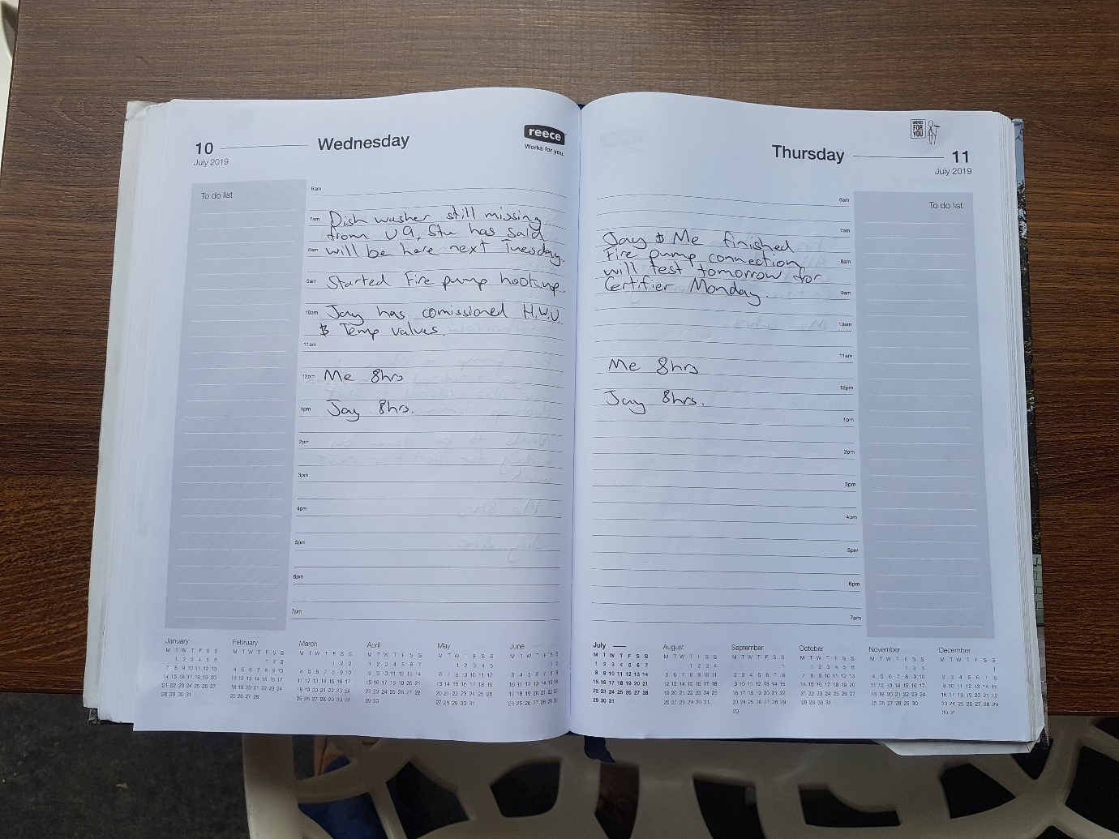Get Outlook for Android

From: Glenn Parrish <glennparrish24@hotmail.com>
Sent: Thursday, 30 January 2020 8:46AM
To: Stuart Betts <sbetts2015@hotmail.com
Subject: Drainage main issue

No worries mate, nah we don’t need to get him involved as we aren’t changing the design of the system it’s still inground drainage. All we need to do is draw it up as we have laid it for the plumbing inspector to sign it off on Monday and then just submit the signed alteration as an ascon for the final certificate. Plus he’ll probably try and charge a fee to fix his mistake!!
Excavator and sand will be there first up on Monday and I’ve booked a pm inspection.

Cheers

Glenn Parrish

Get Outlook for Android
From: Stuart Betts <sbetts2015@hotmail.com>
Sent: Wednesday, 29 January 2020 7:14AM
To: Glenn Parrish <glennparrish24@hotmail.com>
Subject: Re: Drainage main issue

Glenn
I have overlapped your proposal with my plans and the only things out there are the driveway and garden beds so no dramas there. Paul wants to know do you need to get the hydraulic consultant to approve the changes?

Regards

Stuart Betts

Get Outlook for Android
From: Glenn Parrish <glennparrish24@hotmail.com>
Sent: Tuesday, 28 January 2020 11:25AM
To: Stuart Betts <sbetts2015@hotmail.com
Subject: Drainage main issue

G’day Stu
As discussed this morning I have drawn up the proposed new run for the main sewer line due to the issue of the levels of the basement carpark. If you can double check what I have drawn up with your plans that this doesn’t clash with any other structures I’ll book in the excavator and council inspection for Monday the 3rd.
Cheers
Glenn Parrish



