
AHCLSC305
Construct stone structures and features

Copyright © 2020 CSTC Pty Ltd

All rights reserved. No part of the contents of this publication may be reproduced or used in any form or by any means – graphic, electronic, or mechanical including photocopying, digitising, recording, or information storage-and-retrieval systems – without the written permission of CSTC Pty Ltd.
ASSESSMENT FOR AHCLSC305

Student name | Jack Schaffer
Date of assessment submission | 11/09/2020

Trainer/Assessor’s name
Date of assessment marking | Click here to enter a date.
Outcome for unit | ☐ Competent  ☐ Not Yet Competent

TASK INSTRUCTIONS

- As part of the assessment for this unit of competency, you are required to complete a series of activities.
  - Some of these activities will require you to provide a response within this document, others will require you to gather evidence to demonstrate your knowledge and skills.
- At all times, the responses in your assessment must reference Australian (Queensland or Federal) documentation, including legislation, regulations, codes of practice, standards and guidance publications.

ACTIVITIES

Identify/list the scope of the work to be carried out from the concept plan shown.

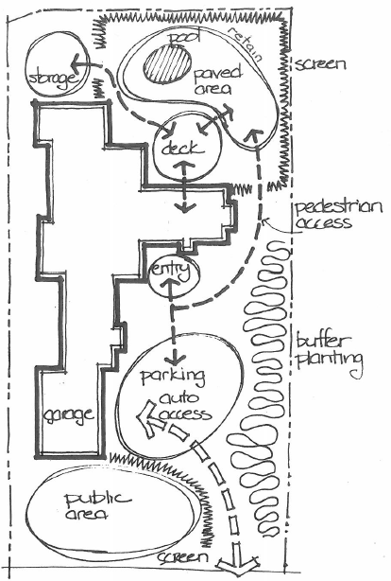

Response
Public area out the front of the garage with screening
A walkway to the parking area
Buffer planting up the right-hand side of the house.
Path to front entry of house from parking
Path from entry of house paved area out the back of the house
Screen around paved area and pool

Outcome for Activity 1 | ☐ Satisfactory  ☐ Not satisfactory
Trainer/Assessor comments

Identify/list the detail on the landscape plan shown.

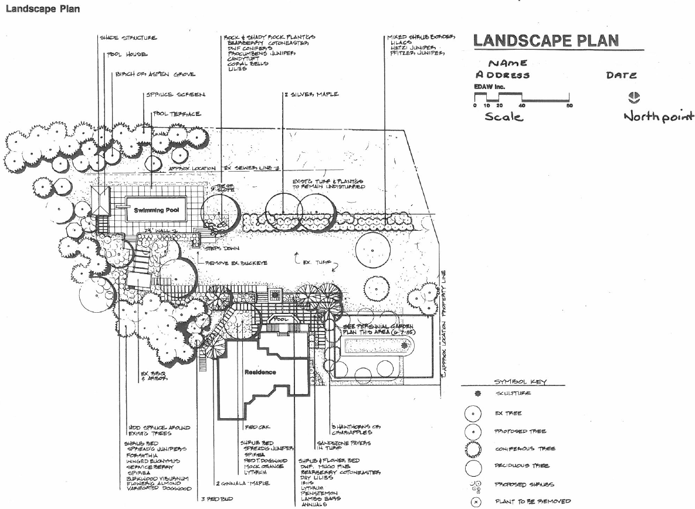

Response
Shade structure, pool house, birch or aspen grove, spruce screen, pool terrace, rock and shady rock plants, 2 x silver maple, mixed shrub border, existing turf and plantings to remain undisturbed, slope, steps down, remove existing buck-eye, existing turf, perennial garden, hawthorns and crab apples, sandstone pavers in turf, shrub and flower bed, BBQ, arbor, wood spruce around existing trees, shrub bed,

Outcome for Activity 2 | ☐ Satisfactory  ☐ Not satisfactory
Trainer/Assessor comments

List the materials required to complete the water feature, by using the wall and water feature construction plan shown.

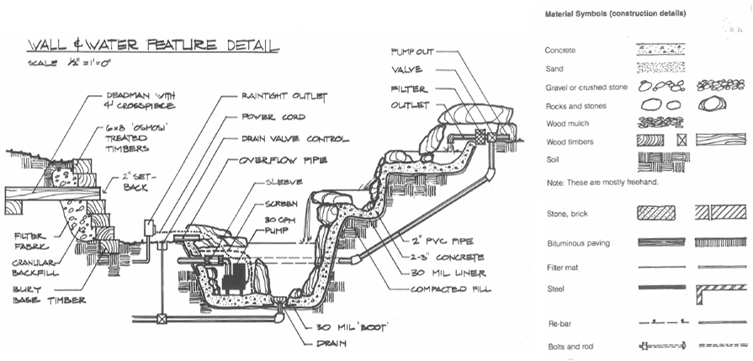

Response
Pump out, valve, filter, outlet, 2 inch pvc pipe, concrete, 30mm liner, fill, 30mm boot, drain, power cord, raintight outlet, drain valve control, overflow pipe, sleeve, screen, 30 GPH pump.

Outcome for Activity 3 | ☐ Satisfactory  ☐ Not satisfactory
Trainer/Assessor comments

Identify formal and informal stone structures and describe their features.

 | Features
- Formal stone structures | Retaining walls, steps, walls, fences, bbq and entertaining areas, edging, water features, fences.  May use cut or uncut stone
- Informal stone structures | Edging, stepping stones, backyard fire pit, decorative accents,  Informal structures use rough or uncut stone and can create a more natural look, weathered stones also look informal.

Outcome for Activity 4 | ☐ Satisfactory  ☐ Not satisfactory
Trainer/Assessor comments

List the components for four (4) common surface drainage systems used in landscape construction.

System | Components
- Spoon | Spoon drains are shallow channels that are usually made from concrete and can be installed around the garden to redirect this excess water to other parts of the garden or to inlets for subsoil drainage systems
- Channel and grate | The channel and grate drain system is used near the edge of houses or at the bottom of steep driveways to collect a large flow of water. The channel is set in concrete and the water will fall into the grate.  The drain consists of a horizontal trench that is open on top; the trench grate covers the top of the trench and allows water to flow into the drain along its entire length,
- Pit | A pit may be placed in the low point of a yard so that the water falls into the pit and goes into the drainage and out of the yard.  A stormwater pit is a water collection pit or storage container for stormwater that holds all the runoff before it drains away through the connected drainage pipes. Stormwater pits are made of pre-cast concrete with a number of outlets for drainage pipes
- Contour | Contour banks are surveyed using a slight fall to ensure that water does not pond behind the bank, but runs to a waterway without scouring the bank channel itself. The length and spacing of banks are designed to suit the slopes and soil types

Outcome for Activity 5 | ☐ Satisfactory  ☐ Not satisfactory
Trainer/Assessor comments

List the advantages and disadvantages of drainage behind and through the stone wall (as shown).

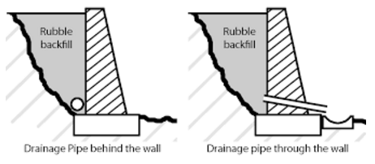

Drainage pipe behind the wall
Advantages
It looks better than having the pipe sticking out of the front of the wall

Disadvantages
It may not drain as well as the pipe through the wall because there is usually only one outlet.

Drainage pipe through the wall
Advantages
Better drainage for the water to get out from behind the wall, can have multiple outlets.

Disadvantages
It doesn’t look nice with a pipe or conduit coming out of the wall

Outcome for Activity 6 | ☐ Satisfactory  ☐ Not satisfactory
Trainer/Assessor comments

Research and list a variety of admixes.

Admix | Description
- Set retarding | To delay the chemical reaction that takes place when the concrete starts the setting process.
- accelerating | Are used to making the concrete go off quicker in colder conditions
- brickies mate | Designed to make mortar more workable and reduces segregation and surface laitance.
- Water reducing | When added to concrete can create a desired slump at a lower water slump ratio than what is normally designed.

Outcome for Activity 7 | ☐ Satisfactory  ☐ Not satisfactory
Trainer/Assessor comments

Research other methods of damp proofing (excluding DPC and base course) and identify the materials used.

Damp proofing method | Materials
- Integral damp proofing | In the integral damp proofing method certain water proofing compounds are added to the concrete mix, so that it becomes impermeable
- Surface treatment | In the surface treatment method a layer of water repellent substances or compounds are applied on these surfaces through which moisture enters.
- Cavity wall construction | In this method the main wall of a building is shielded by an outer skin wall, leaving a cavity between the two. The cavity prevents the moisture from travelling from the outer to the inner wall.
- Guniting | In this method a mixture of cement and water is forced by cement gun on the surface to be made water proof. Later 1 : 3 or 1 : 4 cement mortar is applied to the surface with pressure using compressed air. Thus an impervious layer of mortar is provided.

Outcome for Activity 8 | ☐ Satisfactory  ☐ Not satisfactory
Trainer/Assessor comments

Research and describe suitability of various patterns for stone work projects.

Pattern | Suitability
- Basic running bond | Suitable for residential landscaping as it is one of the most commonly used
- The herringbone | The strongest you can use, outdoor or indoor floor. The interlocking allows it to handle more weight than others. Could be used for driveways
- Ashlar | commonly used in stonework and is a popular way of laying pavers. A mix of square and rectangular pieces of stone are configured into a random pattern.
- Mosaic | A closely fitted pattern of flat stones that may be uniform in color or widely varied, rarely drylaid. Paths , paved areas , gives informal look

Outcome for Activity 9 | ☐ Satisfactory  ☐ Not satisfactory
Trainer/Assessor comments

List the advantages and disadvantages of mortared and dry stone features.

Mortared stone features
Advantages
Stronger and less likely to move
Disadvantages
Small voids can collect water over time , leading to premature failure of the structure/ feature
Over time problems with stonework in general often stem from mortar, which retains dirt, moss, algae and mildew

Dry stone features
Advantages
Better drainage
Results in a veneer with no sign of mortar leaving an all stone surface, which is highly desirable for modern and contemporary styles.
Disadvantages
Not as strong as setting in mortar, more likely to move.

Outcome for Activity 10 | ☐ Satisfactory  ☐ Not satisfactory
Trainer/Assessor comments

Research the different types of stone work finishes.

Response
Capping, raked , full to face, over grouted, weeping joint, water proofing

Outcome for Activity 11 | ☐ Satisfactory  ☐ Not satisfactory
Trainer/Assessor comments

List environmentally safe products for cleaning.

Response
At the completion of the job dispose of materials that cannot be reused or recycled . separate soil and waste material ( eg. organic, inorganic and recyclable piles
Sweep up all mess and place in bin
Using a gerni may be required, set up sandbags in gutters to stop dirt going down drains
Cleaning products
Baking soda
All purpose cleaner)

Outcome for Activity 12 | ☐ Satisfactory  ☐ Not satisfactory
Trainer/Assessor comments

Have team members take photos and videos of your involvement with stone features.

Identify each photo / video with a letter label and describe each photo / video in the table below. Submit the photo / video files along with this workbook.

Advantages
A
B
C
D
E
F
G
H
I
J
K
L
M
N
O
P
Q
R
S
T
U
V
W
X
Y
Z

Outcome for Activity 13 | ☐ Satisfactory  ☐ Not satisfactory
Trainer/Assessor comments

