Workplace Assessment 7.3 – Assessor’s Checklist
(This form is for the assessor’s use only)

Purpose
This Assessor’s Checklist lists the practical skills that the candidate must demonstrate/perform while completing Workplace Assessment 7.3.
This form is to be completed by the candidate’s assessor to document their assessment on the candidate’s performance in Workplace Assessment 7.3.

Task Overview
For this task, the candidate is required to implement the recommended actions from their report in Task 7.2 to address non-compliance.
In this task, the candidate will be assessed in their:
- Practical knowledge of how to implement actions to address WHS non-compliance
- Practical skills relevant to implementing actions to address WHS non-compliance

Instructions to the Assessor

During the assessment
- For each practical skill listed in this Assessor’s Checklist:
  - Tick YES if you confirm you have assessed the candidate demonstrate/perform the practical skill.
  - Tick NO if you have not assessed the candidate demonstrate/perform the practical skill.
- If you ticked YES, provide the date when you assessed the candidate demonstrate the skill.
- Write specific comments on the candidate’s performance in each criterion. Your feedback/insights will help address any area/s for improvement.

After the assessment
- Complete all parts of the Assessor’s Checklist, including the Assessor Declaration on the last page of this form. Your signature must be handwritten.

Candidate Details
Candidate name | Dawei Yang

Assessor Details
Candidate is assessed by | Yanzhong Zhu

Context of the Assessment
Workplace/organisation | Dawn construction
Resources required for the assessment | - Building and construction project  - Access to personnel working on the building and construction project  - Opportunities to implement recommended actions to address non-compliance  - Policies and procedures relevant to addressing WHS non-compliance  - Digital devices, applications, or software that can be used to communicate on the project site, such as, but not limited to:  - Laptop or desktop computer  - Mobile phone

Assessor’s Checklist
During the implementation of recommended actions: | YES/NO | Assessor’s comments
- The candidate seeks management approval for the actions that they will implement. | YES NO
- The candidate meets with relevant personnel who will assist them in the implementation of recommended actions. | YES NO
- The candidate implements actions that are consistent with the recommendations in their site WHS audit report. | YES NO
- The candidate implements actions that address the non-compliances identified in their site WHS audit report. | YES NO
- The candidate informs all personnel who will be affected by the implementation of the actions. | YES NO

Assessor Declaration
By signing here, I confirm that I have assessed the candidate, whose name appears above, implement the recommended actions from their report in Task 7.2.
I confirm that the information recorded on this Assessor’s Checklist is true and accurately reflects the candidate’s performance during their completion of the workplace task.
Assessor’s signature | 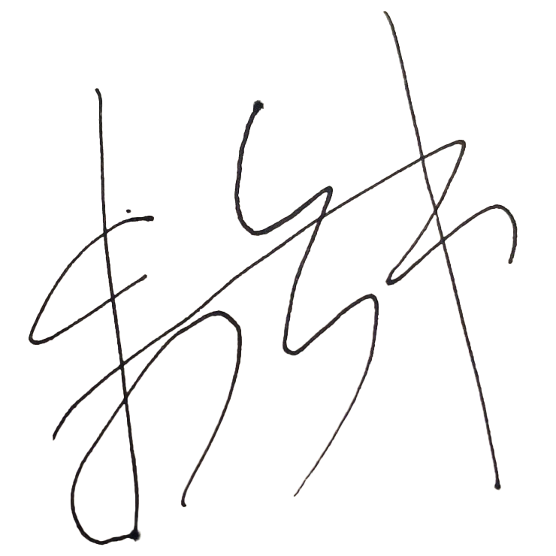
Assessor’s name | Steve Zhu
Date signed | 18/05/2023

End of Workplace Assessment – Assessor’s Checklist

