CPCCBC4004A
Identify and produce estimated costs for building and construction projects

THEORY EXAM INSTRUCTIONS

- This exam will occur under standard assessment conditions.
  - An oral examination may be allowed under certain circumstances.
Answers will be documented and FT003 (Oral examination declaration form) must be completed.
- Participants must provide enough detail in their responses to demonstrate their knowledge and skills.
- Please fill in the details below, providing your name, signature and date of assessment.
  - Your signature acknowledges that this is your own work.
- If a participant initially answers a question incorrectly but modifies their response, they must follow the instructions below:
  - If a participant changes their response in writing, they must put their initials next to the written change.
  - If a participant changes their response verbally, this must be noted on the exam paper by the assessor.

Participant name | Ante Begic
Participant signature | 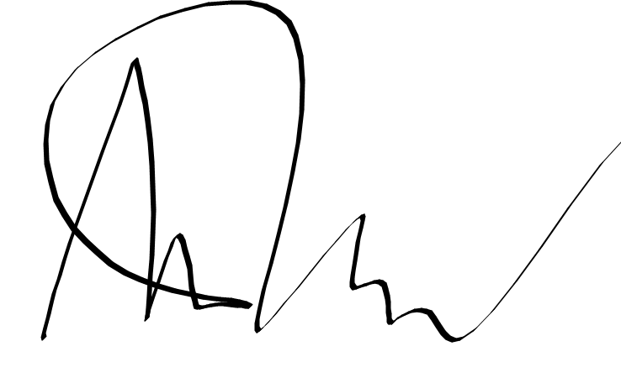

Assessor name
Assessor signature | 

Date | Click here to enter a date.

Number of questions | Number of questions answered correctly | Satisfactory?
37 |  | Yes | No
Assessor Comments
Refer to the plans and specifications below to respond to Q1. to Q9.






- Match the sheet numbers and document types by writing the appropriate letter next to each number in the centre column.

Answer | Sheet Number |  | Answers | Document Type
 | 1 | Sheet 4 | 1 - A | A | Floor plan
 | 2 | Sheet 5 | 2 - B | B | Section plan
 | 3 | Sheet 6 | 3 - C | C | Site plan

- Which sheet number of Drawing WD 9733 identifies the storm water drainage for the proposed structure? Tick your response.

Answer | Choice | Possible Answers
 |  | Sheet 4
 |  | Sheet 5
 |  | Sheet 6

- Identify the Volume and Parts of the NCC that outline the requirements for stormwater drainage for Classes 1 and 10, and Classes 2 to 9.

Answer | Classes 1 and 10 | Classes 2 to 9
 | Volume 2 Part 3.1.3.5 | Volume 1, F1.1

- Which Australian Standard is referenced in the NCC with regards to storm water drainage?

Answer | AS/NZS 3500.3

- What is the area of the verandah? Tick your response.

Answer | Choice | Possible Answers
 |  | 76m²
 |  | 92m²
 |  | 135m²
 |  | 211m²
 |  | 243m²

- What is the pitch of the verandah roof?

Answer | 15

- What size are the verandah beams?

Answer | 150x50 F7 OREGON

- Which of the following Jamb Studs are to be used for both the upper and lower storeys? Tick all that apply.

Answer | Choice | Possible Answers
 |  | 90x45
 |  | 90x70
 |  | 90x90

- Identify three (3) subcontractors that may work on this construction project.

Answer | Carpenter, Landscaper, Surveyors, Painters, Concreter

- Identify three (3) items of plant and/or equipment that may be used on this construction project.

Answer | Concrete Agitator Truck, Cranes, Work Utes, Drills, Hammers, Nail Gun etc

- Identify the Volume and Part of the NCC that outlines the requirements for the timber weatherboards identified in Sheet 5.

Answer | Volume 2, Part 3.5.4.2

- Which Australian Standard is referenced in the NCC with regards to timber structures?

Answer | AS 1720

Refer to the contour plan below to respond to Q13. to Q15.



- What is the datum reading at the tip of the pit?

Answer | 0.00

- What is the level at the kerb invert?

Answer | 0.79

- True or False (Tick your response): The lowest point on the site is found at the northernmost point.

Answer |  | True
 |  | False

- True or False (Tick your response): A Gantt Chart may assist with determining the numbers of on-site personnel required and the time requirements for a project.

Answer |  | True
 |  | False

- Identify labour that may be required for non-contract elements of a construction project.

Answer | Costs associated with running the building business (as opposed to costs associated with the site project) are called company overheads. For example: staff feeds (e.g. office administration staff)

- Explain how the following methods may be used to calculate the costs for on-site work.

Answer | Method | Explanation
 | Per hour | A sub-contractor can quote for labour on an hourly basis for a particular job without specifying the time to complete the job. This charge covers the overheads and profit in running their business.
 | Per unit | Labour can be quoted as part of the cost of construction per unit. For examples, the installation of doors is usually quoted per unit
 | Per metre | The cost of building walls to a specified height such as 2400 mm may be quoted per lineal metre of wall length

- Which of the following documents may you refer to when establishing material quantities for a construction project? Tick all that apply.

Answer | Choice | Possible Answers
 |  | Plans
 |  | Project contract
 |  | Specifications
 |  | Standard construction contracts

- True or False (Tick your response): The fast way to locate suppliers, such as manufacturers and wholesalers, is to find them online.

Answer |  | True
 |  | False

- Explain how each of the following factors affects supplier selection.

Answer | Factor | Impact
 | Location | Dealing with distant suppliers might mean longer delivery times and extra freight costs.
 | Price | Affordability is a key factor, but cheap does not always equate with quality
 | Reliability | Suppliers should be able to deliverythe right goods and on time
 | Stability | Look for experienced suppliers who have been in business a long time. This illustrates financial stability.
 | Supplier groups | While using a single supplier has its advantages, it also has risks. It might be better to use a carefully selected group of suppliers as insurance against any problems occurring.

Read the following information to respond to Q22. to Q27.

The diagram below shows formwork that is required for a concrete slab.


The table below outlines the costs for this task.

Item | Cost
Timber | $2.50 per metre
Concrete | $50.00 per cubic metre (excluding GST)
Labour | $49.50 per hour

- Calculate the lineal meters of timber (150mm wide x 25mm thick) required to form up the edge of a concrete slab which is 6.0m x 2.5m x 150mm. Provide no allowance for waste. Show your answer to two decimal places.

Answer | 6x2 =12  (2.5+.5)x2= 5.1  Total= 17.1m

- Use your response to Q22. to calculate how much the timber will cost.
Show your workings and answer to two decimal places.

Answer | 17.1x2.5  Total= $42.75

- Calculate how many cubic metres of concrete are required.
Show your workings and answer to two decimal places.

Answer | 6x2.5x0.15  Total= 2.25m3

- Use your response to Q24. to calculate the cost of the required concrete. Show your answer to two decimal places and ensure it includes GST.
Answer | 2.25x50x1.1  Total= $123.75

- Calculate how much the labour will cost if the job takes 6 ½ hours.
Show your workings and answer to two decimal places.

Answer | 6.5x49.5  $321.75

- Use your responses for Q23. Q25. and Q26. to calculate how much this project will cost. Show your workings and answer to two decimal places.

Answer | 321.75+123.75+42.75  $488.25

Refer to the electrical plan below to respond to Q28. and Q29.


Source: https://www.dtwd.wa.gov.au/sites/default/files/teachingproducts/BC1944_CCBY.PDF

- Measure the required quantities for the items listed below.

Answer | Quantity | Item
 | 26 | Ceiling light
 | 1 | Wall light
 | 1 | External light
 | 3 | Exhaust fan
 | 2 | Smoke detector

- The costs for each of the items are provided in the table below.
Cost | Item
$49 each | Ceiling light
$29 each | Exhaust fan
$82 each | External light
$39 each | Smoke detector
$59 each | Wall light
Determine the total costs for each item (using the numbers from Q28. ) and the total cost for all items.

Answer | Cost | Item
 | 1274 | Ceiling light
 | 59 | Wall light
 | 82 | External light
 | 87 | Exhaust fan
 | 78 | Smoke detector
 | 1580 | TOTAL

- Name one (1) organisation that provides workers’ compensation insurance.

Answer | Work Cover Qld, Safework NSW

- Which of the following environmental costs should be considered when determining project costs? Tick all that apply.

Answer | Choice | Possible Answers
 |  | Approvals
 |  | Environmental protection
 |  | Permits
 |  | Waste management

- List three (3) statutory costs that should be considered when determining project costs.

Answer | - Development approvals and permits,  - Works regarding heritage places  - Protection for trees and wildlife  - Removal of asbestos  - Use of public land

- Which two (2) of the following methods are commonly used when determining the profit on a project? Tick all that apply.

Answer | Choice | Possible Answers
 |  | Double the builder’s cost
 |  | Lump sum based on market conditions
 |  | Percentage on builder’s total cost

- True or False (Tick your response): Usually a percentage is added to the estimate to cover company overheads.

Answer |  | True
 |  | False

- Identify one (1) example of company overheads for each of the listed categories.

Answer | Factor | Impact
 | Business premises | Rent/ Lease
 | Staff and professional fees | Legal Consultant
 | Transport | Parking fees
 | Finance | Taxes, Debts

- Fill in the blanks: Complete the following chart to identify what is included in the final cost for a project.


Material
Plant and equipment
Direct Costs
Builders Total Cost
Company Overhead

Choose from | Builder’s total cost | Company overheads | Direct costs | Materials | Plant and equipment

- Which of the following should be included in a letter of quotation?
Tick all that apply.

Answer | Choice | Possible Answers
 |  | Conditions to your price
 |  | Discrepancies
 |  | Final cost
 |  | Invitation to proceed

