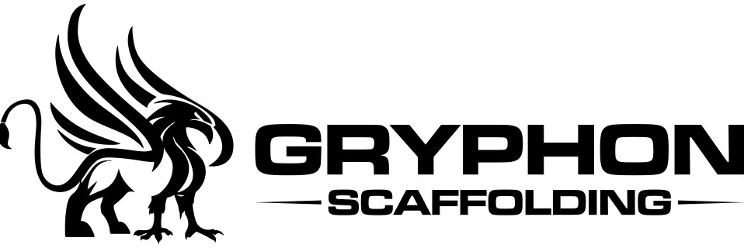

Monthly Meeting Minutes
1 July 2021
Present: | Sekona Mau, Joshua Mau, Bernadette Mau
Next meeting: | TBA
- Safe Work Method Statement
Discussion was had and ideas were submitted as to what needs to be included in the Safe Work Method Statement.
Bernadette to draw up a proposed statement and once completed feedback to be given and any changes made as necessary.

- Equipment Register
Joshua to give Bernadette a list of equipment for the register. Bernadette to compile an equipment register once received.
- General
Sekona gave an update of projects that he is currently working on for submission of quotes.
Joshua gave an update of relevant projects that are currently calling for interest.
- Meeting closed
Meeting closed 4.25pm

