ASSESSMENT FOR

Student name | Kevin Larney
Date of assessment submission

Trainer/Assessor’s name | Tui
Date of assessment marking
Outcome for unit | Competent  Not Yet Competent

TASK INSTRUCTIONS

- As part of the assessment for this unit of competency, you are required to complete a series of activities.
- Some of these activities will require you to provide a response within this document, others will require you to gather evidence to demonstrate your knowledge and skills.
- At all times, the responses in your assessment must reference Australian (Queensland or Federal) documentation, including legislation, regulations, codes of practice, standards and guidance publications.

ACTIVITIES

Draw a simple concept plan for a proposed landscape design which includes stone structures/features.

Response
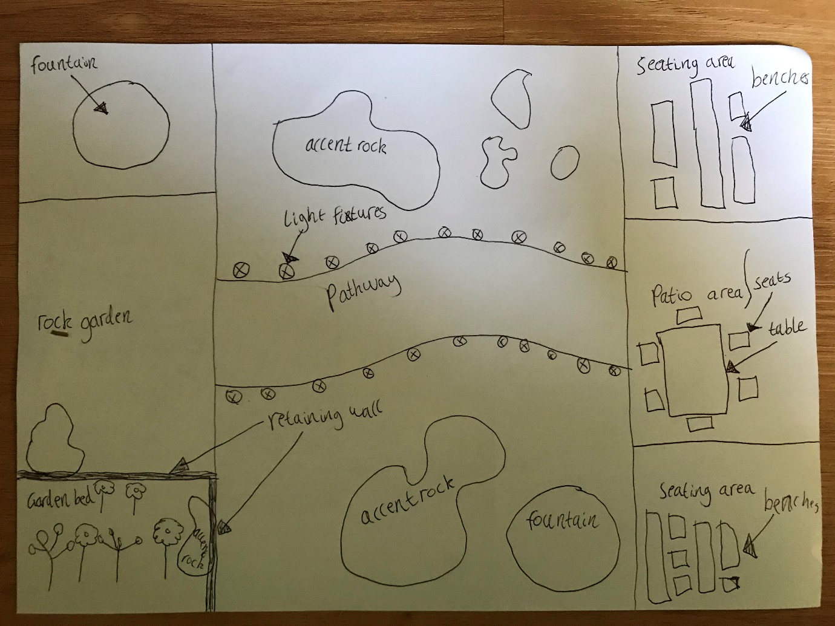

Outcome for Activity 1 | Satisfactory  Not satisfactory
Trainer/Assessor comments

Identify/list the detail on the landscape plan shown.

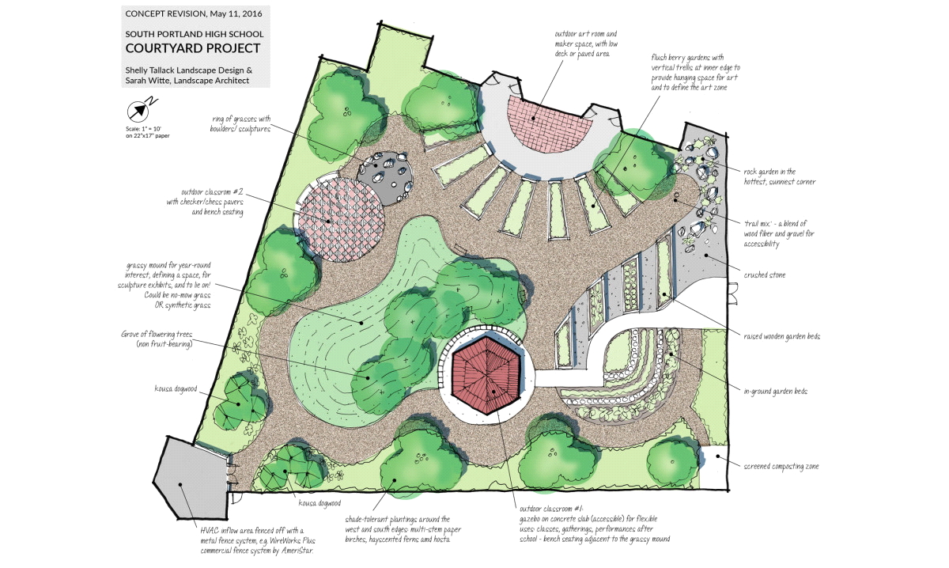

Response
Small descriptions written throughout the landscape plan (plant type, material and building)
Title, location and date.
1:10 scale
Compass
Illustration of area

Outcome for Activity 2 | Satisfactory  Not satisfactory
Trainer/Assessor comments

List the materials required to complete the water feature, by using the wall and water feature construction plan shown.

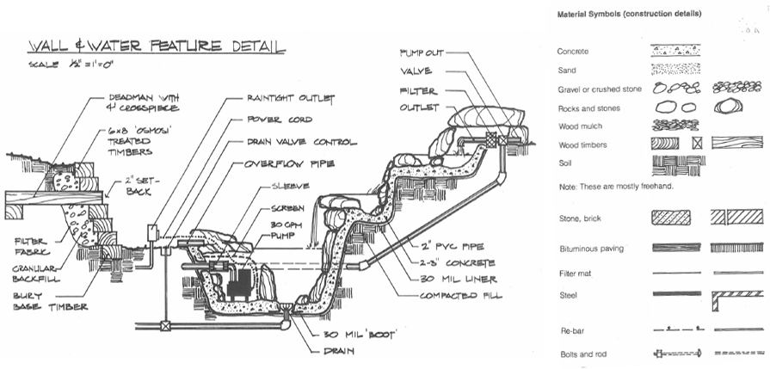

Response
Concrete, sand, gravel or crusted stone, rocks and stones, wood mulch, wood timbers, soil, stone and brick, bituminous pavving, filter mat, steel, re-bar and bolts and rod.

Outcome for Activity 3 | Satisfactory  Not satisfactory
Trainer/Assessor comments

Identify formal and informal stone structures and describe their features.

 | Features
- Formal stone structures | Formal pool with sawn or split stones around the margins.
- Informal stone structures | Informal pool with weathered stones around the margins.

Outcome for Activity 4 | Satisfactory  Not satisfactory
Trainer/Assessor comments

List the components for four (4) common surface drainage systems used in landscape construction.

System | Components
- Spoon | U-shaped concrete channel  Grate cover  Dturdy and long lasting  Concrete
- Channel and grate | Trash box and outlet options  End caps  Concrete  Gratings
- Pit | Curbs  Concrete  Gutters  Inlets
- Contour | Concrete  Disturbed slopes  Stable outlets  End caps

Outcome for Activity 5 | Satisfactory  Not satisfactory
Trainer/Assessor comments

List the advantages and disadvantages of drainage behind and through the stone wall (as shown).

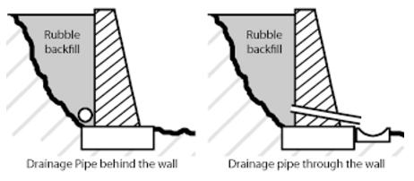

Drainage pipe behind the wall
Advantages
Easier to install
Disadvantages
water flow is less efficient

Drainage pipe through the wall
Advantages
Water flow is more efficient
Disadvantages
Not as aesthetictypes of admix

Outcome for Activity 6 | Satisfactory  Not satisfactory
Trainer/Assessor comments

Research and list a variety of admixes.

Admix | Description
- Water reducing admixtures | Water reducing admixtures, the name itself defining that they are used to minimize the water demand in a concrete mix.
- Retarding admixtures | Retarding admixtures slow down the rate of hydration of cement in its initial stage and increase the initial setting time of concrete.
- Accelerating admixtures | Accelerating admixtures are used to reduce the initial setting time of concrete. They speed up the process of initial stage of hardening of concrete hence they are also called as accelerators.
- Air entraining concrete admixture | Air entraining admixtures are one of the most important inventions in concrete technology.

Outcome for Activity 7 | Satisfactory  Not satisfactory
Trainer/Assessor comments

Research other methods of damp proofing (excluding DPC and base course) and identify the materials used.

Damp proofing method | Materials
- Integral damp proofing | Concrete, clay, lime and sand.
- Membrane damp proofing | Concrete, bituminous flets, epoxy, mastic asphalt, plastic and polymers.
- Guniting damp proofing | Cement, sand, water, reinforcement and glass fibres.
- Mortar damp proofing | Cement, sand, water, damp proofing addititives or compounds, lime reinforcement and bonding agents.

Outcome for Activity 8 | Satisfactory  Not satisfactory
Trainer/Assessor comments

Research and describe suitability of various patterns for stone work projects.

Pattern | Suitability
- Ledgestone veneer | Around fireplace facades, pool areas, spas, feature walls and landscape projects.
- Square veneer | Exterior facades, fireplaces, accent walls, landscaping, columns and pillars, engrances, commercial space and interior feature walls.
- Rectangle veneer | Exterior walls, fireplace surrounds, accent walls, columns and pillars, landscaping, entranceways, interior feature walls and commercial spaces.
- Ashlar veneer | Exterior facades, historical restoration, feature walls, chimneys, columns and pilasters, accent brands, entranceways, commercial spaces and landscape features.

Outcome for Activity 9 | Satisfactory  Not satisfactory
Trainer/Assessor comments

List the advantages and disadvantages of mortared and dry stone features.

Mortared stone features
Advantages
Structural stability, weather resistance, uniform appearance and ease of construciton.

Disadvantages
Rigitity, maintenance, cost, installation time and aesthetic limitations.

Dry stone features
Advantages
Dry Natural aesthetics, better drainage, environmental sustainability and natural ventiallation.
Disadvantages
Structural limitations, weed growth, less formal appearance skill requirement, limited design flexibility and durability concerns.

Outcome for Activity 10 | Satisfactory  Not satisfactory
Trainer/Assessor comments

Research the different types of stone work finishes.

Response
Polished finish, honed finish, flamed finish, brushed finish, sawn finish and tumbled finish.

Outcome for Activity 11 | Satisfactory  Not satisfactory
Trainer/Assessor comments

List environmentally safe products for cleaning.

Response
Water and mild soap, white vinegar and water, baking soda paste, lemon juice and water, castile soap and olive oil soap.

Outcome for Activity 12 | Satisfactory  Not satisfactory
Trainer/Assessor comments

Have team members take photos and videos of your involvement with stone features.

Identify each photo / video with a letter label and describe each photo / video in the table below. Submit the photo / video files along with this workbook.

Advantages
A
B
C
D
E
F
G
H
I
J
K
L
M
N
O
P
Q
R
S
T
U
V
W
X
Y
Z

Outcome for Activity 13 | Satisfactory  Not satisfactory
Trainer/Assessor comments

