Contract clause on variations as per contract on Page 2

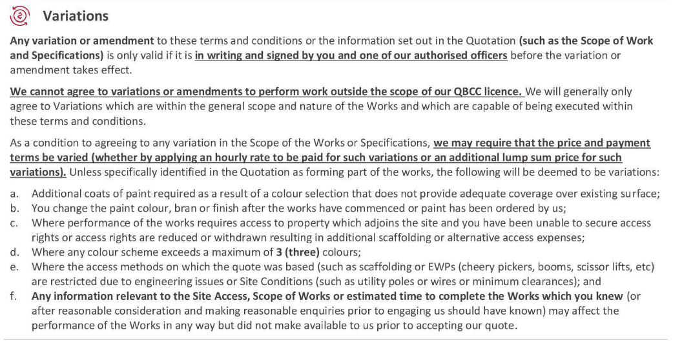

Contract clause on variations as per contract on Page 3



