
AHCLSC303
Construct brick and block structures and features

Copyright © 2022 CSTC Pty Ltd

All rights reserved. No part of the contents of this publication may be reproduced or used in any form or by any means – graphic, electronic, or mechanical including photocopying, digitising, recording, or information storage-and-retrieval systems – without the written permission of CSTC Pty Ltd.
ASSESSMENT FOR AHCLSC303

Student name | Lachlan Pomerenke
Date of assessment submission | Click here to enter a date.

Trainer/Assessor’s name
Date of assessment marking | Click here to enter a date.
Outcome for unit | ☐ Competent  ☐ Not Yet Competent

TASK INSTRUCTIONS

- As part of the assessment for this unit of competency, you are required to complete a series of activities.
  - Some of these activities will require you to provide a response within this document, others will require you to gather evidence to demonstrate your knowledge and skills.
- At all times, the responses in your assessment must reference Australian (Queensland or Federal) documentation, including legislation, regulations, codes of practice, standards and guidance publications.

ACTIVITIES

Draw a simple concept plan for a proposed landscape design which includes brick/block work.

Response
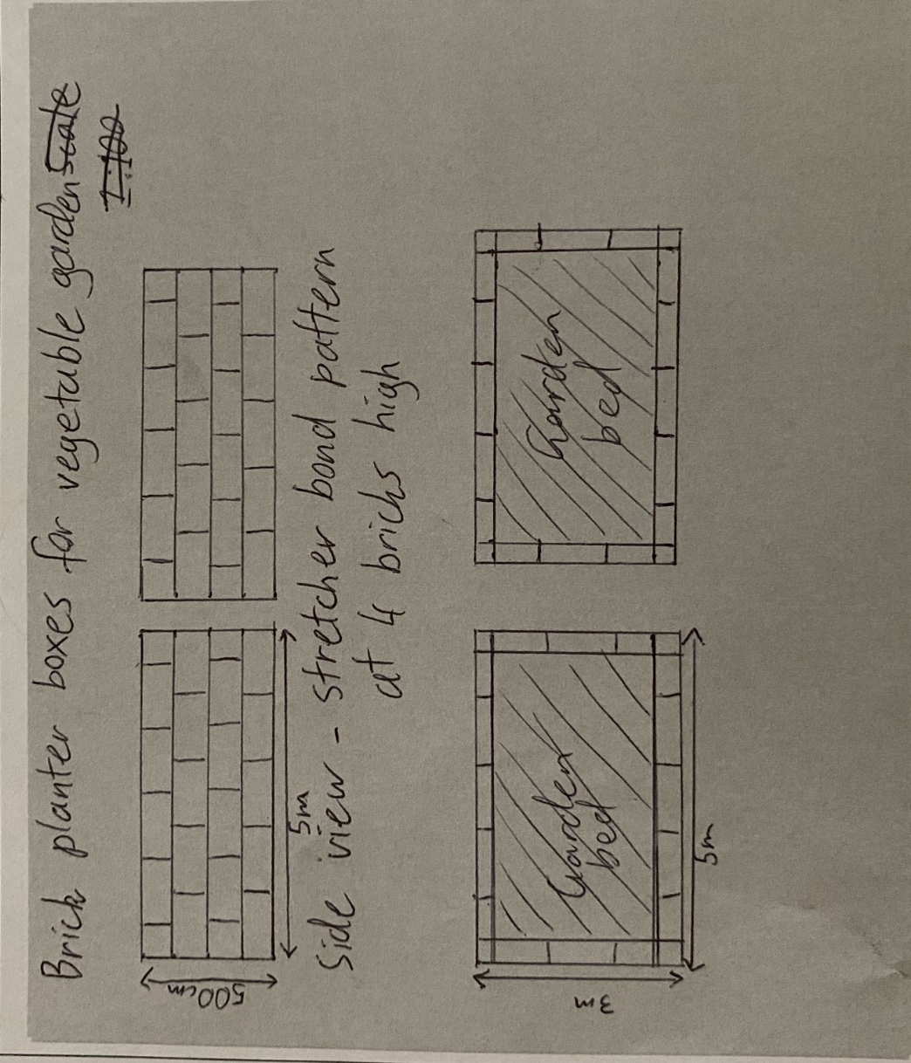

Outcome for Activity 1 | ☐ Satisfactory  ☐ Not satisfactory
Trainer/Assessor comments

Identify/list the detail on the landscape plan shown.

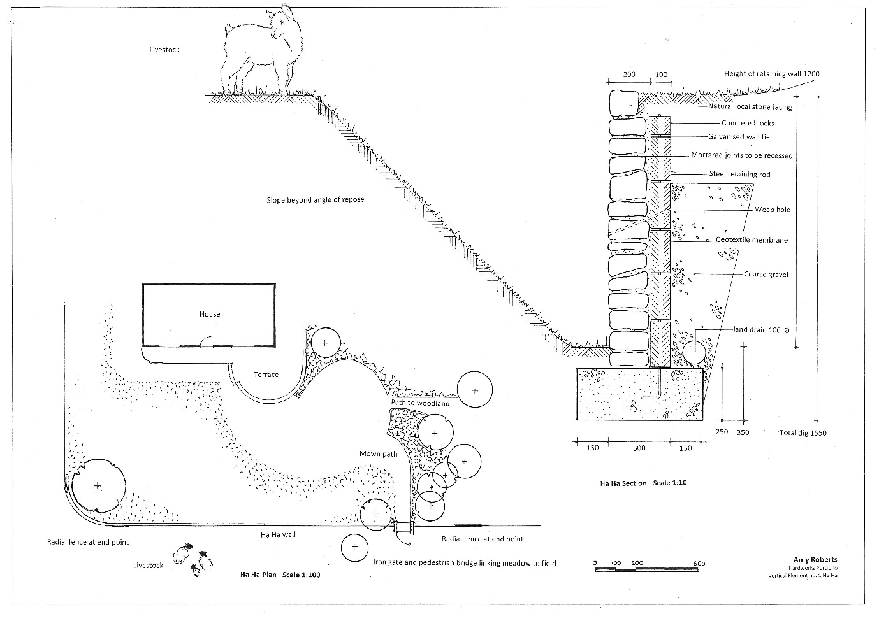

Response
The landscape plan shows details for a proposed retaining wall. The wall runs parallel to the front of the house as a decorative barrier instead of a fence to prevent livestock from entering the house yard from the paddock. The retaining wall face will be made from local natural stone with a cavity wall as damp proof course. The wall is built upon a concrete footing 600mm wide by 260mm deep. The inner concrete block wall will be tied into the foundation with steal and also tied to the facing wall using galvanise wall ties. Behind the inner wall will be lined with a geotextile membrane and coarse drainage gravel. Weep holes will also run from the drainage gravel through both block walls and 100mm land drain will sit at the bottom to prevent water pooling at the bottom of the wall. The height of the retaining wall will be 1200mm. With retaining wall footing the total dig out required is 1550mm deep by 350mm back into the benched earth. The unretained earth in the paddock side of the wall will be required to be cut beyond the angle of response so it stays solid and the animals are unable to get over it. The estimated length of wall is 1500m.

Outcome for Activity 2 | ☐ Satisfactory  ☐ Not satisfactory
Trainer/Assessor comments

List the materials required for the concrete block retaining wall construction plan shown.

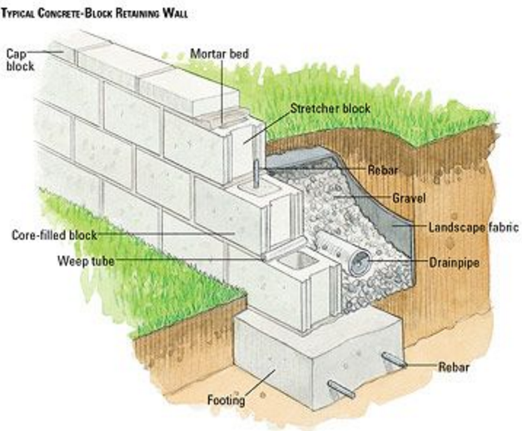

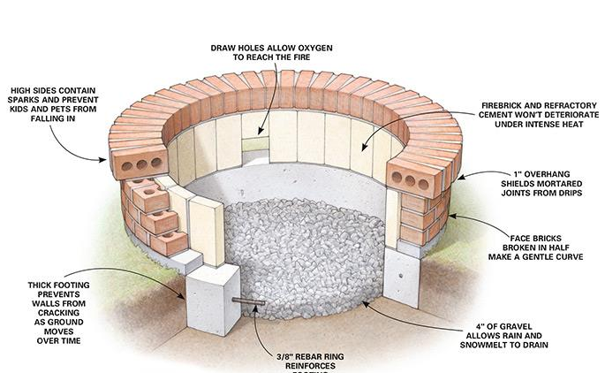

Response
Concrete
Stretcher block
Block cap
Metal rebar
Weep tube
Landscape fabric
Drainpipe
Drainage gravel
Mortar

Outcome for Activity 3 | ☐ Satisfactory  ☐ Not satisfactory
Trainer/Assessor comments

Research and identify the standard dimensions of brick and concrete blocks.

Response
Standard construction brick - 230mm long x 110mm wide x 76mm high.
Standard cinder block – 390 mm long x 190mm wide x 190mm high

Outcome for Activity 4 | ☐ Satisfactory  ☐ Not satisfactory
Trainer/Assessor comments

List the components for four (4) common surface drainage systems used in landscape construction.

System | Components
- Spoon | A spoon drain like a channel and grate is a strip that can bend and mauver with the environment and have an open face. They can become prone to blockages due to soil, sticks and leaves are the most cost effective and efficient drainage system in gully’s or to assist natural water channels
- Channel and grate | Channel and grate drains are often used in pathways or driveways where water floods over a larger surface area in a low volume. The drain will fall one way or the other for the water to run into either garden or into the stormwater system.
- Pit | Pit drains have only a small square exposed for water to flow into when they are installed. They are very good for draining environments where water all falls to one point. They are easy to plug into the stormwater system for the water to escape and also easy to attach channel and grate drains to.
- Contour | A contour drain works by using and manipulation the earths contour to redirect waterflow away from an area or towards a desired drain or dam.

Outcome for Activity 5 | ☐ Satisfactory  ☐ Not satisfactory
Trainer/Assessor comments

List the advantages and disadvantages of drainage behind and through the build wall (as shown).

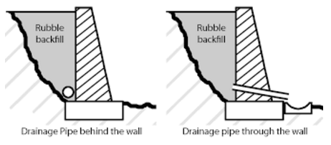

Drainage pipe behind the wall
Advantages
Looks nicer than having holes through the wall
Leaves the wall stronger not leaving little points where it could potentially crack
Disadvantages
Drainage isn’t as effective especially when the bottom of wall meets up with concrete.

Drainage pipe through the wall
Advantages
Provides better drainage for the wall’s stability and longevity.
Weep holes can be pointed onto specific plants next to the wall or into pit or strip drains so water isn’t flowing onto the surface in front of it.
Disadvantages
Doesn’t look as nice as a wall without weep holes
Areas around the weep hole are more likely to crack overtime.

Outcome for Activity 6 | ☐ Satisfactory  ☐ Not satisfactory
Trainer/Assessor comments

Research and list a variety of admixes.

Admix | Description
- Fritz pak  - FR1 water reducer | Reduce water to mix ratio.  Reduce cement content required.  Increase mixture slump.
- Fritz pak NCA | Concrete accelerant  Increases cement hydration for quick initial setting
- Plastiretard | Retarding mixture  Decreases initial cement hydration for a slower setting time  Allows for more time to finish
- Optimum pozzolanic admixture | Used for water retention products such as dam walls or ponds  Reduce the heat of hydration and thermal shrinkage  Prevents the water from leeching anything out of the concrete.

Outcome for Activity 7 | ☐ Satisfactory  ☐ Not satisfactory
Trainer/Assessor comments

Research other methods of damp proofing (excluding DPC and base course) and identify the materials used.

Damp proofing method | Materials
- Membrane damp prove course | Plastic strip that is towards the bottom of the wall or structure that prevents moisture from moving up the wall
- Elector Osmosis | Platinum coated anodes, titanium connecting wire, copper coated cathode and a regular power supply.
- Chemical damp proof course | Silane/siloxane cream added to the mortar bed to form a permanent polysiloxane damp proof course
- Cavity or hollow walls | The outer wall prevents the inner wall from receiving any moisture by leaving a continuous air space or cavity between them. Metal ties through the wall maintaining the gap.

Outcome for Activity 8 | ☐ Satisfactory  ☐ Not satisfactory
Trainer/Assessor comments

Research the suitability of the different types of bonds across various brick/block work projects.

Bond | Brick/block work project suitability
- Stretcher bond | For structural and decorative walls. Commonly used in buildings and can be used to match in features in surrounding landscape.
- Flemish bond | Used as an alternative to the stretcher bond pattern in construction buildings and features.
- English bond | Outer facing cavity wall, boundary walls and gardens
- Honeycomb bond | Decorative screens. Absence of blocks makes the bond unsuitable for structural features.

Outcome for Activity 9 | ☐ Satisfactory  ☐ Not satisfactory
Trainer/Assessor comments

Research and list the specifications for mortar beds and perpend (perps).

 | Specifications
- Mortar beds | The mortar bed between layers of bricks should be 8-10mm thick to allow for a suitable bond between bricks.
- Perpend | Prepends are the vertical joints in brick walls filled with mortar to bond bricks together.

Outcome for Activity 10 | ☐ Satisfactory  ☐ Not satisfactory
Trainer/Assessor comments

List environmentally safe products for cleaning.

Response
Barratec brick and masonry cleaner.
Guard it solutions brick and masonry.
Envirosafe easy brick clean.
Guard remover ECO Efflorescence and cement.
KOH universal cleaner.
BuildKleen masonry and cement.

Outcome for Activity 11 | ☐ Satisfactory  ☐ Not satisfactory
Trainer/Assessor comments

Have team members take photos and videos of your involvement with brick/block features.

Identify each photo / video with a letter label and describe each photo / video in the table below. Submit the photo / video files along with this workbook.

Advantages
A | 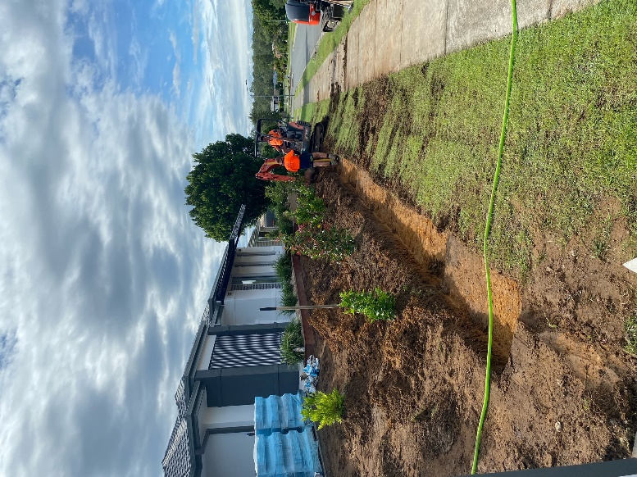  Preparing for a concrete footing for a link block wall by digging out 120mm. using a laser level and fall of the strip to determine how many steps are needed and where they will be
B | 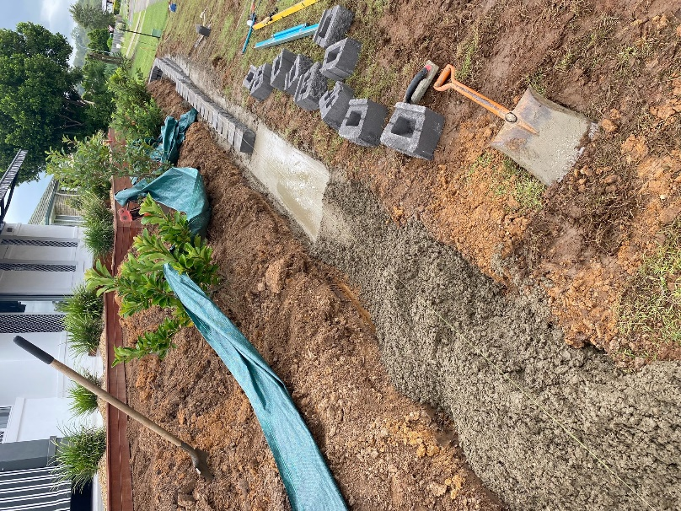  Screeding the concrete level using the laser to float heights at the length of the screed board. Then using the string line to line up the face of the link blocks and them tapping them into place with a rubber mallet and a level to ensure they have the correct amount of lean.
C | 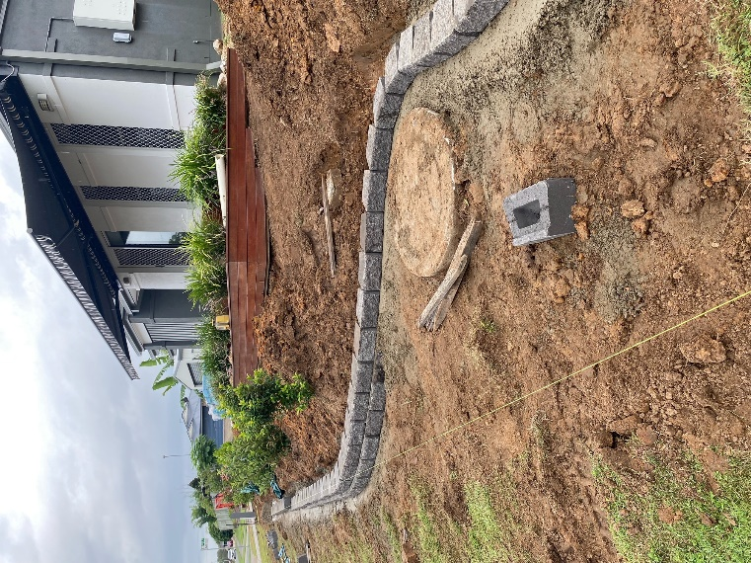  Curving the footing and spacing the blocks evenly for a consistent curve. Using a step where the ground raises towards the sewer pit.
D | 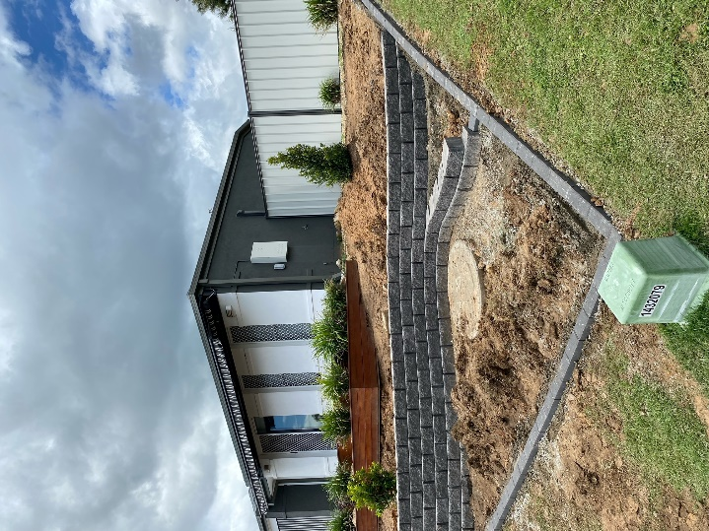  Building the block wall to completion and adding a brick mowing strip on the edge of the property. l
E | 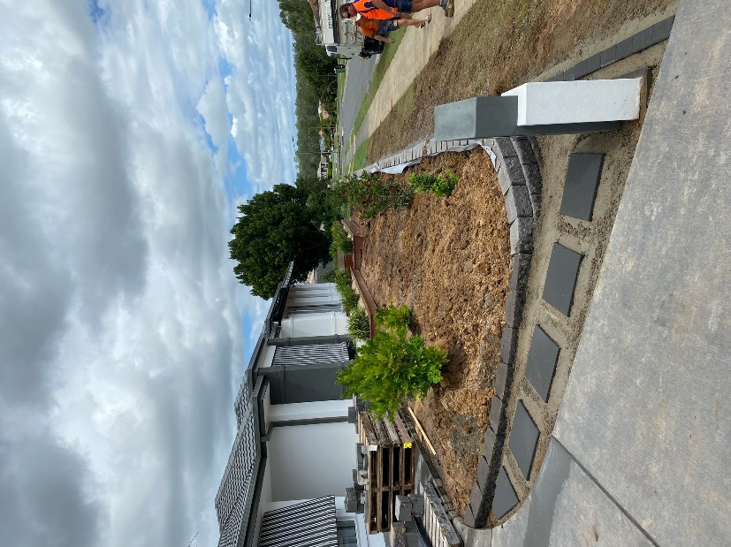  Curing the brick wall and sloping the return up to the height of the driveway and cutting a block to sit flush up against it. Concreting in stepping stones down to the mailbox to then be filled with decorative gravel.
F | 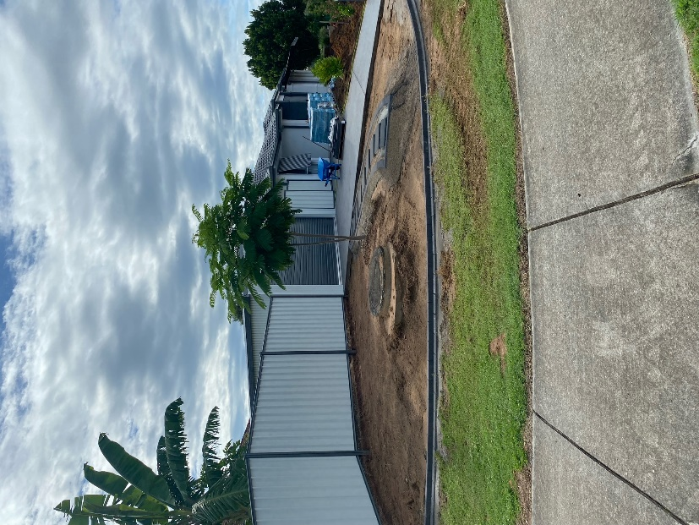  Brick mowing strip with a riser for a garden edge with a complementing steppingstone path with a brick border.
G | 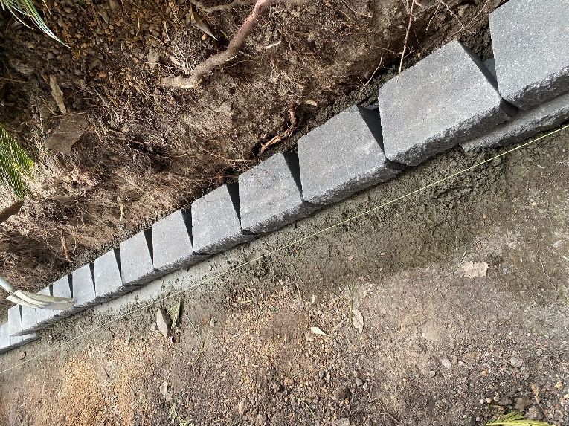  Tapping in another row into the footing using a string to line up the faces. Stepping the blocks up to suit the contour of the ground.
H | 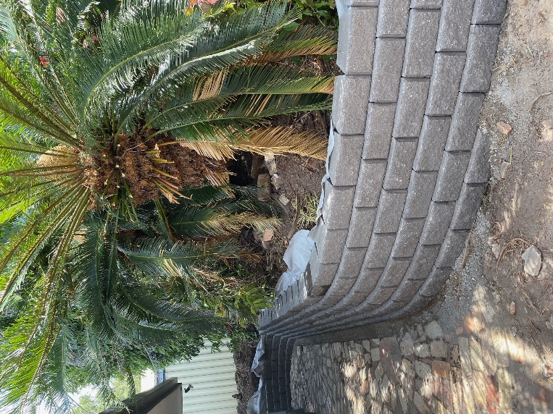  Built block wall from the previous photo with landscaping fabric and drainage gravel installed.
I
J
K
L
M
N
O
P
Q
R
S
T
U
V
W
X
Y
Z

Outcome for Activity 12 | ☐ Satisfactory  ☐ Not satisfactory
Trainer/Assessor comments

