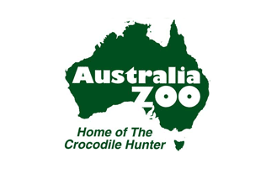
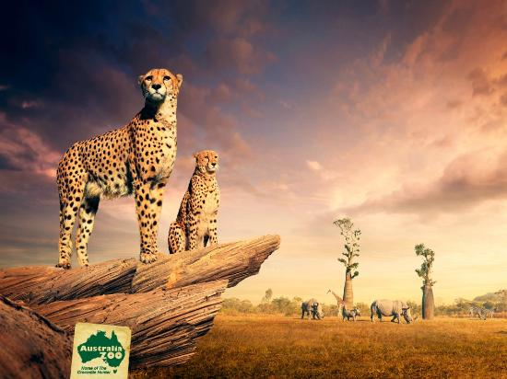
2016

BAGULEY, Abby
Australia Zoo Report

Work, Health & Safety

And Sustainability Report

Context Page

Introduction

Australia Zoo is one of the main tourist attractions on the Sunshine Coast, the zoo has won many awards including winning the 2015 Premier’s Sustainability Awards: Young Achievers Award – Bindi Irwin, Tourism Sustainability Award 2014 and multiple Awards for Major Tourist Attraction on the Sunshine Coast. This report outlines the legislation for Work Health and Safety, Environmental Sustainability, the Acts, Codes of Practice and Guidelines that the zoo follows. The year 11 Business class analysed Australia Zoo for how the zoo follows Work, Health, and Safety and Environmental Friendly Practices and also asked questions about what does Australia Zoo’s sustainability policy with use of waste, water and land. Also recommendations to improve its practices so that the zoo could be eligible for these awards.

Work Health and Safety

1. Work Health and Safety Documentation
Work health and safety (WHS) policy is determined by federal and state governments, with a range of community voices, industry groups, unions and the public (Sutton, 2004). Once the policy has been developed it becomes one of many laws and must be abhorred by all organisations. The Queensland Government became the first state to pass the Work Health and Safety Act 2011 (QLD) came into effect on 1 January 2012 based on the guidelines of the model WHS Act with minor necessary changes for operation within Queensland jurisdiction. The zoo has twenty seven Acts, Regulations and Codes of Practice the zoo follows, examples of these are: WHS Guidelines for Working with Crocodiles in Captivity 2005, Forest Harvesting Codes of Practice 2007, managing the Work Environment & Facilities Codes of Practice 2011.

2. How does Australia Zoo Comply?
Australia Zoo takes Work Health and Safety very serious as they are dealing with animals and may lead to injury from either a keeper or a visitor which also may lead to suing the zoo for not doing their job to keep all visitors safe. In this section of the report will outline how the zoo follows the Work Health and Safety including: safety of training, First Aid, hazard Identification and food handling.

2.1 Safety Training
The staff within Australia Zoo has regular training keep up to date with information and handling with the animals. Also wearing the correct clothing, the zoo’s uniform is one but another is the correct footwear such as closed-in covered boots with no heal. When new staff begin work at the zoo, they have inductions before handling the animals so the keeper feels safe when handling and knows the procedures if an animal misbehaviours.

2.2 First Aid
First Aid is important if something does happen within the zoo unexpectedly. Not all the staff have a background of training for First Aid because there is First Aid Department on site if a visitor does get hurt in anyway. All of the staff do have radios which they need to have with them at all times to keep in contact in case of an emergency or an animal escape from their area. The zoo has two different channels a public channel and a private channel.

2.3 Hazard Identification
Within Australia Zoo, all staff must follow the 5 Step Risk Management & Hazard Reporting Process.
- Identify Hazard – What is the issue?
- Remove Hazard – Correct OR isolate & report
- Report Hazard – Complete a hazard report form
- Evaluate Risk – likelihood x consequence
- Apply Control – Hierarchy of controls

2.4 Food Handling
Australia Zoo does have a food court with many different meals to choose from, plus a café. In the past the food court was a separately owned to the zoo but now the food court is owned by the zoo and in the same department. The keepers have to be safe when feeding the animals because……

3. Recommendations for improvement

3.1 All staff need First Aid
All Australia Zoo staff need to have a background of First Aid.

Sustainability

4. Environmental Sustainability

4.1 Legislation

4.2 Important of Implementing Environmental Sustainability
The meaning of Environmental Sustainability is the ability to maintain the qualities that are valued in the physical environment. The organizing principle for sustainability development, which includes the four interconnected domains: ecology, economics, politics and culture. This section of the report will outline environmental friendly practices such as carbon footprint, waste, water, land and energy.

5. Analysis and Evaluation of Sustainability Program

5.1 Waste
The zoo uses recyclable materials such as ceramic plates, metal cutlery and provide recycle bins because it’s better for the environment which also makes it better for the animals. The reason why the zoo decided to use metal cutlery and ceramic plates is because they would have discuss whether using more water been better for the environment than throwing out all the plastic materials.

5.2 Water
Australia Zoo manages its water uses by reusing the water on gardens. The zoo doesn’t use grey water, only dam and boil are being used at the moment, therefore in the future the zoo may use grey water. The zoo use dams, tanks, rain water, self-filling water taps for visitors to use.

5.3 Energy
Australia zoo has electric golf buggies and also a shuttle bus that is used for staff and visitors is a choice to move around the zoo if preferred. Air-conditioners are used in very few areas around the zoo such as the wombats but the temperature differs on certain animals. The zoo has a few ideas for the zoo in the future that will miner the energy use.

5.4 Land
Australia zoo has over 410,000 acers of land. The zoo reuses plants/branches for a few of different types of animals when each one is done with them. Such as a Koala, they eat all the yummy eucalyptus leaves than after the branch gets passed onto the wombats than followed by into the bird enclosure.
Australia Zoo Wildlife Hospital is very environmentally friendly as it has hay bales inside the walls as well as rammed earth wall too, bamboo on the ceiling, open plan and natural light, recycled material flooring and whirly birds.

5.5 Carbon Footprint
The zoo is in a unique position as a nature-based attraction promoting conservation values. It is important to Australia to ensure the protection of any areas of significant environmental value within the zoo properties. Such initiatives include: minimising energy consumptions, recycling initiative with Coca-Cola, mobile phone recycling program, environmentally friendly paper, recycling with Visy for all paper, water conservation, garden maintenance, BP Global choice program, Biodegradable cleaning solutions, biodegradable coffee cups.

6. Recommendation for improvement

6.1 Solar Panels
In the future Australia Zoo is investigating to installing options

7. Appendices

7.1 Appendix 1
The 27 relevant codes of practice


