CPCCBC4014A
Prepare simple building sketches and drawings

THEORY EXAM INSTRUCTIONS

- This exam will occur under standard assessment conditions.
  - An oral examination may be allowed under certain circumstances.
Answers will be documented and FT003 (Oral examination declaration form) must be completed.
- Participants must provide enough detail in their responses to demonstrate their knowledge and skills.
- Please fill in the details below, providing your name, signature and date of assessment.
  - Your signature acknowledges that this is your own work.
- If a participant initially answers a question incorrectly but modifies their response, they must follow the instructions below:
  - If a participant changes their response in writing, they must put their initials next to the written change.
  - If a participant changes their response verbally, this must be noted on the exam paper by the assessor.

Participant name | Linda Hudakova
Participant signature | 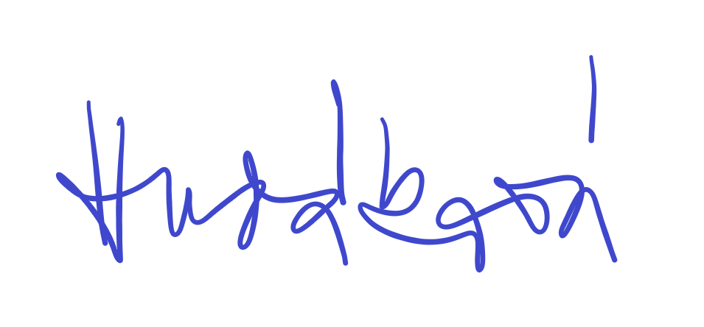

Assessor name
Assessor signature | 

Date | 21/05/2019

Number of questions | Number of questions answered correctly | Satisfactory?
23 |  | Yes | No
Assessor Comments
- Identify three (3) two-dimensional drawings/sketches that may be used to clarify or communicate ideas to clients or other parties. For each drawing/sketch, identify four (4) key features that may be shown.

Answer | Drawing/sketch type | Key features
 | Concept sketches (also known as schematic drawings) | - These form an important part of this process as they are a quick way of getting thoughts onto paper and planning any special or critical areas.
 | Floor plan | - Shows the layout/arrangement of rooms and other parts of a house interior
 | Orthographic drawings | Orthographic Projection is a way of representing a 3D object on a piece of paper in a two dimensional format. This means we use several 2D views of the same object to show great detail instead of one single pictorial view. We present these 2D images in orthographic projection as a Plan View (Floor Plan in the case of building structures) and Elevation Views (each face or side of the object seen separately as front, sides and rear views).

- Name two (2) advantages of a three-dimensional sketch/drawing.

Answer | 3D drawings/sketches provide a more realistic picture of a space, but require more time to develop. However, there are a number of software programs available to assist with their development.

- Name one (1) individual you might contact to establish the scope and standard of the job being undertaken.

Answer | Client, supervisor

- You need to inspect the relevant area to take measurements for your drawings/sketches. Identify two (2) safety requirements you would need to observe on site.

Answer | - Codes of practice  - Workplace policies, procedures, processes and systems  - Job Safety Analyses, Safe Work Method Statements

- Identify two (2) types of tools/equipment you would use when inspecting the area to take measurements.

Answer | Measuring wheel  Spirit level

- Identify two (2) types of tools/equipment you might need when completing sketches/drawings.

Answer | Writing and sketching equipment  Clipboard and paper, computer, digital camera

- What action should be taken if any of the tools/equipment identified in Q5. and Q6. are found to be defective? Tick your response.

Answer | Choice | Possible Answers
 |  | Report, Record
 |  | Stop, Report, Record
 |  | Stop, Tag, Report, Record
 |  | Stop, Fix, Report, Record

- True or False (Tick your response): It is best practice to double check measurements before recording them.

Answer |  | True
 |  | False

- Explain the purpose of the scale on sketches/drawings.

Answer | So plans do not need to be drawn at the real size, a scale is used to indicate at what rate the drawings are reduced or enlarged from the real size.

- You have measured a wall that is 2.4m high. Using a scale of 1:100, what size will this be drawn? Provide your answer in mm. Show your workings.

Answer | 2.4m to mm -> 2.4 x 1000 = 2400mm  Scale of 1:100 -> 2400/100=24mm

- Explain the purpose of a key or legend on sketches/drawings.

Answer | A key or legend is used to explain or define a symbol or mark shown on sketches/drawings, particularly where a symbol or mark has more than one meaning.

- Which of the following are true about drawing contours?
Tick all that apply.

Answer | Choice | Possible Answers
 |  | Equally spaced contour lines indicate uniform slope
 |  | Closely spaced contour lines indicate flat surface
 |  | Closely spaced contour lines indicate steep ground
 |  | Concentric closed contours with decreasing values toward the centre indicate a pond
 |  | Concentric closed contours with decreasing values toward the centre indicate a hill

- Identify the Volume and Parts of the NCC that relate to metal sheet roof cladding for Classes 1 and 10, and Classes 2 to 9.

Answer | Classes 1 and 10 | Classes 2 to 9
 | Volume 2, Parts 3.5.1.0 and 3.5.5.0 | Volume 1, Parts B1.4 and F1.5

- Which Australian Standard is referenced in the NCC with regards to the requirements for the design and installation of metal sheet roof cladding?

Answer | AS 1562

- Sketch the following standard design symbols.

Answer | Item | Sketch
 | Compass (North) | 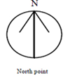
 | Sink with one bowl | 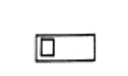
 | Stairs | 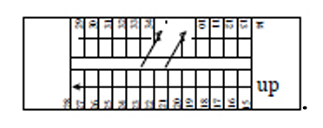
 | Toilet | 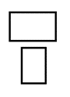

- Explain the meaning of the abbreviations in the table below.

Answer | Abbreviation | Meaning
 | BK | Brick
 | CBD / CPD | Cupboard
 | DP | Down Pipe
 | INSUL | Insulation
 | KIT | Kitchen
 | MSB | Main Switch Board
 | PBD | Plasterboard
 | RWT | Rain Water Tank
 | SHR | Shower
 | TEL | Telephone
 | WC | Water Closet

- True or False (Tick your response): The dashed/chain lines on the section view shown below represent the portions that have been in contact with the cutting plane.



Source: https://www.mcvts.net/cms/lib/NJ01911694/Centricity/Domain/131/Section_Views.pdf

Answer |  | True
 |  | False

- Explain the use of hatching lines for sectional drawings.

Answer | Hatching lines are thin lines normally drawn 45 degrees to be horizontal, right or left. They indicate materials that have come in contact with the cutting plane. A key/legend can be used for lines representing different materials.

- True or False (Tick your response): In an offset sectional drawing, the cutting plane does not travel in a straight line.

Answer |  | True
 |  | False

- Which of the following information should be included in the title block for a sketch/drawing? Tick all that apply.

Answer | Choice | Possible Answers
 |  | Client details
 |  | Contact details for person who prepared drawings
 |  | Date drawing was completed
 |  | Drawing number
 |  | Drawing title
 |  | Job number
 |  | Project name and address
 |  | Revisions / Amendments (if applicable)
 |  | Scale

- True or False (Tick your response): Amendments usually have to be signed or initialled by both the builder and the client to show they both agree.

Answer |  | True
 |  | False

- Explain why it is good practice to have a single repository for sketches/drawings.

Answer | Having a central location where documents are sorted means there is a reference point to check that the sketches/drawings being used are the most current. The title block of a document, provides the history of that document, but not if any future changes have been made.

- Name the Regulation and identify the section that outlines the requirement for structure designers to produce a safety report.
Briefly describe the requirements.

Answer | Section of Act | Requirements
 | In Queensland: Work Health and Safety Regulation 2011(Qld) s 295 | The designer of a structure must give the PCBU who has commissioned the design a written report that specifies the hazards relating to the design which create a risk to those carrying out construction work.

