
AHCLSC302
Construct landscape features using concrete

Copyright © 2021 CSTC Pty Ltd

All rights reserved. No part of the contents of this publication may be reproduced or used in any form or by any means – graphic, electronic, or mechanical including photocopying, digitising, recording, or information storage-and-retrieval systems – without the written permission of CSTC Pty Ltd.
ASSESSMENT FOR AHCLSC302

Student name | Lachlan Pomerenke
Date of assessment submission | Click here to enter a date.

Trainer/Assessor’s name
Date of assessment marking | Click here to enter a date.
Outcome for unit | ☐ Competent  ☐ Not Yet Competent

TASK INSTRUCTIONS

- As part of the assessment for this unit of competency, you are required to complete a series of activities.
  - Some of these activities will require you to provide a response within this document, others will require you to gather evidence to demonstrate your knowledge and skills.
- At all times, the responses in your assessment must reference Australian (Queensland or Federal) documentation, including legislation, regulations, codes of practice, standards and guidance publications.

ACTIVITIES

Identify/list the scope of the work to be carried out from the concept plan shown.

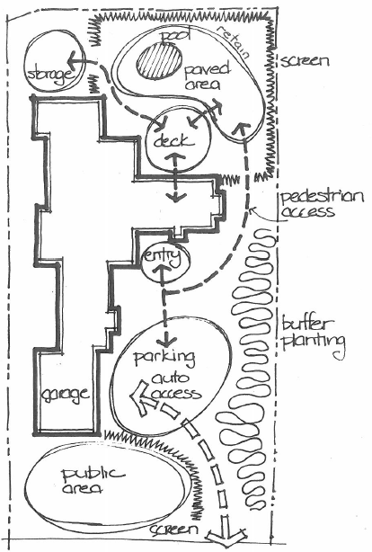

Response
Paving area around pool
Retaining around North end of pool
Installing screens
Garden area for planting

Outcome for Activity 1 | ☐ Satisfactory  ☐ Not satisfactory
Trainer/Assessor comments

Identify/list the detail on the landscape plan shown.

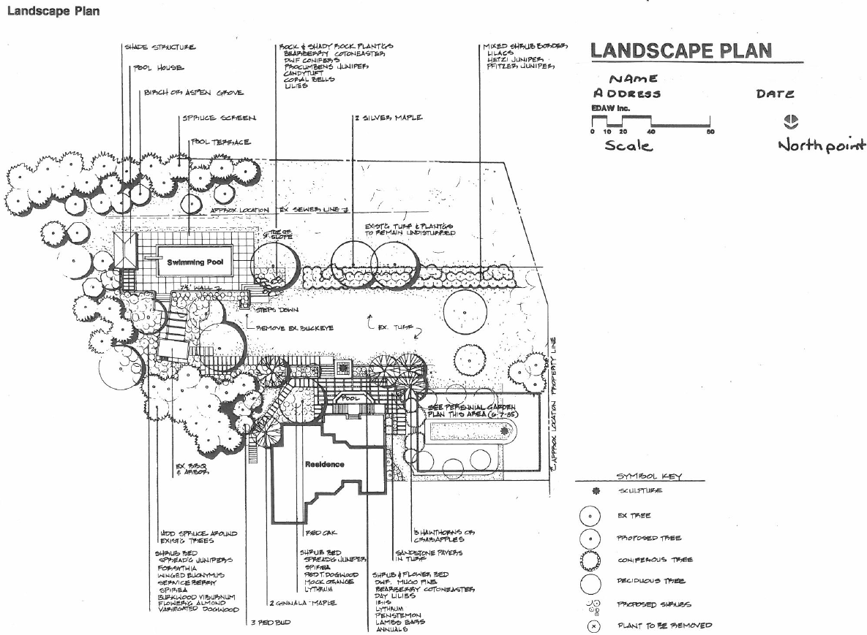

Response
Summary and implications of plans
Legend including scale, orientation, contour
Boundary
Areas to be paved
Garden Plans
Retaining wall plans
Decorative screen panel plans
Design company information
Existing buildings and structures

Outcome for Activity 2 | ☐ Satisfactory  ☐ Not satisfactory
Trainer/Assessor comments

List the materials required to complete the water feature, by using the wall and water feature construction plan shown.

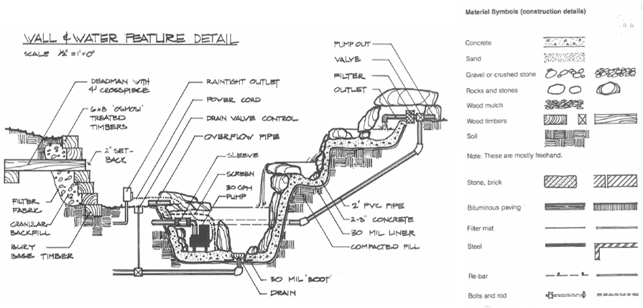

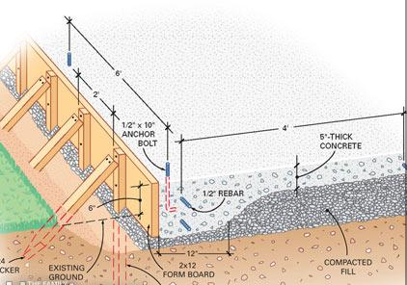

Response
Concrete
Sand
Gravel or crushed stone
Rocks and stones
Wooden timbers
Soil
Bitumen paving
Filter mat
Steel
Rebar
Bolts and rods
Pump out
Valve
Filter
Outlet
2”m pvc
Drain
Power outlet
Drain valve control

Outcome for Activity 3 | ☐ Satisfactory  ☐ Not satisfactory
Trainer/Assessor comments

Research and list relevant laws and standards relating to concreting works
(e.g. Building Codes, Australian Standards, Codes of Practice)

 | Name of document
- Laws | Queensland building and construction commission.
- Standards | AS2870-2011 Residential Slabs and Footings Standard
- Codes | Building Code of Australia (BCA) contained within the National Construction Code.

Outcome for Activity 4 | ☐ Satisfactory  ☐ Not satisfactory
Trainer/Assessor comments

List the components for four (4) common surface drainage systems used in landscape construction.

System | Components
- Spoon | Usually, open faced with no cover.  Used often commercially for big gullies over large open areas.
- Channel and grate | For when water is flowing over an area and a wide drain is ideal.  Commonly used in concrete paths and paving.
- Pit | Pit drain, storm water pipe and appropriate fittings to connect into storm water.  Used when water all falls to one point.
- Contour | Drains level along the contour of a falling area.  Reduces erosion over large falling surfaces.

Outcome for Activity 5 | ☐ Satisfactory  ☐ Not satisfactory
Trainer/Assessor comments

List the advantages and disadvantages of drainage behind and through the build wall (as shown).

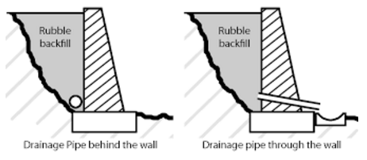

Drainage pipe behind the wall
Advantages
Clean finish. No pipe through it and drain beneath it
Disadvantages
Potential for water to pool behind the wall and cause damage.

Drainage pipe through the wall
Advantages
Allows better waterflow from behind the wall.
Disadvantages
Very slightly weakened wall.
Not as nice of a finish

Outcome for Activity 6 | ☐ Satisfactory  ☐ Not satisfactory
Trainer/Assessor comments

Explain the purpose of a slump test. Describe the process of how such a test is conducted.

Response
A slump test is used to determine the workability of concrete.
A slump test is conducted similarly to building a sandcastle. By filling a container or cone with concrete then flipping it to allow the shape to sit freely and observing if the concrete is able to hold its shape or how it slumps.

Outcome for Activity 7 | ☐ Satisfactory  ☐ Not satisfactory
Trainer/Assessor comments

Research and list a range of curing compounds and the advantages of using each type

Curing compound | Advantages
- Acrylic resins | Acrylic is made of polymers of acrylic acid. It also seals the concrete in good manner. It is having property of adhesion to the subsequent plaster. No need to wash the surface of acrylic with hot water if we want to provide plastering.
- Synthetic resins | Synthetic resins will seal the concrete by forming a membrane. If we want to provide plastering, the membrane can be removed by washing it with hot water.
- Wax compound | Wax compounds have similar properties like resin compound. The wax membrane will lose its efficiency with time increment.
- Chlorinated rubber | Chlorinated rubber type curing compound will form thick layer when we applied. It seals the concrete tightly and also fills the minute pores present in the concrete. But the film cannot stay for longer period. It is worn out in the long run.

Outcome for Activity 8 | ☐ Satisfactory  ☐ Not satisfactory
Trainer/Assessor comments

List environmentally safe products for cleaning.

Response
Oxygenated bleach products
Vinegar
Baking sodar
Sodium peroxide-based products
Hydrogen peroxide-based products

Outcome for Activity 9 | ☐ Satisfactory  ☐ Not satisfactory
Trainer/Assessor comments

Have team members take photos and videos of your involvement with concrete features.

Identify each photo / video with a letter label and describe each photo / video in the table below. Submit the photo / video files along with this workbook.

Advantages
A | Form work is necessary for reinforced concrete slabs. The wooden boxing around the side will give the concrete shape and also determines the height. The mesh in the centre will give the concrete in structural integrity as it sets to it and is hatted so it will be in the middle of the concrete. Finally with this slab in particular as it is to be joining to two pathways it is pinned to them by drilling holes in the existing concrete and reo bar is stuck inside them with chemset. All of the mesh is tied together with tie wire to ensure it is all joined. 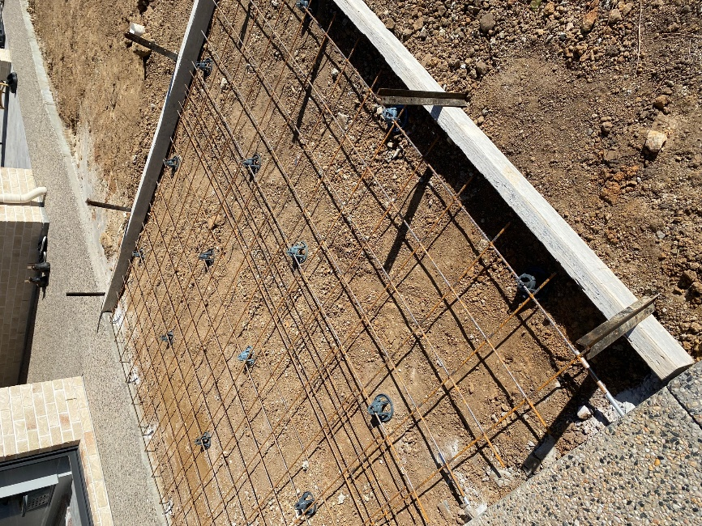
B | 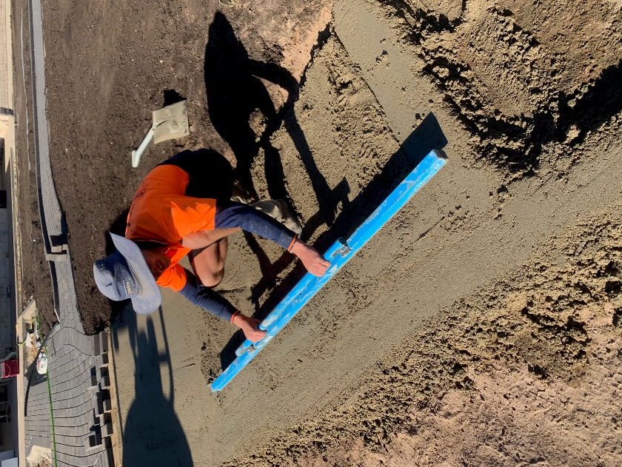  Screeding is how concrete is given its shape. Two pads on either edge of the screed board is floated to height allowing the middle to by cut out with the screed board until it is all at the intended height leaving it smooth and ready for bull floating once partially set.
C | 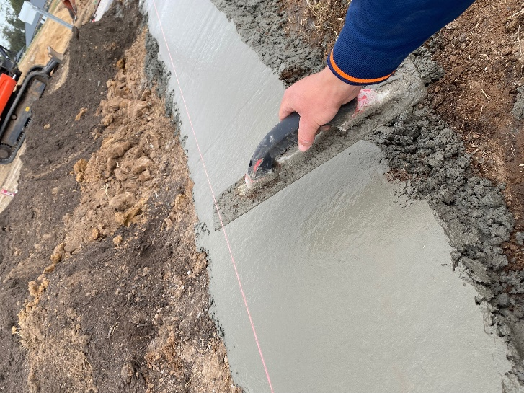  bull floating is performed once the concrete has partially set. It takes out any bumps and imperfections in the concrete after screeding to height
D | 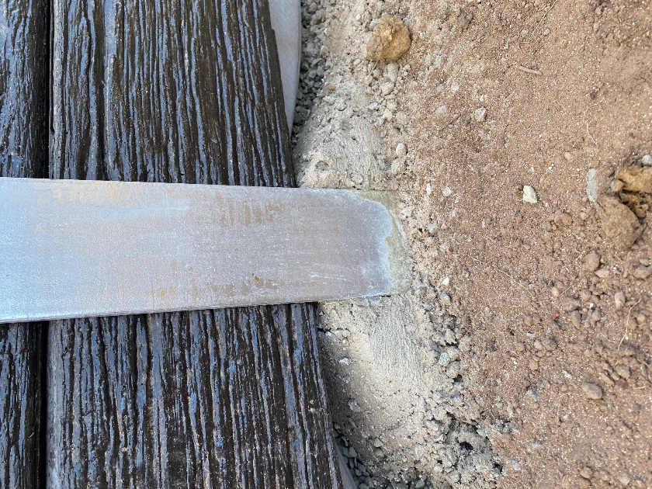Concrete can be shaped to help build structures. In this photo the steel post has been concreted into the ground and with a float I have made two level pads on either side for the concrete sleepers to sit on in order to build a concrete sleeper retaining wall.
E | 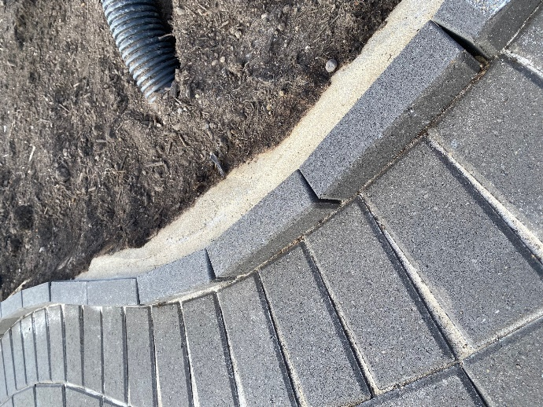Here I have used concrete in a paving project to form an edge against the vertical pavers in order to lock them in to place. A sand and cement mix was also used to grout the pavers as seen in the curl
F | 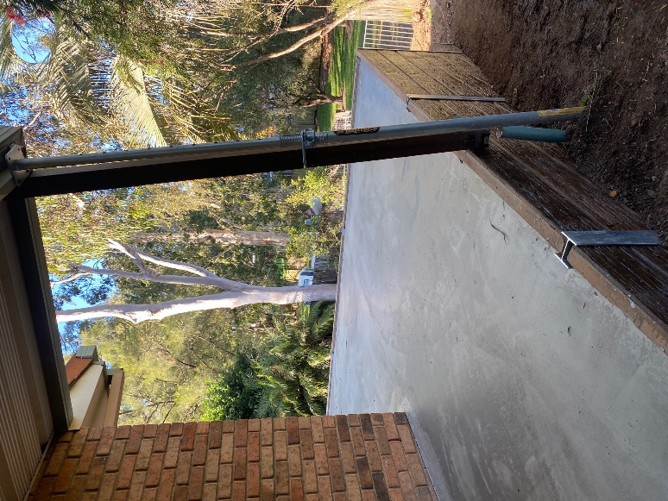Depending on the intended surface for the concrete different finishing processes need to be take. This pathway is going to be paved so it will not need to have a curved edge.
G | 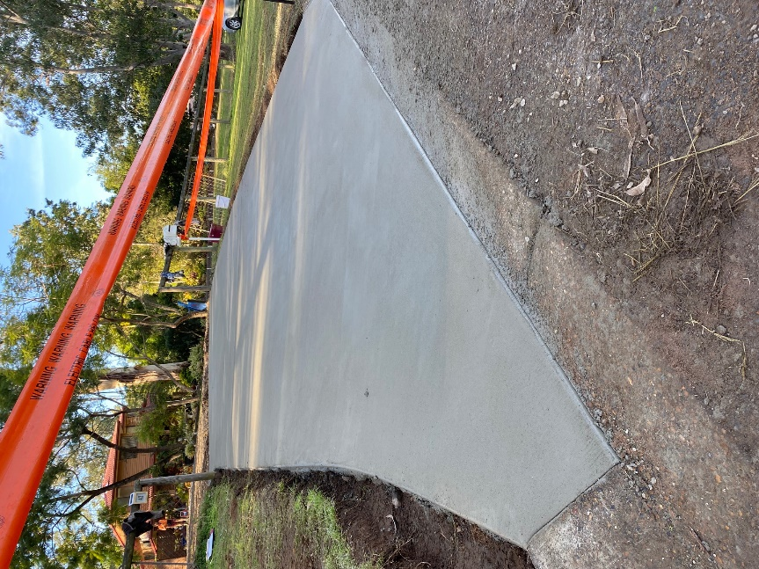This driveway project has a finished edge and edges meeting the curbs that are floated by eye. Bunting should always be placed around setting concrete projects to prevent them from being stood on or driven on
H
I
J
K
L
M
N
O
P
Q
R
S
T
U
V
W
X
Y
Z

Outcome for Activity 10 | ☐ Satisfactory  ☐ Not satisfactory
Trainer/Assessor comments

