
AHCLSC304
Erect timber structures and features

Copyright © 2020 CSTC Pty Ltd

All rights reserved. No part of the contents of this publication may be reproduced or used in any form or by any means – graphic, electronic, or mechanical including photocopying, digitising, recording, or information storage-and-retrieval systems – without the written permission of CSTC Pty Ltd.
ASSESSMENT FOR AHCLSC304

Student name
Date of assessment submission | Click here to enter a date.

Trainer/Assessor’s name
Date of assessment marking | Click here to enter a date.
Outcome for unit | ☐ Competent  ☐ Not Yet Competent

TASK INSTRUCTIONS

- As part of the assessment for this unit of competency, you are required to complete a series of activities.
  - Some of these activities will require you to provide a response within this document, others will require you to gather evidence to demonstrate your knowledge and skills.
- At all times, the responses in your assessment must reference Australian (Queensland or Federal) documentation, including legislation, regulations, codes of practice, standards and guidance publications.

ACTIVITIES

Draw a simple concept plan for a proposed landscape design which includes timber structures/features.

Response
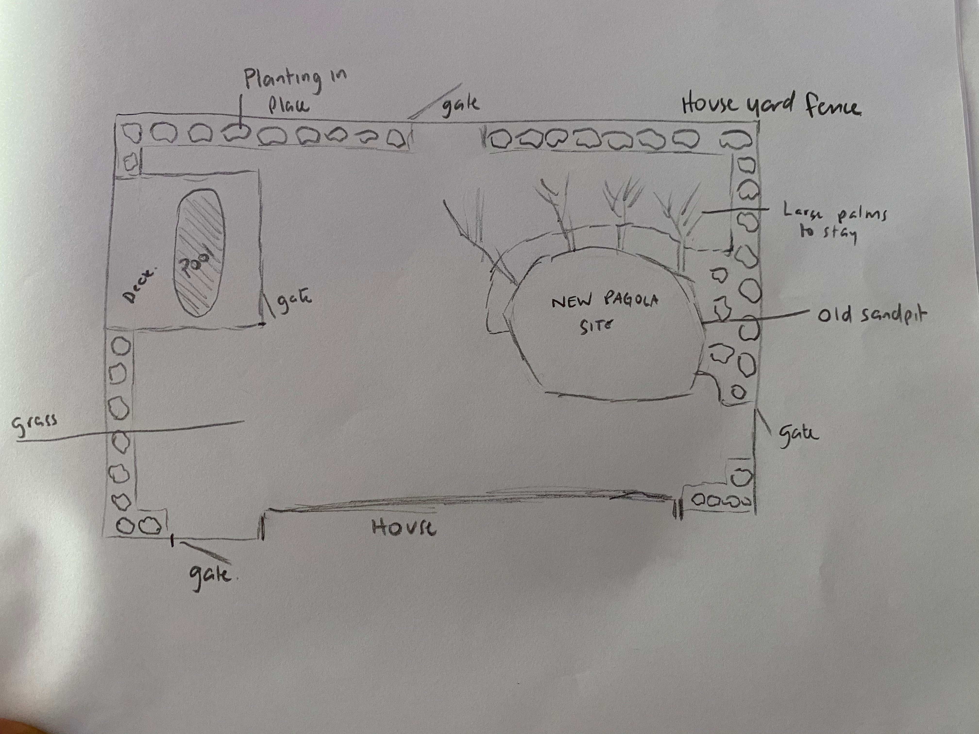

Outcome for Activity 1 | ☐ Satisfactory  ☐ Not satisfactory
Trainer/Assessor comments

Identify/list the detail on the landscape plan shown.

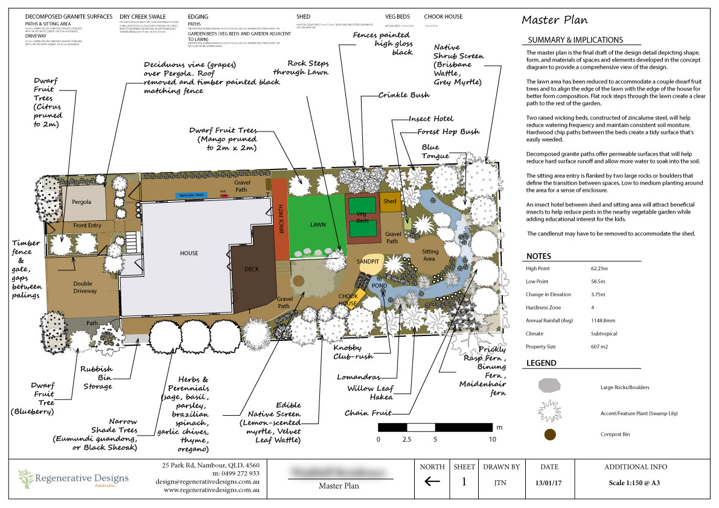

Response
Site plan as follows
Starting at the top left and working clockwise-
Timber fence with gate (painted black), gaps between timber palings, planting to remain where stated with two dwarf fruit trees added to the front to line the right on the drive =way.. The existing pergola is to have the roof removed with the planting of a deciduous grape added to trail over the top. The gravel path leads to the back of the dwelling with the lawn to be reduced to add 2 dwarf fruit trees, a rock path is used to separate the lawn and the added edible natives and herb garden. The vegetable gardens are constructed of zincalume steal with planting between the vegetable garden and fence and existing shed. The pond forms a water corridor that wraps around the back of the garden with screening plants lining the fence with small planting to the front. The gravel pathway in the centre of the garden links the sitting area to the shed, insect hotel, sandpit and chook house areas with large rocks brought in to define the seated area. Large shade trees are to be added to the gravel path that leads to the front of the property with an area for the rubbish bins with an added fruit tree to the front which leaves the double driveway open for cars to enter the garage.

Outcome for Activity 2 | ☐ Satisfactory  ☐ Not satisfactory
Trainer/Assessor comments

List the materials required to complete the timber structures in the construction plans shown.

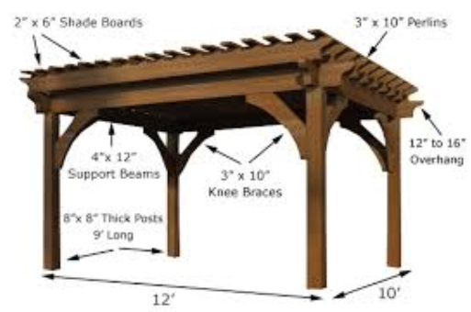

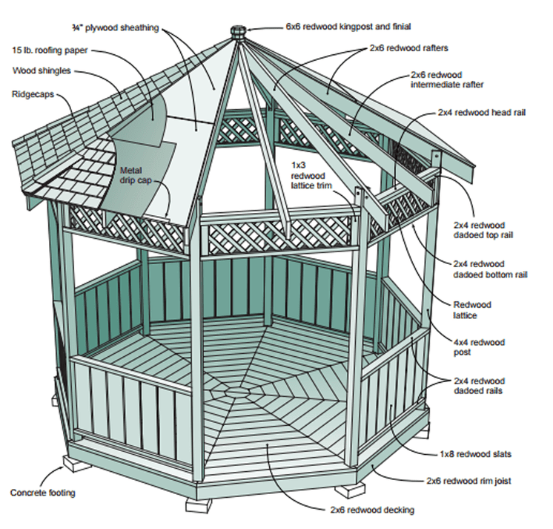

Response
Fig 1
2” x 6” shade boards
4” x 12” support beams
6” x 8” thick posts 9’ long
3” x 10” knee braces
3” x 10” Perlins
Fixings and fastenings i.e. screws, nails

Fig 2
Concrete footings (pre fab)
2 x 6 redwood decking
2x 6 redwood rim joist
1 x 8 redwood slats
2 x 4 redwood dadoed rails
4 x 4 redwood posts
Redwood lattice
2 x 4 redwood dadoed bottom rails
2 x 4 redwood dadoed top rail
2 x 4 redwood head rail
2 x 6 redwood intermediate rafter
2 x 6 redwood rafters
6 x 6 redwood kingpost and finial
1 x 3 redwood lattice trim
¾” plywood sheathing
15lb. roofing paper
Wood shingles
Rigdecaps
Metal dip cap
Fixings and fastenings i.e. screws, nails

Outcome for Activity 3 | ☐ Satisfactory  ☐ Not satisfactory
Trainer/Assessor comments

Research and identify the difference between treated and untreated timbers.

Response
Untreated timber is natural with no chemicals added. Treated timber has had chemicals added to help with durability to resist deterioration from the weather, rot and boring insects.

Outcome for Activity 4 | ☐ Satisfactory  ☐ Not satisfactory
Trainer/Assessor comments

Have team members take photos and videos of your involvement with timber structures and features.

Identify each photo / video with a letter label and describe each photo / video in the table below. Submit the photo / video files along with this workbook.

Advantages
A | Video 1. This shows the shade house I recently completed at my home property.
B | Video 2. Shows more of the shade house I recently completed at my home property.
C | Video 3. Shows the outside of the shade house I recently completed.
D | Pic External Shade house 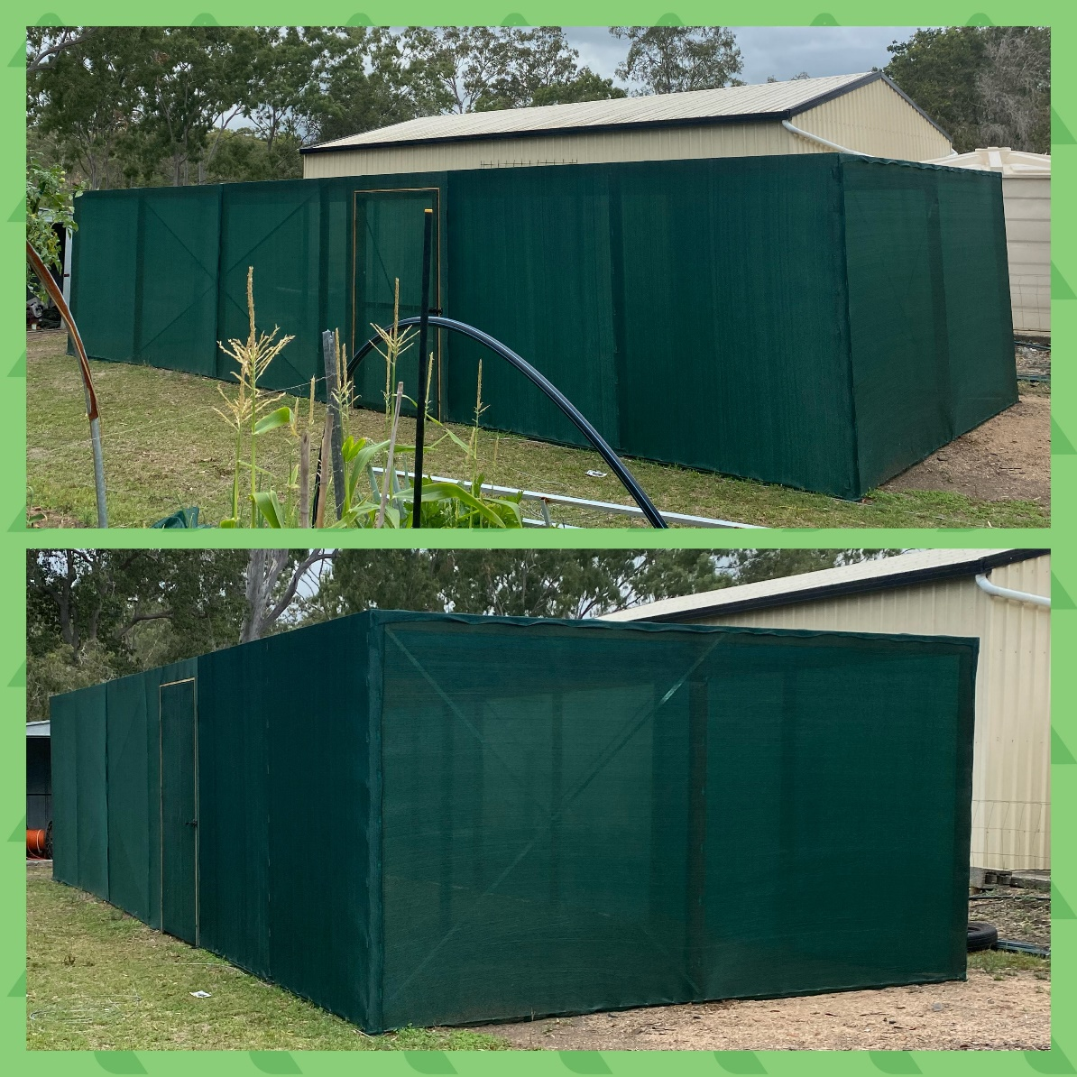
E | Pic Halving joint  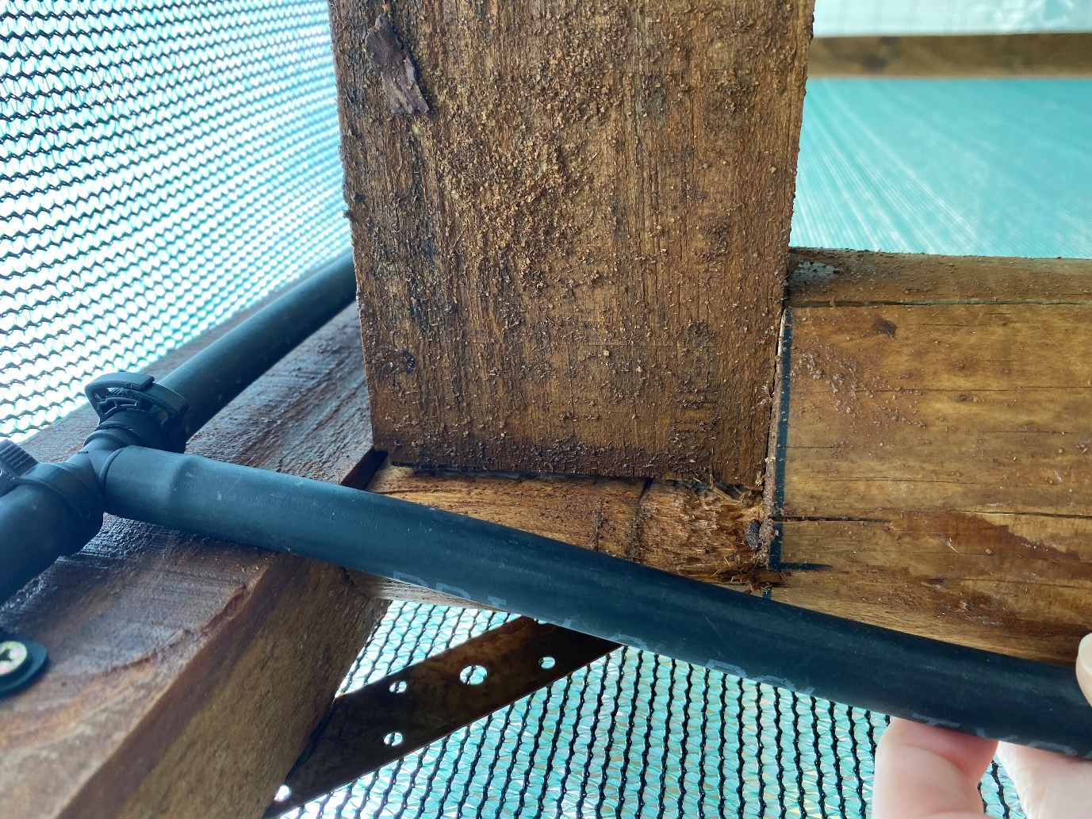
F | Pic Timber construction  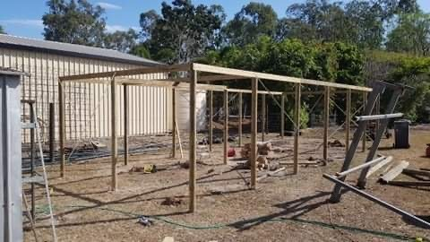
G
H
I
J
K
L
M
N
O
P
Q
R
S
T
U
V
W
X
Y
Z

Outcome for Activity 5 | ☐ Satisfactory  ☐ Not satisfactory
Trainer/Assessor comments

