
AHCLSC307
Implement a retaining wall project

Copyright © 2020 CSTC Pty Ltd

All rights reserved. No part of the contents of this publication may be reproduced or used in any form or by any means – graphic, electronic, or mechanical including photocopying, digitising, recording, or information storage-and-retrieval systems – without the written permission of CSTC Pty Ltd.
ASSESSMENT FOR AHCLSC307

Student name | Morgan Anstee
Date of assessment submission | 15/12/2020

Trainer/Assessor’s name
Date of assessment marking | Click here to enter a date.
Outcome for unit | ☐ Competent  ☐ Not Yet Competent

TASK INSTRUCTIONS

- As part of the assessment for this unit of competency, you are required to complete a series of activities.
  - Some of these activities will require you to provide a response within this document, others will require you to gather evidence to demonstrate your knowledge and skills.
- At all times, the responses in your assessment must reference Australian (Queensland or Federal) documentation, including legislation, regulations, codes of practice, standards and guidance publications.

ACTIVITIES

Draw a simple concept plan for a proposed landscape design which includes a retaining wall.

Response
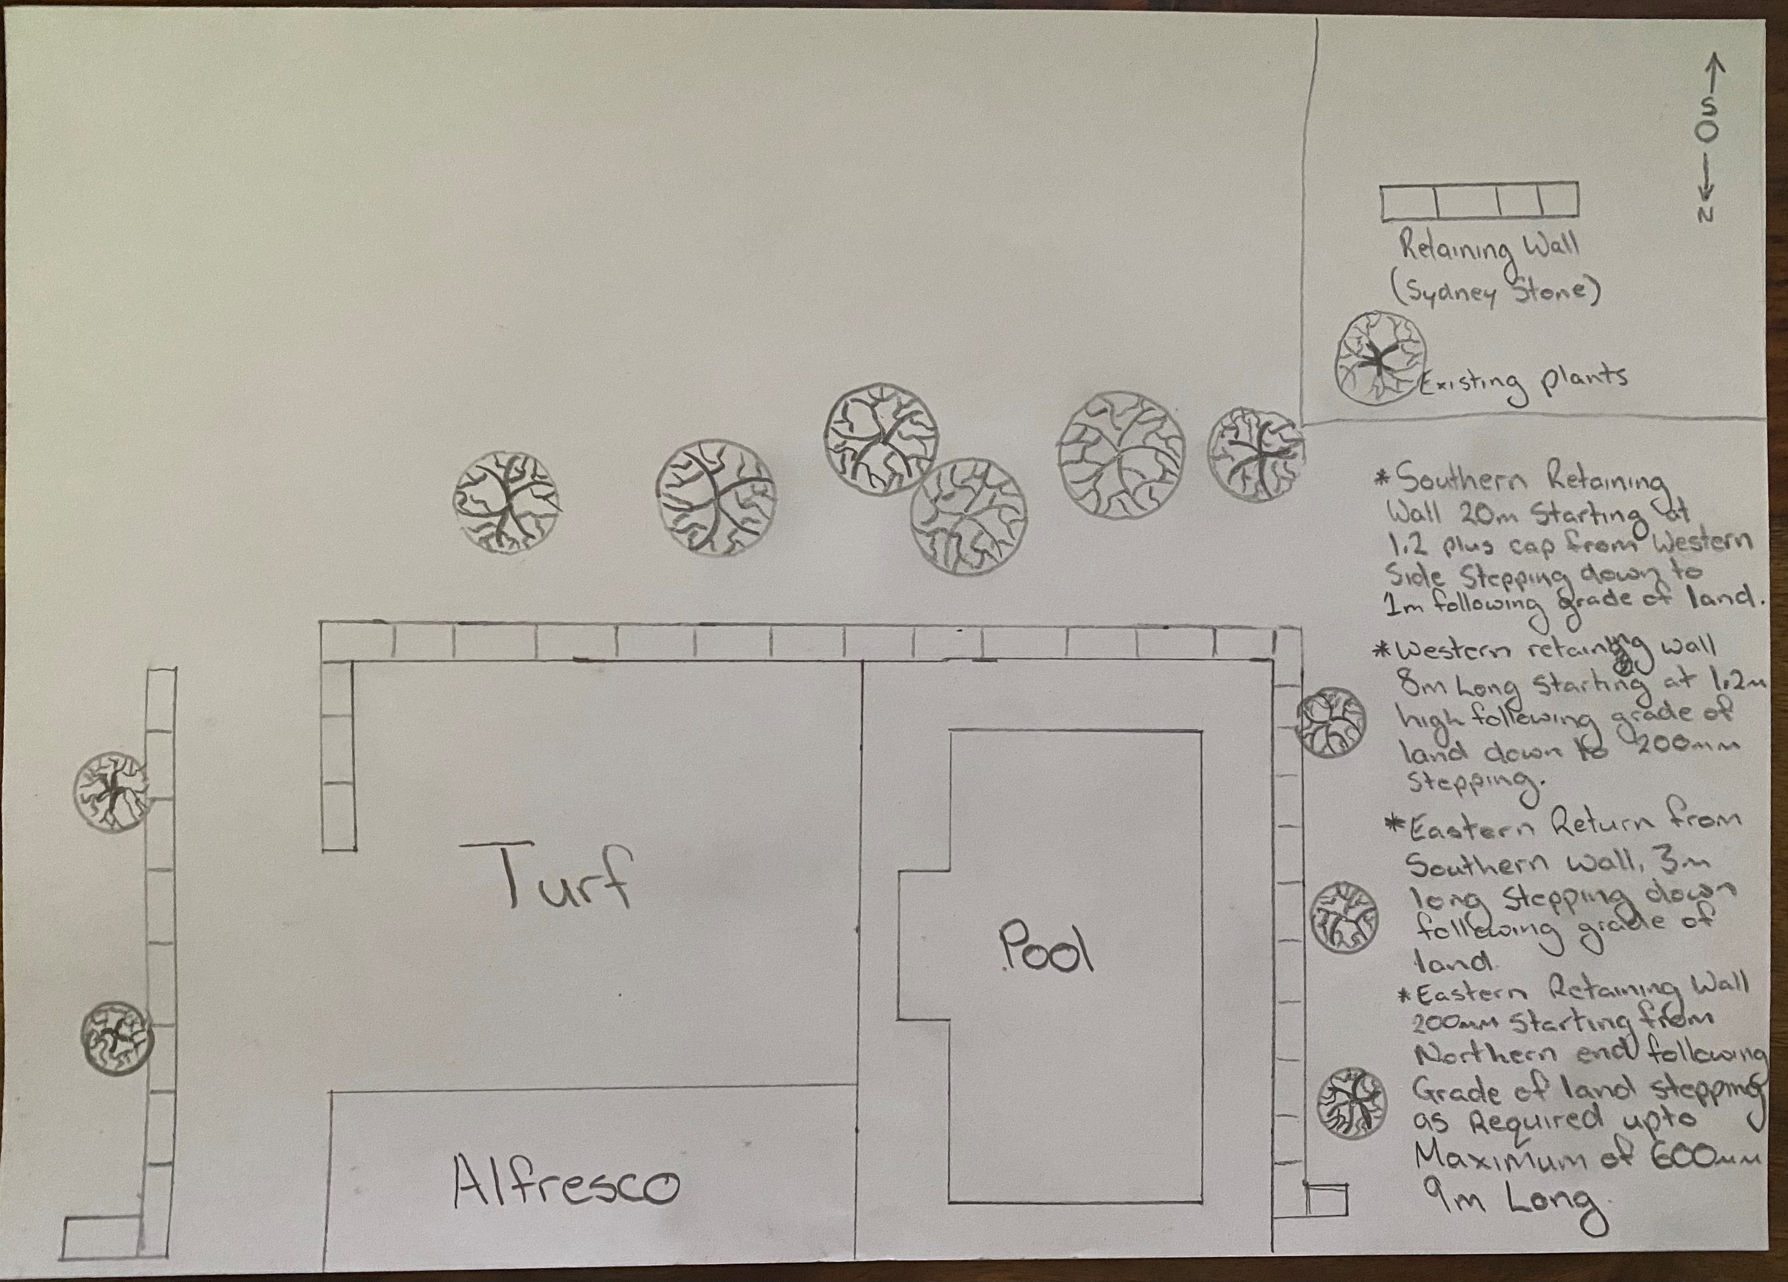

Outcome for Activity 1 | ☐ Satisfactory  ☐ Not satisfactory
Trainer/Assessor comments

Identify/list the detail on the landscape plan shown.

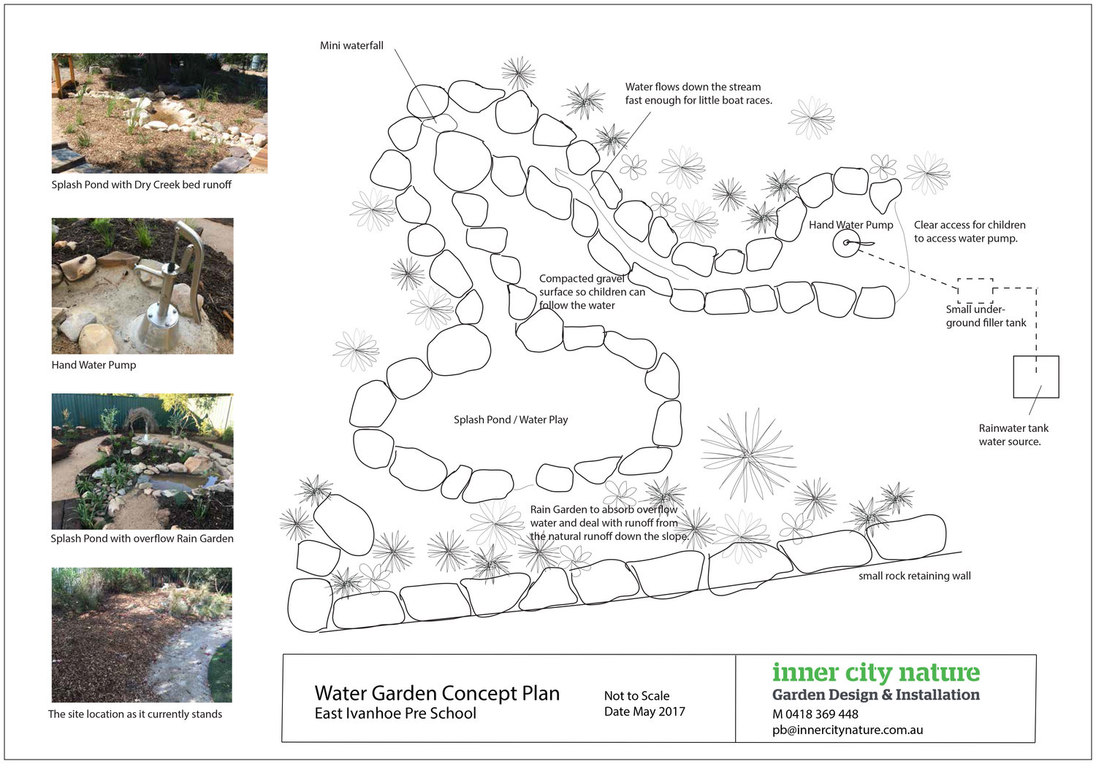

Response
- Small Rock retaining wall
- Rainwater tank water source
- Small underground filler tank
- Hand water pump
- Splash pond/ water play area with overflow rain garden
- Water flow direction
- Mini waterfall
- Compacted gravel surface so children can follow the water
- Trees, plants and shrubs

Outcome for Activity 2 | ☐ Satisfactory  ☐ Not satisfactory
Trainer/Assessor comments

List the materials required to complete the retaining wall, by using the wall and water feature construction plan shown.

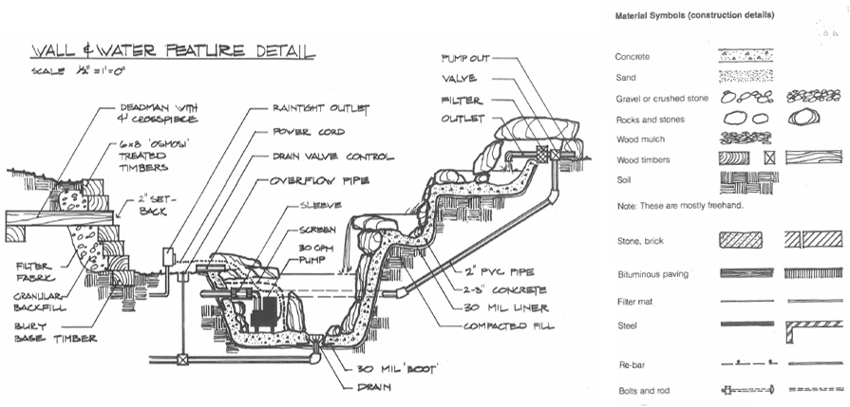

Response
- Concrete
- Sand, Gravel or crushed stone
- Rocks, Stones, Wood Mulch, Soil, Fill
- Wood timbers
- Filter fabric
- Re-bar
- Anchor bolts
- Form work
- PVC pipe
- Overflow pipe
- Pump, Outlets, Filter, Power, Drain valve control
- Stone Bricks and Bituminious paving
- Drain, sleeve, bolts and rods, steel

Outcome for Activity 3 | ☐ Satisfactory  ☐ Not satisfactory
Trainer/Assessor comments

Identify the requirements of your local council with regards to retaining walls.

Response
20.5.1 Garden beds with a grade less than a 1 in10 must be retained by the use of either masonry, rock or treated timber sleepers.
20.5.2 Retaining walls which exceed 600mm in height must be designed by a practising Structural Engineer and require approval from Council.
20.5.3 Foundations, drainage lines and aggregate must be solely placed within the property boundary.
20.5.4 Details of all retaining walls must be illustrated on the landscape plan.
20.17.14 Retaining/feature walls that exceed 700 mm in height and create a drop off ledge and are adjacent to pedestrian/share ways must be fitted with a safety fence.
23.2.1 Retaining walls that are visible to the street or public area must not exceed 1 metre in height.
23.2.2 The height of a retaining wall is the vertical distance between the top of the wall and finished ground level on the lower side of the retaining wall.
23.2.3 Retaining walls that are visible to the street or public area must be designed using materials that do not detract from the streetscape and development, and with a minimum setback from the boundary fence and another retaining wall by at least 1 metre to allow landscaping in the setback areas.
23.1.11 No part of a retaining wall including footings and aggregate drainage lines must encroach onto a drainage easement or transmission line easement without the approval of the consent authority.
3.6.6 Any fence and associated retaining wall within the front setback area from the primary road frontage must have a maximum height of 1.2 metres above existing ground level. Where the front fence is located on the front property boundary line, the height of the fence is measured above the existing ground level of the adjacent footpath of verge.
3.6.9 Where a retaining wall is required at the side and rear boundary and the combined height of the wall and fence exceeds 1.8metres, the retaining wall must be setback from the fence by at least 250mm to allow suitable landscaping in the setback area.

Outcome for Activity 4 | ☐ Satisfactory  ☐ Not satisfactory
Trainer/Assessor comments

What strategies could you implement to address environmental impacts, including:
- Spillages
- Dust
- Site cleanliness
- Noise

Impact | Strategy
- Spillages | Regular site inspections and safety audits  Training to staff on safe handling and use of chemicals, fuels, oils and lubricants  Provision, training and use of spill containment kits  Refuelling of machines to be done 25m away from any water  Have Safety Data Sheets on site  PPE  Clean spillage immediately
- Dust | Take into account the existing vegetation and only clear what is needed  Use a hose to regularly wet down the site  Minimise the amount of soil exposed to wind  Reduce the speed of vehicles  Cover stock piles and skip bins  Providing physical barriers, services isolations, mats, and regular cleaning to maintain air quality and minimise dust.  PPE
- Site cleanliness | Provision of separate bins for general waste and recyclables  Staff to be advised of requirement to use correct bins provided  At the completion of work the site is to be restored to its pre works condition  Maintain a waste register
- Noise | Use plant and equipment with lower noise emissions  Use a quitter work method ie Mains powered electrical equipment instead of diesel generators  Locate noisy plant as far as possible from sensitive boundaries and main work areas  Place equipment on dampening material to reduce noise ie not directly onto concrete  Regularly service vehicles and machinery  Turn off engines or reduce to idle when they are not in use.  PPE

Outcome for Activity 5 | ☐ Satisfactory  ☐ Not satisfactory
Trainer/Assessor comments

List the components for four (4) common surface drainage systems used in landscape construction.

System | Components
- Spoon | Machinery is used to shape the land to channel excess water (e.g. into sub-surface drain or storm water drain). These are used in smaller landscape areas.
- Channel and grate | An individually designed drain which intercepts surface run-off and directs it to a known water course. An example includes diverting storm water.
- Pit | A water collection pit or storage container it is not designed to hold all the runoff, but needs to be large enough to contain the water pouring into it long enough to allow it to drain through the drainage pipes at a rate that keeps up with the flow of water.
- Contour | A water carrying or water holding channel or ridge constructed of earth, located on or near a contour line. They are used to slow down the flow of water across a slope.

Outcome for Activity 6 | ☐ Satisfactory  ☐ Not satisfactory
Trainer/Assessor comments

List the advantages and disadvantages of drainage behind and through the built wall (as shown).

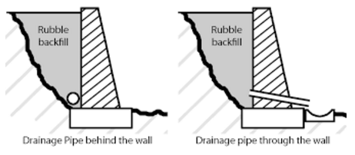

Drainage pipe behind the wall
Advantages
Simple to install, cost effective, simplicity
Aesthetically pleasing as hidden behind the wall
Disadvantages
Water build up behind the wall if fill and filters are not used adequately
water has to travel along behind the wall to escape

Drainage pipe through the wall
Advantages
Simple to install, cost effective, water can escape through the wall instead of building up behind.
Disadvantages
Could get blocked, therefore allowing water to build up
regular cleaning of pipe required
not as aesthetically pleasing
Have to ensure water coming through the wall can not get waterlogged on the land below.

Outcome for Activity 7 | ☐ Satisfactory  ☐ Not satisfactory
Trainer/Assessor comments

Explain the following terms:
- Batter
- Angle of repose

Term | Definition
- Batter | Batter is the shaping of the land between two different levels and used when there is adequate space available. To batter a wall or an excavation is to angle the slopes of the excavation or the wall at an angle greater than 90 degrees. The battering of a retaining wall means that the face of the wall will slope away from the front of the wall and towards the material being retained. To batter a wall or a slope will enhance its structural capability to withstand overturning.
- Angle of repose | The steepest slope of the unconfined material, measured from the horizontal plane on which the material can be heaped without collapsing.

Outcome for Activity 8 | ☐ Satisfactory  ☐ Not satisfactory
Trainer/Assessor comments

Describe what is happening the in sketched diagram and the photograph shown below.

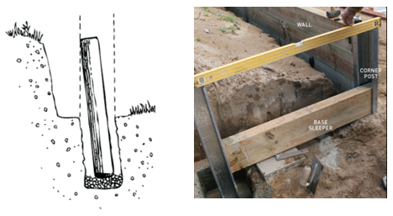

 | Description
- Sketched diagram | Setting a post into the ground with the required lean back with a gravel base in the bottom of the hole
- Photograph | Setting & checking heights and corner posts for timber sleeper retaining wall

Outcome for Activity 9 | ☐ Satisfactory  ☐ Not satisfactory
Trainer/Assessor comments

Have team members take photos and videos of your involvement with retaining wall projects.

Identify each photo / video with a letter label and describe each photo / video in the table below. Submit the photo / video files along with this workbook.

Advantages
A
B
C
D
E
F
G
H
I
J
K
L
M
N
O
P
Q
R
S
T
U
V
W
X
Y
Z

Outcome for Activity 10 | ☐ Satisfactory  ☐ Not satisfactory
Trainer/Assessor comments

