CPCCBC4008B
Conduct on-site supervision of building and construction project

THEORY EXAM INSTRUCTIONS

- This exam will occur under standard assessment conditions.
  - An oral examination may be allowed under certain circumstances.
Answers will be documented and FT003 (Oral examination declaration form) must be completed.
- Participants must provide enough detail in their responses to demonstrate their knowledge and skills.
- Please fill in the details below, providing your name, signature and date of assessment.
  - Your signature acknowledges that this is your own work.
- If a participant initially answers a question incorrectly but modifies their response, they must follow the instructions below:
  - If a participant changes their response in writing, they must put their initials next to the written change.
  - If a participant changes their response verbally, this must be noted on the exam paper by the assessor.

Participant name | Emma Carew
Participant signature | 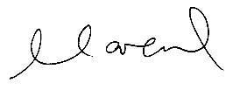

Assessor name
Assessor signature | 

Date | 12/11/2018

Number of questions | Number of questions answered correctly | Satisfactory?
24 |  | Yes | No
Assessor Comments
- List eight (8) essential elements that you (as the builder) need to supervise with regards to the administration of claims and payment processes.

Answer | - Payment claims  - Variations  - Contract claims  - Interest payments  - Retentions  - Bank guarantees  - Back charges/set offs  - GST

- The money you draw out is an example of a business expense. Explain where you would find the guidance on how to draw against allowances.

Answer | The money you draw out must be identified within your company policies (financial plan). It involves looking at cash flow, asset values and withdrawal plans.

- Describe at least six (6) types of on-site communication that you (as the builder) may engage in during a construction project. Identify who would be involved in such communications.

Answer | Types of on-site communication:  - Verbal – Phone  - Mobile - Text  - Written – Emails, File Notes, Site Reports, Variation Requests, Extensions of Time  - Face to Face – Project Meetings with Clients & Contractors, Toolbox Talks  - On-Site Diary  Who would be involved:  You need to record all communication with the following members:  - Clients  - Contractors  - Inspections  - Union matters  - Suppliers

- Assume there are a number of sub-contractors now working on-site and the quality of the work must be assessed.
Identify five (5) quality control procedures and detail how these procedures can ensure the performance of work to industry regulatory and contractual standards.

Answer | - Quality/Site Checklists  Site checklists are a list of items required of things to be done, or points to be considered which can be used as a reminder. Checklists should be maintained for all stage of your building project  - Regular on-site progress and quality checks  The primary function of on-site inspections is to ensure that construction work complies with the approved plans and recognised building standards, including the Building Code of Australia (BCA).  Under the relevant Queensland legislation, building inspections on dwellings must be performed at the following stages - footing, slab, frame and final.  - Reviews of building work against the plans and specifications with clients  - Quality Manual  The procedures for checklists, quality checks and on-site reviews identified are transferred into written form within a Quality Manual.  These quality control procedures are then adhered to through things like checklists and forms, as well as the responsibilities and accountabilities.  This practice ensures your business maintains its quality systems and continuously improves those systems.

- As part of the Work Health and Safety Act 2011 (Qld) it is a legal requirement to look after the safety of your workforce.
Identify two (2) reasons why you should implement a site safety policy.

Answer | A site safety policy should be implemented because it:  - Demonstrates that your business is addressing its health and safety obligations.  - Shows that your business is committed to working within a set of health and safety principles.  - Clarifies functions and responsibilities in your business.  - Ensures that safe systems of work are recorded, communicated to workers and implemented in a consistent way throughout your business.  - Guides the future actions of workers in a formal way.  - Helps your business to manage staff more effectively by defining acceptable and unacceptable behaviour in the workplace.  - Saves time by allowing health and safety matters to be handled quickly through an existing procedures.

- Practical project completion procedures must be fully completed to ensure a competent handover of the finished product to the client.
Describe the steps involved, outlining the people and documents involved in the processes.

Answer | Practical completion is achieved when the project requirements have been delivered, in accordance with the project brief, approved design and intent, contractual obligations and statutory requirements (BCA).  On reaching this stage, you are obliged to:  - Inform the client that the building is ready for a practical completion inspection  - Check against your contract, project brief and statutory requirements  - Carry out an inspection of the dwelling with the client before handover.  - The works must be finished excluding defects or minor omissions)  - Document all activities in a handover report  - Check with your bank or lending authority as they may wish to inspect the project prior to finalising its payment to your contractor

- What action can the client take if the builder goes over time (i.e. has not reached practical completion by the end of the building period)?
If there is a delay in time, who does that need to be communicated to?

Answer | It depends on the contract. Some contracts define liquidated damages for late completion and some contracts do not. The agreed completion date may extend if the builder claims allowable extensions of time in accordance with the contract. Wet weather, materials hold-ups, variations to the work and disputes are some genuine reasons for extending the building time.  Some contracts give the owner a right to require the builder to give his/her best estimate of completion. Where the parties agree the building is over the building period, then the owner may be entitled to liquidated damages if defined in the contract. Owners should contact their solicitor where damages have not been agreed.

- Explain the terms under which a builder can increase the contract price.

Answer | Most contracts have provisions for variation, prime costs and provisional sum items. When a situation arises which is not the builder’s fault then the builder does have a right in most cases to increase the contract price.  However, state laws limit the circumstances and the amount by which a builder may increase the price.  In all cases, the builder must follow the variation procedure set out in the contract.  The provisional sums and prime costs may increase the price of the contract (without variation) where the owner selects products and services which cost more than the allowances provided for in the contract.

- What is warranty insurance? Detail what it covers and distinguish it from contract works and public liability insurance.

Answer | Warranty insurance covers the owner against major defects to the work for a period of six years and six months.  Contract Works and Public Liability Insurance covers fire, damage, theft and injury during the construction period while the builder is in possession of the building site.

- Once you take on a building contract you are totally responsible for what goes on at the construction site. Explain how you would administer a claim if anything on your site was stolen or damaged.

Answer | How to administer an insurance claim for items stolen or damaged onsite:  Making a Claim  - Take an organised step by step to lodging the claim  - Contact the Police and keep the incident number they provide  - Review the PDS to check claim is valid and excess that may need to be paid  - Contact your insurance company and have as much information available as possible.  - Minimise the loss  - Provide evidence and keep a written report  - Evidence such as:  - Original receipts, police reports, valuation reports, medical certificates product make, model and serial numbers, photographs or videos of property or items, or the event itself.  - Keep all paperwork, notes and supporting materials together in a folder or notebook, such as the contact details of any witnesses or even receipts for the items that have been lost or damaged.  Working Through the Claim  - Work with insurance assessor to help determine how the claim will be managed.  - Gather repair / replacement quotes  - After quotes and scopes settled, discuss cash settlement with insurer

- What is a dispute resolution clause? How the client can make use of such a clause?

Answer | A typical dispute resolution clause outlines a set of procedures that parties must follow in the event of a dispute arising out of, or in connection with, the contract.  The most common types of building related disputes are:  - Technical disputes (including defects and quality of work/products)  - Contractual disputes (including non-payment, project completion, extension of time)  A dispute resolution clause can assist you in resolving your dispute before formal Court proceedings are required.  A dispute resolution clause ensures that any issues the client has with the quality or completion of work are:  - Discussed upfront and concerns are listened to carefully.  - Spoken about calmly and patiently  - Followed up with in writing  - Given directly to yourself (as the primary contractor)  - Clarified with your client – to avoid any misunderstanding

- Describe the process where the builder or the client wishes to make a variation to a contract. What happens if the parties do not agree to the proposed variation?

Answer | Most contracts allow the client and builder to make requested variations.  The contract sets out a process for each party to request a variation. Where a party may not agree and disputes a variation then the parties are referred to the dispute procedure under the contract.  The builder must:  - give the consumer written notice of the variation  - state why the variation is necessary  - state the time it will take to complete the works  - provide a cost of the variation  - state the effect it will have on the contract price  A client variation can be requested at any time during the contract and parties should refer to the variations clause in the contract. Generally, when you request a variation, the builder has the option to agree or refuse to carry out the variation.

- What are ‘prime cost items’? Provide an example of when they are used.

Answer | A Prime Cost item (PC) is an agreed, reasonable estimate for materials (fixtures and fittings) which may not have selected at the time of entering into the contract. Prime Costs are usually one-off items, however they can relate to a large number of items when the labour cost remains constant. Examples may include kitchen and bathroom items.

- What are ‘provisional sum items’? Provide an example of when they are used.

Answer | A Provisional Sum item (PS) is a reasonable estimate for material and labour of a particular part of the home which the builder cannot give a definite price for.  The reason being the owner had not made a decision for what they wanted at the time of entering into the contract. Examples are pool and landscaping.

- Does the builder need to provide evidence for increases in Prime Cost and Provisional Sum items? Explain your response.

Answer | Yes the builder is required to quantify the extra claim if requested by the owner. The builder is required to provide evidence of the cost of a prime cost item or a provisional sum item when claiming payment for that item.

- On what grounds may a builder claim interest on late payments?

Answer | Yes, most contracts give the builder a right to charge interest on late payment the same as any other commercial transaction.  The contract will refer to the clause that relates to default interest. Generally, the client must pay the builder default interest on any amount that is unpaid if it is over the contracted payment date.

- Describe the procedure that occurs when a client notices defects (after practical completion has occurred) through to getting client sign-off after these defects are corrected.

Answer | The contractor must give the builder a defects document which:  - lists any minor defects/minor omissions that the contractor and owner agree exist and states when the contractor will deal with these  - lists any minor defects or minor omissions that only the owner believes exist  - must be signed by the homeowner and the contractor and copied to the owner.  A contractor must repair any defects noticed at handover, or within 12 months of when the work is finished.  The Builder must notify the contractor of any such defects within 12 months of when you notice them.  The QBCC's complaints process provides information about what to do if the contractor fails to correct these defects.  Note: The builder is not required to fix work not included in the contract and is not required to fix any defect which is the result of abuse, wear & tear or normal shrinkage or movement.

- What completed documents do you need to give to the client on handover?

Answer | - Certificates of inspection  - Product warranties for appliances installed  - Reports, notices or other documentation issued by service providers (e.g. electricity, gas, telephone, water or sewerage)  - Practical completion certificate = Form 7  - Defects – Complete defects report during handover inspection

- A contract states the total sum for a house build to be $435,000. As per the contract agreement, progress payments will be made to the builder at five (5) stages throughout the build. You are required to create:
- Five (5) separate checklists for each of the following stages, detailing the work to be completed at each stage: Base, Frame, Enclosed, Fixing, Practical completion
- Progress payment sums (of the total gross)

Deposit | 5%
Base stage | 15%
Frame stage | 20%
Enclosed stage | 25%
Fixing stage | 20%
Practical completion | 15%

Answer | Base Stage Check List – 15%  The foundation is laid and includes:  - Surveying / measuring out site  - Pouring the footings  - Under slab drainage  - Moisture barrier  - Special mesh for termite protection.  Frame Stage Check List – 20%  - Installation of internal and external support structure, along with walls  - Conduit for electrical and plumbing  - Roof frame and sheeting, gutters and insulation complete  Enclosed Stage Check List – 25%  - Windows, doors and remaining walls installed.  - Safe for plumbers, electricians, cabinet makers and other tradesman to begin fitting out the property.  Fixing Stage Check List – 20%  - Plumbing, electrical (including lights and powerpoints) and other fixtures and fittings installed.  - Cornices, tiling, cabinets and shelving, reveals and architraves installed  Practical Completion Stage Check List – 15%  - All painting, installations and detailing complete and owner is ready to move in.  Progress Payment Sums  Deposit – 5% = $21,750  Base – 15% = $65,250  Frame – 20% = $87,000  Enclosed – 25% = $108,750  Fixing – 20% = $87,000  Practical Completion – 15% = $65,250

Answer

- Prepare an invoice to claim a progress payment for the base stage of the build in Q19. Your clients are Mr and Mrs Jack and Joan Webster of 77 Shakespeare Street, Coorparoo, Queensland.

Answer | Please see attached QBCC Form 3 – Progress Claim

- Write emails to the sub-contractors for their completed work of the base stage. In each email you are to request an invoice for the following:
- J&B Surveying Pty Ltd (quoted $1100)
- EK & KP Earthmovers Limited (quoted $2,960)
- Jacksons Concreting Pty Ltd (quotes $10,800)
- DB Shaw & Sons Bricklayers Pty Ltd (quoted $5700)
- The Timber Fella (quoted $840)

Answer | J&B Surveying Pty Ltd (quoted $1100)  Jim and Bob,  Can you please forward your invoice for completed base stage works as quoted at $1,100.00 for 77 Shakespeare Street, Coorparoo.  Thank you  Emma Carew  Emma Carew Construction Pty Ltd  EK & KP Earthmovers Limited (quoted $2,960)  Ellis and Ken,  Can you please forward your invoice for completed base stage works as quoted at $2,960.00 for 77 Shakespeare Street, Coorparoo.  Thank you  Emma Carew  Emma Carew Construction Pty Ltd  Jacksons Concreting Pty Ltd (quotes $10,800)  George,  Can you please forward your invoice for completed base stage works as quoted at $10,800.00 for 77 Shakespeare Street, Coorparoo.  Thank you  Emma Carew  Emma Carew Construction Pty Ltd  DB Shaw & Sons Bricklayers Pty Ltd (quoted $5700)  David,  Can you please forward your invoice for completed base stage works as quoted at $5,700.00 for 77 Shakespeare Street, Coorparoo.  Thank you  Emma Carew  Emma Carew Construction Pty Ltd

Answer | The Timber Fella (quoted $840)  Tina,  Can you please forward your invoice for completed base stage works as quoted at $840.00 for 77 Shakespeare Street, Coorparoo.  Thank you  Emma Carew  Emma Carew Construction Pty Ltd

- Write a payment schedule authorisation for your Office Administration (Accounts) to make payments to the following suppliers who have invoiced you in the past 14 days including:
- IXL Steelworks for steel mesh, rebar, chairs and ties ($4,330)
- Bunnings 18 bags of Portland cement @ $3.80/bag plus $35 for delivery
- MD Landscaping Supplies for 3m³ of bricklayers loam @ $65/1m³ plus delivery $35
- AKA Brickworks for 460 brick packs x 7 packs delivered @ $364.32 per pack ($0.79/brick) plus $48 delivery

NOTES
- All suppliers have 30 day terms. All invoices arrived within the past week.
- You have a note in your diary dated nine (9) days ago that four bags of Portland cement were busted but the contents were mainly intact. After confirming this with their delivery driver, Bunnings called and offered you a credit note on the 4 bags but did want the damaged bags returned. At the time you spoke to Bunnings, Client Services Officer, Jack Daniels. There is no mention of the credit note in their current invoice.
- You also have a note in your diary dated fourteen (14) days ago that one package of bricks was opened and had 183 bricks missing. The Delivery Driver made a note on your invoice and the delivery copy that one pack was opened and missing 183 bricks. You note that no one in your business has followed up on this matter as there is nothing in your diary or on file and the invoice does not mention a credit note for the 183 missing bricks.

Answer | Please see attached Payment Authorisation Schedule – 30 November 2018

Answer

- You are on site late in the afternoon doing quality checks on the steel preparation for pouring of the concrete slab in two days’ time. So far the moisture protection, termite protection, electrical conduit, drainage pipes and sewerage pipes for bathrooms and kitchens have been positioned in accordance with the plans and drawings. The formwork for the slab is erected along the outer edges of the building footprint and on top of the cured concrete footings.

You notice some discrepancies, firstly that the steel is not tied off properly to the penetrations and secondly that the penetrations are not taped at membrane or capped to prevent spillage down the pipes (this is for all penetrations in wet areas and kitchen area for the slab floor).

You also note that the steel mesh laps in several places are not lapped at all but instead are butted together and even then, they have been tied off inadequately between the mesh sheets. You also note that bar chairs that support the mesh and particularly at joins in the mesh are about one metre and in other places up to two metres apart. From previous experience you know that under the pressure of pouring the concrete the mesh will most likely flatten in these areas down to the plastic membrane.

The last thing you see during your check is that in the northern end, the edge formwork does not appear to be adequately braced and would very likely dislodge during the concrete pour and the membrane in this area has several holes, some of which are greater than a ten dollar note and others 50 cent coin-sized in nine (9) different places of the membrane sheeting.

YOUR TASK

- You are to create/design a House Foundation and Slab Floor Checklist for your business and mark it off in accordance with this inspection. Have a reference area at the bottom of the checklist for quoting the BCA, standards, local government and State regulations, manufacturers’ recommendations etc. and other relevant documentation that applies and what should be done with the penetrations and the mesh laps and other rectifications that are required before the pour occurs.
- Write an email to the concreting sub-contractor, Jackson Pollock of JP Concreters P/L to alert your concerns and to have the errors rectified before the pour. Arrange to meet Jackson at an appropriate time on-site tomorrow to discuss and check the rectifications. (N.B. The slab floor pour is scheduled for 6:30AM in two days’ time).
- Make appropriate arrangements by email with the local authority and your building certifier to check the slab in readiness for the pouring of this concrete slab. Make up fictitious names and addresses for your emails.

Answer

- You are to research your current company’s quality procedures manual or alternatively review the draft quality manual (provided).
Once you have familiarised yourself with this Quality Manual you are to:
- Determine what quality checks and balances the company has in place for when it engages in a building project.
- Explain in 600 words your assessment of the checks and balances
- Attach the index/contents page from the quality manual you review to your response and acknowledge the source document.

Answer | ECDB Pty Ltd has the following checks & balances in place when it engages in a building project:  PLAN – DO – CHECK - ACT  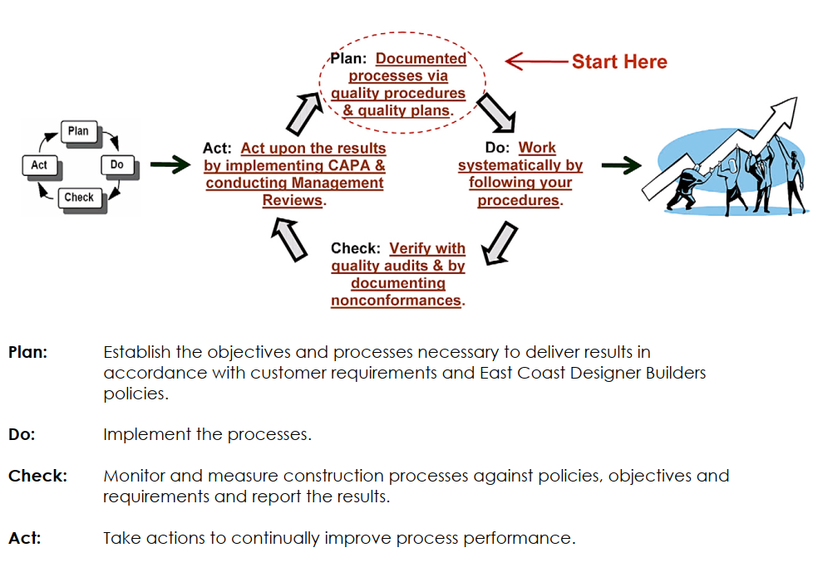  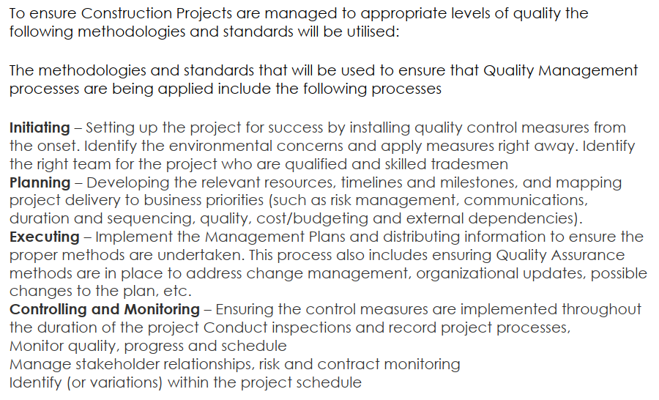  ECDB monitor and continually improve the way in which their Quality Management system achieves results:  - Conducting regular reviews of customer satisfaction levels  - Complying with stated policies and procedures  - Ensuring correction and corrective action is implemented where planned results are not achieved  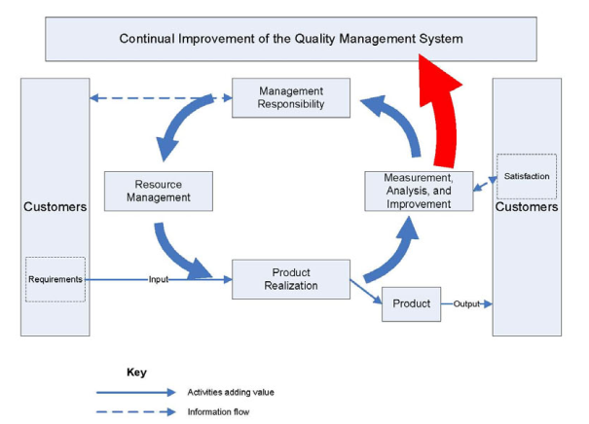  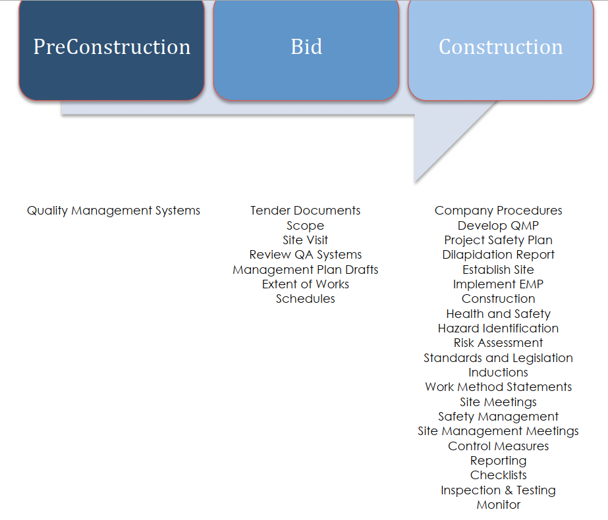
Answer

