Organisation Name | Matt Greenwood Constructions | ABN | 92163040186
Organisation Address | Lot 202 Gillies Range Rd, Gordonvale 4865

Project | Sarah Close, Gordonvale 4865

Task / Operation / High Risk Activity | Install Roof Trusses |  |  |  |  |  |  | Number
Applicable Legislation, Standards or References | QLD WH&S Act, QLD WH&S Regulation, QLD Mobile Crane COP, QLD Electrical Safety Act, QLD Electrical Safety Regulation, QLD How to Manage WH&S Risks COP, AS 4440 Installation of Nailplated Timber Trusses, AS 1576 Scaffolding, AS 2550 Cranes, Hoists and Winches
High Risk Construction Work | - Falls of more than 2 metres  - Powered mobile plant
Required Licences, Certificates, Competencies, Permits or OHS Authorities | DG ( Dogger ), CN ( Non Slew Crane) or C2 ( 20t Slew Crane )
Personal Protective Equipment  (Tick PPE required)  Ensure that all workers are trained in the use and maintenance of all PPE required for task by site supervisor | Safety Footwear | Safety Helmet |  | Respirator* | * Provide specific details of PPE required  Harness and Lanyard as required.
 | Hearing Protection | High Vis |  | Other*
 | Eye Protection* | Gloves
Plant, Equipment or Tools | Crane |  |  | Maintenance Checks |  |  | Responsibility of subcontractor
Special/Hazardous Materials | (Ensure MSDS for hazardous Materials are available to workers) Mobile Scaffold, Bond Beam Trestles.
Emergency Procedures/Resources  (Specific to this JSA-SWMS)  Ensure that all workers are trained in these emergency procedures by site supervisor | General Emergency procedures are available in the Site Health and Safety Plan.  First Aid procedures are as per site specific induction and Health and Safety Plan.
Environmental Impacts and Controls | Impacts |  | Controls ( If there is a potential impact define controls)
Environmental Impacts and Controls | Hydro Carbons (oil and fuel spills) |  | Spill Kits |  |  | Designated Refueling and Servicing Areas |  |  | Other (specify)
Environmental Impacts and Controls | Sediment Run Off |  | Silt Fences (Erection and Monitor) |  |  | Drainage |  |  | Containment Ponds
Environmental Impacts and Controls | Dust |  | Watering |  |  | Site Speed Limits |  |  | Dust Containment Fences

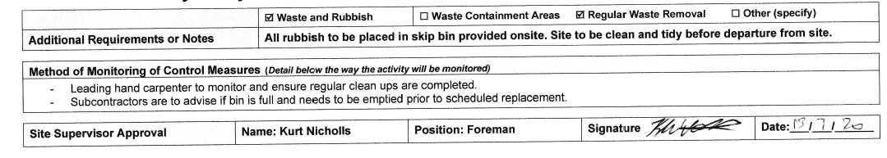

Job Sequence
Risk levels: VH – Very High, H – High, M – Medium, L- Low
Sequence of job steps  (What to do in the right order) |  | Potential hazards  to people or the environment  for each step  (eg. Manual Handling) | Risk Level  (each hazard) | Control Measures  (How to do it)  Elimination Substitution Engineering Administration PPE | Risk Level after Control | Person Responsible
 | Truss delivery truck access and truss unloading. | Blocking Traffic and Pedestrian Flow outside site. | M | Traffic controllers and signage are positioned in accordance with the MUTCD Part 3. | L | Site Supervisor
 | Truss delivery truck access and truss unloading. | Persons being stuck by falling objects. | M | The unloading area is to be barricaded to deny access of other workers and pedestrians.  Hard Hats are to be worn by all workers involved in the unloading process.  High Vis clothing is worn by all workers. | L | Site Supervisor
 | Truss storage | Stored trusses blocking pedestrian flow and site access / egress. | M | Trusses stored in suitable area, if trusses block footpaths suitable barricading and signage to be erected. | L | Site Supervisor
 | Crane set up | Blocking Traffic and Pedestrian Flow outside site. | H | Traffic controllers and signage are positioned in accordance with the MUTCD Part 3. | L | Site Supervisor
 | Crane set up | Soft ground/underground services. | H | Assessment of the ground condition and location of underground services to be undertaken prior to crane set up. Suitable outrigger packing to be positioned on set up. | L | Site Supervisor/ Crane operator
 | Crane set up | Proximity to Power Lines. | VH | The location of power lines to be identified prior to operation.  Authorised spotters or visual markers to be used after consultation with Power entity if the operation is closer than specified in the Code of Practice (SWNELP) 3m LV, 6m HV, 8m HV.  Dry natural fibre rope tag lines are to be used when working near powerlines. | M | Site Supervisor/ Crane operator
 | Slinging of trusses | Faulty or damaged lifting gear. | M | All lifting gear to be inspected by a competent person (dogger, rigger) prior to use. | L | Dogger
 | Slinging of trusses | Incorrect slinging method. | M | A licenced dogger or rigger must sling the truss. Slinging points must be in accordance with the manufactures’ recommendations. | L | Dogger
 | Lifting of trusses | Falling trusses | M | The work area must be barricaded and signed off to deny access to all other workers.  Workers must not stand under load where possible | L | Site Supervisor
 | Lifting of trusses | Controlling the truss | M | A tag line must be used to control the truss as it is lifted. | L | Dogger
 | Lifting of trusses | Incorrect crane signals whilst directing the truss | M | A licenced dogger or rigger must direct the crane. | L | Dogger
 | Access work area | Persons falling from heights | H | All workers to maintain three points of contact when climbing ladders. | L | Site Supervisor, Carpenter
 | Position truss | Persons falling from heights | H | Workers to remain on bond beam scaffold when landing roof trusses. | M | Site Supervisor, Carpenter
 | Conduct work at height | Persons falling from heights | H | The following controls will be used either together or individually  Where the trusses are erected at up to 900mm centres work can be performed off the bottom cord if;  - The trusses are braced  - Only competent, trained persons to perform work.  - No damage to bottom cord  - Person completing work take extra precaution  And/ OR | M | Site Supervisor, Carpenter
 | Conduct work at height | Persons falling from heights | H | A mobile scaffold is used as a catch platform below the work area or as a work platform where ever possible.  OR | L | Site Supervisor, Carpenter
 | Conduct work at height | Persons falling from heights | H | Scaffold planks are laid across the bottom cord to create a work platform | L | Site Supervisor, Carpenter
 | Fix Truss | Use of Electric drill | M | Only trained and competent workers to use.  Drill lead checked for any damage prior to use.  Correct safety features to be correctly installed. i.e drill handle | L | Site Supervisor, Carpenter
 | Fix Truss | Truss collapse. | M | Install temporary bracing | M | Site Supervisor, Carpenter
 | Fix Truss | Falling objects | M | Barricade & sign post area below when working at height above others.  Hard hats to be worn | L | Site Supervisor, Carpenter
 | Un-slinging of crane | Persons falling from heights | M | Access lifting sling by either;  - Standing on scaffolding  - Standing on bottom cord if the cord has been inspected for defects and a catch platform (mobile scaffold) is used.  - Use a step ladder. | L | Dogger
 | Filling in remaining trusses | Persons falling from heights | M | Workers to remain on bond beam scaffold supplied where possible  Correct footwear to be worn  Extra precaution when climbing around on top of trusses | L | Site Supervisor, Carpenter
 | Strapping, Batten screwing and speedy bracing to complete job | Persons Falling from heights | M | Correct footwear to be worn  Extra precaution when climbing around trusses  Use mobile scaffold where possible | L | Site Supervisor, Carpenter
 |  | Use of coil gun | M | Ensure correct PPE are worn. (Safety Glasses, Ear protection)  Only trained and competent workers to use  Precaution taken when using coil gun on top cords of trusses  Straps to be shot on when standing on scaffold or bottom cord where possible | L | Site Supervisor, Carpenter
 |  | Use of electric drill | M | Only trained and competent workers to use  Screw Batten screws whilst standing on bottom cord or scaffold where possible | L | Site Supervisor,  Carpenter
 | Exiting the roof | Persons falling from height | M | Ensure workers use ladders supplied with bond beam scaffold  Maintain three points of contact when climbing down the ladder | L | Site Supervisor,  Carpenter

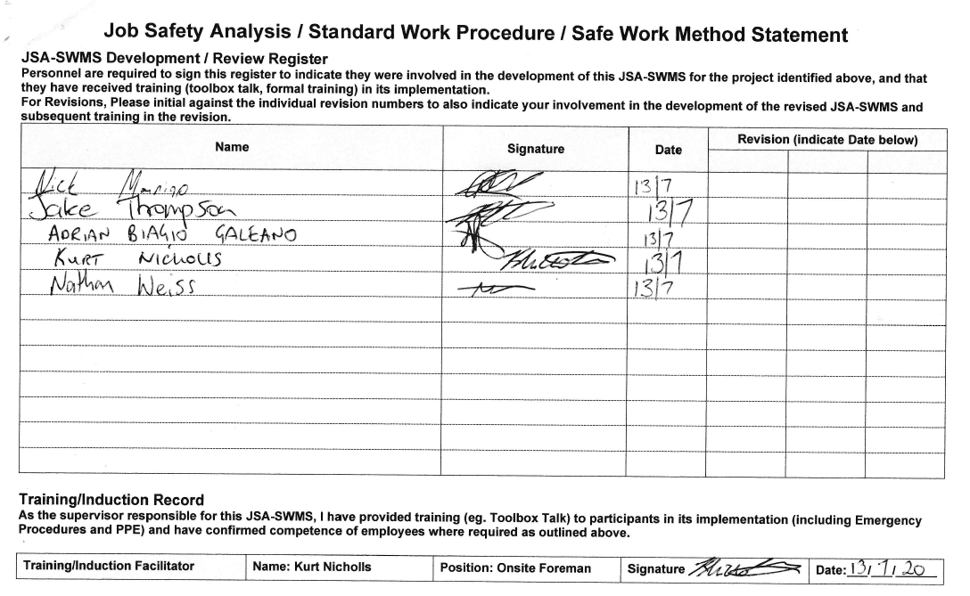

LIKELIHOOD  How likely could it happen? | CONSEQUENCES: How severely could it affect health and safety?
LIKELIHOOD  How likely could it happen? | Insignificant  No medical treatment required | Minor  Minor lost time injury or illness | Moderate  Moderate lost time injury or illness | Major  Serious lost time injury or illness | Catastrophic  Death or permanent disablement
Almost Certain  Is expected to occur in most circumstances | Medium | High | Very High | Very High | Very High
Likely  Will probably occur in most circumstances | Medium | Medium | High | Very High | Very High
Possible  Might occur at some time | Low | Medium | High | High | Very High
Unlikely  Could occur but doubtful | Low | Low | Medium | Medium | High
Rare  May occur but only in exceptional circumstances | Low | Low | Low | Medium | Medium
Based on Table 6.6 HB436-2004 Risk Management Guidelines Companion to AS/NZS4360:2004
Risk Level | Action
VH - Very High | ACT NOW – Urgent - Do something about these risks immediately
H – High | Highest management action required urgently
M – Medium | Manage by specific monitoring or management procedures
L – Low | These risks may not need immediate action – manage by routine procedures

Consequence scales for environmental hazards and risks
Consequence | Description
Catastrophic | Catastrophic long term environmental impairment of eco systems functions
Major | Very serious long term environmental impairment of eco systems functions
Moderate | Serious medium term environmental effects
Minor | Moderate short term effects not affecting eco system functions
Insignificant | Minor effects on biological or physical environment

