BSBWOR502
Lead and manage team effectiveness
ASSESSMENT SUMMARY

The assessment activities for BSBWOR502 Lead and manage team effectiveness cover all aspects of the unit of competency required. To demonstrate competence in this unit, a participant must undertake all tasks and complete them satisfactorily and consistently. For Apprentices and Trainees, this includes employer completion of the Employer Record Book (ERB).

Participants must read all the information given before starting any assessment task. The assessment tasks are intended to be equitable, fair and flexible. If a participant has any questions or requires alternative arrangements to be made such requests should be directed to their Trainer/Assessor, who should note such arrangements in the ‘Assessor Comments’ on the affected assessment. If a participant feels they are not yet ready to be assessed, they should discuss their options with their Trainer/Assessor.

To satisfactorily complete the assessment, the participant is required to answer all questions correctly and demonstrate their skills to industry standards. If a participant does not answer some questions or perform some tasks, they will be deemed ‘Not Satisfactory’ for the task and ‘Not Yet Competent’ for the unit of competency. The Trainer/Assessor is able to provide the participant with additional information on interpreting the assessment outcomes and provide guidance on the participant’s options. Should a participant still be deemed ‘Not Satisfactory’ they will have the opportunity to undertake a supplementary assessment or appeal the result.

By signing the cover page for each assessment item, the participant acknowledges they understand the assessment instructions and requirements and consent to being assessed. The participant also verifies and assures the RTO that the work submitted is their own work.

Participant Name | Rhion Gardner

Task | Assessment Results
Theory Exam | Satisfactory | Not Yet Satisfactory
Practical Assessment | Satisfactory | Not Yet Satisfactory
Outcome for Unit of Competency | Competent | Not Yet Competent

Assessor Name
Assessor Signature | 
Unit Competence Determination Date | Click here to enter a date.

BSBWOR502
Lead and manage team effectiveness

THEORY EXAM INSTRUCTIONS

- This exam will occur under standard assessment conditions.
  - An oral examination may be allowed under certain circumstances, whereby the Participant’s answers will be documented by a party other than the Participant. This must be acknowledged in writing (e.g. FT001 and Assessor Comments)
- Participants must provide enough detail in their responses to demonstrate their knowledge and skills.
- Please fill in the details below, providing your name, signature and date of assessment.
  - Your signature acknowledges that this is your own work.
- Assessors are to complete marking in pen of a different colour to the Participant.
- If a Participant initially answers a question incorrectly but modifies their response, they must follow the instructions below:
  - If a Participant changes their response in writing, they must put their initials next to the written change.
  - If a Participant changes their response verbally, this must be noted on the exam paper by the assessor.

Participant name | Rhion Gardner
Participant signature
Date | Click here to enter a date.

Assessor name
Assessor signature
Date | Click here to enter a date.

Number of questions | Number of questions answered correctly | Task outcome (Tick)
22 |  | Satisfactory | Not Yet Satisfactory

ASSESSOR Comments
- Discuss why a team leader should consult with their team about the team’s purpose/goals and each team member’s role.

Answer | Area | Response
 | Team purpose/goals | Team leaders must consult with their team to achieve a common purpose/goal. Team members must work together and rely on each other to successfully complete their respective tasks. This is done with ongoing consultation with the team.
 | Team members’ roles | Team leaders must consult with their team regarding each individual role since team members have complimentary roles that jointly contribute to the team’s goals. This goal will not be achieved unless all team members take responsibility for and are effective at their individual tasks.

- Explain what the term ‘open communication’ means and its importance to your team. In your response, be sure to identify the link between open communication and trust.

Answer | Open communication occurs when the team can freely share all of the information necessary to complete their task, without being afraid of their comments. Open communication relies on trust. An environment of trust, supportiveness and open communication means that the team members are not afraid to report concerns, mistakes, delays, etc.to the rest of the team so that these issues are recognised and addressed.

- Teams need to have a balance between similarities among team members and diversity. Discuss what this statement means.

Answer | Teams need to have similarities among goals that need to be achieved but also need to have diversity to develop innovative solutions.

- Describe the benefits and disadvantages of the following five (5) strategies of conflict resolution.

Answer | Conflict  resolution strategy | Benefits | Disadvantages
 | Avoiding | This can result in a resolution of the issue with communication between parties. | The team lose focus and can avoid certain steps in the process and not resolve the issues.
 | Accommodating | The team can reach their final goal with cooperation. | A member of the team ignores and dismisses their issues. This can make the team member have more issues.
 | Forcing | This can make the team leader and the other party reach a consensus and an understanding of each other’s views. | This is uncooperative to the team and can lead to an unhealthy relationship between parties.
 | Compromising | Both parties resolve any issues and come to a mutual and acceptable solution. | Both parties can become resentful and untrustworthy of the other party.
 | Consensus | This is the best result for a team where all members Collaborate and work together to find the solution to the issue. | This is not always successful for a team to reach.

- As team leader, you have to help resolve the following three (3) conflicts between members of your team:
- Two team members are disputing which of them should write a report.
- Two members are arguing bitterly about Australia’s refugee policy.
- Two team members are quarrelling over which equipment will be the best for the team to purchase.

For each of these situations:
- Explain what type of conflict it is
- Discuss what action you would take to stop the conflict

Answer | Conflict number | Type of conflict | Resolution strategy
 | 1 | Process conflict | The team leader should explain the reason why they have chosen which team member will write the report and resolve any issues between parties.
 | 2 | Team conflict | Team leaders can limit these conflicts when selecting team members. The team leader needs to set an example to encourage the team members to come to a collaborative agreement and to focus on the team goals.
 | 3 | Task conflict | The team leader needs to fully discuss with each team member how the task should be performed and allow them individually to present the team members ideas regarding which equipment is best for the task. The team leader then needs to implement the best equipment to reach their common goal.

- Explain four (4) approaches you might implement to encourage a team to reach consensus on an issue.

Answer | 1.Discussion between team members. Open communication.  2.When picking teams try to pick team members with similarities.  3.Build an environment of trust and supportiveness.  4.Setting an example to encourage your team

- Identify and describe each of the five (5) stages of team development.

Answer | Stage | Description
 | Forming | This stage is the time when team members get to know one another and to start thinking and have an intellectual discussion between members to find out similarities.
 | Storming | This stage normally starts with conflict and stress on team members resulting in them competing for status and control and arguments arise about the teams direction.
 | Norming | At this stage the team finally starts to cooperate so they can then establish rules regarding the behaviour of the team and can regulate them appropriately.
 | Performing | This stage is the best stage of a team when they can finally develop the strategies to reach the teams goals.
 | Adjoining | This stage the goal has been reached and the team can demobilize.

- Explain why the process in Q7. enables a team leader to understand the dynamics of team building.

Answer | By observing the behaviour of the team, the team leader can now understand what needs to be done. They can then assess what stage the team is in and then help the team to move forward towards the performing stage.

- Your team has been especially productive lately and you are proud to be its leader. The one area of the team’s weakness has now been addressed by the arrival of two new team members, who fill in the team’s lone ‘expertise gap’ extremely well. You are then very upset that there have been several arguments amongst team members recently, and productivity has come to a near standstill.

Use the five stage model of team development to:
- Explain what is likely to have happened to the team
- Decide what action you should take as team leader

Answer | The team has an existing hierarchy from when it was at the storming stage and has moved beyond this with the norming stage and is now at the performing stage. The introduction of two new team members has broken this hierarchy thus creating tension and conflict. Once you have conflicts within the team their objectives and tasks are disagreed upon resulting in the team to lose focus and creating arguments. The best way, as a team leader, is to identify what are the team’s conflicts and to find out if they are relationship conflicts, task conflict or process conflicts. Once this has been identified the team leader needs to build that environment of trust between team members through consultation and discussion. Then the team leader can reiterate what are the team’s roles and help the team understand the teams goals.

- Explain why it is important that a team leader acts as a role model.

Answer | The team leader needs to act as a role model because teams are built on trust and team members need to rely on each other. By being a role model, it sets an example to other team members. It shows the team how to fulfil their duties and encourages your team to follow the team leader.

- Outline four (4) ways in which you would act as a role model as a team leader.

Answer | 1.Fulfilling your own tasks, duties and responsibilities  2.By not expecting other team members to do something that you would not do  3.Being trustworthy  4.Being open to communication with other team members

- Your goal is to manufacture 40 brown 1 metre X 1 metre tables each week. Your manager has made sure that you have enough raw materials and staff to achieve this, though the team will have to work hard to reach the goal of 40. Consider this project as a SMART goal, by matching the goal elements with the aspects of the task by writing the appropriate letter next to each number in the centre column.

Answer | Element |  |  | Task aspects
 |  | Specific | 1 - C |  | Set a challenging but attainable goal
 |  | Measurable | 2 - A |  | Each week
 |  | Achievable | 3 - D |  | brown 1 metre X 1 metre tables
 |  | Resourced | 4 - E |  | 40
 |  | Timetabled | 5 - B |  | enough raw materials and staff

- Identify three (3) areas to be considered when designing a KPI and provide an example for each.

Answer | Area | Example
 | Financial | Number of new contracts signed per period.
 | Customer | Number of customers retained.
 | Employee | Employee satisfaction rating.

- Define the term ‘control’ and explain its importance in a team achieving its goal.

Answer | Control is a function of the team which helps to check errors in order to take corrective actions. This is done to minimize the team deviating from their tasks and ensuring that the goals of the team are achieved.

- A team leader’s feedback to team members should be two-way, constructive, objective and impersonal. Explain each of these factors and why they can improve the team’s performance.

Answer | Area | Explanation
 | Two-way | This will help the team member improve their individual performance by motivating and rewarding them and can address individual performance problems. The team leader and team member have the opportunity to ask and answer questions.
 | Constructive | This is where the team can help other team members who are both performing and underperforming. This can also involve formal or informal training.
 | Objective and impersonal | This is where team members are provided with examples of when they have performed well or underperformed and must be impersonal. This will then show the team how to improve.

- To support team members in meeting expected performance outcomes, identify two (2) examples of formal and informal learning they may undertake.

Answer | Learning type | Examples
 | Formal | Classroom
 | Formal | online
 | Informal | Mentoring
 | Informal | Webinars

- Give two (2) examples of team issues that should be immediately communicated to line managers/management.

Answer | Team conflicts  Task conflicts

- Outline why the examples from your response to Q17. should be reported to line managers/management urgently.

Answer | Team and task conflicts are destructive to the whole team and will break down the trust the team members have with each other and ultimately the team will not be able to reach their goals

- Why should information from management, including line manager, be shared throughout a team?

Answer | This shows the team that they are united with open communication and that they can trust their team leader.

Read the following scenario to respond to Q20. and Q21.

Roger and Janet have to write a report to present to their manager in twelve days.

They meet for one day to plan what they will do. The project has two parts. They decide that:
- Roger will do Part One. It will take three days for him to collect the information, and three days to write his part of the report
- Janet will do Part Two. It will take her four days to research the topic, but only two days to write her part of the report.
- Each will then read the reports from the other. This will take two days
- They will then spend two days putting all the parts of the project together into a final draft.
- They will bind the report and hand it in on the next day.

- Explain why it is useful to use a Gantt chart to assist with team planning and control.

Answer | The Gantt chart will show the team when they need to complete their task and also start the next task.

- Create a Gantt chart for Roger and Janet. You may either use the template below, or insert an image on the following page.

Answer
  Day 14
  Day 13
  Day 12
  Day 11
  Day 10
  Day 9
  Day 8
  Day 7
  Day 6
  Day 5
  Day 4
  Day 3
  Day 2
  Day 1
  Person | Roger
  Task | Collect information
Answer | 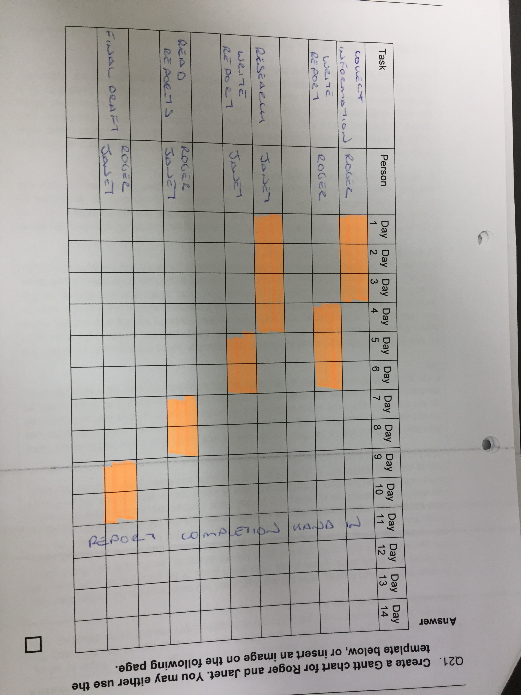

Read the following scenario to respond to Q22.
Simon is having his first performance feedback from his team leader, John. John began by asking Simon how he thought his performance was. Simon had put a lot of thought into this before the interview, and spent a few minutes going through his thoughts. Every time that Simon looked up, John seemed to be gazing into space.

As soon as Simon had finished, John told him that Simon had better improve his performance if he wanted to stay in the team. Simon asked John which areas of his performance John was most unhappy with, and if John could give him some specific examples. John’s reply was that if Simon didn’t know what he was doing wrong, Simon was even more useless than he thought he was. When Simon tried to repeat some of the points about his performance that he thought he had done well, John stopped him and told him he was not interested in excuses. He told Simon that he did not like him and had not wanted him in the team in the first place. Furthermore, he had already discussed Simon with two other members of the team who shared John’s opinion about Simon. Simon thought that he was good friends with all of his other team members, and asked Simon who the two were. John told him it was none of his business.

John then told Simon that he had better not be late for work again after Simon had been late twice the last week. Simon said that he had not held the team up when he was late, and had made the time up, and that he thought it was ok to be late as John was often late, and had even held up a rare team meeting by an hour the week before when John had been late. John replied that he was a leader, so it was acceptable for him to be late. It was, however, not acceptable for lowly team members to be late.

He was worried that the team would not meet its goal now that John’s line manager had moved the team’s deadline forward a week, and he blamed Simon. Simon said that no one in the team apart from John knew about this change. John replied that as team leader he was the only one who had to know about such information, and that he did not believe in meetings which a waste of time when he could email each team member what they were expected to do. Simon then said that he had not received John’s weekly control report the week before that also would have given him feedback about such issues. John replied that he had been too busy last week to prepare it, and that Simon had better be very careful if he tried to criticise his team leader.

He said that Simon was failing in meeting his KPI of assembling and painting 40 elite computer desks a week. Simon said that he had two problems – Ed was not providing him with the drawers on time, and not enough paint was available. John said that Ed was an old schoolmate of his, so he knew Ed was doing a good job, and that Simon had better make do with the paint he had, and that John had no intention of asking his line manager for more.

Simon also tried to say that he had been worried about completing his task as soon as John had allocated him his role in the team. As team leader, John had allocated tasks and duties to each team member and emailed these to each. Both Simon and Jane, another team member, had felt that each was suited to the other’s role. They had both emailed this point to John, who had not replied. Simon had also sent an email to John asking to do a training course he thought he needed to do to successfully finish his tasks, as well as asking for Jane to spend some time training him. John’s only reply was that Jane was too busy to train Simon.

John told Simon to leave his office and improve his performance or leave.

- Write a report assessing John’s performance as a team leader. Refer to the Sample Report Structure for reference. Attach your response here.

Sample report structure

- INTRODUCTION
- Outline the objectives of your report and why the issue is important

- BODY
- A step-by-step explanation of each of the following issues:

- Consulting team members to establish a common understanding of team purpose, roles, and individual responsibilities
- Open communication and facilitating trust in the team
- Assessing a fair and SMART KPI
- Supporting team members in meeting their expected performance outcomes and addressing performance problems
- Allowing team members to have input to planning and decision making
- Ensuring that team members are fully prepared to take on their roles and responsibilities and are able to take responsibility for their own tasks
- Encouraging team members to participate in team activities
- Acting as a role model for the rest of his team
- Communicating information from his line manager to the team
- Communicating unresolved issues raised by team members to line managers
- Evaluating team performance and taking any corrective action necessary to ensure that the team would meet its goal.

- CONCLUSION
- A summary of your finding.

- RECOMMENDATIONS
- A list of actions that you believe that John should take in order to improve his performance as a team leader.

TIPS:
- For each point in the body:
- Briefly explain the issue and its importance
- Go through the case study looking for an example of this issue which you compare with your explanation of the issue
- Write your answer to this question
- Write in simple English. This usually results in the clearest answers.

- INTRODUCTION
TEAM LEADER PERFORMANCE REPORT
- Allocating team roles
- Creating trust
- Resolving conflict
- Increasing performance
- Open communication

- BODY
ISSUES
- John has not allocated tasks and duties to the appropriate team member.
- John was emailed about these allocations by Simon and Jane but had not responded.
- John emailed the tasks and duties and did not communicate with Simon or Jane.
- John is creating team conflicts with personally rewarding the underperforming Ed.
- John is not resolving conflicts with open communication.
- John is not increasing productivity by asking his line manager for more paint.
- John is not setting a good example by showing up to meetings late.
- John is dividing the team by talking with other members about Simon’s performance.
- John had not openly shared that the team’s deadline had moved.
- John is not proving training.

- CONCLUSION
John will need training in all aspects of being a team leader. He needs to build up the trust a team leader needs for the team to reach its goals. He needs to report more to his line manager and needs to set a good example of himself to get the team back on track.

BSBWOR502
Lead and manage team effectiveness

PRACTICAL ASSESSMENT INSTRUCTIONS

- The following practical assessment will require the Participant to complete work related activities.
- The Assessor will conduct observations of the Participant’s work to determine whether they display sufficient practical skills and knowledge.
- Please fill in the details below – providing your name, signature and date of assessment.
  - The Participant’s signature acknowledges that the Assessor provided clear instructions and the Participant understood what was required to complete this assessment.
- The Assessor may substitute a Practical Task with an alternate task of equal value.
  - Alternate tasks must be fully documented by the assessor in the Assessor Comments area.

Participant name
Participant signature
Date | Click here to enter a date.

Assessor name
Assessor signature
Date | Click here to enter a date.

Task | Task outcome (Tick)
Task | Satisfactory | Not Yet Satisfactory
Task 1

Assessor Comments
BSBWOR502
Lead and manage team effectiveness

Practical Task 1
Description of task:
A suitable observer is to verify the participant’s ability to lead teams in the workplace and to actively engage with the management of the organisation.

The participant is to gather evidence of how they have completed each component of the Practical Task, which is to be submitted with this Practical Assessment sheet. Examples can be found on the following pages. The observer is to provide detailed comments on the tasks completed by the participant. The assessor is to verify the observer’s comments in the Assessor Comments section, and provide the Practical Assessment outcome on the front cover of this document.
Resources required:
Project documentation, Office equipment and resources.
Assessment of task
Name of participant:
Name of observer:
Role of observer
(Confirm suitability to sign)
Email address of observer
Signature of observer:
Date: | Click here to enter a date.
When completing the task, did the participant: |  | Tick if satisfactorily completed.  Provide comments if left unticked.
1 Establish team performance plan
- Consult team members both orally and in writing to establish a common understanding of team purpose, roles, responsibilities and accountabilities in accordance with organisational goals, plans and objectives.
- Develop performance plans to establish expected outcomes, outputs, key performance indicators (KPIs) and goals for work team.
- Support team members both orally and in writing in meeting expected performance outcomes.
2 Develop and facilitate team cohesion
- Develop strategies to ensure team members have input into planning, decision making and operational aspects of work team.
- Develop policies and procedures to ensure team members take responsibility for own work and assist others to undertake required roles and responsibilities.
- Provide oral and written feedback to team members to encourage, value and reward individual and team efforts and contributions.
- Develop processes to ensure that issues, concerns and problems identified by team members are recognised and addressed.
3 Facilitate teamwork
- Encourage team members and individuals, both orally and in writing to participate in and to take responsibility for team activities including communication processes.
- Support the team in identifying and resolving work performance problems.
- Ensure own contribution to work team serves as a role model for others and enhances the organisation’s image for all stakeholders.
4 Liaise with stakeholders
- Establish and maintain open communication processes with all stakeholders both orally and in writing.
- Communicate information from line manager/management to the team both orally and in writing.
- Communicate unresolved issues, concerns and problems raised by team members and follow-up with line manager/management and other relevant stakeholders both orally and in writing.
- Evaluate and take necessary corrective action regarding unresolved issues, concerns and problems raised by internal or external stakeholders.
The Participant’s performance was: Satisfactory Not Satisfactory

EXAMPLE EVIDENCE

The following are examples of types of evidence that may be collected:

- A student diary that could include:
- The team’s purpose, a list of team members and the roles, responsibilities and accountabilities of each member
- How the team purpose etc., relates to organisational goals and plans

- Other documentation which shows:
- How you consulted team members to help all team members have a common understanding of the team’s purpose and the individual roles and responsibilities of each team member.
- Plans and KPIs developed by the team
- Examples of your support of team members to meet their performance expectations
- How you supported team cohesion, participation and performance
- How you helped the team achieve consensus or tied to and if, consensus was not achieved, what other strategies you used.
- Issues that you resolved and the strategies you used to resolve them.
- Strategies you used to make sure that team members were involved in planning, decision making and the operating of the team
- Policies and procedures used to ensure team members take responsibility and fulfil their roles
- Processes to make sure that issues raised by team members are addressed
- Processes to resolve performance issues
- How you provided feedback to team members to encourage them
- How you encouraged team members to take responsibility for team activities
- Any team performance problems encountered and how you supported the team to identify and resolve them.
- How you acted as a role model and any affect you noted on team members
- Issues brought up by team members and how you communicated them with management.
- Other stakeholders you interacted with and communication processes you established and used to liaise with them.

observer Comments

