Workplace Assessment Task 7 – Assessor’s Checklist
(This form is for the assessor’s use only)

Purpose
This Assessor’s Checklist outlines the specific criteria that the candidate’s submission for Workplace Assessment Task 7 must satisfactorily meet.
This form is to be completed by the candidate’s assessor to document their assessment of the candidate’s submission in Workplace Assessment Task 7.

Task Overview
For this task, the candidate is required to submit a completed Physical Resources Costing Form. The form documents the estimated labour cost of completing the building.

When assessing the candidate’s submission
- Review the candidate’s submission against the following:
  - The construction drawings and specifications.
  - The prices provided by the supplier of the physical resources.
- For each criterion listed in this checklist:
  - Tick YES if you confirm the candidate’s submission satisfactorily meets the criterion.
  - Tick NO if you confirm the candidate’s submission does not satisfactorily meets the criterion.
- Write specific comments on the candidate’s performance in each criterion. Your feedback/insights will be helpful in addressing any area(s) for improvement.

After assessing the candidate’s submission
- Complete all parts of the Assessor’s Checklist, including the Assessor Declaration on the last page of this form. Your signature must be handwritten.

Candidate Details
Candidate name | Dawei Yang
Title/designation | Carpentry
Assessor/Observer Details
Candidate is assessed by | Steve Zhu
Training Organisation | Dawn construction
Relevant qualifications held | Builder
Assessment Context
Workplace/organisation | 95 woodlands rd Gatton
Name of building and construction project | Granny Flat
Type of project | Residential building  Commercial building
State/territory | QLD
Resources required for assessment | - Completed Physical Resources Costing Form  - Prices provided by the supplier of physical resources

ASSESSOR’S CHECKLIST

Section 1 of Physical Resources Costing Form | YES/NO | Assessor’s comments
- Candidate correctly identified all the equipment needed in completing the building. | YES NO
- Candidate correctly identified all the machinery needed in completing the building. | YES NO
- Candidate correctly identified all other plant for hire needed in completing the building. | YES NO

Section 2 of Physical Resources Costing Form | YES/NO | Assessor’s comments
- Candidate correctly identified all the limitations of each equipment identified. | YES NO
- Candidate correctly identified all the conditions of use of each equipment identified. | YES NO
- Candidate correctly identified all the operational costs of each equipment identified. | YES NO
- Candidate correctly identified the schedule of usage of each equipment identified. | YES NO
- Candidate correctly identified the price of hiring each equipment identified. | YES NO
- Candidate correctly identified the price of transporting equipment to construction site. | YES NO
- Candidate correctly identified all the limitations of each machine identified. | YES NO
- Candidate correctly identified all the conditions of use of each machine identified. | YES NO
- Candidate correctly identified all the operational costs of each machine identified. | YES NO
- Candidate correctly identified the schedule of usage of each machine identified. | YES NO
- Candidate correctly identified the price of hiring each machine identified. | YES NO
- Candidate correctly identified the price of transporting machine to construction site. | YES NO
- Candidate correctly identified all the limitations of each plant for hire identified. | YES NO
- Candidate correctly identified all the conditions of use of each plant for hire identified. | YES NO
- Candidate correctly identified all the operational costs of each plant for hire identified. | YES NO
- Candidate correctly identified the schedule of usage of each plant for hire identified. | YES NO
- Candidate correctly identified the price of hiring each plant for hire identified. | YES NO
- Candidate correctly identified the price of transporting plant for hire to construction site. | YES NO

Assessor Declaration
By signing here, I confirm that I have thoroughly reviewed the candidate’s Physical Resources Costing Form for this workplace assessment task.
I confirm that the information recorded on this Assessor’s Checklist is true and accurately reflects the candidate’s submission for this workplace task.
Assessor’s signature | 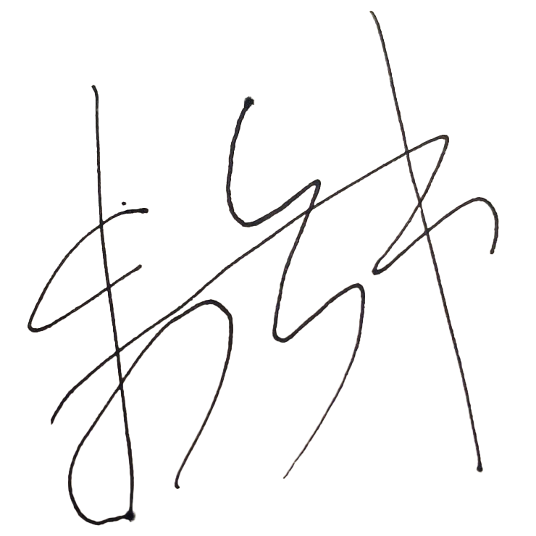
Assessor’s name | Steve Zhu
Date signed | 18/12/2022
END OF ASSESSOR’S CHECKLIST

