CPCCBC6016
Assess construction faults in large building projects

ASSESSMENT SUMMARY

The assessment activities for CPCCBC6016 Assess construction faults in large building projects cover all aspects of the unit of competency. For Apprentices/Trainees, this includes supervisor completion of the Apprentice/Trainee Record (ATR).

Participants must read all the information given before starting any assessment task. The assessment tasks are intended to be fair, flexible, valid and reliable. If a Participant has any questions or requires alternative arrangements to be made such requests should be directed to their Trainer/Assessor, who should note such arrangements in the ‘Assessor Comments’ on the affected assessment. If a Participant feels they are not yet ready to be assessed, they should discuss their options with their Trainer/Assessor.

To satisfactorily complete the assessment, the Participant is required to answer all questions correctly and demonstrate their skills to industry standards. If a Participant does not answer all questions or perform all tasks, they will be deemed ‘Not Satisfactory’ for the task and ‘Not Yet Competent’ for the unit of competency.

The Trainer/Assessor can provide the Participant with additional information on interpreting the assessment outcomes and guide the Participant’s options. If a Participant is still deemed ‘Not Satisfactory’ they will have the opportunity to undertake a supplementary assessment or appeal the result as per the process in the Student Handbook.

By signing below, the Participant acknowledges:
- They understand the assessment instructions and requirements, and consent to being assessed.
- The work submitted is to be their own work – with the work of/with others needing to be clearly acknowledged and documented.
- They consent to any photo/video recording of their work that occurs during assessment.

Participant name | Alan Leededr
Participant signature | 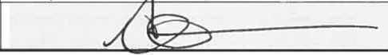

Pre-requisite unit(s) to be achieved and authenticated prior to undertaking assessment
Not applicable

Task | Date completed | Assessment Results
Theory Exam | Select Date. | Satisfactory | Not Satisfactory
Practical Assessment | Select Date. | Satisfactory | Not Satisfactory
Outcome for CPCCBC6016 | Select Date. | Competent | Not Yet Competent

Evidence requirements checklist (ticked by assessor and evidence supplied to RTO)
Theory Exam | Practical Assessment  Rectification report with detailed sketches

Assessor name
Assessor signature | 

CPCCBC6016
Assess construction faults in large building projects

THEORY EXAM

Participant name

FOR THE PARTICIPANT
Instructions
- You will complete written questions as outlined on the following pages. You must attempt all questions and provide enough detail in your responses to demonstrate your knowledge.
- It is anticipated that you should complete this assessment within two (2) hours, but additional time may be allowed upon negotiation with the Assessor.
- You must complete all questions unassisted by the Assessor or other personnel but may refer to reference material as needed. All questions must be answered correctly for a ‘Satisfactory’ assessment outcome to be awarded.
  - An oral examination may be allowed under certain circumstances, whereby your answers will be documented by another party.
  - Any written questions that are incomplete, or not answered satisfactorily will need to be completed again after further training support.
    - If you answer a question incorrectly but modify your response, put your initials next to the written change (or the Assessor must initial a verbal change).
Resources required
Pen

FOR THE ASSESSOR
Instructions
- Where oral examination has occurred, ensure that this is acknowledged in writing (e.g. FT001 and Assessor Comments)
- All questions must be satisfactorily demonstrated by the Participant for a Satisfactory determination (indicated by an Assessor tick to the right of the question).
- Assessors are to complete marking in pen of a different colour to the Participant.
- If the Participant verbally modifies their response, write in the modified response verbatim and put your initials next to the written change.

ASSESSOR COMMENTS
As necessary, outline:
- Details on reattempts, alternative arrangements or reasonable adjustments made.
- Where a Participant is deemed ‘Not Satisfactory’, provide recommendations for future training.

- Explain the purpose of the Building Act 1975.

Answer | 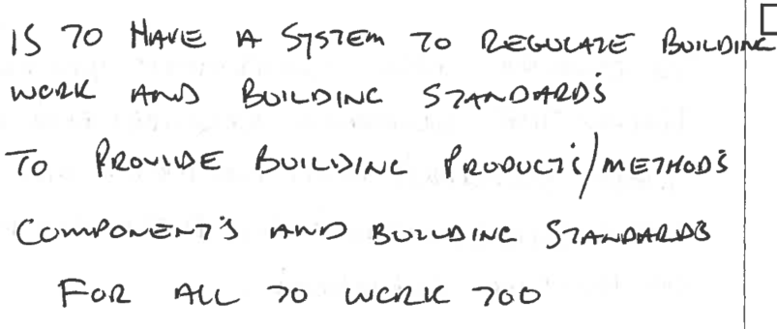

- Explain the purpose of the Plumbing and Drainage Act 2018.

Answer | 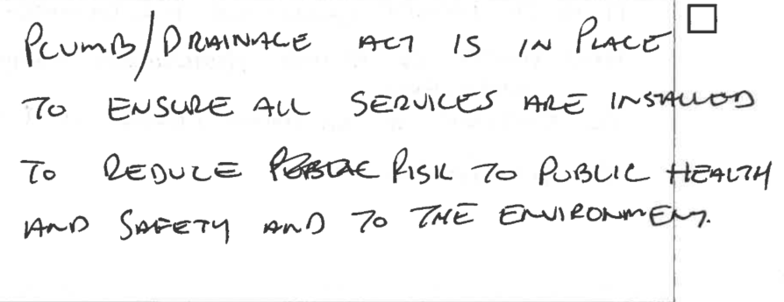

- a) What is the name of the Environmental Protection Act in your State/Territory?
b) What is the purpose of this Act and its regulations?

Answer  a)  b) | 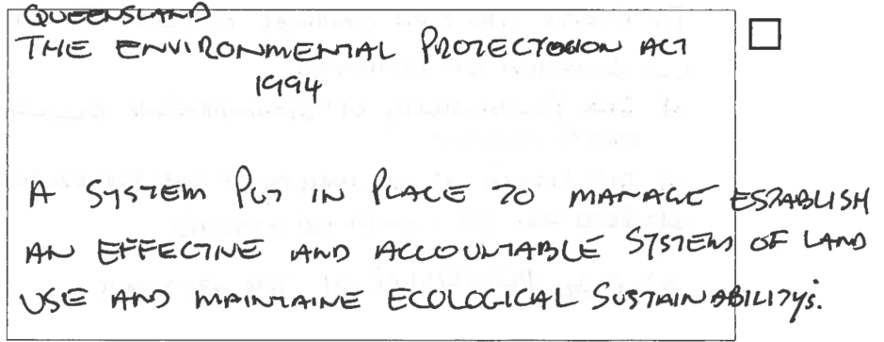

- What are the requirements for compliance and conformance according to National Construction Code (NCC)?

Answer | 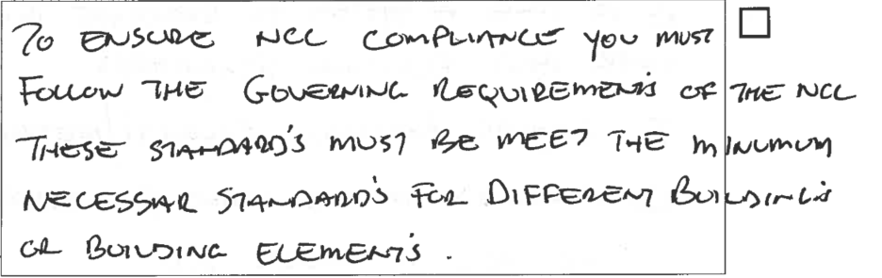

- Discuss the purpose of Work Health and Safety ‘Codes of Practice’.

Answer | 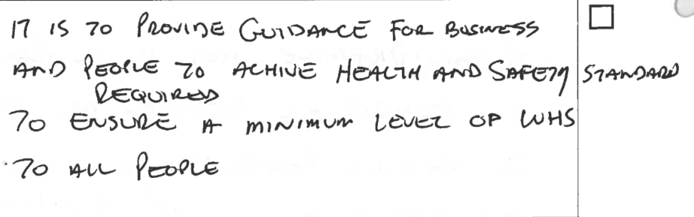

- The National Construction Code (NCC) Volume Two Amendment 1 – Part 3.0 Structural provisions discusses ‘Resistance to actions’. Explain what is stated.

Answer | 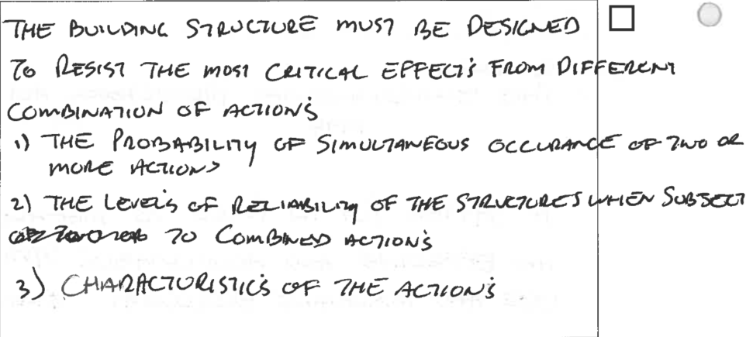

- What is covered in AS/NZS 1170 series?

Answer | 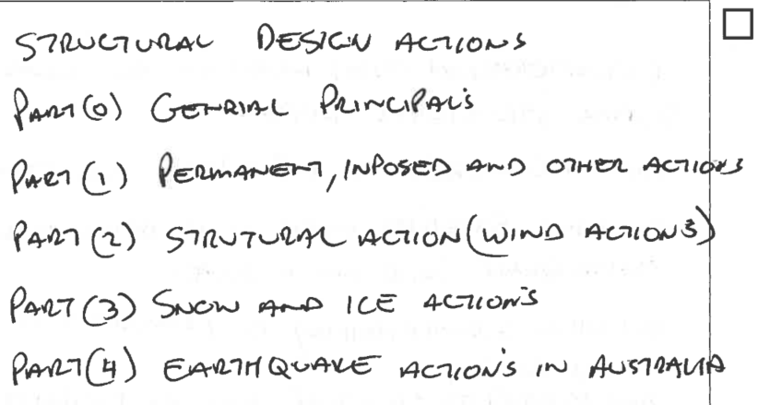

- Explain why you should review project drawings, details and specifications when assessing construction faults in buildings.

Answer | 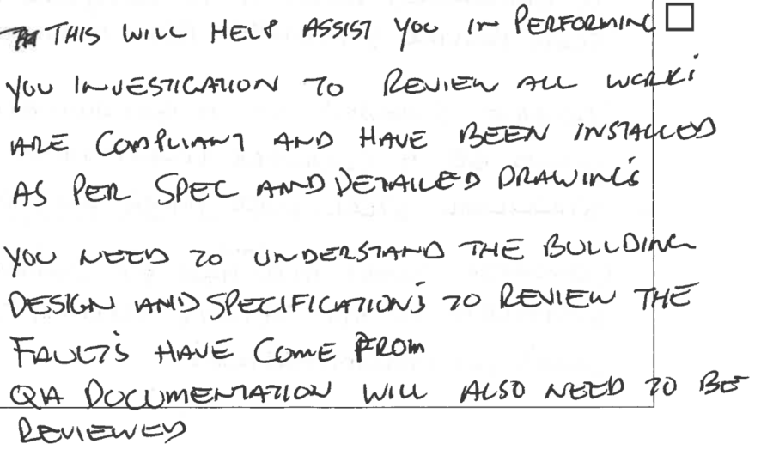

- Discuss the basic principles of structural design that must be considered in any building design.

Answer | 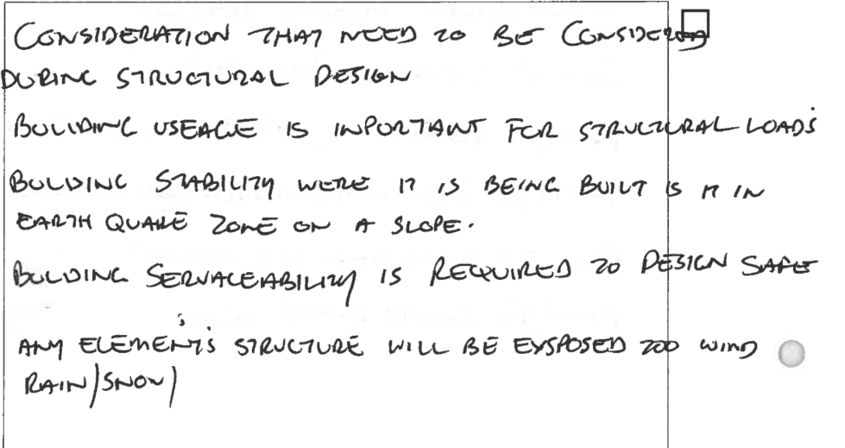

- Discuss compressive and tensile stresses on buildings.

Answer | 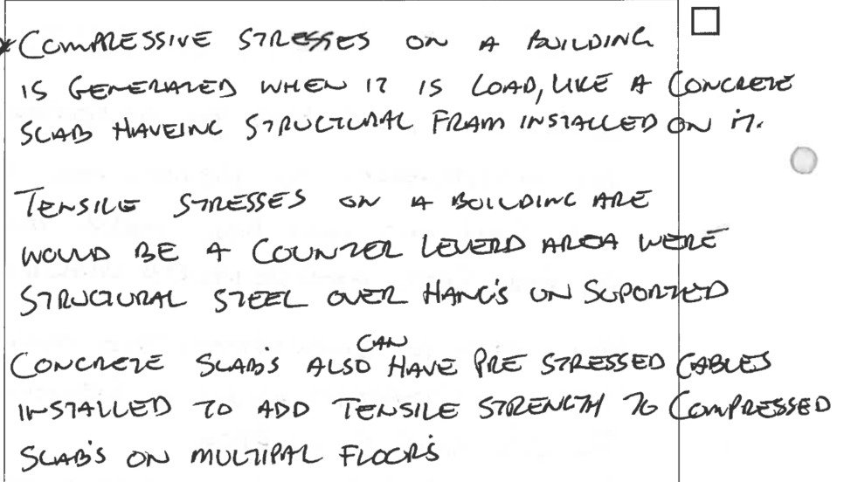

- Discuss the structural significance of building basements in tall buildings.

Answer | 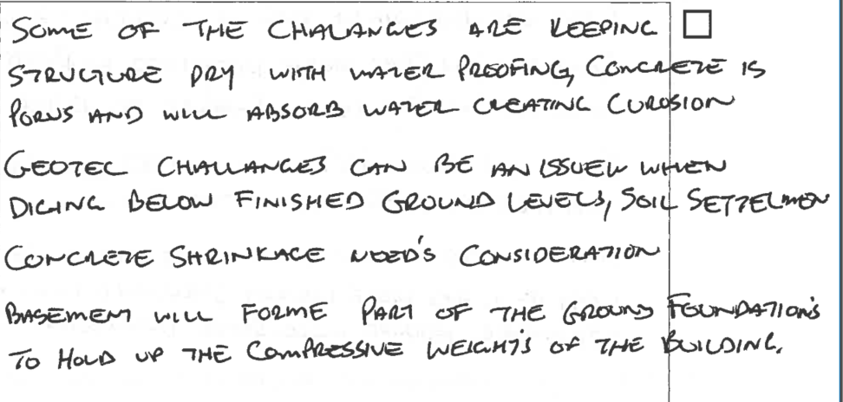

- What is meant by the term the ‘aesthetics’ of a structural design?

Answer | 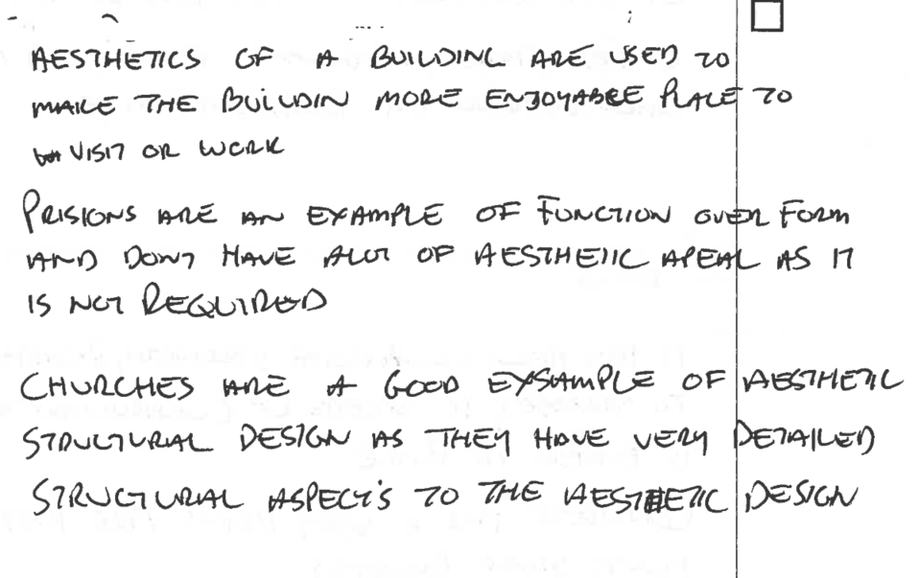

- Explain economic factors and how these affect design.

Answer | 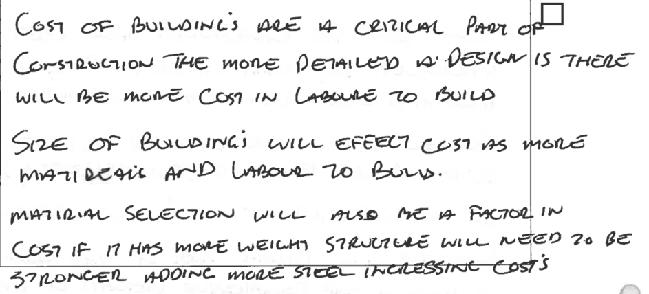

- ‘The function of a structure is to resist forces in equilibrium’ - what does this mean?

Answer | 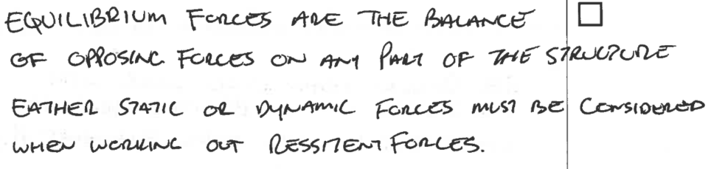

- Why is reinforced concrete commonly used for the construction of high-rise buildings?

Answer | 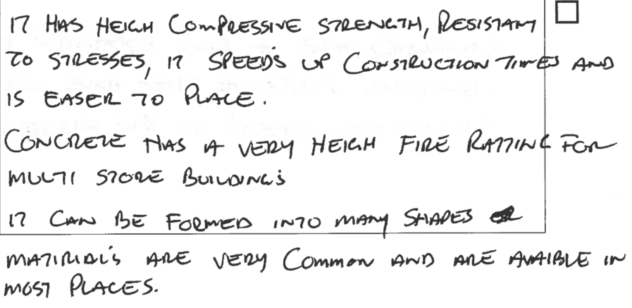

- Discuss why you might need to consult the structural engineer regarding the loads and forces acting on a beam or column.

Answer | 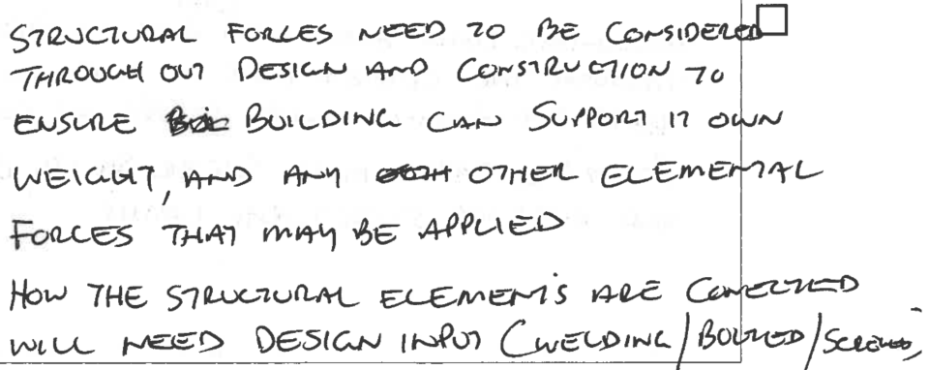

- Determine the bending behaviour of a column under axial load.

Answer | 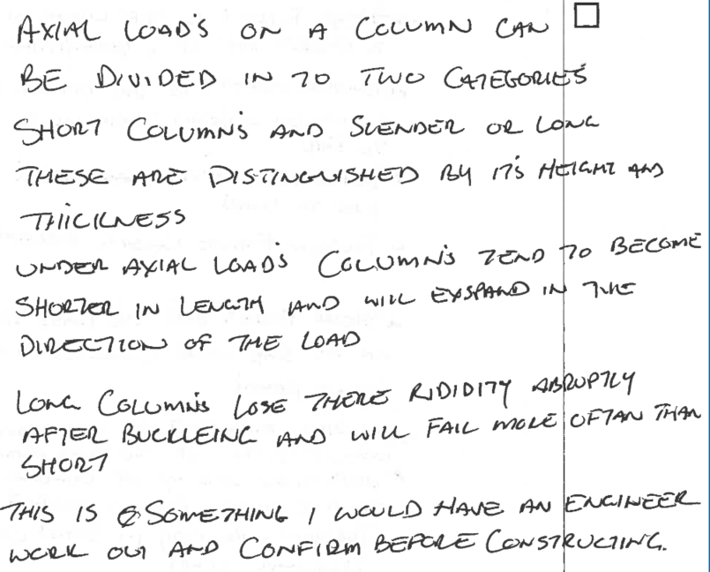

- Describe the performance characteristics of columns under eccentric load.

Answer | 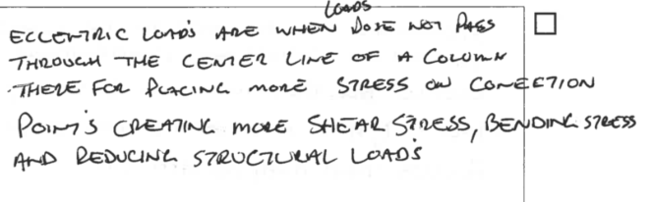

- Discuss bending moments, shear forces, deflection and torsion of beams and slabs.

Answer | Beams/Slabs | Response
 | Beams | 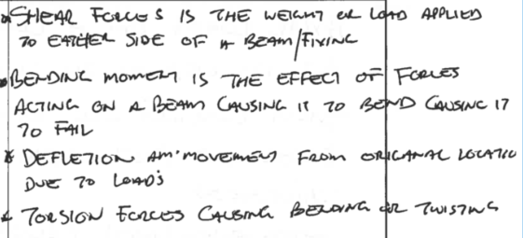
 | Slabs | 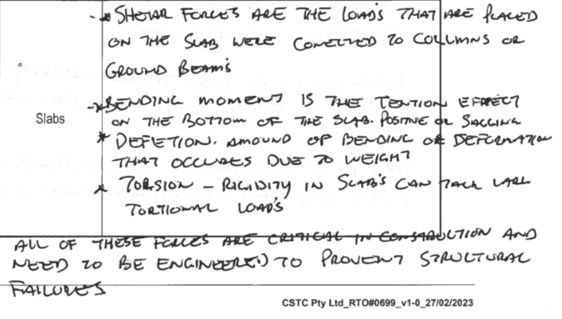

- Discuss how beams are connected to columns. Explain your answer.

Answer | 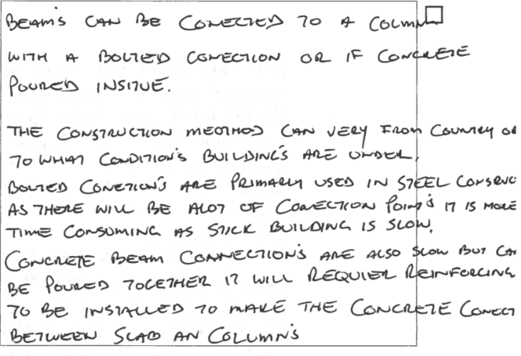

- Describe the slenderness ratio and its effect on columns.

Answer | 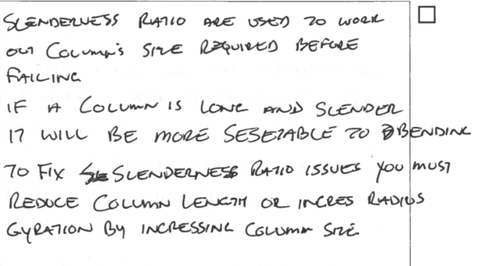

- Discuss the characteristics of dead loads and live loads. Include how each is calculated.

Answer | Load | Characteristics and calculations
 | Dead load | 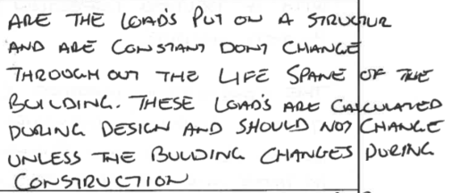
 | Live load | 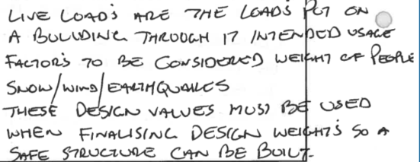

- What is the advantage of using composite floor systems consisting of steel beams, profiled metal decking, and reinforced concrete slabs?

Answer | 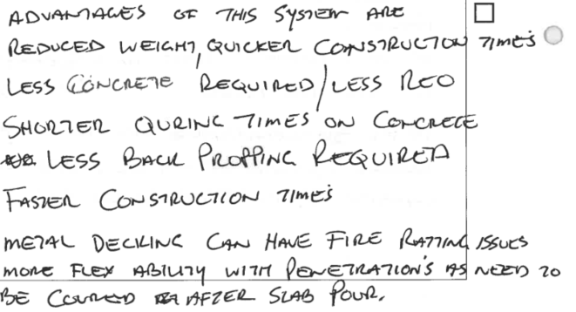

- Discuss the characteristics of the following high performance structural elements.

Answer | Structural element | Characteristics
 | Castellated beams | 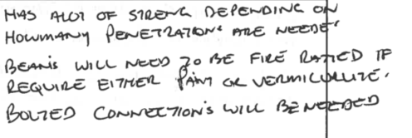
 | Laminated beams | 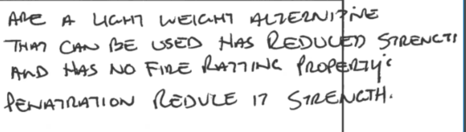
 | Pre-stressed concrete beams | 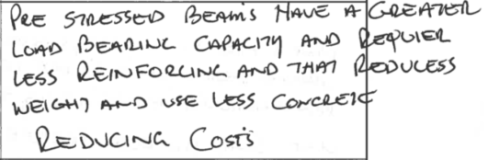
 | Trusses | 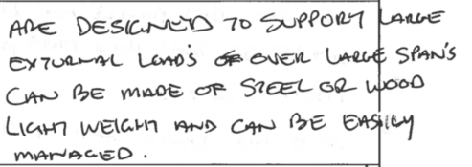
 | Waffle slabs | 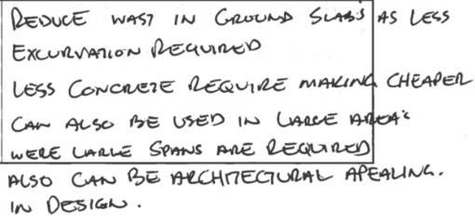

- How does thermal impact affect a load on structure?

Answer | 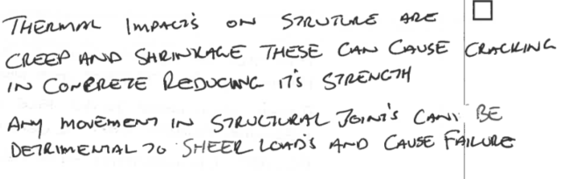

- Describe the process associated with fabricating and installing tilt-up concrete panels.

Answer | 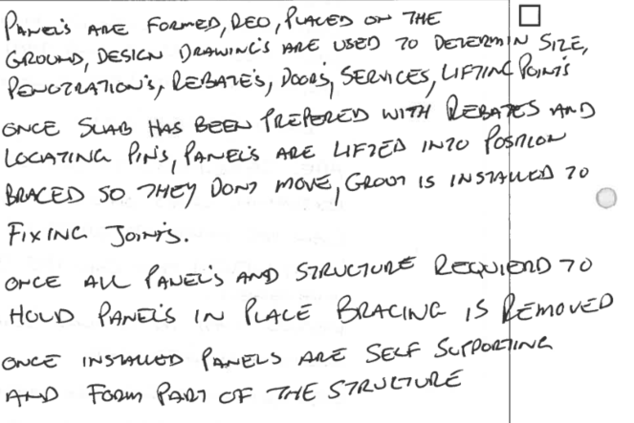

- What are the impacts of creep and shrinkage on concrete structures?

Answer | 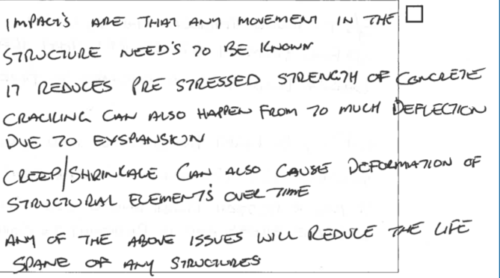

- Discuss considerations that must be made when using masonry in the construction of high-rise buildings.

Answer | 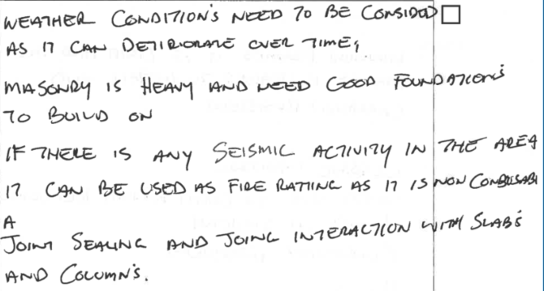

- Explain the differences between structural steel and cold-formed steel.

Answer | 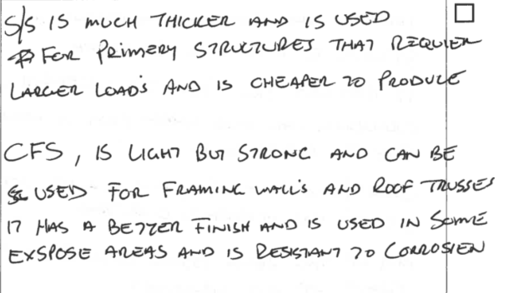

- Discuss three (3) uses of aluminium in the construction industry and why it is used.

Answer  1.  2.  3. | 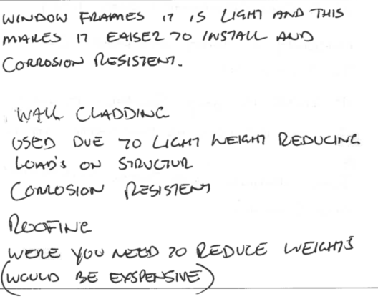

- Briefly discuss the use of the following temporary structures and components in the construction of large and complex buildings.

Answer | Temporary structure | Use
 | Bracing | 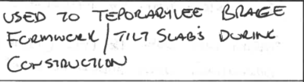
 | Closed Sheeting | 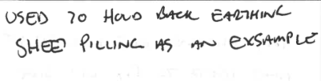
 | Formwork props | 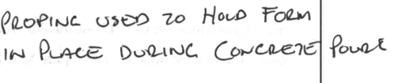
 | Pressure resistant formwork | 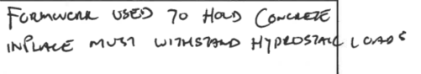
 | Scaffolding sole plates | 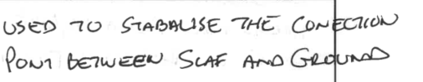
 | Shields | 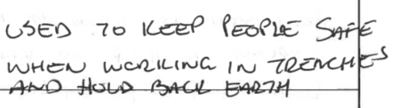
 | Shoring collar set | 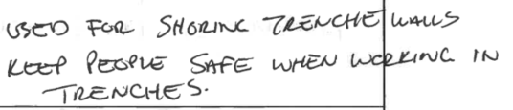
 | Soldier set | 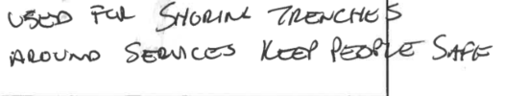

- How do you determine which document to use when communicating construction problems to relevant personnel?

Answer | 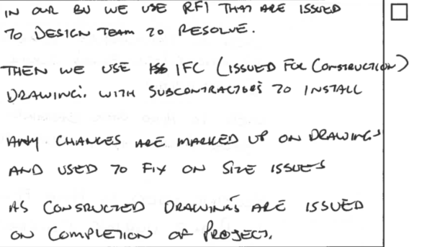

- You are contracted to undertake refurbishment of an inner-city hotel. Explain how this is different from a restoration or renovation.

Answer | 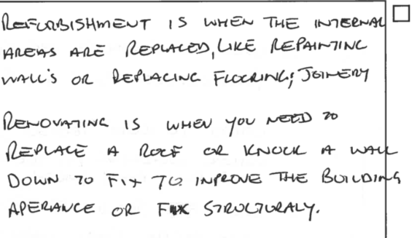

- Discuss why you might suggest refurbishing using fire-resistant building materials where possible.

Answer | 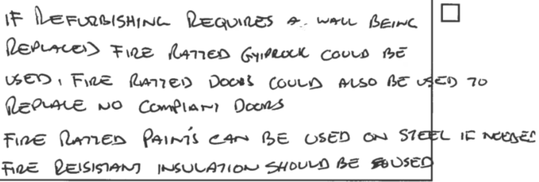

- Complete the table below by identifying the type of fire-resisting construction (i.e. Type A, Type B, or Type C) given the following class of building and number of storeys each class of building has.

Answer | Rise in Storeys | Class of building:  2,3,9 | Class of building:  5,6,7,8
 | 4 or more | A | A
 | 3 | A | B
 | 2 | B | C
 | 1 | C | C

- Describe how you would monitor alternative forms of construction to ensure compliance.

Answer | 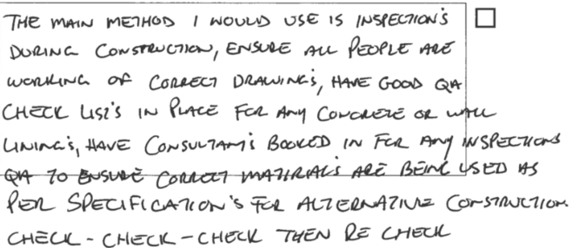

CPCCBC6016
Assess construction faults in large building projects

PRACTICAL ASSESSMENT

Participant name | Alan Leeder

FOR THE PARTICIPANT
Instructions
- The tasks outlined on the following pages will require performance of normal workplace activities, as a result of a structured activity set by an Observer in the workplace or a simulated activity set by your Assessor/Observer.
- The timeframe for these tasks will be established by your Assessor/Observer, in consideration of location conditions and industry requirements.
- You must complete all tasks unassisted by the Assessor or other personnel, unless the steps note this assistance.
- You must attempt all tasks (and itemised steps) for a ‘Satisfactory’ assessment outcome to be awarded.
  - For any observation conducted that is incomplete, or without satisfactory performance, the observation will need to be completed again after further training support.

FOR THE ASSESSOR/OBSERVER
Instructions
- The following observation record should be used to judge and record your observations of the Participant as they complete the task(s) set. You must record your observations of the Participant’s performance.
  - For each occasion, indicate the task performed and whether it was a simulation or workplace-based task.
    - Any simulated assessment must ensure the Participant still performs under workplace conditions which reflect industry standards.
  - In the comments, provide clear detail regarding the task that the Participant was required to do (e.g. PPE used, materials handled, attachments connected, plant types).
- All steps must be satisfactorily demonstrated by the Participant for a ‘Satisfactory’ determination (indicated by an Assessor tick to the right of each itemised step, or an Observer tick to the right of each itemised step, and confirmation by an Assessor in the Assessor Comments).
  - Where you have determined that one or more task steps have not been satisfactorily demonstrated, provide the Participant with additional support and outline details of such assistance in the Assessor/Observer Comments. Allow the Participant two (2) further opportunities to demonstrate the task again to allow an opportunity for a ‘Satisfactory’ assessment outcome to be achieved.
  - If after three (3) attempts the Assessor determines that the Participant cannot demonstrate the required steps, a ‘Not Satisfactory’ outcome is to be determined.

TASK OUTCOME
Task | Date | Task Type (Tick) | Location | Task outcome (Tick)
 |  |  |  | Satisfactory | Not Satisfactory
Task 1 | 7/08/2024 | Workplace  Simulation

ASSESSOR COMMENTS: GENERAL
As necessary, outline:
- Details on reattempts, alternative arrangements or reasonable adjustments made.
- Where a Participant is deemed ‘Not Satisfactory’, provide recommendations for future training.

ASSESSOR COMMENTS: PRACTICAL TASK 1
Individual student (as named on cover page)
Multiple students [ All from Attendance Report, Specific students involved – identify students]
Task | Provide detail
1.1A. | Specify specific construction fault/s on Type A building requiring rectification.  Concrete reinforcing incorrectly installed and concrete quality of finishes
1.1A. | Specify () construction faults associated with two (2) of:  Structural Installation Refurbishment Renovation Restoration  Other (please specify): Shrinkage with concrete, and incorrect penetration installation into slabs before pouring
1.1C. 1.1D. 1.5A. 1.5B. | Specify workplace practices adhered to when documenting and communicating construction problems to relevant personnel and external professionals.  Pre pour inspections form structural engineer, QA documentation , RFI issued for problem resolution
1.1E. | Specify problem-solving techniques applied:  RFI issued for ground conditions and how to achieve competition due to poor ground conditions and weather
1.2A. | Specify existing or designed-in construction common/ not common problems identified.  None Other (please specify): Fire ratting issued due to incorrect penetration sizes, no flammable materials to not be used
1.2B. | Specify alternative methods or materials suggested.  Precast panels used for structure instead of block work, saved time and money
1.2C. | Specify equipment and programs accessed to extract information:  ACONX document controlled system for access in drawing on our project
1.4C. 1.5C. | Specify how alternative method of construction will be managed and monitored.  Alternat method issued to consultants for approval and them recasting if applicable was completed, new drawing issued and then completed

CPCCBC6016
Assess construction faults in large building projects

Practical Task 1
Description of task:
The participant must demonstrate the skills and ability to assess construction faults and determine remedial action for construction faults associated with at least two (2) of the following: structural; installation; refurbishment; renovation or restoration on a Type A building project. The assessor will be seeking evidence of:
- Identify and analyse construction faults.
  - Collect information relating to specific construction faults.
  - Analyse original construction project plans and specifications to identify potential causes of construction faults or problems. Use problem-solving techniques to identify typical faults and problems.
  - Adhere to workplace practices when documenting and communicating construction problems to relevant personnel.
  - Make contact with project team members and external professionals to elicit expert analysis and opinions.
  - Use problem-solving techniques to identify typical faults and problems.
  - Develop and document a rectification action that meets the Performance Requirements of the National Construction Code (NCC).
- Analyse construction techniques, methods and materials.
  - Analyse working drawings and specifications to identify any existing or designed-in construction problems.
  - Prepare alternative methods and materials to meet the project specification objectives and comply with the NCC and relevant building legislation.
  - Use equipment and programs to access, extract information and develop relevant documentation.
  - Use building terminology accurately in the communication of issues.
- Evaluate alternative construction solutions.
  - Consider and analyse commonly occurring on-site problems with building materials and their causes.
  - Prepare reports identifying available alternative methods and materials available to meet the construction aims and objectives of the specifications.
  - Prepare detailed sketches of available alternative methods and materials that meet the construction aims and objectives of the specification.
- Resolve construction faults using alternative construction methods.
  - Consider and document solutions and recommend suitable alternative methods to resolve the problem and meet project aims and objectives and organisational processes.
  - Integrate selected methods into the project construction works to align with construction schedules and timeframes.
  - Manage and monitor alternative forms of construction to ensure compliance.
- Communicate preferred solution to construction problem.
  - Use digital tools to document technical resolution in detail of identified problem.
  - Lodge appropriate documentation and communicate with appropriate project and other construction professionals.
  - Determine and implement strategies to monitor corrective action processes and procedures.

These tasks may be simulated or real. The Participant is to gather evidence of how they have completed each component of the Practical Task, which is to be submitted with this Practical Assessment sheet. The Observer is to provide detailed comments on the tasks completed by the Participant (on the Observer Comments, overleaf). The Assessor is to verify the Observer’s comments, noting their findings in the Assessor Comments (on the back of the Practical Assessment cover page) and provide the assessment outcome.
Resources required:
Type A building project; access to equipment, technology and software to assess and remediate construction faults in large building projects and collaborate effectively with external professionals; access to relevant government building legislation codes and standards; access to environmental and sustainability requirements; access to manufacturer specifications and installation instructions; workplace policies, procedures and site safety requirements; project plans and specifications.
Observer details
Name of observer: | Aidan Ahearn
Role of observer  (Confirm suitability to sign) | Medium Rise Builder / site supervisor commercial construction
Email address of observer | Aidan107@hotmail.com
Signature of observer: | 
Date: | Select Date.

When completing the task, did the Participant: | Tick if satisfactorily completed.  Provide comments if left unticked.
1 Identify and analyse construction faults.
- Collect information relating to specific construction faults.
- Analyse original construction project plans and specifications to identify potential causes of construction faults or problems. Use problem-solving techniques to identify typical faults and problems.
- Adhere to workplace practices when documenting and communicating construction problems to relevant personnel.
- Make contact with project team members and external professionals to elicit expert analysis and opinions.
- Use problem-solving techniques to identify typical faults and problems.
- Develop and document a rectification action that meets the Performance Requirements of the National Construction Code (NCC).(attach rectification request/ report)
2. Analyse construction techniques, methods and materials.
- Analyse working drawings and specifications to identify any existing or designed-in construction problems.
- Prepare alternative methods and materials to meet the project specification objectives and comply with the NCC and relevant building legislation.
- Use equipm ent and programs to access, extract information and develop relevant documentation.
- Use building terminology accurately in the communication of issues.
3. Evaluate alternative construction solutions.
- Consider and analyse commonly occurring on-site problems with building materials and their causes.
- Prepare reports identifying available alternative methods and materials available to meet the construction schedule and objectives of the specifications.(attach report/s)
- Prepare detailed sketches of available alternative methods and materials that meet the construction aims and objectives of the specification. ).(attach detailed sketches)
4. Resolve construction faults using alternative construction methods
- Consider and document solutions and recommend suitable alternative methods to resolve the problem and meet project aims and objectives and organisational processes. (attach report/s)
- Integrate selected methods into the project construction works to align with construction schedules and timeframes.
- Manage and monitor alternative forms of construction to ensure compliance.
5. Communicate preferred solution to construction problem.
- Use digital tools to document technical resolution in detail of identified problem.
- Lodge appropriate documentation and communicate with appropriate project and other construction professionals.
- Determine and implement strategies to monitor corrective action processes and procedures.

Observer comments:
Defect rectification Atherton Hospital slab

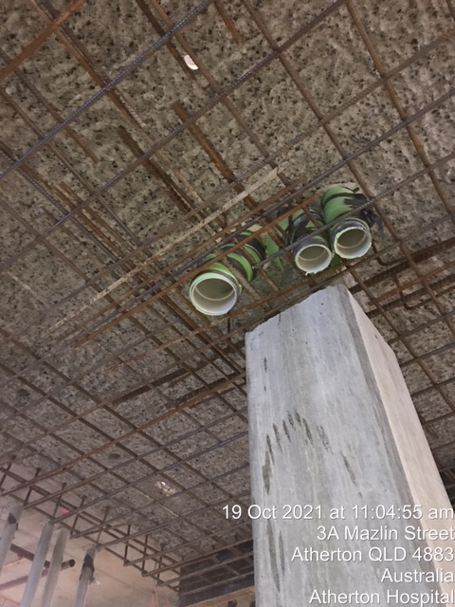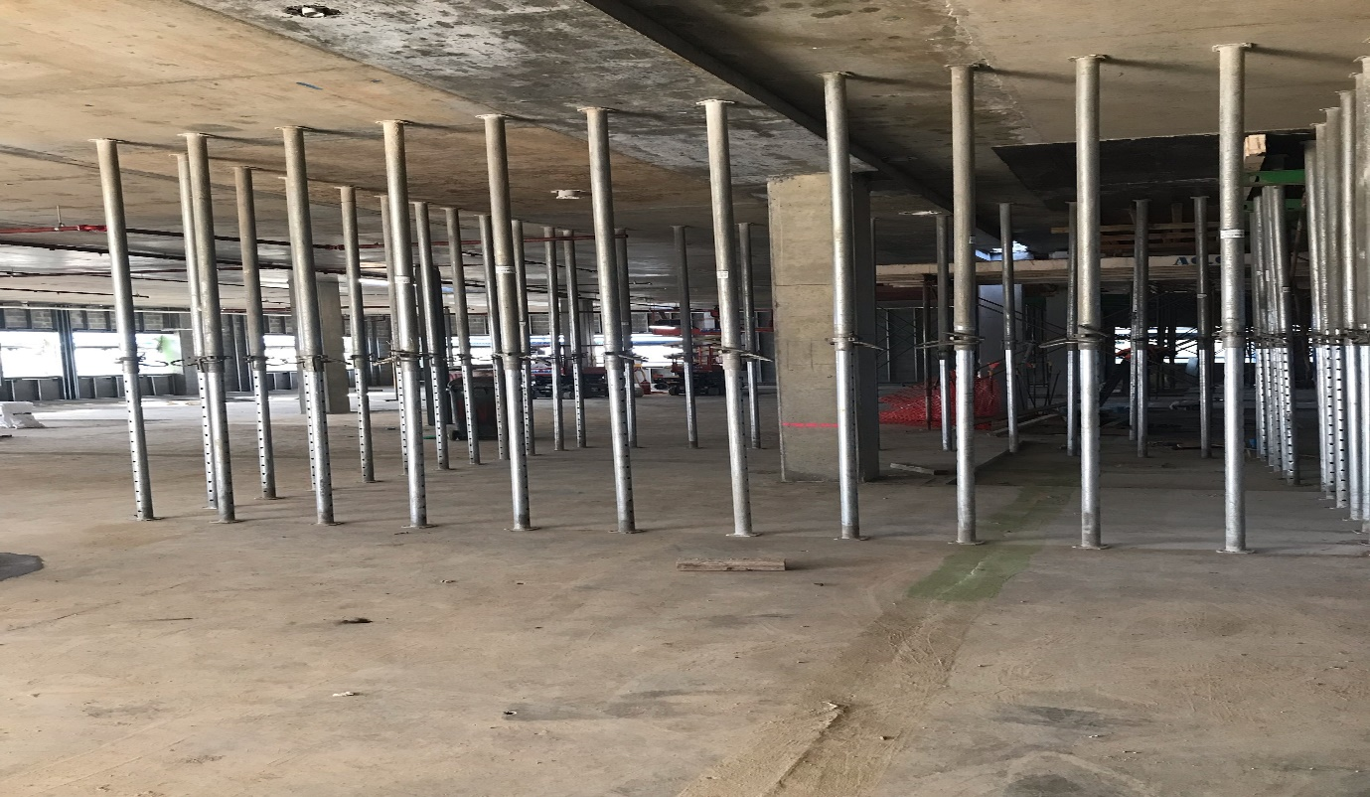

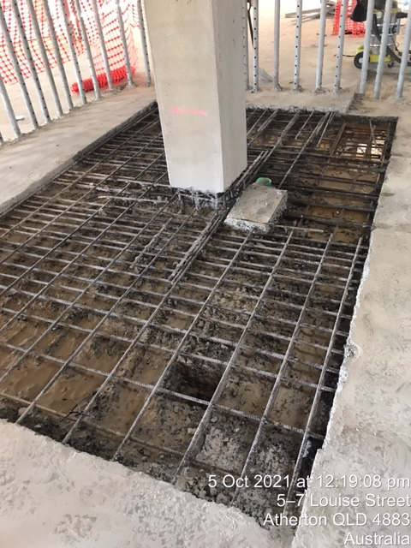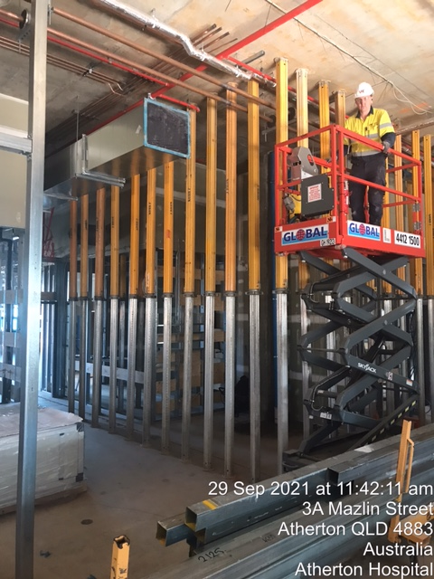
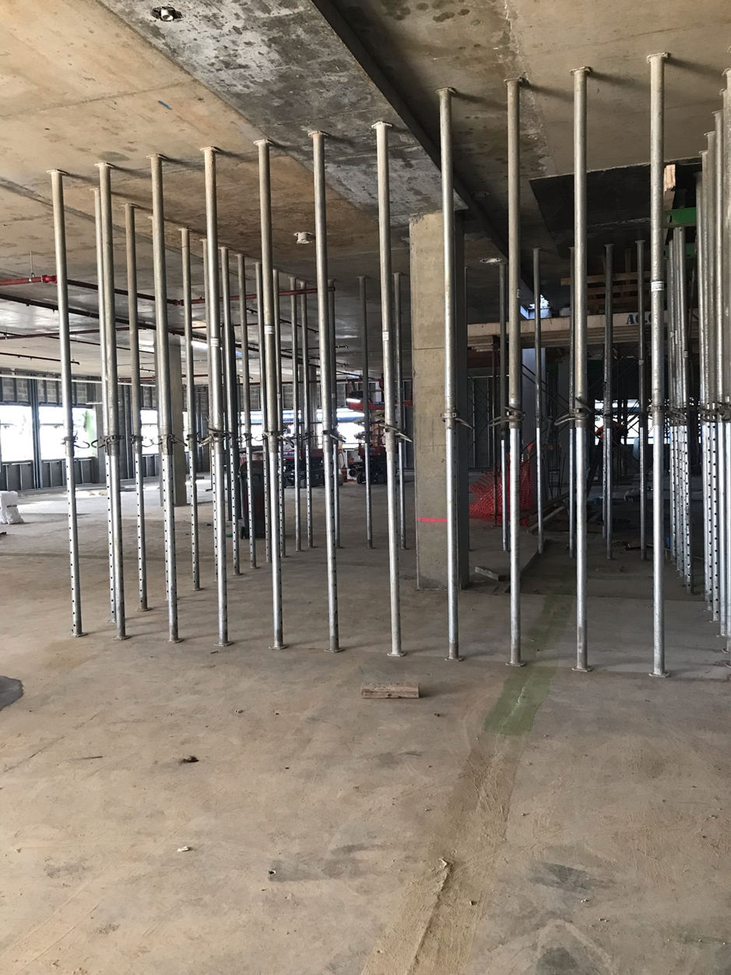

Design Changes HMAS Cairns

