
AHCLSC302
Construct landscape features using concrete

Copyright © 2020 CSTC Pty Ltd

All rights reserved. No part of the contents of this publication may be reproduced or used in any form or by any means – graphic, electronic, or mechanical including photocopying, digitising, recording, or information storage-and-retrieval systems – without the written permission of CSTC Pty Ltd.
ASSESSMENT FOR AHCLSC302

Student name | Jack Schaffer
Date of assessment submission | Click here to enter a date.

Trainer/Assessor’s name
Date of assessment marking | Click here to enter a date.
Outcome for unit | ☐ Competent  ☒ Not Yet Competent

TASK INSTRUCTIONS

- As part of the assessment for this unit of competency, you are required to complete a series of activities.
  - Some of these activities will require you to provide a response within this document, others will require you to gather evidence to demonstrate your knowledge and skills.
- At all times, the responses in your assessment must reference Australian (Queensland or Federal) documentation, including legislation, regulations, codes of practice, standards and guidance publications.

ACTIVITIES

Identify/list the scope of the work to be carried out from the concept plan shown.

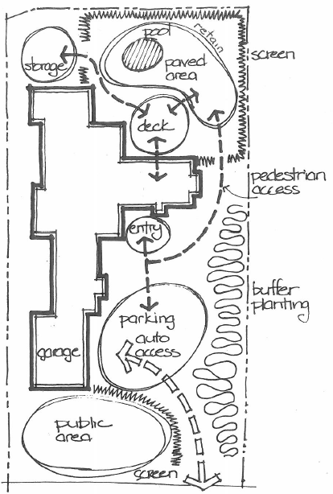

Response
A screen planted out the front for privacy to public area. Get more details on public area requirements eg lawn/paving. Plant buffer zone on the right hand side of the house. Build retaining wall to retain back right corner near pool. Screen back area around the pool

Outcome for Activity 1 | ☐ Satisfactory  ☐ Not satisfactory
Trainer/Assessor comments

Identify/list the detail on the landscape plan shown.

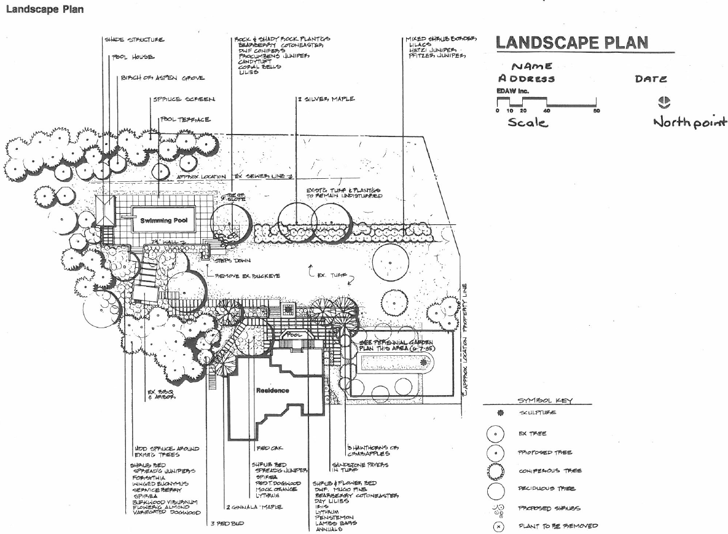

Response
Shade structure pool house, burch/aspen grove/ spruce screen, pool terrace, rock and shady rock planters, mixed shrub border, property line, sewer line, perennial garden, existing turf and plantings, steps, swimming pool , pool, sandstone pavers in turf, existing BBQ and arbor,

Outcome for Activity 2 | ☐ Satisfactory  ☐ Not satisfactory
Trainer/Assessor comments

List the materials required to complete the water feature, by using the wall and water feature construction plan shown.

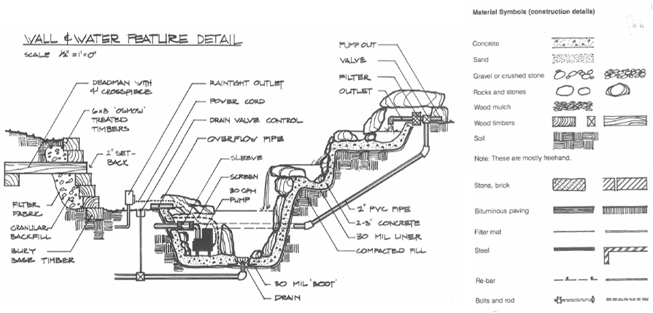

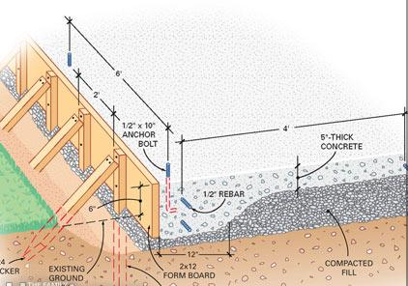

Response
Pump out, valve, filter, outlet, 2 inch pvc pipe, concrete, 30mm liner, fill, 30mm boot, drain, power cord, raintight outlet, drain valve control, overflow pipe, sleeve, screen, 30GPH pump.

Outcome for Activity 3 | ☐ Satisfactory  ☐ Not satisfactory
Trainer/Assessor comments

Research and list relevant laws and standards relating to concreting works
(e.g. Building Codes, Australian Standards, Codes of Practice)

 | Name of document
- Laws | Work Health and Safety Act 2011 (Qld)  Work Health and Safety Regulation 2011 (Qld)  QLD Building ACT 1975  QLD Building Regulation 2006
- Standards | Australian Standard AS 3600:2018 CONCRETE STRUCTURES  Australian Standard AS 3600 :2018 Amd1:2018 CONCRETE STRUCTURES
- Codes | Qld Development Code  Building Code of Australia  National code of practise for precast, tilt up and concrete elements in building construction

Outcome for Activity 4 | ☐ Satisfactory  ☐ Not satisfactory
Trainer/Assessor comments

List the components for four (4) common surface drainage systems used in landscape construction.

System | Components
- Spoon | Spoon drains are shallow channels that are usually made from concrete and can be installed around the garden to redirect this excess water to other parts of the garden or to inlets for subsoil drainage systems.
- Channel and grate | The channel and grate drain system is used near the edge of houses or at the bottom of steep driveways to collect a large flow of water. The channel is set in concrete and the water will fall into the grate.  The drain consists of a horizontal trench that is open on top; the trench grate covers the top of the trench and allows water to flow into the drain along its entire length.
- Pit | A pit may be placed in the low point of a yard so that the water falls into the pit and goes into the drainage and out of the yard.  A stormwater pit is a water collection pit or storage container for stormwater that holds all the runoff before it drains away through the connected drainage pipes.Stormwater pits are made of pre-cast concrete with a number of outlets for drainage pipes.
- Contour | Contour banks are surveyed using a slight fall to ensure that water does not pond behind the bank, but runs to a waterway without scouring the bank channel itself. The length and spacing of banks are designed to suit the slopes and soil types.

Outcome for Activity 5 | ☐ Satisfactory  ☐ Not satisfactory
Trainer/Assessor comments

List the advantages and disadvantages of drainage behind and through the build wall (as shown).

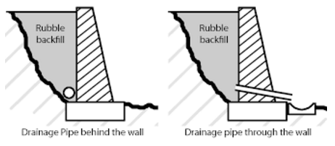

Drainage pipe behind the wall
Advantages
It looks better than having pipe sticking out of the front of the wall.
Disadvantages
It may not drain as well as the pipe through the wall because there is usually one or limited outlets.

Drainage pipe through the wall
Advantages
Better drainage for the water to get out from behind the wall, can have multiple outlets if wanted.
Disadvantages
It doesn’t look nice with a pipe or conduit coming out of the wall.

Outcome for Activity 6 | ☐ Satisfactory  ☐ Not satisfactory
Trainer/Assessor comments

Explain the purpose of a cone test. Describe the process of how such a test is conducted.

Response
The slump test is done to make sure a concrete mix is consistent and workable. The measured slump must be within a set range, or tolerance, from the specified slump. The slump testing procedure consists of filling the slump cone in layers, compacting each layer with rodding, then taking away the slump cone and measuring the vertical drop of the concrete after it is no longer confined.

Outcome for Activity 7 | ☐ Satisfactory  ☐ Not satisfactory
Trainer/Assessor comments

Research and list a range of curing compounds and the advantages of using each type

Curing compound | Advantages
- Synthetic resin compound  - PVA Based concrete curing compound | Synthetic resins will seal the concrete by forming membrane. If you want to plaster over the concrete, the membrane can be removed by washing it with hot water.  PVA based compounds form a temporary film over the surface. They will naturally begin oxidising after 6 – 7 days and will leave the surface after 28 days, allowing after-trades to be applied. If you want to effectively cure the concrete and prevent shrinkage cracking, a PVA based compound, is a good choice.
- Acrylic Concrete curing compounds | Acrylic compounds are applied in much the same way as other compounds,however, they will leave a permanent film on the surface..If after-trades are required, such as floor coverings, the acrylic film will need to be removed from the surface to ensure correct adhesion. This can be achieved by mechanical means (e.g. grinding).
- Hydrocarbon concrete curing compounds | Hydrocarbon compounds will break down and leave the surface, allowing after trades to be easily applied.
- Chlorinated rubber compound | Chlorinated rubber type curing compound will form a thick layer when applied. It seals the concrete tightly and also fills the small pores in the concrete. But the film cannot stay for longer periods, it will wear out in the long run.

Outcome for Activity 8 | ☐ Satisfactory  ☐ Not satisfactory
Trainer/Assessor comments

List environmentally safe products for cleaning.

Response
- Products that are Biodegradable, Phosphate-free, Chlorine-free, Bleach-free, Non-toxic
Water-only cleaning can be very effective in applications that do not have oil residues or deeply ingrained/ infused stains.
High-pressure washing -gerni
Ecoclean - Heavy Duty Detergent Sanitiser is a heavy duty detergent with disinfectant and natural citrus solvents. Used for cleaning and degreasing.
Citrus Resources natural solvents are an alternative to strong petroleum, chlorinated or glycol ether solvents commonly used for heavy duty cleaning and degreasing. Can be used on machinery, and to remove graffiti from solvent-resistant hard surfaces.

Outcome for Activity 9 | ☐ Satisfactory  ☐ Not satisfactory
Trainer/Assessor comments

Have team members take photos and videos of your involvement with concrete features.

Identify each photo / video with a letter label and describe each photo / video in the table below. Submit the photo / video files along with this workbook.

Advantages
A
B
C
D
E
F
G
H
I
J
K
L
M
N
O
P
Q
R
S
T
U
V
W
X
Y
Z

Outcome for Activity 10 | ☐ Satisfactory  ☐ Not satisfactory
Trainer/Assessor comments

