
AHCLSC302
Construct landscape features using concrete

Copyright © 2020 CSTC Pty Ltd

All rights reserved. No part of the contents of this publication may be reproduced or used in any form or by any means – graphic, electronic, or mechanical including photocopying, digitising, recording, or information storage-and-retrieval systems – without the written permission of CSTC Pty Ltd.
ASSESSMENT FOR AHCLSC302

Student name | Aimee Hofstede
Date of assessment submission | 1/02/2020

Trainer/Assessor’s name
Date of assessment marking | Click here to enter a date.
Outcome for unit | ☐ Competent  ☐ Not Yet Competent

TASK INSTRUCTIONS

- As part of the assessment for this unit of competency, you are required to complete a series of activities.
  - Some of these activities will require you to provide a response within this document, others will require you to gather evidence to demonstrate your knowledge and skills.
- At all times, the responses in your assessment must reference Australian (Queensland or Federal) documentation, including legislation, regulations, codes of practice, standards and guidance publications.

ACTIVITIES

Identify/list the scope of the work to be carried out from the concept plan shown.

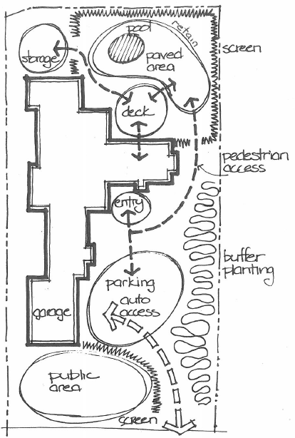

Response
Activity 1.
List-
- Study the concept plan, measure the site, check for boundaries and services to check if the concept is perceivable for the area in mind.
- The design has many individual areas to look at regarding materials, break these down into sections as follows-
- Public grassed/ or paved area with edging and a screen that could be purchased prefabricated and ready to concrete in place or a mass hedging plant could be used as an alternative.
- The parking area for cars constructed of a concrete or paved driveway with parking in front of the garage.
- A paved or concrete area at the entry of the home.
- The buffering planting to line the right fence with turf to be laid surrounding this area.
- A concrete or paved path joining the entry, pool and deck to the storage shed.
- A deck constructed between the house and pool area with timber or concrete for entertaining.
- The pool area with pool, paved deck, pool fencing and a retaining wall into the back garden which will be screened with a screening plant surrounding the exterior.
Please allow for footings, form work and the necessary equipment to concrete, building equipment including power tools and landscape equipment for the gardens etc.

Outcome for Activity 1 | ☐ Satisfactory  ☐ Not satisfactory
Trainer/Assessor comments

Identify/list the detail on the landscape plan shown.

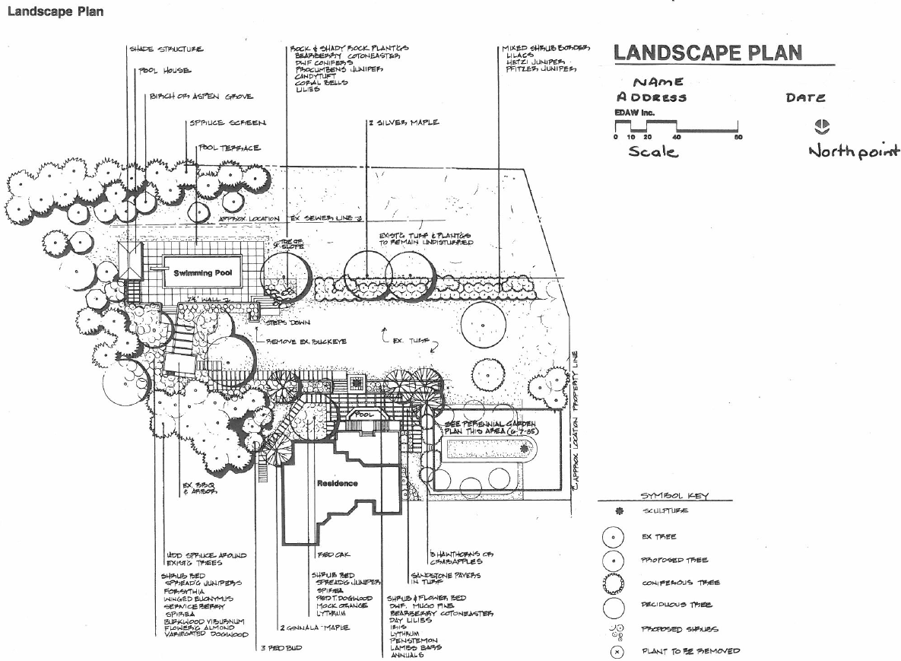

Response
List-
- Shade structure in the pool area next to the pool house for storage.
- Sporadic planting of Birch or Aspen grove to be added to existing trees.
- Swimming pool with Spruce screen added to the west of the terrace
- Steps down into the pool area with a garden under the tree (can’t read the name) to be made up of rock and shady plants. See attached plan for the plant list.
- Remove the buckeye from the existing garden area.
- Rock wall to the east of the pool which looks onto the BBQ above.
- Use of existing BBQ and --------.
- Wood spruce surrounding the BBQ and the shrub garden toward the pool house, making use of existing trees and added new additions.
- New planting surrounding the Oak, Maple and (Red Bud?)
- Silver maples to be planted with mixed shrubs. (see attached list on plan) with the area to use the pre-existing turf and plants are to remain.
- Through the middle the turf will remain with the existing trees as per plan and along the boundary.
- See Perennial garden plan for the garden area at the north east of the site.
- Sandstone pavers and turf to link the Perennial garden to the firepit area making use of the trees available and adding the shrubs as required for the fire pit area.
- Take note of the sewer line please and the boundary markings.

Outcome for Activity 2 | ☐ Satisfactory  ☐ Not satisfactory
Trainer/Assessor comments

List the materials required to complete the water feature, by using the wall and water feature construction plan shown.

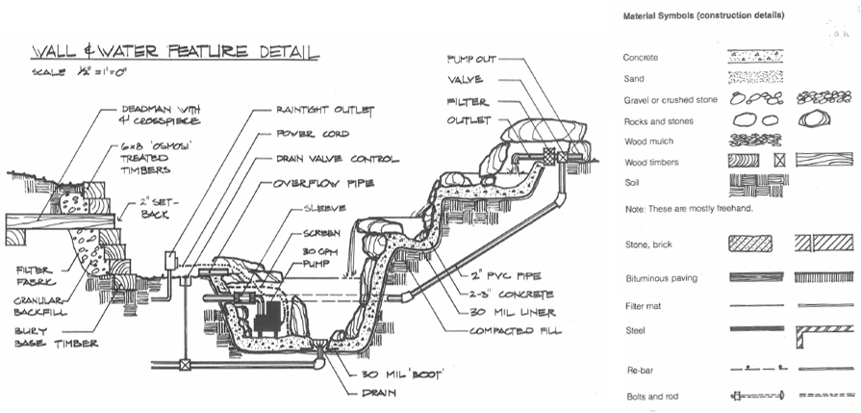

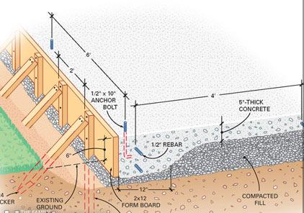

Response
Material List-

- Concrete
- Sand
- Gravel or crushed stone
- Rocks and stones
- Wood mulch
- Wood timber including 6x8 ‘Osmosi’ Treated timber, ‘deadman’ with 4” crosspiece
- Stone, brick
- Butminous paving
- Filter mat, fibre fabric
- Steel
- Re bar
- Bolts and rod
- Compact fill
- Raintight outlet
- Power cord
- Drain valve control
- Overflow piper
- Sleeve
- Screen
- 30 rpm pump
- 30 mm Boot
- Drain
- 2” PVC pipe
- Valve
- Filter
- Outlet

Outcome for Activity 3 | ☐ Satisfactory  ☐ Not satisfactory
Trainer/Assessor comments

Research and list relevant laws and standards relating to concreting works
(e.g. Building Codes, Australian Standards, Codes of Practice)

 | Name of document
- Laws | Mining and Quarrying safety and health act 1999  Work, Health and safety Act 2011
- Standards | The concrete pumping code of practice 2019  Standards and Tolerance guides QBCC
- Codes | - The concrete pumping code of practice 2005, 2019  - Code of Practice Concreting Masonry cutting and drilling 2019  - Work Health and Safety Regulation 2011

Outcome for Activity 4 | ☐ Satisfactory  ☐ Not satisfactory
Trainer/Assessor comments

List the components for four (4) common surface drainage systems used in landscape construction.

System | Components
- Spoon | - Spoon drain components are concrete which is slopped to a common point, concrete pit internal dimensions 300mmx 300mm with a pvp pipe leading out to a drainage point e.g. sewer, a galvanized steel frame and grate. Road base for below the concrete for bedding.
- Channel and grate | Channel Drain components are a Catch basin, poly drain channel, bottom plate with PVC outlet, outlet, end plate inlet/outlet, grating, grating locks. Road base for below this system
- Pit | - Pit drain components are storm water system from driveway or paved area in the form of PVC pipe, sediment control pit with grate, inlet pipe, inspection shaft, disposal trench. Road base for below structure.
- Contour | - Contour drain components are the use of a machine to dig shallow lateral lines into the land to form shallow long drainage that will direct the water to a common point which in most cases can be a dam or lake where water run off can be captured. This method can also be concrete lined with water flow directed to a drain.

Outcome for Activity 5 | ☐ Satisfactory  ☐ Not satisfactory
Trainer/Assessor comments

List the advantages and disadvantages of drainage behind and through the build wall (as shown).

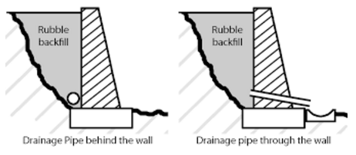

Drainage pipe behind the wall
Advantages
- The blockwork/wall would have no pvc pipe coming out of the front. Making the appearance uniformed.

Disadvantages
- The water is seeping through the wall which if left as is, will crack or cause the wall to fall over. All 3 scenarios are dangerous hazards.
- If the drainage pipe was slotted at the top to carry the water to an exit at the end of the wall this pipe may work better.

Drainage pipe through the wall
Advantages
- The water has an exist point through the pipe in the wall to take most of the water away.

Disadvantages
- The pipe isn’t at the lowest point of where the water will sit meaning water will be trapped and unable to get away causing the wall to seep and have the possibility of cracking etc like in pic a).

.

Outcome for Activity 6 | ☐ Satisfactory  ☐ Not satisfactory
Trainer/Assessor comments

Explain the purpose of a cone test. Describe the process of how such a test is conducted.

Response
A cone test is a test carried out to investigate the soil to determine the geotechnical engineering properties of the soil and delineating soil stratigraphy.
- This test consists of sending a probe into the ground to measure the force the soil applies to the probe as it penetrates the ground. The probe is made up of a cone tip at 60 degrees which measures resistance to the penetration. Above it is a friction sleeve measuring side friction, above this is the push rod. More push rods can be added until the probe cannot go any future into the ground, or the depth required is met.
CTP testing can be done in different soils to see what the soil consists of and the different fictions of resistance. This test measures tip resistance, side friction, identifying soil types and is a faster and generally cheaper than core drilling and taking samples. The results are often more consistent and reliable.

Outcome for Activity 7 | ☐ Satisfactory  ☐ Not satisfactory
Trainer/Assessor comments

Research and list a range of curing compounds and the advantages of using each type

Curing compound | Advantages
- Water Curing | - Water curing. This process is a low-cost option for a small slab. Water the slab with a hose up to 5 times a day to put moisture back into the slab. Care must be taken to ensure the water temperature is no more than 5 degrees below the temperature of the slab as cracking can result.
- Ponding | - Ponding. This too is a low cost and effective form for curing of a small to medium size slab. This process is easily done by creating a dam or dyke around the slab using clay or soil and filling the pond up with water. Be sure your pond holds water and be available to top it when needed. The advantage of ponding is the surface is a uniform level and temperature meaning there is less likelihood of thermal cracking.
- Wet Coverings | - Wet Coverings. This is the process of putting fabric or sand etc evenly onto the hardened surface. Be sure it is weighted down and wet. Do not allow it to dry out. This method is useful on slanted surfaces where the surface area is at a different height.
- Membrane Curing | - Membrane Curing is the process of spraying a compound product onto the slab that acts as a barrier to the elements i.e. the sun. It locks the moisture in and is the only method to consider on a large slab. E.g. Runway or highway. Special care must be taken to apply this method at the right time and of an even consistency.

Outcome for Activity 8 | ☐ Satisfactory  ☐ Not satisfactory
Trainer/Assessor comments

List environmentally safe products for cleaning.

Response
Environmentally friendly cleaning products. Examples below.
- Bio-shield Outdoor cleaner
- Vigor All Purpose cleaner
- Simple Green All Purpose cleaner
- EP Concrete cleaner
- ACT Concrete cleaner
- Terminator-HSD Concrete cleaner

Outcome for Activity 9 | ☐ Satisfactory  ☐ Not satisfactory
Trainer/Assessor comments

Have team members take photos and videos of your involvement with concrete features.

Identify each photo / video with a letter label and describe each photo / video in the table below. Submit the photo / video files along with this workbook.

Advantages
A
B
C
D
E
F
G
H
I
J
K
L
M
N
O
P
Q
R
S
T
U
V
W
X
Y
Z

Outcome for Activity 10 | ☐ Satisfactory  ☐ Not satisfactory
Trainer/Assessor comments

