CPCCBC4002A
Manage occupational health and safety in the building and construction workplace

THEORY EXAM INSTRUCTIONS

- This exam will occur under standard assessment conditions.
  - An oral examination may be allowed under certain circumstances.
Answers will be documented and FT003 (Oral examination declaration form) must be completed.
- Participants must provide enough detail in their responses to demonstrate their knowledge and skills.
- Please fill in the details below, providing your name, signature and date of assessment.
  - Your signature acknowledges that this is your own work.
- If a participant initially answers a question incorrectly but modifies their response, they must follow the instructions below:
  - If a participant changes their response in writing, they must put their initials next to the written change.
  - If a participant changes their response verbally, this must be noted on the exam paper by the assessor.

Participant name | Emma Carew
Participant signature | 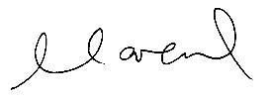

Assessor name
Assessor signature | 

Date | 11/11/2018

Number of questions | Number of questions answered correctly | Satisfactory?
13 |  | Yes | No

Assessor Comments
- Complete the missing words from the sentence below.

Management of risk is reliant on effective quality information which may be sourced ____________ or _______________of the workplace.
internal
external

Answer

- Name at least six (6) external sources of reference information to ensure a systematic approach to workplace risk.

Answer | 1. WHS acts, regulations  2. Standards and guidance material  3. Codes, guidance material, alerts  4. Safety alerts issued by authorities  5. Safework Australia website  6. WHS specialist advisers

- Name at least ten (10) internal sources of reference information to ensure a systematic approach to workplace risk.

Answer | 1. Hazard, incident and injury reports  2. Investigation reports  3. Workplace inspections  4. Maintenance records  5. Minutes of meetings  6. Job Safety Analysis (JSA’s), safe work method statements and risk assessments  7.Work procedures including standard operating procedures (SOPs_  8.Reports and audits  9.Organisational data: licences, insurance records and enforcement notices  10.Collated information: incident and injury reports trend analysis, WHS performance data  11. Safety Data Sheets (SDSs) and chemical registers

- Name the seven (7) risks to health and safety nominated in the regulations made under section 276 of the WHS Act for representation and participation.

Answer | 1. Noise  2. Manual tasks  3. Confined spaces  4. Falls  5. Demolition work  6. Electrical work  7. Hazardous chemicals

- Briefly explain what is a Code of Practice in the Building and Construction industry.

Answer | The Code of Practice for the Building and Construction industry outlines specific principles and standards of behaviour that underpin best practice while promoting positive change in the industry.

- Using the risk table and common workplace hazards information below/overleaf, respond to the given scenario to determine the level of risk.
Include a written explanation for how you came to your conclusion.

Matrix | A:  Death or permanent disability | B:  Serious injury | C:  Lost time injury | D:  Casualty Treatment | E:  First Aid
1: Very Likely | E | E | H | H | M
2: Likely | E | H | H | M | M
3: Possible | H | H | M | M | L
4: Unlikely | H | M | M | L | L
5: Very Unlikely | M | M | L | L | L

E: Extreme | H: High | M: Medium | L: Low

Common workplace hazards
Mechanical hazards | Plant, equipment and items (and parts of them) that have the potential to cut, rip, tear, abrade, crush, penetrate, produce projectiles or cause sudden impact.
Chemical and biological hazards | Chemicals, compounds, materials, powders, dusts and vapours that have the potential to impair health, have adverse effects on human reproduction, cause disease or have explosive, flammable, toxic or corrosive properties.
Sources of energy | A range of sources of energy that have the potential to cause harm, including electricity, heat, cold, noise, high powered light and damaging radioactive sources.
Body stressing or impact hazards | Activities that cause stress to the muscles and/or skeleton, including manual handling of people, animals, goods or materials and things or circumstances that can cause a person to slip, trip or fall at the same level.
Gravity | Activities that are carried out where a person can fall or an object can fall onto people.
Psychological hazards | Events, systems of work or other circumstances that have the potential to lead to psychological and associated illness, including work-related stress, bullying, workplace violence and work-related fatigue.

SCENARIO

- Fourteen (14) workers, working in pairs (groups of 2), will be working off pre-installed quick stage scaffolding.
- The Scaffolding Handover Certificate has been provided to the Principal Contractor and has been sighted by the sub-contractor employing the 14 workers.
- The scaffolding covers the full height of a 20 storey building and all four external walls of the 20 storey building are fully scaffolded and screened.
- The activity involves the workers removing by peeling off a thin plastic protective cover sheeting from a previously installed (matt burnished) 25 millimetres thick aluminium façade sheeting on all four external walls of the multi-story building.
- The feature sheeting is stylised with a wave pattern down its vertical edges and is in multiples of 6 metre lengths and has been installed vertically and positioned centred in a 15 millimetres deep recess down the outside walls of the building from Floor 4 through to Floor 16.
- The burnished aluminium feature panels number seven (7) per wall and the workers will need to access from floor level 3 to floor level 17 of the scaffolding to remove the protective coating.
- At its widest point this façade sheeting is 1 metre and at is narrowest 300mm.

Answer | Level of Risk for the Given Scenario  “Removal by peeling off thin plastic protective sheeting from a previously installed aluminium façade sheeting on all four corners of a multi-story building”  Mechanical hazards – Risk Score = Medium  Given the scenario above a risk score of Medium was determined as there was a potential risk for a cutting injury. It was scored 3: Possible, D: Casualty = Medium. As a control measure PPE to be worn.  Chemical and biological hazards – Risk Score = Low  Given the scenario above a risk score of Low was determined as a cleaning agent will be used. In reviewing MSD for product if has a low health risk. It was scored 4: Unlikely, E: First Aid = Low.  Sources of energy – Risk Score = Low  Given the scenario above a risk score of Low was determined as working outside so exposed to sun, however scaffold fully screened. It was scored 3: Possible, E: First Aid = Low. As a control measure PPE to be worn and sunscreen.  Body stressing or impact hazards – Risk Score = Medium  Given the scenario above a risk score of Medium was determined due to manual removal of product and moving between scaffold levels. It was scored 3: Possible, D: Casualty = Medium.  Gravity – Risk Score = Low  Given the scenario above a risk score of Low was determined as there was a potential for falling objects / tools. It was scored 3: Possible, E: First Aid = Low  Psychological hazards – Risk Score = Low  Given the scenario above a risk score of Low was determined as there was a potential for fatigue moving up and down scaffold. It was scored 4: Unlikely, E: First Aid = Low. As a control measure regular breaks are provided to avoid risk of fatigue.

- You are to conduct a workplace inspection (see workshop layout plan on the following page) to identify specific risks for four (4) cabinetmakers/woodworkers in the work area.
In the conduct of this workshop inspection you would gather as necessary, expert advice, including advice from the workplace personnel working in the area being inspected. Your completed inspection report should align with best practice and statutory obligations.

You are to make recommendations from your inspection report findings and nominate with whom you would consult (e.g. relevant parties) regarding compliance issues relating to statutory requirements and to ensure agreed control measures are implemented in conjunction with any relevant workplace personnel and then suggest a monitor and review period to ensure the effectiveness of control measures required.

Remember that a workplace inspection would under normal circumstances be a collaborative effort and more often than not is best when conducted by a team. In this instance you are the team and we recognise a team may comprise as few as two members and this is done because it is important to have ‘fresh eyes’ in case something is missed therefore have someone else review your report before submitting it for assessment.

Answer | Please find attached completed Workplace Inspection which details all items inspected in the workshop.

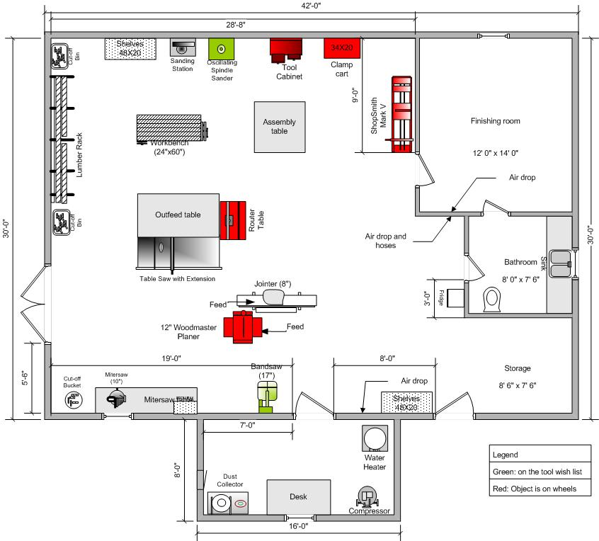

- Who would you need to consult within an organisation when determining the effectiveness of an OHS communication strategy?

Answer | - Management  - Health and Safety representatives  - Health and Safety committees  - Designated work groups

- What are the benefits of providing appropriate information, education and training for safe workplaces?

Answer | The reduction in frequency and severity of workplace injury and disease as staff gain knowledge and skills to perform their duties safely.

- What are the benefits of providing appropriate information, education and training for a supportive workplace culture?

Answer | Increased awareness of OHS issues within the organisation.  Improved staff morale and corporate culture as staff become more knowledgeable and responsible for their own safety and the safety of others and those around them

- Work Health and Safety Queensland (WHSQ) aims to help you understand your compliance obligations under three (3) Acts.
Name the three (3) Acts.

Answer | 1. Work Health and Safety Act 2011  2. Safety in Recreational Water Activities Act 2011  3. Electrical Safety Act 2002

- Education and Training Programs help establish appropriate education and training programs for employees and include induction training, on the job training, refresher training, WHSE consultation training.
Why is it important to monitor and review these training and education programs?

Answer | - Evaluate training programs for effectiveness  - Ensure employees have an adequate understanding  - Review training materials for accuracy of content, currency and suitability  - Conduct post-training surveys  - Conduct regular reviews of training needs

- For this task, please refer to the brief below:

You are to inspect (audit) an area or place in your workplace or alternately identify a workplace that will allow you to inspect it for the purposes of completing a Risk Assessment and Safety Audit.

You can retrieve a Risk Assessment template from the following URL: http://www.safeworkaustralia.gov.au/sites/SWA/about/Publications/Documents/542/RiskAssessment_RiskControlFormManualTasks.PDF
Your role is to identify each occupation working in this place (be it an office or a construction site or other workplace location), referring to contracts as necessary and to then review this office/workplace/site/location and identify the risks.
Complete a risk assessment and inspection report and make recommendations for any non-compliance and continuous improvement against the relevant parts of Act and/or Regulations, relevant Codes of Practice and relevant Advisory Standards and/or Endorsed Standards as they apply. Interview and consult with workers and experts, as necessary.
You are to determine and write (where necessary) safe work method statements (SWMS) and job safety analysis (JSA) support documentation for inclusion in and changes to the site safety plan and management’s further reference and action based on your Risk Assessment and Audit findings.

Example templates will be provided to you by your instructor.
Presenting your findings:
You must present your fully completed assignment and attachment forms and paperwork with a reference bibliography in a portfolio to your Instructor in the timeframe allocated by the Instructor.

You must also prepare a tool box talk presentation for the workers and management around your findings and then determine effective monitoring and review procedures to eliminate or control the identified risks and/or hazards. You will present your toolbox presentation to your instructor and classmate colleagues.

Answer

