CPCCBC4010B
Apply structural principles to residential low rise constructions

CPCCBC4011B
Apply structural principles to commercial low rise constructions

THEORY EXAM INSTRUCTIONS

- This exam will occur under standard assessment conditions.
  - An oral examination may be allowed under certain circumstances.
Answers will be documented and FT003 (Oral examination declaration form) must be completed.
- Participants must provide enough detail in their responses to demonstrate their knowledge and skills.
- Please fill in the details below, providing your name, signature and date of assessment.
  - Your signature acknowledges that this is your own work.
- If a participant initially answers a question incorrectly but modifies their response, they must follow the instructions below:
  - If a participant changes their response in writing, they must put their initials next to the written change.
  - If a participant changes their response verbally, this must be noted on the exam paper by the assessor.

Participant name | Emma Carew
Participant signature | 

Assessor name
Assessor signature | 

Date | 3/11/2018

Number of questions | Number of questions answered correctly | Satisfactory?
134 |  | Yes | No
Assessor Comments
- What are the four (4) primary loads which a structure must resist?

Answer | 1. Dead Loads (fixed vertical)  2. Live Loads (variable but most likely vertical)  3. Negative and Positive Wind Loads (variable but mostly horizontal)  4. Hydrostatic Pressure (from water pressure in the ground)

Refer to the table shown below to respond to Q2. to Q3.

Live loads for floors as per building usage | Uniformly distributed load (kPa or kN/m²)
Houses | 1.5
Flats, motel bedrooms, apartments | 2.0
Offices | 3.0
Workshops | 5.0
Parking, vehicle >2.5t | 5.0
Hospitals, school assembly areas with fixed seating | 3.0
Dance halls, bars, lounges | 5.0

- Calculate the live load of a dance hall measuring 23m x 8m.
Show your calculations.

Answer | - Area of the floor - 23m x 8m = 184m2  - Live load rating of a dance hall = 5.0kPa  - 184m2 x 5kPa = 920kN

- Calculate the live load of a commercial office premises floor measuring 33m x 11m. Show your calculations.

Answer | - Area of the floor - 33m x 11m = 363m2  - Live load rating of a commercial office = 3.0kPa  - 363m2 x 3kPa = 1089kN

- What happens when wind flows around a building?

Answer | When wind flows around a building, it can produce some very high suction pressures. These occur mainly at the leading edges.  Moving air affects a structure by exerting pressure on it. This pressure varies with the velocity of the air (speed and direction).

- Explain the difference in pressure exerted by wind on a building, as compared to a wind vortex.
What must be done to the building structure to prevent it being blown away?

Answer | The effect of wind on a building depends on the interaction of many variables. Natural variables include wind speed, wind height, ground surface features, and the properties of the air.  Together, these variables create differences in pressure that push and pull on the exterior surfaces of building.  Wind blowing against the building results in positive pressure which pushes against the building.  A Vortex results in negative pressure with pulls at the building.  To prevent the building structure from being blown away, it must have:  - Careful placement of bracing to maintain stability  - Roof materials (trusses or framed construction) tied down to the external load bearing walls to prevent uplift  - Tie down rods which connect the roof wall and floor/footing and metal strapping rated to resist the known wind region effects

- What are some of the factors to be considered for wind loadings?

Answer | - The shape of the building  - Openings in roof or walls  - Flat vertical planes compared to angled planes  - Geographical location  - Terrain  - Building height and shape  - Surrounding structures

- Explain the term ‘load path’ in reference to a building.

Answer | A load path is simply the direction in which each consecutive load will pass through connected members.  The sequence commences at the highest point of the structure working all the way down to the footing system, ultimately transferring the total load of the structure to the foundation.

Please refer to the information below in responding to Q8. to Q14.

There is a building 21 metres long x 10 metres wide x 8 metres high with a 25⁰ pitched gable roof.
The rafter line on the metal clad roof measures 5.5 metres on the rafter line, that is, from the fascia/gutter line up to the ridge line.

The wind load rates are as follows:
- Windward wall is 21 metres long x 8 metres high with a wind load rate of +1.5KN/m²;
- Leeward wall 21 metres long x 8 metres high with a wind load rate of -0.8kN/m²;
- Windward roof with a wind load rate of +0.8kN/m²; and
- Leeward roof with a wind load rate of -1.5kN/m²

- What is the wind load rate for the windward wall? Tick your response.

Answer | Choice | Possible Answers
 | ☒ | +1.5kN/m²
 | ☐ | -1.5kN/m²
 | ☐ | +0.8kN/m²
 | ☐ | -0.8kN/m²

- What is the wind load rate for the leeward wall? Tick your response.

Answer | Choice | Possible Answers
 | ☐ | +1.5kN/m²
 | ☐ | -1.5kN/m²
 | ☐ | +0.8kN/m²
 | ☒ | -0.8kN/m²

- What is the wind load of the windward wall (Area of wall x wind load rate)? Tick your response.

Answer | Choice | Possible Answers
 | ☐ | -252kN
 | ☐ | 134.4kN
 | ☒ | 252kN
 | ☐ | 86.4kN

- What is the wind load for the leeward wall (Area of wall x wind load rate)? Tick your response.

Answer | Choice | Possible Answers
 | ☒ | -134.4kN
 | ☐ | -94.2kN
 | ☐ | 252kN
 | ☐ | 134.4kN

- What is the wind load rate for the windward roof? Tick your response.

Answer | Choice | Possible Answers
 | ☒ | +0.8kN/m²
 | ☐ | -43.2kN/m²
 | ☐ | -1.5kN/m²
 | ☐ | +1.5kN/m²

- What is the wind load for the leeward roof? (Area of roof x wind load rate). Tick your response.

Answer | Choice | Possible Answers
 | ☒ | -173.25kN
 | ☐ | 92.4kN
 | ☐ | 173.25kN
 | ☐ | -134.4kN

- What is the wind load for the windward roof? (Area of roof x wind load rate). Tick your response.

Answer | Choice | Possible Answers
 | ☐ | 252kN
 | ☐ | -92.4kN
 | ☐ | -252kN
 | ☒ | 92.4kN

- What are the main structural principles that apply to residential and commercial low rise structure erection and demolition?

Answer | - Loads and loading  - Section properties  - Behaviour of structural materials  - Performance of beams  - Performance of columns  - Performance of roof trusses  - Principles of formwork  - Solution of force systems  - Wind bracing

- How is the classification of a building (or part of a building) determined?

Answer | The classification of a building or part of a building is determined by the purpose for which it is designed, constructed or adapted to be used.

- Refer to the BCA A3.2 building classes and give the classification definition for the classes of buildings listed in the table below.

Answer | Class | Classification definition
 | 1 | One or more buildings which in association constitute: a. Class 1a – a single dwelling b. Class 1b – boarding house, hostel
 | 2 | A building containing 2 or more sole-occupancy units each being a separate dwelling
 | 3 | A residential building, other than a building of class 1 or 2, which is a common place of long term or transient living for a number of unrelated persons (E.g.: boarding house, school, hotel)
 | 4 | A dwelling in a building that is Class 5, 6, 7, 8 or 9 if it is the only dwelling in the building
 | 5 | An office building used for professional or commercial purposes, excluding buildings of Class 6, 7, 8 or 9
 | 6 | A shop or other building for the sale of goods by retail or the supply of services direct to the public
 | 7 | A building which is Class 7a (a car park) or class 7b (for storage or display of goods or produce for sale)
 | 8 | A laboratory or building for the production, assembling, altering, repairing, packing, finishing or cleaning of goods for sale
 | 9 | A building of a public nature: Class 9a – health-care building, Class 9b – an assembly building, Class 9c – aged care building
 | 10 | A non-habitable building or structure: Class 10a – non-habitable building, Class 10b – fence, mast, pool, Class 10c - Shelter

- What is the purpose of understanding loads on a building?

Answer | Loads exert forces on a building which need to be analysed so you know the effects of materials and their structural performance under loads

- Forces are represented as vectors and have three (3) properties.
Name these properties.

Answer | - Magnitude – the size of the force  - Direction – the direction of the force  - Position – the body effect by the force

- How can you best visualise where a building’s loads are being transmitted (felt) on the structural elements of the building?

Answer | You can visualise which portion of the building’s load is transmitted to which structural element by following the load paths  The load path is the direction in which each consecutive load will pass through connected members. The sequence commences at the highest point of the structure working all the way down to the footing system, ultimately transferring the total load of the structure to the foundation.

- What do the structural members of a building consist of?

Answer | Structural members are the primary load bearing components of a building and they consist of the following:  - Beams  - Columns  - Retaining walls  - Floors  - Wind bracing

- What are the two (2) main principles of structural effectiveness for structural members when considering the shape and type of material to use?

Answer | - Mechanical properties – strength, toughness, elasticity, plasticity, ductility, malleability, brittleness, hardness  - Section properties - the mathematical properties of structural shapes

- Explain the beam types listed in the table below.

Answer | Type | Explanation
 | Simply supported beam | Simply supported beams are supported at each end only. If downwards pressure is applied bending would occur at the middle of the beam.
 | Continuously supported beam | Continuously supported beams are supported by three or more support points. They deflect less than simple beams of the same span because the positive and negative bending cancel each other out. Generally 20% more efficient than a simple span.
 | Cantilevered beams | Cantilever beams overhang their supports. The cantilever section of the beam cannot support the same loads as the back span which is the section of beam between the supports. A typical allowance for the amount of cantilever in a beam is 30% of the back span therefore a 45 m beam could have a cantilever section 15 m long.

- Explain the terms listed in the table below.

Answer | Term | Explanation
 | Strength | The resistance it is able to offer to the load that will just cause fracture, for example, the resistance that 1 mm² of section can offer to the load that will just cause fracture.
 | Hardness | The degree of resistance to indentation (a gap or space cause by a force being applied) or abrasion (the result of friction by rubbing or grinding causing wear).
 | Toughness | The resistance to fracture of a material by repeated bending or twisting after its yield point (breaking point) has been passed.
 | Elasticity | The ability for a material to deform with loading and then returns to its original shape when removed.
 | Plasticity | The opposite to Elasticity - If a material deforms when loaded and does not return to its original shape when the load is removed, permanent deformation occurs. This is called 'plastic behaviour'.
 | Ductility | The property which enables a material to be drawn out in the direction of its length.
 | Brittleness | The property which causes a material to break or snap off without any noticeable lengthening. It is the reverse of ductility - often caused by fatigue.
 | Malleability | A material that can be hammered or worked into various shapes. In some ways this property is similar to ductility.

- Discuss the terms compression, tension and shear forces when applied to materials and structural members of a building.

Answer | Term | Explanation
 | Compression | Compression is when two opposing forces are pushing into each other at the same point, resulting in compressive stress
 | Tension | A tension force is a pulling force that is trying to make the building material longer.
 | Shear | Shear stress is the shearing action of vertical loads and horizontal shearing due to bending. The region of shear is parallel to the direction of force.

- What is a column and how does it transmit load forces?

Answer | A column is a vertical support member subjected to compressive loads, also referred to as pillars, posts, stanchions and struts.  A column transmits load forces by compression force.

- Is a column, stump or post in compression, tension or shear?
Explain your answer.

Answer | A column, stump or post is in compression because the principal stress comes mainly from axial forces which fall along one line, usually the centreline.

- Explain the letters ‘CHS’ and ‘SHS’ with reference to columns, pillars, posts/stumps and stanchions as vertical (usually steel or concrete pipe) support members subjected to compressive loads.

Answer | CHS = Circular hollow section – this is the most efficient shape for a column.  SHS = Square hollow section – this is the second most efficient shape for a column

- Explain the terms listed in the table below with relation to structural performance of columns.

Answer | Term | Explanation
 | Axially load column | When the load is central to the centre of gravity axis, it produces a direct compressive stress within the column. Axially loaded columns are sometimes referred to as 'concentric columns'.
 | Non-axially loaded column | When the load is off-centre the column is called an 'eccentric column'. This results in bending and compressive stress being applied to the column.
 | Buckling | Buckling is a major consideration in designing all compression members. Buckling is deformation (deflection, bending) at right angles to the direction of the applied load.  Buckling will always occur about the weakest axis unless some form of lateral (sideways) restraint is used to prevent it.
 | Slenderness ratio | The maximum load a column can be allowed to support depends on the slenderness ratio and the material from which the column is made. The slenderness ratio involves:  - the column height  - the size and shape of its cross-section  the manner in which the two ends of the columns are supported or fixed
 | End fixity and effective length | The way in which a column buckles is affected by how rigidly it is connected to other members at the top and the bottom. The term for the type of end fixing is end fixity and this affects the way a column buckles. The length of a column which may buckle is defined as the effective length.

- How will bearers, joists, lintels, beams or girders transmit load forces?

Answer | These are horizontal members which transfer loads horizontally along their length to the supports where the loads are usually resolved into vertical forces.

- How do floor boards transmit load forces? Explain with reference to residential and commercial low rise structures.

Answer | The floor load path flows down through the footings to the foundations

- How do walls, floors, and roofs transmit load forces?

Answer | Walls, floors and roofs transmit loads by compressive force to the floor below.  - The roof load path flows down through the walls to the foundation  - The wall load path flows down through the floor to the foundation.  - The floor load flows down through the footing to the foundation

- Explain what load imposition from torsion (twisting) can do to a building’s structure.

Answer | Torsional stress occurs when a moment or "turning force" is applied to a structural member (or piece of material) making it deflect at an angle (twist).  Torsion produces shear stresses inside the material. A beam in torsion will fail in shear; the twisting action causes the molecules to be slid apart sideways (for example, a pole with a sign hanging off one side).

- Explain what retaining walls are and what is critical to their sufficiency of structure.

Answer | A retaining wall is a wall built to hold back soil. It is required to support soil where a sloping site requires excavation and either there is insufficient room or it is impractical to batter the soil. Retaining walls must be:  - One metre high must and designed by a qualified structural engineer  - Able to resist soil pressures to be a stable structure

- Draw two separate hand sketches to explain the difference between a batter and a retaining wall.

Answer
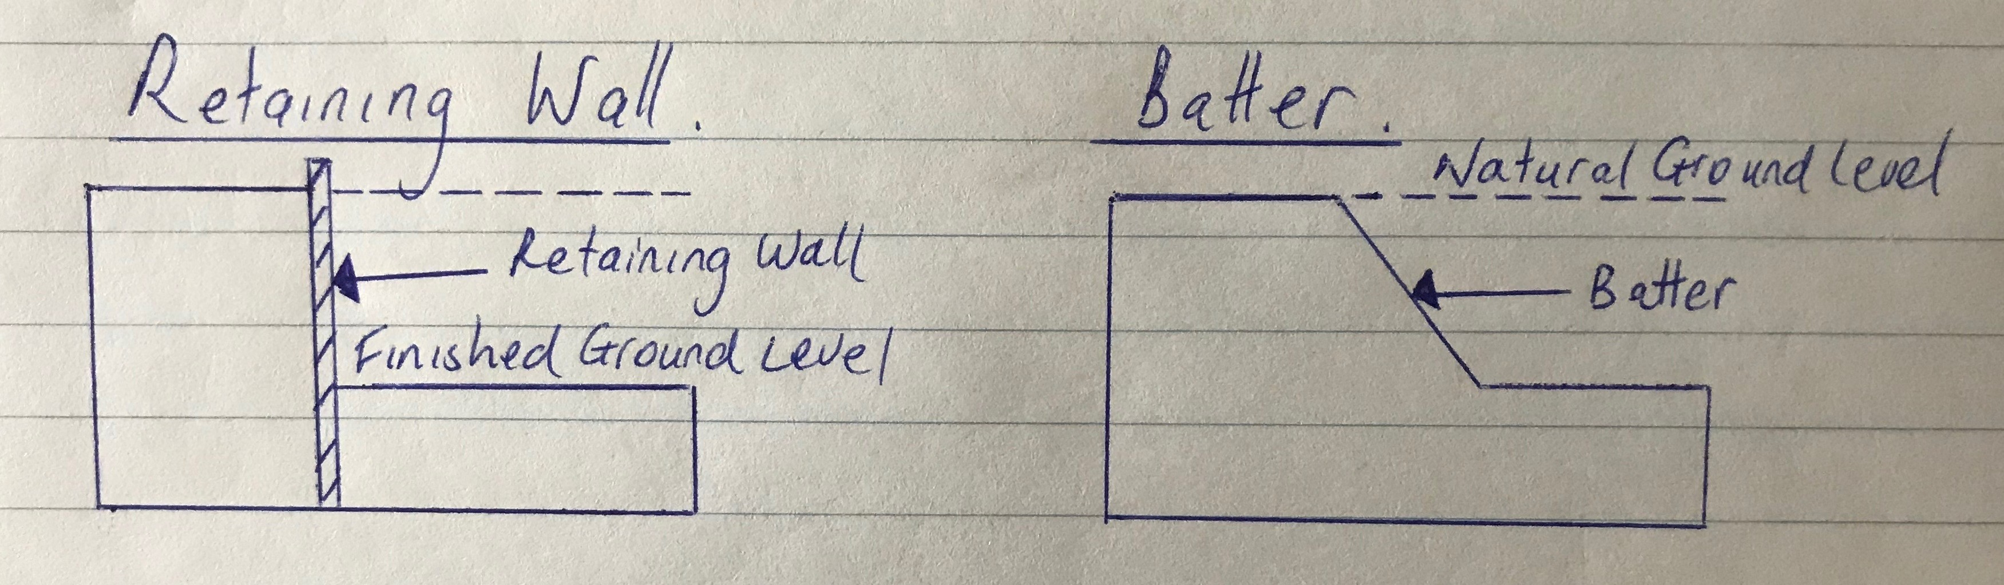

- Explain the differences between an inclined retaining wall, a gravity retaining wall and a cantilevered retaining wall.

Answer | Inclined Retaining Wall  An inclined retaining wall leans into the excavated soil and is constructed at an angle between 45 and 80 degrees. It may be constructed from brickwork or pre-cast interlocking concrete units.  Gravity Retaining Wall  A gravity retaining wall relies on its own weight to resist overturning forces from the soil. It is typically constructed of heavy materials such as stone, brickwork or concrete.  Cantilevered Retaining Wall  A cantilever retaining wall is the most complex of the three types and must be carefully designed by an engineer. It relies upon the correct placement of steel reinforcement and varying thickness of concrete to resist the compressive and tensile forces exerted on the wall by soil pressures.

- What is a ground level concrete slab floor?

Answer | Concrete slabs are floor systems of concrete and steel reinforcing. They are constructed and supported on the ground.

- What is a slab subfloor made of?

Answer | A slab subfloor sits on engineered reinforced strip footing foundation primarily made from concrete, steel mesh and rebar for added strength

- What should you consider when selecting the type of slab floor?

Answer | It is important to take into consideration the type of flooring, the laying of pipes and reinforcement. The type of flooring in a house must be adequately supported by the flooring structure below.

- Name and describe each of the general soil classifications that are followed in Australia.

Answer | AS2870  - Class A -  - Class S -  - Class M -  - Class H -  - Class E -  - Class P -

- What purpose does the soil report serve? Who prepares a soil report?
Which Australian Standard (AS) will be relevant to the soil report?

Answer | Purpose of a soil report  A soil report determines the:  - Soil classification  - Soil bearing capacity (moisture and movement in soil)  - Type of footing system and slab  Who prepares a soil report  A Geotechnical Engineer  Which Australian Standard is relevant to the soil report  AS 2870

- There are many different types of on-the-ground concrete slabs. Write a brief description for those listed in the table below.

Answer | Term | Explanation
 | Slab on ground | The slab is formed and set into the ground. The concrete is placed and leaves no space between the ground and the structure. It does not require internal stiffening beams and can only be constructed on Class A or Class S sites.
 | Stiffened raft slab | The slab is the simplest and most common slab construction. It is supported on the ground with a separate edge strip footing made from concrete, steel mesh and rebar for added strength
 | Waffle raft slab  (aka waffle pod slab) | The slab ribs are formed on top of the ground using a grid of polystyrene void forms and these are laid out on a levelled area. Suited to very reactive clay soils and slab design would be to engineer’s specifications and installed to manufacturer’s specifications
 | Pier and slab | On sites with more reactive soils, it's common for concrete piers to be sunken into the soil to improve stability. This is normally done by digging holes at intervals and depths determined by an engineer, then pouring concrete into them and attaching the slab to these piers.

- Briefly explain how a concrete slab sub-floor is installed.

Answer | - The site is scraped back to the soil, keeping it as level as possible and ridding it of all plant matter.  - Formwork is put up around the edges of the slab to prevent the concrete from spreading.  - Trenches are dug around the edges for all stiffening beams  - Bedding sand is laid down to level things out.  - A plastic vapour barrier is used to coat the site and prevent dampness from rising through the slab.  - Rebar or mesh is then spread out to cover the area.  - In some situations a layer of gravel may be laid down to provide a solid base.  - The concrete is then poured on top, spread out and levelled.  Housing slabs should ideally be left for 28 days to cure; this gives the slab extra strength and helps prevent cracking.

- Where are ground-level concrete slab sub-floors used?
What are the advantages and disadvantages concrete slab sub floors over conventional timber or steel sub-floor framing on stumps/posts with strip or sheet flooring?

Answer | These foundations are generally used to support heavier building materials like brick and steel.  Advantages  - Extremely durable and hardy base for a floor  - Typically well insulated, because the underside of the floor is not exposed  - No maintenance once the concrete has cured  Disadvantages  - Impossible to access piping once the slab has cured  - Cracks can cause major structural damage, and may be unrepairable  - Can increase unwanted noise

- Explain the terms listed in the table below.

Answer | Term | Explanation
 | Foundation movement | Foundation movement is caused by changing soil conditions, hydrostatic pressure, structural instability of footers or piers, invasive tree roots and poor exterior drainage management. Earthquakes, floods and frost heave also can contribute to soil shifts and foundation movement.  The slab must be designed and constructed to make sure that it is strong and stiff enough to oppose stresses. It is necessary to have a method of regulating the moisture content of the foundation soils so that the overall stress is minimised.
 | Slab bending | When there is foundation movement because of reactive soils, the slab will bend.  The resulting movement is classified as either dishing or doming.  The type of bending will determine where steel reinforcement needs to be placed in the concrete slab.  A ground slab can experience: dishing and doming
 | Stiffening beams | The design of the arrangement of stiffening beams is influenced by the reactivity of the foundation soils.  Ground slabs are typically constructed with stiffening beams which are placed along the perimeter of the slab.

- Buildings are usually designed to support the vertical loads created by dead and live loads. They also need to be able to resist lateral loads from wind and vortex loads. In building we use numerous techniques to overcome this problem.
Briefly explain the three common cable bracing techniques and sketch diagrams to explain your answer.

Answer | Diagonal Bracing - Diagonal components of bracing interconnect and stiffen columns and beams. The main types of bracing are:  - Knee  - K-brace  - Cross bracing

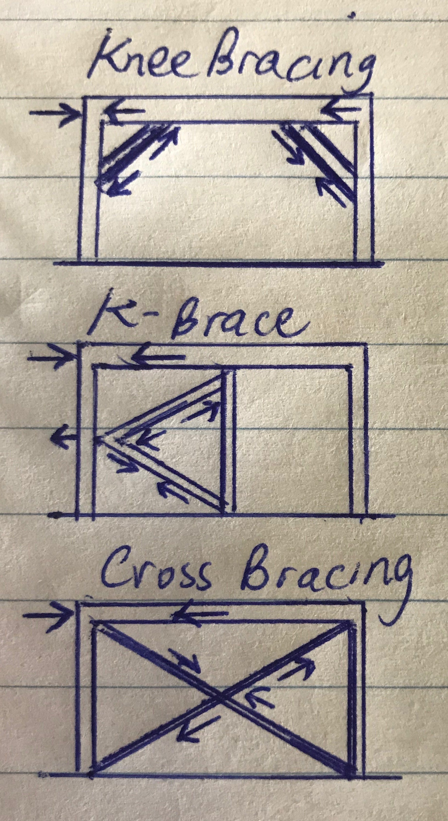

- Different bracing systems are used in residential and commercial construction which when operating together contribute to bracing a building against lateral wind, vortex and other forces.
Explain the bracing systems listed in the table below.

Answer | Term | Explanation
 | Rigid frame | A steel or reinforced concrete frame with rigid joints will resist changes resulting from forces in different directions.
 | Shear wall | A wood, concrete or masonry wall will resist changes in shape. The wall will transfer lateral loads to the foundation.
 | Braced frame | The frame is timber or steel and is braced with diagonal members.
 | Horizontal floor | A rigid floor structure is like a deep flat beam. The floor transfers lateral loads to the shear walls and to the braced or rigid frames.
 | Lift shaft with solid walls | Most office blocks are made stiff by using an internal concrete shaft as a stiff central core to which all the floors are rigidly fixed.  The floors act as horizontal diaphragms which transfer the stiffness from the core to the whole building.
 | Theory of triangulation | Triangulation involves the use of triangular shapes to give stability to structures. It relates particularly to pinned or hinged structures. Usually these types of structures offer no resistance to bending moments when a force is applied.

- What are important considerations when undertaking demolition work?

Answer | It is important that any demolition work of existing structures is done in accordance with legislative and planning requirements. Safe work practices are a vital part of the demolition process.

- What must be included in an application for a permit to demolish or remove a building?

Answer | - You must get a demolition permit  - Assistance to complete the application process by a building surveyor  - Get a planning permit (if within a heritage overlay)

- Describe the process of applying for a demolition permit using a simple flow diagram.

Answer
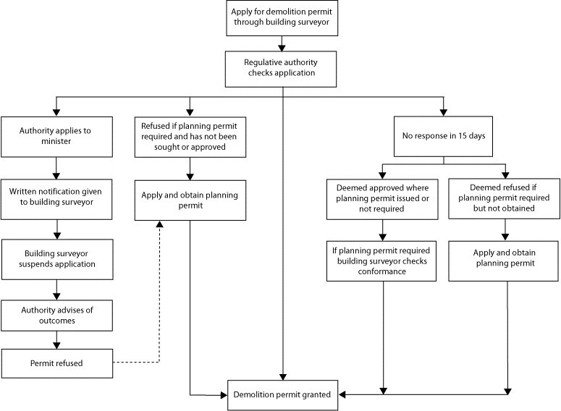

- Name the primary Australian Standard and codes of practice to be followed when performing demolition of structures.

Answer | - AS 2601 – The Demolition of Structures  - Code of Practice – Demolition 1991  - Code of Practice for the safe removal of asbestos 2nd edition 2005

- When performing demolishing what are some of the agencies which might be accessed for information and guidance?

Answer | - Safe Work Australia  - Australian Building Codes Board (ABCB)  - WorkCover

- Name some of the people included in the construction process, from professionals involved in building design to specialist tradespeople.

Answer | - Architects  - Engineers  - Drafts people  - Building surveyors  - Land surveyors  - Quantity surveyors

- Who would you consult to gain insight to using the right sized and right shaped materials for a project?

Answer | Generally you would consult industry professionals – such as an architect, designer and engineer.

- Briefly describe the role of an architect.

Answer | Architects design buildings and in many cases also supervises their construction. They help set viable and realistic budget, guide you through the planning process and obtain competitive quotes and manage consultants.  Architects also:  - Developing a client design brief  - Preparing concept sketches and working out what is possible  - Preparing site analysis reports including documentation of site constraints  - Preparing contract documentation, including the contract, specifications and working drawings  - Organising tendering  - Overseeing contract administration  - Organising design development and permit applications  - monitor the budget

- Briefly describe the role of a structural engineer.

Answer | Structural engineer design structures such as buildings, bridges, tunnels, etc. The majority of structural engineers work primarily as consultants to architects or design-build contractors.  Engineers also:  - Prepare reports on how to protect neighbouring properties  - Design the structure of retaining walls, columns, beams and loading walls in building projects  - Prepare reports on the structural adequacy of existing buildings  - Conduct Soil testing  - Write Floor plans  - Design footing systems detailing positions of bearers and joists  - Design concrete slabs

- What is the difference between a building surveyor and a land surveyor?

Answer | Building Surveyors provide professional advice on property and construction. They work on the design and development of new buildings as well as the restoration and maintenance of existing ones.  Building Surveyors also:  - Assess building plans submitted for approval to ensure compliance  - Provide advice/assistance to builders/owners before finalisation/lodging plans  - Pre-purchase inspecting of all types of buildings  - Inspecting buildings during construction to ensure methods and materials Keeping records and writing reports of building progress and instances where regulations have been breached – plans altered  - Giving evidence in court when prosecutions are necessary for breaches of building regulations  - Issuing compliance certificates on completion  Land Surveyors assess the surrounding terrain and landscape for the purpose of development. They commonly use specialised technology and equipment to do this as many of today's development, subdivision, building and tunnelling projects are so complex.  Land Surveyors also:  - Taking levels on a site to produce detailed contour plans  - Determining location of existing buildings and other features on a site  - Setting out the building line, marking the location of columns or the external perimeter of a building  - Checking the vertical alignment of a building during construction  - Conducting boundary surveys and re-establishment of survey pegs  - Checking the positioning and overall height of a structure at completion to ensure compliance with the conditions of permits

- What is a quantity surveyor and work do they perform?

Answer | A Quantity Surveyor (QS) is a professional working within the construction industry concerned with construction costs and contracts.  Services provided by a Quantity Surveyor may include: Cost planning and commercial management throughout the entire life cycle of the project from inception to post-completion.  Quantity Surveyors also:  - Initial cost advice during the pre-contract stage, preparing approximate estimates  - Costing planning information concerned with the development of a design  - Preparing the necessary tender documents, critically examining the tenders and priced bill of quantities when lodged for tender  - Valuing the work during the construction stage at required intervals  - Recommending the amounts to be paid to the main contractors including assessment of any variations  - Controlling costs during the construction stage  - Outlining the economics of alternative methods of construction

- Name some of the building approval plans that will be necessary to see a project through its construction.

Answer | There is a range of documentation that needs to be prepared to see a building project through to its completion, including:  - Building approval plans  - Contract plans  - Design and specification  - Engineer footing details and specifications  - Original contour survey plan  - Registered plans  - Retaining wall  - Site plans  - Soil investigation reports  - Structural floor, wall and roof systems  - Underpinning, rock anchors and shoring designs and specifications

- What is a land title and what would you expect it to contain?

Answer | A land title is an official record of who owns a piece of land. It can also include information about mortgages, covenants, caveats and easements. It contains:  - A Plan with lot number  - Name of owner  - Reference numbers  - Certificate stamp

- Why would you need a construction permit or building permit?

Answer | A construction permit or building permit is a permit required in most jurisdictions for:  - new construction  - adding onto pre-existing structures  - major renovations

- What is a building permit and what does it show and record?

Answer | A building permit is the document which shows that your plans have been approved by a building surveyor.  The building surveyor checks that the plans meet building regulations and includes:  - Occupation permit  - Progress payments  - Relevant dates  - Building surveyor  - Inspection dates  - Paperwork you are required to comply with

- What other permits could be required? Give two examples.

Answer | - Asset protection - this includes payment of a bond to cover repair to council assets and is approved prior to beginning construction (if a council asset is damaged)  - Road opening - required prior to installing crossovers. Crossovers are pieces of timber placed on sand on the footpath so that trucks do not damage the footpath.

- What would be reasonable to expect to see in a project specification?

Answer | Project specifications contain all the written information that accompanies the plans and provide supplementary information to the drawings.  Project specifications take precedence over any notations on the drawings.  The sections included in a project specification include descriptions about:  - the job  - the site  - the proprietor  - other parties in the contract arrangement, for example: a trades section detailing standards and quality of work

- What is a sub-division plan and what is its purpose?

Answer | A sub-division plan is prepared for planning approval prior to the development of the land. It is a good source of information relating to adjoining properties.

- What would a site plan tell you?

Answer | A site plan shows a 'bird's eye view' of the building site which shows the location of a structure on a block of land and is informative when looking at adjoining properties

- Explain what a floor plan will tell you.

Answer | Floor plans are like cross sections which are taken horizontally half way up the wall and are drawn to a scale of 1:100 or 1:50 (depending on project type).  Floor plans show a vast amount of detail including:  - all horizontal dimensions such as room size and wall thickness  - size and location of windows and doors  - location of fixtures and fittings  - any particular requirements in a room such as floor coverings  - an indication of the materials used for wall construction  - the overall floor areas

- What is the purpose of a cross sectional drawing?

Answer | Cross sections indicate the type of structural materials that are incorporated into the construction.  Cross sections are a slice taken vertically through a given point along the building. They are generally drawn to a bigger scale than floor plans and elevations so that more detail can be shown.

- What information would you expect Municipal (Council) drainage plans and Water Authority documentation to provide you?

Answer | 1. Municipal drainage plans provide details of legal points of discharge for stormwater drainage.  2. Water authority documentation such as a sewer plan provides details of plumbing fixtures, drainage lines and points of attachment to existing building(s) on a site.

- Briefly discuss the purpose of footing design and name the Australian Standard (AS) which applies for low rise commercial building projects.

Answer | Footing design plans provide details on:  - Footing depths and widths  - Slabs and stiffening beams  - The type and positioning of steel reinforcement  Footing designs for residential projects are made to comply with AS 2879 - 2006 Residential slab and footing - construction.

- What are contour plans? Describe their purpose in building and construction projects.

Answer | Contour plans are a graphical representation of the lay of the land and show the degree of slope on a site. They typically relate back to a site datum and can be used to determine:  - the extent of cut and fill needed  - height of retaining walls  - overall finished height of buildings (referenced back to natural ground level)

- What is a site condition report and what is its purpose?

Answer | A site condition report needs to be prepared prior to construction and is a record of details about:  - The existing site  Buildings on adjacent boundaries and setbacks of structures  - Condition of fences  - Vegetation on the site on the boundaries  - Location of services (water, gas, electricity and phone lines)

- What does the AS3959 refer to?

Answer | AS 3959 refers to the construction of buildings in bushfire prone areas. There may be state or territory variations as indicated in the BCA.  AS 3959 provides a method of assessing the bushfire risk of a site by categorising the terrain including the slope and type of vegetation present.  The categories of bushfire attack are:  - low  - medium  - high  - extreme

- Australia is zoned into four regions for high winds. What and where are these regions?

Answer | - Region A - Normal  - Region B - Intermediate  - Region C - Tropical cyclones  - Region D - Severe tropical cyclones  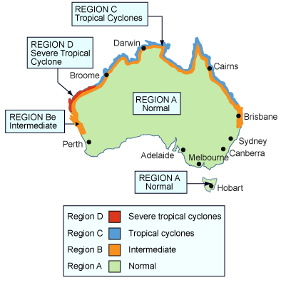

- The acceleration coefficient is a number which indicates the expected severity of the earthquake ground movement. Which Australian Standard should be referenced for this information?

Answer | AS 1170.4

- What defines an alpine area in Australia?

Answer | Alpine areas are defined as those areas which are 1,200 m or more above Australian height datum (AHD) for NSW, ACT and Victoria and 900 m or more above AHD for Tasmania.  Sub-alpine areas are those areas 600 - 1,200 m in NSW, ACT and Victoria and between 300 - 900 m in Tasmania.

- Where in the Building Code of Australia (BCA) can you find information relating to alpine and sub-alpine areas in which the snow loads could play a significant part in design and construction?

Answer | BCA Section 3.7.5 Alpine Areas

- What can we reference when intending to use new and emerging building technologies in the construction of a building?

Answer | The BCA has requirements to allow for new and emerging building technologies. Any new technology must satisfy performance requirements and this can be determined by using the following assessment methods:  - documentary evidence  - verification methods  - expert judgement  - comparison to deemed to satisfy provisions

- What are some of the critical considerations to be made about footings and the transfer of loads from the building to its footing foundations?

Answer | Footings are the construction that transfers the load from the building to the foundation. There are many things to consider such as the type of the foundation soil and the choice of an appropriate footing system  Pressure of foundation soils – the BCA requires a minimum bearing pressure of :  - 100 kPa for under strip and pad footing systems  - 50 kPa for under slab footings  Footings selection, size and type of house construction  - Cladding  - Brick veneer  - Solid brick  Stump materials  - Timber  - Concrete  - Steel  Pier and beam - Blinding concrete is used to transfer the loads from the house to the good bearing

- What codes and standards should be checked to ensure footings specified within the building plan are compliant?

Answer | To assess the structural integrity of footings specified within the building plan, you should refer to:  - BCA Volumes - Section 3.2.4.5 for information on strip footing dimensions and reinforcement.  - AS 2870-2011 - Residential slabs and footings - construction

- Name the relevant Australian Standard for protection against subterranean termites.

Answer | AS 3660.1-1995 - Protection of new buildings from subterranean termites

- What should be considered when constructing a floor system?

Answer | When constructing the floor system it is important to take into consideration the type of flooring, the laying of pipes and reinforcement.  The type of flooring in a house must be adequately supported by the flooring structure below.

- When designing and installing a concrete residential slab and footings what Australian Standard applies?

Answer | AS 2870-2011 - Residential slabs and footings - construction

- What are bearers in a sub floor framing system?

Answer | Bearers are the first of the sub-floor frame members to be installed. They are positioned over stumps, piers or other supports. In most cases they are timber, however, a wide variety of engineered timber products are available. As well, mild steel and cold-formed steel sections may be used to achieve greater spans.

- What are floor joists in a sub-floor framing system?

Answer | Floor joists are the next series of members for the sub-floor frame. They are supported by the bearers.  Typically the floor joists run over the tops of bearers, however, they may be attached to the sides of bearers. Like bearers, floor joists may be single span or continuous span. They can be made of timber or steel.

- Sketch free hand compact simple drawing in section to show the following floor system components of the external load bearing wall and bottom plate, joist and bearer to include:
- Wall frame
- Sheet flooring
- Floor joist
- Bearer
- Brick pier with stump cap

Answer
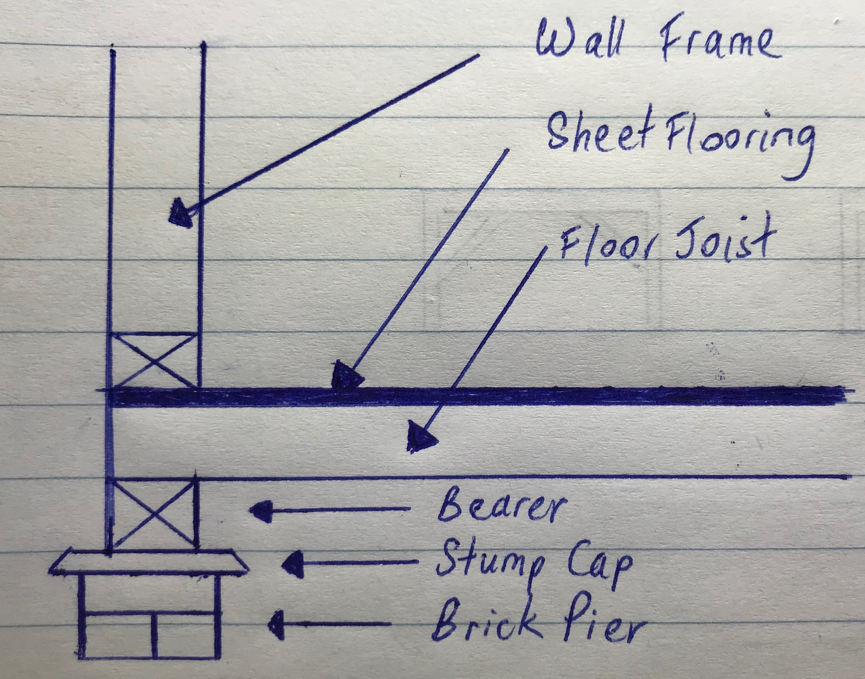

- What is a strip timber flooring system (also sometimes referred to as a fitted floor)?

Answer | Fitted floors (cut-in floors) are installed after walls have been erected and after roofing, wall cladding, doors and windows have been installed.  Where boards are laid parallel with walls, a minimum 10 mm gap shall be provided between the board adjacent to the bottom plate and the bottom plate.  Board lengths have to be at least the equivalent of two joist spacings. Finger-jointed hardwood flooring manufactured in accordance with AS 2796 is equivalent to continuous strip flooring.

- Explain the benefit or otherwise of a platform floor.

Answer | A platform floor provides a working platform for the builder as the floor is laid before erecting the wall and roof framing.

- Briefly explain drilled or driven piles as a footing system for commercial/industrial type buildings.

Answer | A pile is a vertical structural element of a deep foundation, driven deep into the ground at the building site.  Prefabricated piles are driven into the ground using a pile driver which are either  - Wood  - Reinforced concrete  - Steel  Concrete piles are available in square, octagonal, and round cross-sections and are reinforced with rebar and prestressed.  Steel piles are either pipe piles or a beam section.

- Which section of the Building Code of Australia addresses piling as a foundation system?

Answer | BCA Volume 1, B1.4 Determination of structural resistance of materials and forms of construction

- Explain the term ‘screw piles’. What must preface to approve the use of screw piles as a foundation system?

Answer | Screw piles are power driven galvanised steel columns and are an alternative pier system to timber piles.  The piles have a helix auger on the ends, which enables the pile to drill itself into the ground.  This engineered system requires an accreditation certificate to ensure acceptance by building authorities.

- What does a concrete pier typically consist of?

Answer | A concrete pier typically consists of a:  - round or square concrete pillar  - footer piece which serves to spread the load carried by the pier  - footer is placed below the frost line and top end above the ground surface  - the concrete pier top is typically equipped with a frame or bracket which support structures upright beams are attached  - effective for most soil types in areas which have little or no earthquake or hurricane activity

- Where could you use a bulk pier and beam system?

Answer | Bulk pier (and beam systems) are satisfactory where good bearing soil is located between 800 mm and 1,200 mm below the NGL.

- What is the construction method for bulk pier and beam?

Answer | Construction method for bulk pier and beam:  - Excavate the pier holes. The number, location and spacing will be shown on the design engineer's drawings.  - Pour concrete in the piers. The concrete is poured to approximately 500 mm below the NGL or FGL. No reinforcement is required in the pier holes. The concrete would be 20 MPa compressive strength.  - Excavate the strip footing. After three days, excavate the strip footing (or concrete beams) between the piers. These concrete beams will be excavated around the entire perimeter of the house.  - Position steel reinforcement for the beam.  - Pour the beam

- Name the framing system shown below.

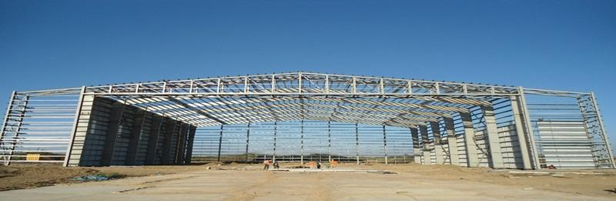

Answer | Portal frame construction using steel or steel-reinforced precast concrete

- Name the framing system shown below.

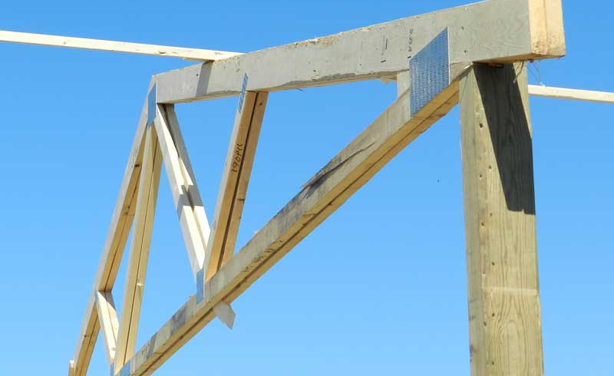

Answer | Pole & Truss Wall

- Name the building system shown below.

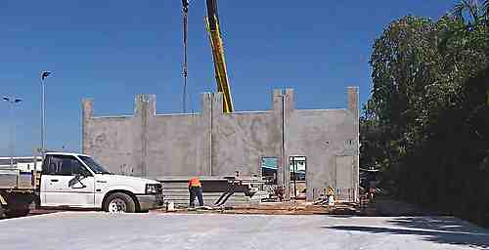

Answer | Tilt-slab construction: Tilt up is a pre-cast concrete system of building walls

- Which section of the Building Code of Australia addresses masonry components for a building?

Answer | BCA Volume 1, B1.4 Determination of structural resistance of materials and forms of construction  Masonry (including masonry-veneer, unreinforced masonry and reinforced masonry): Australian Standard 3700.

- What are masonry coatings?

Answer | Masonry Coatings is a generic term for any wall or masonry covering. This could be exterior wall coatings, masonry paints, wall rendering, textured coatings or even pebble dashing.

- A ‘wythe’ or ‘leaf’ is the building and masonry term given to the width of a single brick or concrete block unit. A brick or block masonry wall might incorporate any of cavity brick, single-leaf masonry (brick or block) or lightweight autoclaved (aerated) concrete block (AAC). The cavity between ‘wythes’ can be anything from 50mm to 110mm.
Draw freehand sketches of the following and label your sketches:
- A single masonry wall founded on a cavity brick base with engaged pier,
- A cavity brick masonry wall with 50mm cavity
- A brick veneer and timber framed wall with 50mm cavity
- A masonry retaining wall one (1) metre high

Answer

- What is cladding? What BCA section and Australian Standard address specific aspects of cladding?

Answer | Cladding systems are the building envelope. They enclose the building and provide protection from the weather.  External cladding contributes to the comfort, structural adequacy and aesthetics of a building.  There are many types of cladding, these include: Timber, Plywood, Hardboard and Masonry  Exterior plywood cladding is available in various veneer grades and profiles. Plywood should comply with AS 2271 'Plywood and Blockboard for Exterior Use  Exterior hardboard cladding that is manufactured for use as an exterior cladding must comply with AS 2858.

- Explain timber cladding systems like chamfer boards and weatherboards.

Answer | Timber cladding has natural advantages on sites that are subject to high winds, extreme climate, highly reactive soils and subsidence or earth tremors.  Timber's natural resilience and high strength-to-weight ratio enables it to withstand far greater stresses and movement than other materials and:  - performs best with wide eaves and verandahs  - provides weather protection to walls  Cladding must be watertight with adequate flashing and sarking in accordance with best industry practice. Special care has to be taken with detailing and protection at ground level and north facing walls.

- Describe plywood cladding.

Answer | Exterior plywood cladding is available in various veneer grades and profiles.  Plywood should comply with AS 2271 'Plywood and Blockboard for Exterior Use'.  If a plywood cladding is structural, the manufacturer will indicate the stress grade. Plywood cladding can also provide structural bracing and roof hold-down resistance.  Plywood has standard tolerances on length, width, squareness, thickness and edge straightness. Plywood can be treated for protection against insect and fungal attacks

- Describe exterior hardboard cladding.

Answer | Exterior hardboard that is manufactured for use as an exterior cladding must comply with AS 2858.  The manufacturers' guidelines should be consulted when using hardboard sheet cladding as structural bracing or for diagonal or vertical applications.

- Many additional services can be installed in a building and the building plans and relevant standards and codes must be identified and adhered to ensure appropriate allowances are made for the installation of these services.
Name some of the services that can fall under this scope of additional installations.

Answer | - Dusting for heating and cooling  - Electrical, electronic and communication systems  - Extractive vacuum and exhaust systems  - Passive and active fire detection and prevention systems  - Plumbing and drainage  - Powered systems for operating doors and windows  - Smoke control and containment systems

- What is a roof system? Name some roof types and what a roof might be built from.

Answer | A roof system is the structure that forms the roof of a building.  In Australia the roof system may be made up of:  - a timber frame roof built on-site  - a prefabricated truss roof in which major components are constructed in a factory and then assembled on-site  Types of roof systems include:  - Gable including dual pitch  - Hip  - North light  - Rafter and purlin  - Skillion  - Pre-fabricated and site fabricated trussed roof framing  Structural roof system components specified in a building’s plan must be assessed for compliance with relevant codes and accepted industry construction principles.

- Draw simple line diagrams to represent a gable roof, a hipped roof, hip and valley roof and a skillion roof.

Answer
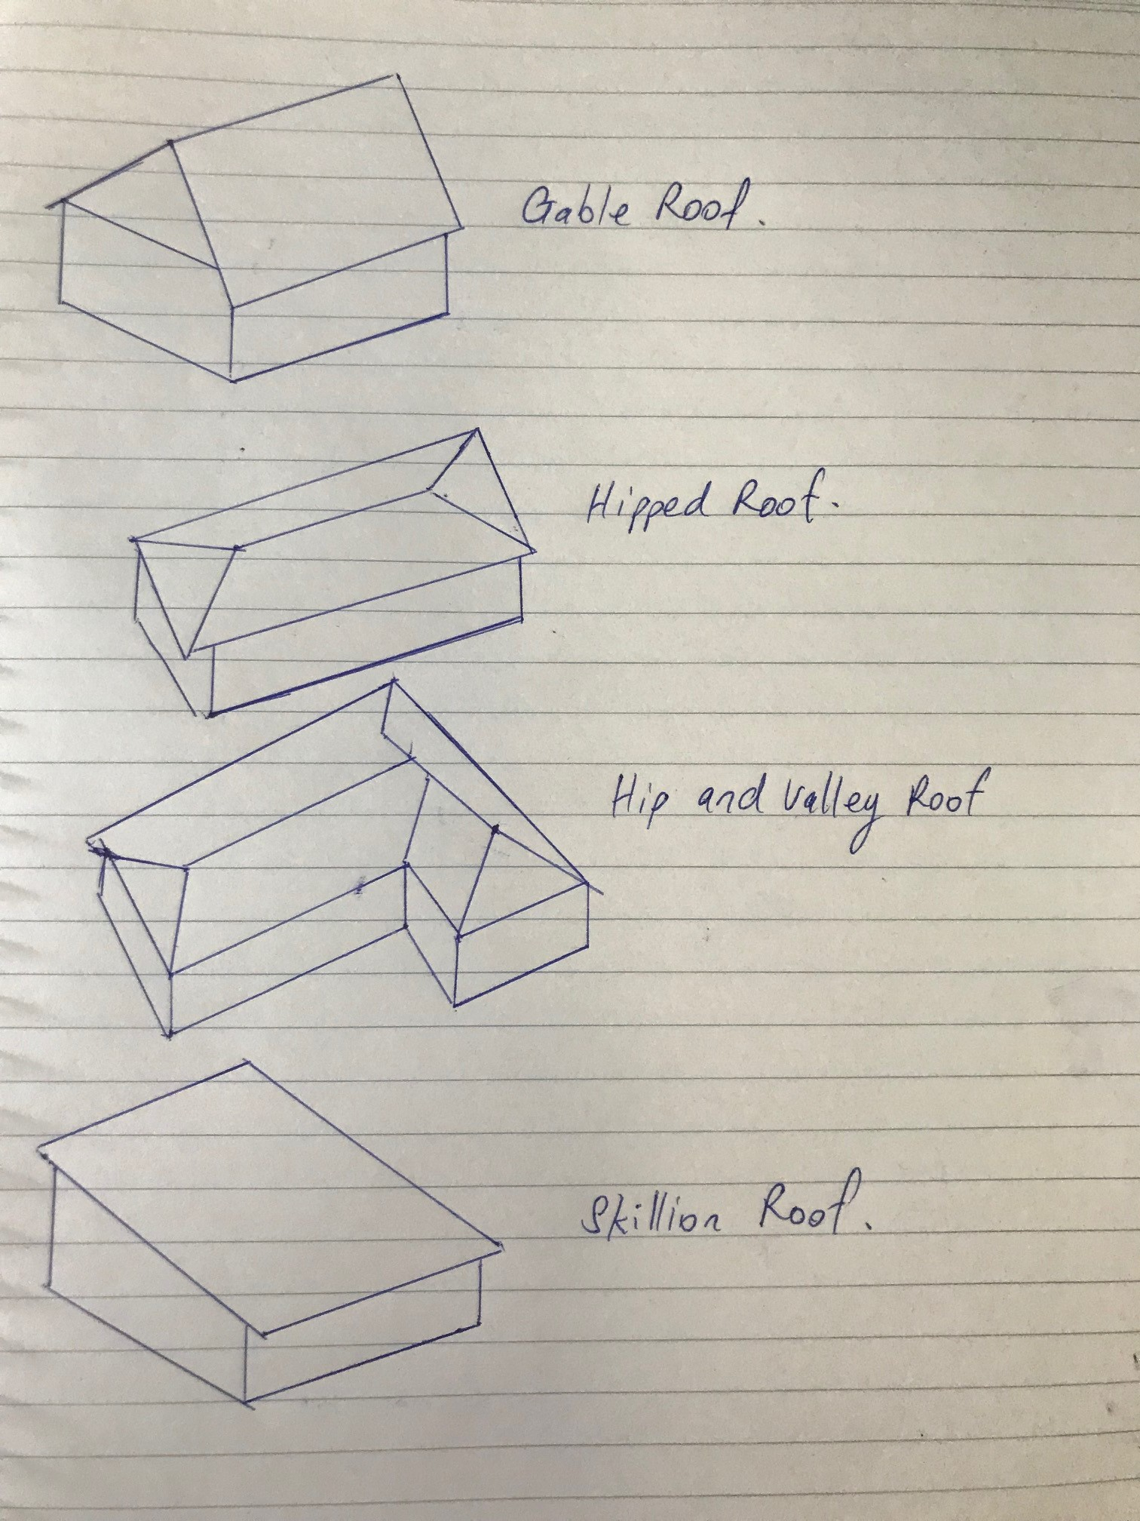

- Name at least eight (8) practical advantages of using prefabricated roof trusses.

Answer | Prefabricated roof trusses have several practical advantages:  - Strong, but light to erect.  - Can be made to suit most roof shapes.  - Less on-site fabrication, therefore less site labour is required.  - Less affected by bad weather.  - Factory production allows automated production.  - Better quality control is possible.  - Trusses make maximum structural use of the timber.  - Trusses are capable of long spans.  - Internal walls are usually non-load bearing, therefore lighter weight internal walls are possible.

- What is roof cladding? What are the two most common materials used in Australia?

Answer | Roof cladding is the material used to protect the building from the extremes of the weather.  The two most common options are:  - Roof Tiles  - Metal Roof Sheeting

- What pitch of roof should roof tiles be applied? Are there exceptions?

Answer | Roof tiles can generally be used on roofs of 15º or greater pitch, however, some materials and methods of manufacture require 25º or greater pitch.

- Describe the materials listed in the table below.

Answer | Term | Description
 | Terracotta tile | The tile is formed in wet clay and then fired to give a hard, long-life roofing product.  Come in a number of profiles.  Have a roof life greater than 50 years in most environments, however, salt atmospheres sometimes cause premature fretting.
 | Concrete tile | Generally modelled on terracotta tiles. Modern concrete tiles have roof lives approaching those of terracotta. They are stable, warp-free and have the same basic profiles as terracotta tiles. Colour on the concrete tiles is an applied coating. Although some colours fade quickly (within five years), most of the popular red/brown/charcoal colours have long colour retention.
 | Slate tile | These are a naturally occurring rock.
 | Fibre cement shingles | Fibre cement shingles are slate-like products manufactured from fibre-reinforced. cement
 | Timber shingle/shake | Timber shingles/shakes are made of sawn or split timber boards.
 | Aluminium or steel pressed tile | These are metal that is shaped to imitate a tile. They are often covered with coloured sand glued to the metal.

- Devise a useful roof framing checklist for ensuring the quality of the roof frame once it is installed.

Answer | - Rise and pitch of roof against plan  - Correct propping of ridge, hips, valleys, rafters and under purlins at correct centres  - Adequate collar ties  - Line of rafter, hips and valleys  - Support to strutting beams  - Fascia and barge boards  - All tie-downs and fixings  - Ceiling joist and alignment with rafters  - Hanging beams  - Trimmers for location  - Trimming to manhole

- Describe the intent of wall systems and the materials they are typically made from.
What part of the BCA and the AS reference wall systems?

Answer | Wall systems  - Provide structural support to roof systems  - Allow for installation of services  - Provide a means to apply external and internal linings  AS 1684.2-2006

- Explain the purpose of bracing.

Answer | Bracing is attached to studs to provide lateral support to wall framing.  Metal straps, timber or sheet bracing can be used for bracing.

- You are to provide a pictorial sketch with labels to show a common timber stud or steel wall and ceiling frame and include the following members:
- Hanging Beam
- Ceiling joists
- Top plate
- Lintel
- Common stud
- Jamb stud
- Jack stud
- Nogging
- Bottom plate
- Timber or metal bracing
- Sheet flooring
- Floor joists
- Bearers
- Stumps

Answer

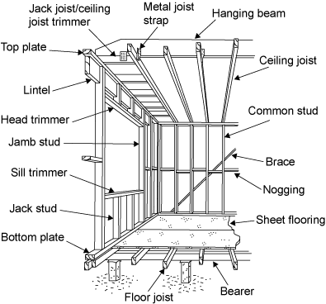

- Name the relevant volume and part in the Building Code of Australia (BCA) as well as the two (2) relevant Australian Standards that apply to the design, application and installation of timber framing for residential housing.

Answer | AS 1684.2-2006 provides tables for selecting wall framing members. This includes tables for selecting common studs (Table 7) and for the size of lintels in load bearing walls - for single or upper storey and for sheet or tile roofs (Table 17).

- What might be a typical checklist to be used for ensuring the quality of the frame members and the frame as a whole?

Answer | - Walls for plumb, square, straight and level  - Top and bottom plates have a tight fit on studs  - Bracing and tie-downs in accordance with plan  - Noggings at correct centres and support for fixtures  - Corner blocking  - Walls tied together  - Room sizes and ceiling heights with plan  - Window and door clearances and openings  - Jamb studs to all openings  - Concentrated load bearing studs  - Lintels for adequate bearing  - Block under studs if timber floor  - Any excessive notching  - Provisions for plumbing services and fixtures  - Safety of frame  - Adequacy of temporary bracing.

- What is sarking? What purpose does it serve?

Answer | Sarking is a waterproof, vapour-permeable, flexible sheet material. It is fixed directly behind timber cladding or under flooring material.  The purpose of sarking is to direct any water that may have penetrated the cladding back to the outside of the structure. It also provides a draughtproof barrier to keep wind-driven rain or dust out of the wall cavity.  Sarking is not a substitute for well-chosen and properly installed cladding. It should never be regarded as the principal means of weatherproofing

- What is flashing?

Answer | Flashings are used at corners and vertical joints and around openings. The purpose is to ensure that water is prevented from penetrating the wall frame cavity. Because the flashing does not extend fully behind the cladding, non-permeable materials may be used.

You are to refer to the roof section diagram below in responding to Q120. to Q126.

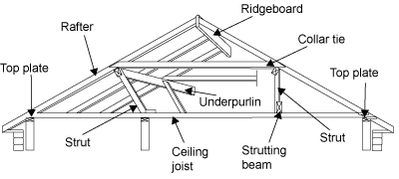

- What is a ceiling joist?

Answer | Ceiling joists prevent the rafters spreading and causing the roof to sag or collapse.  They provide the structure onto which the ceiling is fixed and also are the member that connects or ties the lower ends of rafter couples (pairs).

- What is the purpose of a hanging beam?

Answer | A hanging beam is generally a deep timber beam located perpendicular (at right angles or 90º) to ceiling joists and directly above them.  The function of a hanging beam is to reduce the span of the ceiling joists. This allows for a more economic joist size and consistent section. Hanging beams must only support ceiling joists and the attached ceiling materials.

- What is the purpose of roof struts?

Answer | Roof struts are needed in the roof frame to transfer the loads from underpurlins and other beams to the load bearing walls.

- What is the ridge board in a conventional framed roof?

Answer | Ridgeboards locate and stabilise rafter ends.  The ridgeboard in a conventional framed roof is not so much a structural member as a set out member.  It makes sure that rafter couples meet at a consistent height giving a horizontal ridgeline free from sags.

- What function do rafters perform in a roof?

Answer | The rafters give the roof its required slope and provide the structure onto which the roof covering is fixed.

- Explain the role of under purlins in a conventional roof frame system.

Answer | In a conventional roof frame the underpurlins support the underside of the rafters. This allows for the most economic rafter size and prevents the roof from sagging and collapsing.

- What are collar ties used for in a conventional roof frame system?

Answer | Collar supplement the ceiling joists and prevent the rafter couples spreading.  Collar ties must be fitted to every second pair of common rafters.

- What advantages can be gained from installing roof trusses as against a conventional stick framed roof?

Answer | The advantages of trusses include:  - They are strong, but light to erect.  - They can be made to suit most roof shapes.  - There is less on-site fabrication, therefore less site labour is required.  - They are less affected by bad weather.  - Factory production allows automated production.  - Better quality control is possible.  - Trusses make maximum structural use of the timber.  - Trusses are capable of long spans.  - Internal walls are usually non-load bearing, therefore lighter weight internal walls are possible.

- What must the design of a timber roof truss adhere to?

Answer | The design of a timber roof truss must accord with engineering principles and with AS 1720.1.  This includes the wind design. AS 4440-1997 'Installation of nail plated timber roof trusses' provides details for correct practices when installing roof trusses

- Discuss timber cladding and reference the relevant Australian Standard as it applies to the specific cladding. Be sure to name what part of the BCA deals with cladding.

Answer | Buildings clad with timber have many natural advantages that are subject to high winds, extreme climate, highly reactive soils and subsidence or earth tremors.  Timber's natural resilience and high strength-to-weight ratio enables it to withstand far greater stresses and movement than masonry or other rigid materials.  Timber cladding performs best with wide eaves and verandahs. This provides weather protection to walls.  Cladding must be watertight with adequate flashing and sarking in accordance with best industry practice. Special care has to be taken with detailing and protection at ground level and north facing walls.  There are a range of timber species, sizes and profiles including:  - Hardwood (AS 2796 'Seasoned hardwood - Milled products' sets out the grades and tolerances for hardwood , AS 082 and AS 083 set out the grades for unseasoned sawn weatherboards)  - Cypress pine(AS 093 'Unseasoned cypress pine - Milled weatherboards (Chamferboard)' sets out grades and tolerances for cypress pine. Manufacturers' literature can also be referred to)  - Preserved treated pine (AS 1784 'Preservative treated cladding milled from Australian grown conifers' sets out grades and tolerances for treated pine, AS 1495 sets out grades and tolerances for preservative treated radiata pine cladding)  - Imported timbers (The most commonly used imported cladding timber is western red cedar. Other imported timbers include redwood and Baltic pine. There is no Australian Standard to govern the grades and tolerances of imported timbers.  Always refer to BCA Volume 2 – Part 3.5.3 Wall Cladding

- What must be checked when installing skylights, windows and doors?

Answer | You must always check against the building’s plan and then supervise installation to ensure it is compliant with standards/accepted industry construction.

- What is the relevant Australian Standard to be referenced for glazing of windows and doors?

Answer | - BCA Vol 1 Clauses B1.4, FV1, F1.13, J3.4  - AS 2047

- Write a descriptive interpretation of the extract of the window schedule shown below.

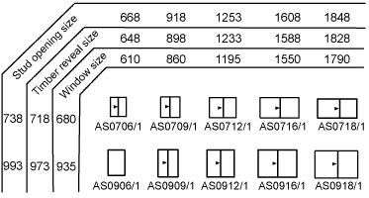

Answer | The schedule shows the window sizes, timber reveal sizes and stud opening sizes  Aluminium window schedules differ from for timber window frames. The timber reveals fitted to the windows for brick veneer and weatherboard construction are an additional size over the window size. This appears as an extra row of figures on a schedule.  For example:  AS0706/1  Window Size: 610 wide x 680 high  Timber Reveal Size: 648 wide x 718 high  Stud Opening Size: 668 wide x 738 high

- Illustrate by sketch the correct positioning of flashings and sarking for timber cladding.
Your sketches should reflect the use of weatherboard stops for installation of timber chamfer boards or timber weather boards where the internal and external corner joins has the cladding butting up to the weatherboard stop.
Alternate installations still require flashings and sarking for man-made manufactured boards such as HardiePlank or PrimeLine in which case sketches would reflect the use of internal and external corner jointers supplied by the manufacturer.

Answer

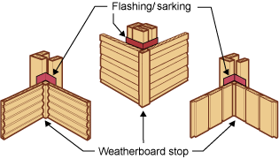

- Briefly describe each of the building materials listed below and outline the related construction methods used for low rise commercial projects.

Answer | Term | Explanation
 | Brick veneer construction | Brick veneer and cladding over timber-framed and lightweight section steel-framed construction
 | Cavity brick construction | A cavity wall is two wythes of masonry, separated by a cavity of varying dimension.  The cavity may or may not contain insulation.
 | Earth wall construction | A technique for building walls, foundations, and floors using natural raw materials such as earth, chalk, lime or gravel.  Stabilised rammed earth is a variant of traditional rammed earth that adds a small amount of cement (typically 5–10%) to increase strength and durability.
 | Autoclaved aerated concrete block construction | Concrete that has been manufactured to contain lots of closed air pockets. It is lightweight and fairly energy efficient and produced by adding a foaming agent to concrete in a mould, then wire-cutting blocks or panels from the resulting ‘cake’ and ‘cooking’ them with steam (autoclaving).
 | Pole frame construction | Pole frame construction uses primary structural frames including clear span truss supported by columns, supported/ connected by purlins, girts and sheathing.
 | Portal frame construction | Portal frame construction is a method of building and designing structures, using steel or steel-reinforced precast concrete or using laminated timber (such as glulam). The connections between the columns and the rafters are designed to be moment-resistant, i.e. they can carry bending forces.
 | Post and beam construction | Beams are generally horizontal members which transfer loads horizontally along their length to the supports where the loads are usually resolved into vertical forces.  There are several types of beams:  - Simply supported beams are supported at each end only.  - Continuously supported beams are supported by three or more support points.  - Cantilever beams overhang their supports. The cantilever section of the beam cannot support the same loads as the back span which is the section of beam between the supports.
 | Post and truss construction | A roof truss mostly wooden with two principal rafters and two vertical Queen posts with a restraining tie beam at the bottom and a straining beam at the top.  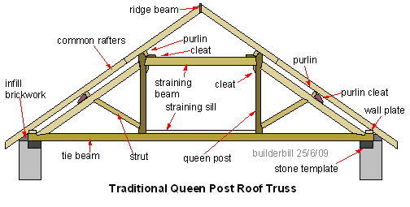
 | Single leaf concrete masonry construction | Single leaf concrete masonry is defined as small masonry units joined together with mortar.  )
 | Tilt panel or tilt slab construction | Tilt up is a pre-cast concrete system of building walls.  Traditional pre-cast concrete products are made in a factory, and then have to be delivered to the site.  Tilt slabs are poured on site.

