Skills & Knowledge

- For your organisation, plan, draft and finalise three different simple documents that are used commonly in your organisation for internal use. Ensure you accurately convey the required basic information in a format suitable for use. Take into account your organisational policies and procedures for document production.

Document 1: Credit Card Policy
Purpose: To inform staff of the company policies when in possession of a company credit card.
Format: Microsoft Word
Communication means: Formal, Written
Target Audience: All Staff with possession of company credit card
Inclusions: Dot points, Use of Bolds.
Organisational requirements:
- Approval from appropriate personnel
- Document access for relevant recipients
- Appropriate use of company name, logo and inclusions
- Suitable methods of filing and saving business document

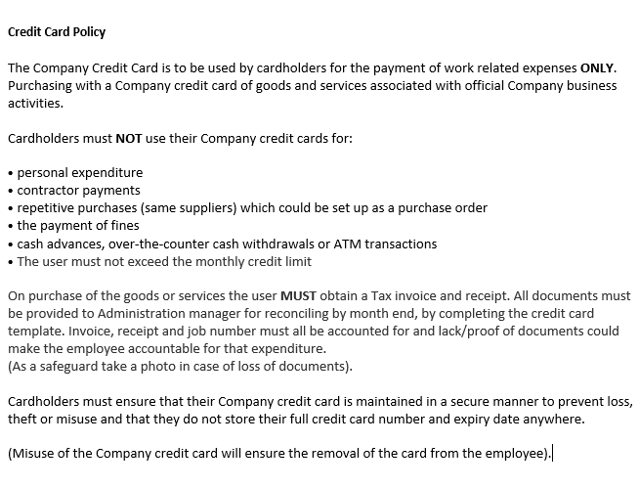

Document 2: Office Procedures
Purpose: To inform staff of the company policies when working in the office.
Format: Microsoft word
Communication means: Formal, Written
Target Audience: Admin Staff / Staff working in the office.
Inclusions: Numbered points.
Organisational requirements:
- Approval from appropriate personnel
- Document access for relevant recipients
- Appropriate use of company name, logo and inclusions
- Suitable methods of filing and saving business document
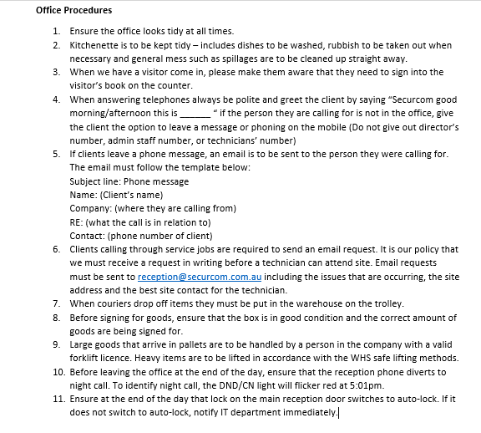

Document 3: Email
Purpose: Inform admin staff of upcoming team meeting.
Format: Email – outlook
Communication means: Formal, Written
Target Audience: Admin Staff
Inclusions: attachments
Organisational requirements:
- Approval from appropriate personnel
- Document access for relevant recipients
- Appropriate use of company name, logo and inclusions
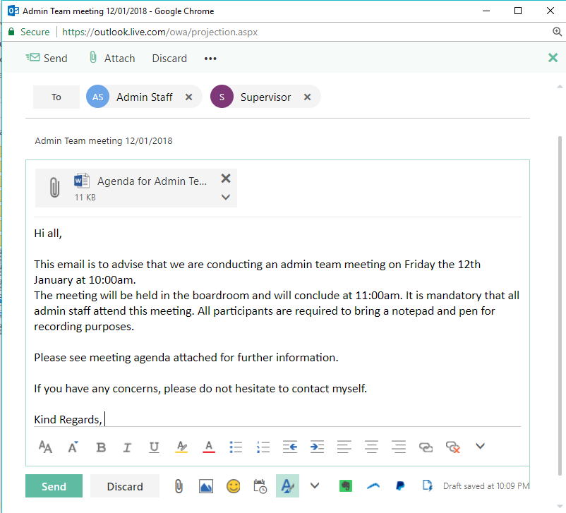
- Suitable methods of filing and saving business document

Major Activity

Using the document that you have developed for Assessment Activities, write a report to your supervisor about the information that you have found. Use at least two different software programs to communicate a meeting so that you can present your findings.

Software 1: Email
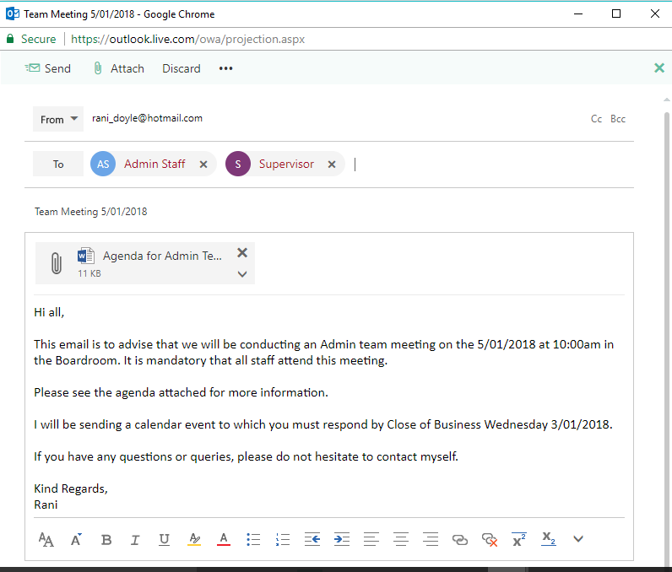

Software 2: Calendar Event
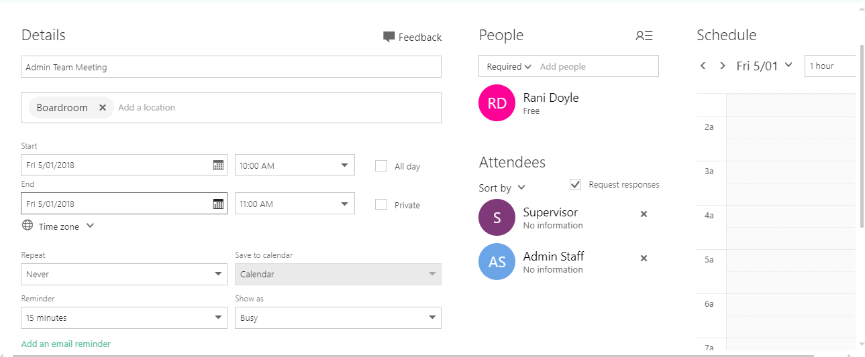

Your intended recipients are your class or work group. You must ask another member of your team to proof read the document before you complete the final draft. Once the final draft is prepared your trainer, team leader or supervisor should sign off on the document.

You should negotiate a time, date and intended venue with your trainer to use for the intended meeting with you workgroup or class with your trainer/team leader/manager.

- Who is the audience? (Remember when you choose the audience; the rest of these answers must target the audience to ensure that the audience receives the message in a format that you can understand.
The target audience is the Admin team and admin supervisor.

- What is the purpose of the document?
Topic will be Changes made WHS within the workplace in relation to the chairs being left in walk way.

- How will you format the document?
Microsoft Word
- How will the document be structured?
The document will be structured with Headings, sub headings and dot points to make the readability of document easier and not overwhelming with a lot of text.

- What inclusions will you use to communicate the purpose of the communication?
I will include illustrations and various shapes as inclusions in this document.

- What organisational requirements will you need to use?
Organisation requirements that will need to be included when creating this document will include:
- Approval from appropriate personnel
- Document access for relevant recipients
- Appropriate use of company name, logo and inclusions
- Suitable methods of filing and saving business document

- What is the appropriate method of communication?
Written method of communication is most appropriate.
- What is the means of communication?
Formal Communication will be used

- Write a draft of the document using the skills you have learnt. The letter should be no more than one page long and must reflect the answers from question 1.
Dear All
This letter is to advise that we are conducting a meeting to discuss additional Policies and procedures put in place regarding workplace health and safety.
This meeting will be conducted on the 5th of January 2018 at 10:00am. The meeting will take place in the board room. All participants are required to bring a notepad and pen for recording purposes.
DRAFT
If you have any concerns, please do not hesitate to contact myself.
Yours Sincerely,
Rani.

Email: rani.d@hotmail.com
Phone: 3248 5599

- While you were writing the letter, you identified that you required two additional pieces of information. How did you source this information and why did you need it? Add this information to the draft of the letter.
When proofreading my draft of the letter, I realised that I had left out two key points that needed to be added in the letter. I sourced this information from when I had gathered information when creating a plan to write this letter.

Updated Draft:

Dear All
This letter is to advise that we are conducting a meeting to discuss additional Policies and procedures put in place regarding workplace health and safety. This will be a formal, interactive meeting and you are all required to attend and contributions during the meeting is encouraged.
This meeting will be conducted on the 5th of January 2018 at 10:00am and will conclude at 11:00am. The meeting will take place in the board room. All participants are required to bring a notepad and pen for recording purposes.
If you have any concerns, please do not hesitate to contact myself.
Yours Sincerely,
Rani.

Email: rani.d@hotmail.com
Phone: 3248 5599

- Proof read document and review for suitability, readability, structure and sequencing, and whether it would meet the organisation’s needs. What resources did you use to assist you with spelling? Who is the intended recipient?

Suitability: This document’s suitability is suitable as it addresses the topic formally and follows the criteria of questions answered in the planning process.

Readability: This letter is worded we making the readability of the document easy for the reader.

Structure and Sequencing: Sequencing and structure was efficient making the body of the letter flow with no awkward placing of random information here and there.

Meets organisation needs? This document meets the organisational needs as they have been adhered to in the process of creating this document.

Resources used to assist with spelling: Resources that were used to assist with spelling included the dictionary.

Intended recipient: The intended recipient is all admin staff and admin supervisor.

- How is information stored and secured in your workplace?

This information is stored and secured on the workplace common drive with accordance to the storage and filing company policies.

