CPCCBC4004A
Identify and produce estimated costs for building and construction projects

PRACTICAL ASSESSMENT INSTRUCTIONS

- The following practical assessment will require the participant to complete work related activities.
- Observations will be conducted of the participant’s work to determine whether they display sufficient practical skills and knowledge.
- Please fill in the details below, providing your name, signature and date of assessment.
  - Your signature acknowledges that the assessor provided clear instructions and the participant understood what was required to complete this assessment.
- The assessor may substitute a Practical Task with another task of equal value.
  - Alternate tasks must be fully documented by the assessor.

Participant name | Alex Butler
Participant signature | 

Assessor name
Assessor signature | 

Date | 24/09/2019

Number of tasks | Number of tasks completed | Satisfactory?
1 (2X) |  | Yes | No

Assessor Comments
CPCCBC4004A
Identify and produce estimated costs for building and construction projects

Practical Task 1 (2X)
Description of task:
On two (2) occasions, a suitable observer is to verify the participant’s ability to establish the estimated costs associated with the acquisition of materials and labour on building and construction sites, together with the application of relevant overhead costs and margins. These tasks may be simulated or real.

The participant is to gather evidence of how they have completed each component of the Practical Task, which is to be submitted with this Practical Assessment sheet. The observer is to provide detailed comments on the tasks completed by the participant. The assessor is to verify the observer’s comments in the Assessor Comments section, and provide the Practical Assessment outcome on the front cover of this document.
Resources required:
Project plans/drawings/specifications, Computer with costing software.
Assessment of task
Name of participant: | Alex Butler
Name of observer: | Conan Butler
Role of observer  (Confirm suitability to sign) | General manager
Email address of observer | conan@eastcoastconcrete.com.au
Signature of observer: | 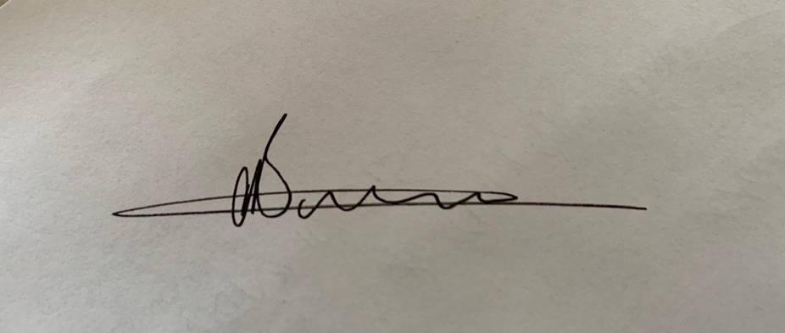
Date: | Click here to enter a date.
When completing the task, did the participant: |  | Tick if satisfactorily completed.  Provide comments if left unticked.
 |  | 1st  Occasion | 2nd  Occasion
- Identify, read and understand plans and drawings:
- Interpreting levels, heights, gradients and other measurements
- Make measurements and identify quantities that conform to standard industry practice (e.g. national codes, standards)
- Identify types and numbers of appropriate on-site personnel and estimate the time required on-site, including labour hours for non-contract elements of on-site work.
- Calculate costs or rates for required on-site work.
- Identify physical resource requirements, producing lists of materials and calculated quantities against project or standard construction contracts.
- Establish prices from suppliers for:
- Materials and consumables
- Plant or requirement requirements
- Determine and apply estimates of unit costs, as appropriate.
- Identify and apply costs of statutory/additional costs, including:
- WorkCover requirements
- Environmental Protection Agency requirements
- Seeking approvals
- Waste management site fees
- Apply company overhead recovery and margins.
- Using a costing software program, calculate completed estimated project costs for inclusion in a tender or bill.
- Effectively communicate using the following methods:
- Verbally using language/concepts appropriate to cultural differences
- Non-verbal communication
The participant’s performance was: Satisfactory Not Satisfactory

observer Comments

