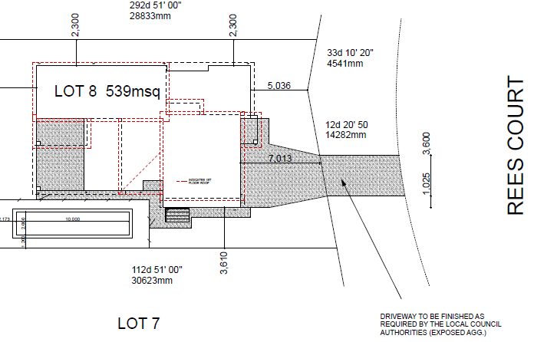
10 ft - Storage container
Deliveries

Site toilet
Deliveries and storage plan
Lot 8 Rees Court, Palm Beach, QLD

Site entry / exit
Temp fence

