CPCCBC4016A
Administer a construction contract

THEORY EXAM INSTRUCTIONS

- This exam will occur under standard assessment conditions.
  - An oral examination may be allowed under certain circumstances.
Answers will be documented and FT003 (Oral examination declaration form) must be completed.
- Participants must provide enough detail in their responses to demonstrate their knowledge and skills.
- Please fill in the details below, providing your name, signature and date of assessment.
  - Your signature acknowledges that this is your own work.
- If a participant initially answers a question incorrectly but modifies their response, they must follow the instructions below:
  - If a participant changes their response in writing, they must put their initials next to the written change.
  - If a participant changes their response verbally, this must be noted on the exam paper by the assessor.

Participant name | Everett Putney
Participant signature | 

Assessor name
Assessor signature

Date | Click here to enter a date.

Number of questions | Number of questions answered correctly | Satisfactory?
49 |  | Yes | No
Assessor Comments

- Identify the various types of building and construction contracts and explain when it is appropriate to apply each type of contract.

Answer | Australian standard contracts - AS2124 and AS4000 series  Australian Construction Contracts govern how the parties to the construction contract behave and how the project manager and the contract manager administer the relationship between the parties. There are several popular standard forms of construction contracts that are currently used in Australia  Construction Industry Contract (CIC) suite  The Australian Building Industry Contract suite (ABIC) is promulgated through a Joint Development Committee which is a joint venture of Master Builders Australia Ltd and the Australian Institute of Architects (AIA). It is designed for use with an architect as the principal’s representative  Contracts required/supplied by regulatory authorities  Individual Organisational Contracts  There are numerous standard forms produced apart from those discussed above. Many public authorities and local government bodies have their own standard forms. Moreover, Master Builders Australia Ltd and its (State-based) member associations produce standard forms for various purposes  Joint Contracts Committee (JCC) suite  The JCC family of contracts was first created by a Joint Contracts Committee (JCC) comprised of representatives from three organizations:  - the Royal Australian Institute of Architects,  - the Master Builders Federation of Australia  - the Property Council of Australia (formerly BOMA - the Building Owners and Managers Association of Australia)  It originated from earlier contracts such as MBW1 in 1970 and E5b in 1970, even going back to an English contract – the RIBA  MBA and HIA contracts  Industry contracts on the market include:  Master Builders  QBCC  HIA  ABIC Simple Works (for architects)  Simple Building Works (SBW)  This form of contract is used for building works that are not complex in nature

Answer

- Use the drawings you completed in the assessment for CPCCBC4014A (from the floor plan below) and the listed task requirements to prepare the new dwelling contract documentation for the client’s signature.

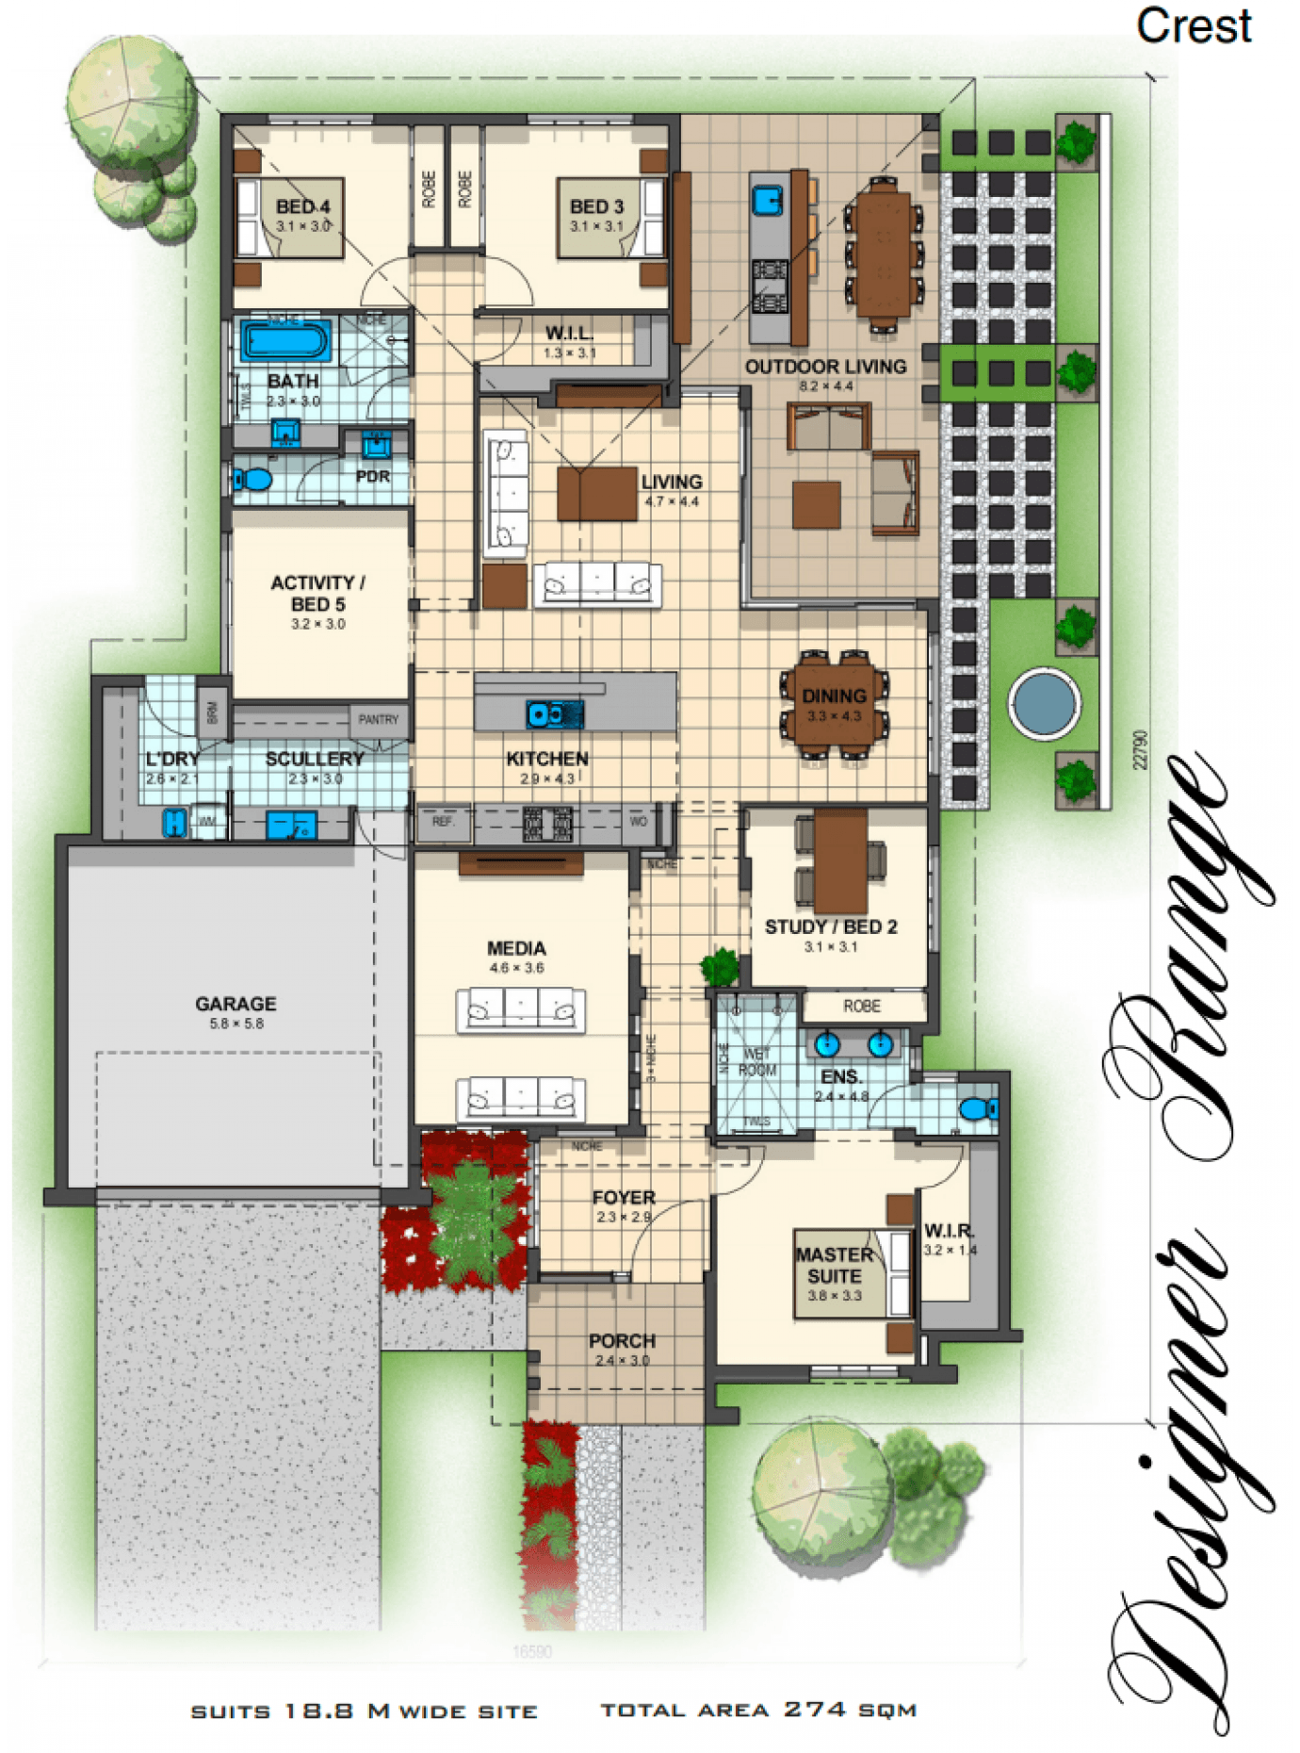
TASK REQUIREMENTS

You are to download the contract documents from the Queensland Building and Construction Commission (QBCC) website at: http://www.qbcc.qld.gov.au/sites/default/files/QBCC_New_Home_Construction_Contract.pdf

Your should:
- Analyse the various types of building and construction contracts you will need and then apply the appropriate application of each type of contract;
- Identify and apply legislative requirements relating to building and construction contracts.
- Identify and apply essential terms and elements of a valid contract;
- Analyse the importance of identifying an intention to create legal relations;
- Identify and analyse rights and liabilities of parties under a contract;
- Identify and apply common building contract terms and procedures;
- Identify and analyse circumstances that bring about a breach of contract;
- Accurately select the contract, appropriate for the type of construction;
- Accurately identify and prepare the range of documents collectively make up a contract;
- Accurately identify and apply requirements associated with an offer and acceptance of a contract;
- Confirm the capacity of the parties to form a binding agreement in the form of a contract; and
- Identify and apply factors associated with the parties' consenting to a contract.

Answer

- How should you handle any customer complaint?

Answer | - Deal with the complaint immediately  - Stay calm  - Identify the problem  - Decide what can be done  - Arrange a second opinion to confirm your view  - Keep records  - Fix the problem

- What does the ‘cooling off’ period refer to when undertaking domestic building work with a total contract price of $20,000 or more?

Answer | A cooling off period means that either party can cancel the building contract as long as it is in writing and:  - Before 5 business days after making of the contract; or  - If relevant provisions of the Act have not been met

- What are the consequences for a client not using a QBCC licensed contractor?

Answer | Your works are not protected under the QBCC act

- What is the Queensland Home Warranty Scheme?

Answer | Under the home warranty scheme, licensed contractors must pay a premium on behalf of the consumer for residential construction work they carry out.  The scheme provides home owners with cover for loss where the licensed contractor does not complete the contracted works or fails to rectify defective work

- What are the consequences of Cost Plus and Construction Management contracts on Home Warranty Insurance protection?

Answer | The nature of the contractual arrangements means that you will NOT receive the full range of protection ordinarily available under the Queensland Home Warranty Scheme (especially for non-completion).

- At the commencement of a contract valued over $20,000, what must the contractor give to the owner? What timeframes apply?

Answer | A progress claim schedule
  Progress Payments
  1. Deposit | 5% (Contract sum)
  2. Base Stage | 15%
  3. Frame stage | 20%
  4. Enclosed stage | 25%
  5. Fixing stage | 20%
  6. Practical completion | Balance

- Where must the total contract price be stated?

Answer | On the first page of the contract

- What are the maximum deposits recommended and how should progress payments be scheduled?

Answer | $20k or more – max 5%  $3.3k-$20k – max 10%  Less than $3.3k – recommended 20%  Scheduled by stages of the building process from deposit to PC

- Who has responsibility of building inspections and approvals?

Answer | Certifier

- Identify and describe the term used to describe circumstances such as:
- Where there has been a change to the materials used or
- A change to the scope of the work to be performed under the contract?

Answer | A variation to the contract - A variation of a contract may be ‘additions to’ or ‘deductions from’ the works to be executed

- How do you reduce the risk of dispute?

Answer | Confirm all details in writing  Read contracts before signing them  Develop good communication and relationships  Be organised  Train your staff  Know your legal obligations  Seek help early

- What is the process for dispute resolution?

Answer | - Deal with the complaint immediately  - Stay calm  - Identify the problem  - Decide what can be done  - Arrange a second opinion to confirm your view  - Keep records  - Fix the problem

- When might an extension of time (EOT) apply? How is it approved?

Answer | when an owner increases the scope of works for example. Must be approved through an EOT form in writing

- When is the client/home owner required to pay the final contract payment?

Answer | At issue of formal practical completion

- What are implied warranties?

Answer | An implied warranty of fitness for a particular purpose is a warranty implied by law that if a seller knows or has reason to know of a particular purpose for which some item is being purchased by the buyer, the seller is guaranteeing that the item is fit for that particular purpose

- Explain the responsibilities of an Owner Builder.

Answer | Follow conditions of your permit  Display an owner builder sign  Supervise the works for quality control  Manage dispute resolution should the need arise  Pay subcontractors in accordance with contractual agreements

Answer

- What is ‘notifiable work’, who is responsible and to whom does it apply?

Answer | Notifiable work is common, everyday plumbing and draining work performed by plumbers and drainers on existing buildings. If you are a QBCC plumbing and drainage licensee, you must always report notifiable  It includes:  - installing, replacing or removing any electric, gas, solar or heat pump hot water heaters  - installing fixtures such as toilets, showers and sinks  - extending, altering, replacing or removing water supply pipes  - extending, altering, replacing or removing waste pipes (depending on the placement of the pipework

Answer

Answer

- What is the difference between the Prime Cost Item Schedule and the Provisional Sum Schedule in a contract? Give one example to help explain your answer.

Answer | ‘Prime cost’ refers to a set budget allocated for an item or set of items that need to be bought for a building or renovation project. Eg. PC fixtures such as taps – if you haven’t specified a particular brand, model and style of taps, or if it’s impossible to get an idea of the price for what you want, then your builder is likely to allocate a certain amount of dollars for taps rather than specifying exact costs  ‘Provisional sum’ refers to an estimate in your builder’s contract for what it’ll cost do a particular part of your building or renovation job. Provisional sums are estimates that are provided where the builder can’t give an exact figure for the work required, after having made reasonable enquiries into what it’ll actually cost.  One example might be for excavation. Even with a soil test, it may be difficult to know exactly what’s under the ground, and therefore difficult to pinpoint the cost and effort required

- What does Section 109 of the Queensland Building and Construction Commission Act 1991 provide to the consumer/client?

Answer | A building contractor must, at the request of a consumer, allow the consumer reasonable access to a building site at which building work is being carried out for the consumer

- What are some of the preliminary contracts that a builder could ask a client to sign prior to signing the main contract?

Answer | Drawings  Specifications  Foundation data  Engineers specs  Footing performance  Termite management

- What are liquidated damages in terms of a signed building contract?

Answer | Client’s charging “liquidated damages” under a contract means there is a fixed sum of money which the builder agrees to pay the client, often in relation to late completion of the project. Many queries about liquidated damages come from Building association members who are parties to commercial construction contracts, although they can still apply to residential projects as well

- What contract documentation would you review to identify any unusual aspects related to materials and installations for a low rise construction project?

Answer | Schedule of finishes/specifications

- Where would you find any possible penalties associated with a build?

Answer | In the head contract – Liquidated damages section

- What is the Australian Standard Contracts - AS2124 and AS4000 series?

Answer | AS2124 and AS4000 are designed for use on major building and engineering projects where a ‘superintendent’ is engaged to administer the contract who is an independent professional (or a firm of consultants) or an employee of the principal. The contract  price may be calculated as a lump sum or re-measurement (schedule of rates/bill of quantities) or a combination of these

- How does the Queensland Building and Construction Commission (QBCC) regulate the Queensland building industry?

Answer | Through:  licensing contractors  educating contractors about their legal rights and responsibilities  educating consumers about their rights and obligations  handling disputes fairly and equitably  protecting homeowners against loss through the Queensland Home Warranty Scheme  implementing and enforcing legislative reforms and, where necessary, prosecuting people not complying with the law

- What industry legislation should builders and trade contractors have a good understanding of?

Answer | QBCC act  QCAT  Building Act  BCIPA (recently changed)  WHS Act

- What supporting documents should you be aware of and include in your contracts with the consumer?

Answer | Drawings  Specifications  Foundation data  Engineers specs  Footing performance  Termite management

- What are the four (4) essential elements of an agreement for it to be regarded as a contract?
What is the consequence if any essential element is missing?

Answer | offer  acceptance  intention of legal consequence  consideration  if any are missing the agreement is not legally binding

- When would an offer be considered to have lapsed?

Answer | when the time for acceptance expires;  if the offer is withdrawn before it is accepted; or  after a reasonable time in the circumstances (generally the greater the value of the contract, the longer the life of the offer)

- What is able to be ‘accepted’? What happens to the offer if new terms are suggested?

Answer | Only what is offered. If new terms are considered as a counter offer which can be accepted or rejected

- What does it mean when a contract is supported by valuable consideration?

Answer | One party promises to do something in return for a promise from another party  Consideration is what each party gives to the other as the agreed price for the other’s promises  Usually the consideration is the payment of money

- Identify the term for each of the definitions listed in the table below.

Answer | Term | Definition
 | Addition | Any construction or change to a building or facility that increases its external dimensions and cubic contents.
 |  | A procedure for resolving disputes that involves less formality than a court hearing. An arbitrator’s decision is final and cannot be appealed.
 |  | Assists builders, contractors and owners by ensuring that construction projects meet building regulations and codes of practice. Inspections assess design documentation and make on-site inspections during building work.
 |  | Demonstrates that a building, other than a dwelling has been inspected and passed.
 |  | The achievement of performance criteria described in a regulation or other statutory requirement. This is usually demonstrated by a compliance or approval certificate.
 |  | An agreement entered into between two or more parties that involves an exchange or specified goods and/or services for specified financial reimbursement or other considerations.
 |  | One or more buildings which in association constitute a single dwelling being a detached house or one or more attached dwellings.
 |  | A person who carries out domestic building work on his her own land, who is not in the business of building.
 |  | Independent professionals with the same power to issue building permits and occupancy permits as municipal building surveyors.
 |  | A person accepted by the appropriate authority as qualified to design, construct (or install) or supervise the erection of, buildings or services; usually recognised by a certificate of registration.
 |  | That part of an allotment which is covered by buildings, expressed as a percentage of the area of the allotment.
 |  | A minor clause in a contract the remedy for breach of which is damages for any loss. Also, a promise to repair or replace defective goods.

- Explain the terms listed in the table below.

Answer | Term | Definition
 | Minor breach | the non-breaching party cannot sue for specific performance but actual damages
 | Material breach | is any failure to perform that permits the other party to the contract to either compel performance, or collect damages because of the breach.
 | Fundamental breach | is a breach that permits the aggravated party to terminate performance of the contract. In addition that party is entitled to sue for damages

- Who are the parties that need to be consulted with for binding agreements to be confirmed?

Answer | Buyers advocates  Legal practitioners  conveyancers

- What is consent?

Answer | Is an act of reason and deliberation that is implied in every agreement

- When might ‘apparent consent’ be negated?

Answer | Apparent consent may be negated because of mistake, fraud, innocent misrepresentation, duress or undue influence, all of which are defences to the enforcement of the contract

- A construction contract can be terminated for ‘cause’ or for ‘convenience’. Explain these two terms.

Answer | 1. A termination for cause occurs when one party stops work because of a deficiency in performance by the other party. Because the contract is terminated as a result of a party's own poor performance, the law typically provides the terminated party with little recourse in the event of a termination for cause.  2. A termination for convenience, occurs when the owner stops work for reasons other than a deficiency in performance by the contractor. Because a termination for convenience is not the result of poor performance, the law may provide the aggrieved contractor with significant rights against the breaching owner

- What does repudiation mean?

Answer | Repudiation is a term used to describe the rejection of a proposal or idea.  When a party to a contract is unwilling, or exhibits behaviour which suggests that they are unwilling to perform their contractual obligations, the innocent party has the right to terminate the contract due to repudiation

- Explain the concept ‘conditions for completion at the cost of the contractor’.

Answer | Defects after completion  17.1 The Contractor must make good defects or omissions in the work under this Contract which become apparent within 6 months of the Date of Practical Completion.  17.2 If there are any such defects or omissions, the Owner must give the Contractor written notice to make good such defects or omissions within the 6 month period  and must give the Contractor reasonable access to the Site for that purpose.  17.3 Subject to reasonable access being provided, the Contractor must within 28 calendar days of the notice being given rectify any defects notified to the Contractor under Condition 17.2 during usual business hours

- What does ‘abandonment of contract’ mean?

Answer | Abandonment can have different meanings. One type of abandonment is contract abandonment, where the parties both have conducted themselves in such a way that the original contract is no longer valid. Both parties may mutually agree to do this, or it can become part of a claim.  Another type of abandonment is where a contractor fails to perform the work on a project by either not starting the project in a reasonable amount of time, or not completing the work, or failing to resume work in a reasonable amount of time. Abandonment of a construction project without legal excuse is a cause for disciplinary action under B&P sect.1707

- Throughout the building schedule, progress payments are made when each new stage is ready to commence.
Nominate the recommended stages and percentages for these progress payments on a typical new residential housing building project.

Answer
  Progress Payments
  1. Deposit | 5% (Contract sum)
  2. Base Stage | 15%
  3. Frame stage | 20%
  4. Enclosed stage | 25%
  5. Fixing stage | 20%
  6. Practical completion | Balance

- Which section of the Subcontractors’ Charges Act 1974 (Qld) address vexatious notices of claim?

Answer | Section 22

- Describe the circumstances in which a person is deemed to give notice of a claim of charge without unreasonable grounds.

Answer | A person who vexatiously or without reasonable grounds gives a notice of claim of charge is liable to pay to a person prejudicially affected thereby such damages as the person sustains in consequence thereof.  (1A) Without limiting subsection (1), a person gives a notice of a claim of charge without reasonable grounds if the person knows, or ought reasonably to know, that the amount of the claim exceeds, to an unreasonable extent in the circumstances of the claim, the amount actually payable to the person.  (2) Damages pursuant to subsection (1) must be determined and fixed by the court on an application by the person prejudicially affected

- Who should you consult if you are considering ousting a contractor from a building site?

Answer | A legal practitioner

- What document should you refer to if you are considering ousting a contractor from a building site?

Answer | QBCC indicates which offense dictates the legal ousting of a contractor

- Contract Cost Adjustment Provisions address risk by providing mechanisms for adjusting contract payment to reflect changes in costs.
What can cost adjustment apply to?

Answer | Labour and materials  Currency exchange rates for goods purchased in foreign currency  Other costs, including duties and taxes or shipping and transport

- What document will outline the time extensions you are entitled to over the contract period?

Answer | The head contract

