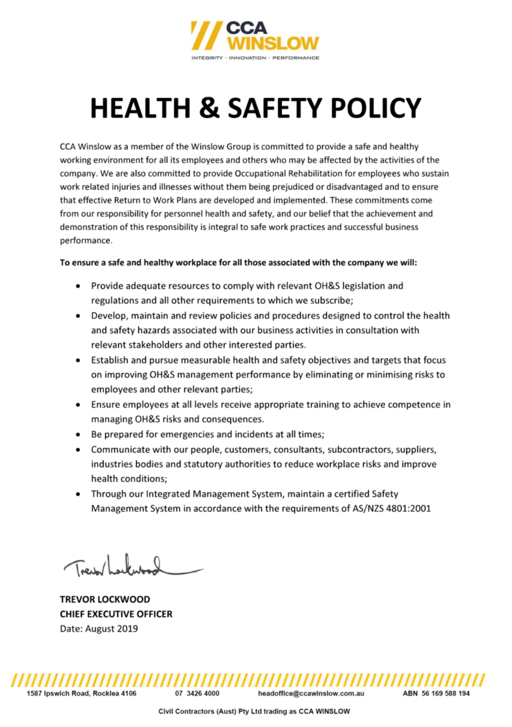

Review of CCA Winslow’s Health & Safety Policy | November 2020
The intention of a Toolbox Talk is to share lessons and information across the company to help prevent injuries, incidents and improve the safety culture of our workplaces.
We all want to prevent injuries, and see our people going home at the end of each shift free of work related injury or disease. By sharing such information and learning from it, we can reduce the likelihood of injuries and incidents happening.
Policy Review

Recently CCA Winslow engaged an external consultant to review our current 2019 Health & Safety Policy, as part of the company’s continual improvement process.

It is CCA Winslow’s duty to ensure that workers are provided with safe systems of work while engaged at CCA Winslow projects and workplaces.

To meet this obligation CCA Winslow regularly reviews the Health & Safety Policy and Safety management system to ensure it reflects current legislation, aligns with industry practice and manages relevant health & safety hazards and risks for our workers.
Recommendations from review
The review report provided a number of recommendations;

1. Refer to Workplace Health and Safety (WHS).
2. Policy to use the terminology “workers” as per the definition in the legislation.
3. Include in the Policy; the provision of safe plant and structures; the provision of safe storage of plant, structures and substances; the provision of adequate facilities.
4. Define further consultation avenues.
5. Identify the management of psychosocial hazards that may impact CCA Winslow workers.

What does this mean for workers
Updating the CCA Winslow Policy will ensure that the company is further aligned to the intent of the WHS legislation and ensure that workers health and safety are ensured to the best of our abilities.
What Next?
As part of CCA Winslow’s consultation process, workers being asked to provide feedback on the current Health & Safety Policy and the recommendations for updating.

Please speak with your supervisor, HSR or HSEQ Advisor to provide feedback.

