
AHCLSC305
Construct stone structures and features

Copyright © 2022 CSTC Pty Ltd

All rights reserved. No part of the contents of this publication may be reproduced or used in any form or by any means – graphic, electronic, or mechanical including photocopying, digitising, recording, or information storage-and-retrieval systems – without the written permission of CSTC Pty Ltd.
ASSESSMENT FOR AHCLSC305

Student name | Lachlan Pomerenke
Date of assessment submission | Click here to enter a date.

Trainer/Assessor’s name
Date of assessment marking | Click here to enter a date.
Outcome for unit | ☐ Competent  ☐ Not Yet Competent

TASK INSTRUCTIONS

- As part of the assessment for this unit of competency, you are required to complete a series of activities.
  - Some of these activities will require you to provide a response within this document, others will require you to gather evidence to demonstrate your knowledge and skills.
- At all times, the responses in your assessment must reference Australian (Queensland or Federal) documentation, including legislation, regulations, codes of practice, standards and guidance publications.

ACTIVITIES

Draw a simple concept plan for a proposed landscape design which includes stone structures/features.

Response
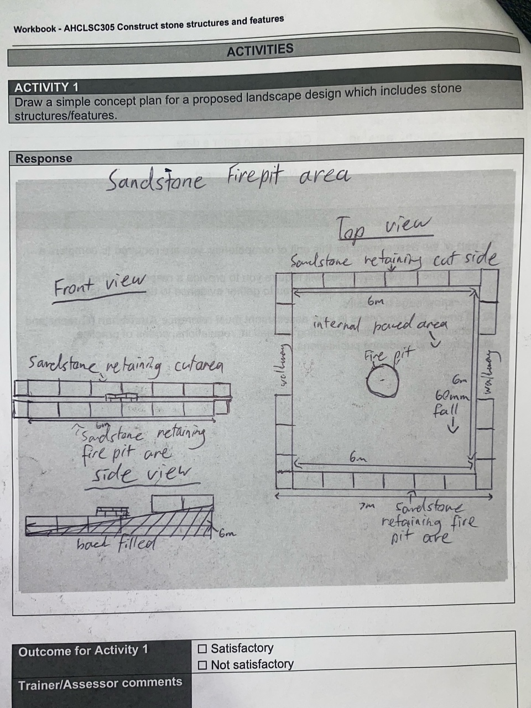

Outcome for Activity 1 | ☐ Satisfactory  ☐ Not satisfactory
Trainer/Assessor comments

Identify/list the detail on the landscape plan shown.

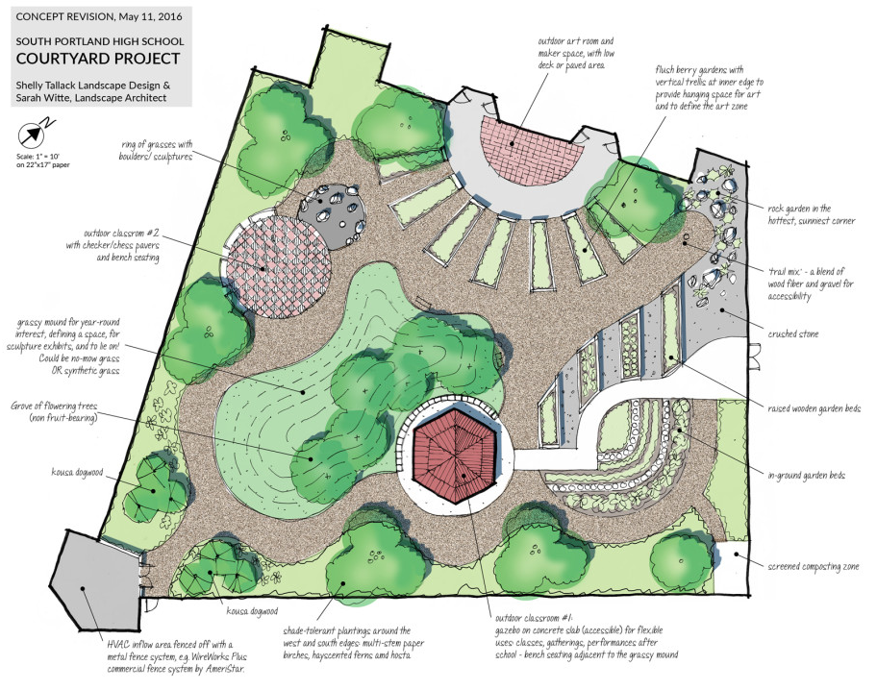

Response
Project plans for South Portland High School courtyard project
- Proposed outdoor art room with paved or decked area
- Flush berry gardens with trellises to hang art.
- Rock garden in crushed stone in the sunniest area
- Wood fibre and gravel walkways
- Raised and inground garden beds with a composting zone on the East side of the site
- Gazebo for outdoor classes on a concrete slab with a concrete walkway for easy access.
- Shade tolerant plantings around the West and South edges
- Flowering trees around the gazebo on a grassy mound to be lied on using either fake or real grass.
- Open paved area for another learning space with bench seating
Ring of grass with boulders/ sculptures to separate open learning area and open art room.

Outcome for Activity 2 | ☐ Satisfactory  ☐ Not satisfactory
Trainer/Assessor comments

List the materials required to complete the water feature, by using the wall and water feature construction plan shown.

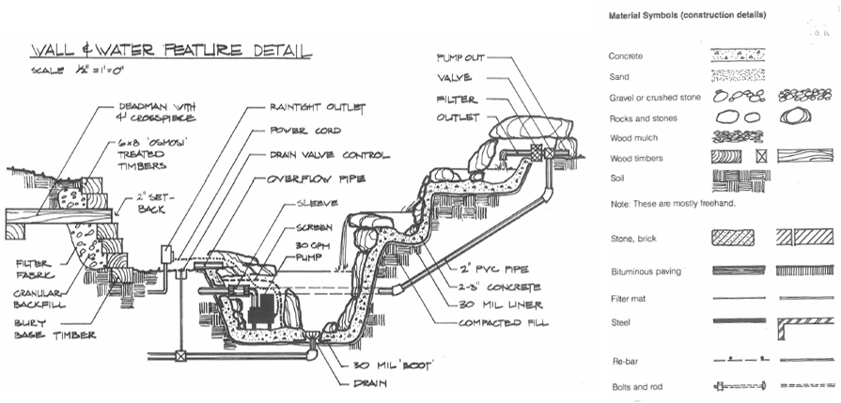

Response
Concrete
Sand
Gravel
Rocks and stones
Wood mulch
Wooden sleepers
Soil
Stone, brick
Bituminous paving
Filter mat
Steel
Re-bar
Bolts and rod

Outcome for Activity 3 | ☐ Satisfactory  ☐ Not satisfactory
Trainer/Assessor comments

Identify formal and informal stone structures and describe their features.

 | Features
- Formal stone structures | Uniform pathways and flooring areas. Features such as seats, benches, and counters. Square steppingstones and large sandstone retaining walls. Formal stonework follows a pattern or consistent sizing to make a uniform look
- Informal stone structures | Informal stone structures make a more natural non-uniform look that is applicable wherever the heart desires. Small slate retaining walls and large boulder walls are very common. The process takes a lot longer but can create beautiful pathways, paved areas, and steppingstones. Informal stonework can be used as cladding or for feature walls.

Outcome for Activity 4 | ☐ Satisfactory  ☐ Not satisfactory
Trainer/Assessor comments

List the components for four (4) common surface drainage systems used in landscape construction.

System | Components
- Spoon | A spoon drain like a channel and grate is a strip that can bend and mauver with the environment and have an open face. They can become prone to blockages due to soil, sticks and leaves are the most cost effective and efficient drainage system in gully’s or to assist natural water channels
- Channel and grate | Channel and grate drains are often used in pathways or driveways where water floods over a larger surface area in a low volume. The drain will fall one way or the other for the water to run into either garden or into the stormwater system.
- Pit | Pit drains have only a small square exposed for water to flow into when they are installed. They are very good for draining environments where water all falls to one point. They are easy to plug into the stormwater system for the water to escape and also easy to attach channel and grate drains to.
- Contour | A contour drain works by using and manipulation the earths contour to redirect waterflow away from an area or towards a desired drain or dam.

Outcome for Activity 5 | ☐ Satisfactory  ☐ Not satisfactory
Trainer/Assessor comments

List the advantages and disadvantages of drainage behind and through the stone wall (as shown).

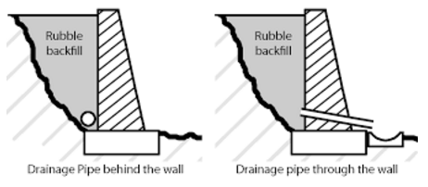

Drainage pipe behind the wall
Advantages
Looks nicer than having holes through the wall
Leaves the wall stronger not leaving little points where it could potentially crack
Disadvantages
Drainage isn’t as effective especially when the bottom of wall meets up with concrete.

Drainage pipe through the wall
Advantages
Provides better drainage for the wall’s stability and longevity.
Weep holes can be pointed onto specific plants next to the wall or into pit or strip drains so water isn’t flowing onto the surface in front of it.
Disadvantages
Doesn’t look as nice as a wall without weep holes
Areas around the weep hole are more likely to crack overtime.

Outcome for Activity 6 | ☐ Satisfactory  ☐ Not satisfactory
Trainer/Assessor comments

Research and list a variety of admixes.

Admix | Description
- Fritz pak  - FR1 water reducer | Reduce water to mix ratio.  Reduce cement content required.  Increase mixture slump.
- Fritz pak NCA | Concrete accelerant  Increases cement hydration for quick initial setting
- Plastiretard | Retarding mixture  Decreases initial cement hydration for a slower setting time  Allows for more time to finish
- Optimum pozzolanic admixture | Used for water retention products such as dam walls or ponds  Reduce the heat of hydration and thermal shrinkage  Prevents the water from leeching anything out of the concrete.

Outcome for Activity 7 | ☐ Satisfactory  ☐ Not satisfactory
Trainer/Assessor comments

Research other methods of damp proofing (excluding DPC and base course) and identify the materials used.

Damp proofing method | Materials
- Membrane damp prove course | Plastic strip that is towards the bottom of the wall or structure that prevents moisture from moving up the wall
- Elector Osmosis | Platinum coated anodes, titanium connecting wire, copper coated cathode and a regular power supply.
- Chemical damp proof course | Silane/siloxane cream added to the mortar bed to form a permanent polysiloxane damp proof course
- Cavity or hollow walls | The outer wall prevents the inner wall from receiving any moisture by leaving a continuous air space or cavity between them. Metal ties through the wall maintaining the gap

Outcome for Activity 8 | ☐ Satisfactory  ☐ Not satisfactory
Trainer/Assessor comments

Research and describe suitability of various patterns for stone work projects.

Pattern | Suitability
- Random ashlar | Formed dressed stones of random heights and widths fitted closely together. Most commonly used for house cladding
- Boulder wall | Boulder walls are suitable for large retaining wall projects through to small garden beds and mowing strips. Large uniform sandstone boulders can be used to make flush levels and tight joins or unrefined boulders straight from quarry can be used for a non-uniform look.
- Random course ashlar | In a random course ashlar, the stones in each course are of the same dimensions but vary from course to course. This pattern is also commonly used as cladding on the exterior of buildings.
- Random rubble | Stone placed at random with a level header. The outwards facing stones are hammer dressed for a more desirable finish. This masonry pattern is suitable for structural purposes with grouting and reinforcement but is more commonly used for small structures such as garden beds.

Outcome for Activity 9 | ☐ Satisfactory  ☐ Not satisfactory
Trainer/Assessor comments

List the advantages and disadvantages of mortared and dry stone features.

Mortared stone features
Advantages
Makes structures stronger
Can be used to make patterns and arches
Allows for taller structures to be built
Disadvantages
Costly
Takes a long time
If the structure fails it will be harder to repair

Dry stone features
Advantages
Shorter on time and less material cost
Can be easily adjusted if the structure moves or sinks
Disadvantages
Not as strong and stable as a motored stone structure

Outcome for Activity 10 | ☐ Satisfactory  ☐ Not satisfactory
Trainer/Assessor comments

Research the different types of stone work finishes.

Response
- Polished finish by grinding sanding and buffing
- Natural cleft. Leaving the quarried face up to show small natural lines in slate type flooring
- Honed finished by grinding and sanding to a smooth, yet not glossy finish. Best for low maintenance, high traffic areas.
- Flamed finish by applying a high temperature flame to create thermal shock to the stones surface. Used in outdoor areas for slip resistant areas.
- Sandblasted finish by blasting with high pressure sand for a rough but tidy look for high traffic areas.
- Leather finish is only available in varieties of marble and granite. The finish gives the stone a suede look and feel, and the texture is smooth and slip resistant.
- Split face. Mainly used for cladding by splitting stone to create an uneven front surface.
- Veneer stone is any stone of any finish used as a decorative facing material as a non-load bearing wall cladding.

Outcome for Activity 11 | ☐ Satisfactory  ☐ Not satisfactory
Trainer/Assessor comments

List environmentally safe products for cleaning.

Response
Bondi wash floor wash. A gentle nontoxic floor and general cleaner.
Oats eucalyptus disinfectant floor and surface antibacterial cleaner.
Optimate plant-based floor cleaner.
Lemon myrtle floor cleaner concentrate.
Lithofin MN power clean

Outcome for Activity 12 | ☐ Satisfactory  ☐ Not satisfactory
Trainer/Assessor comments

Have team members take photos and videos of your involvement with stone features.

Identify each photo / video with a letter label and describe each photo / video in the table below. Submit the photo / video files along with this workbook.

Advantages
A | 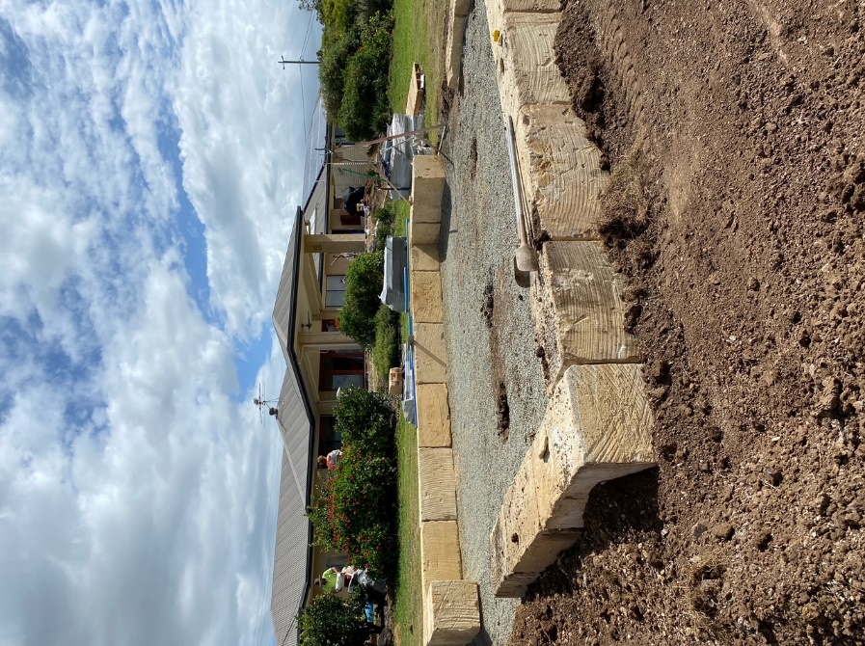  Complete stonework for a firepit area with blocks cut in and adjusted to make a square 6x6m are inside
B | 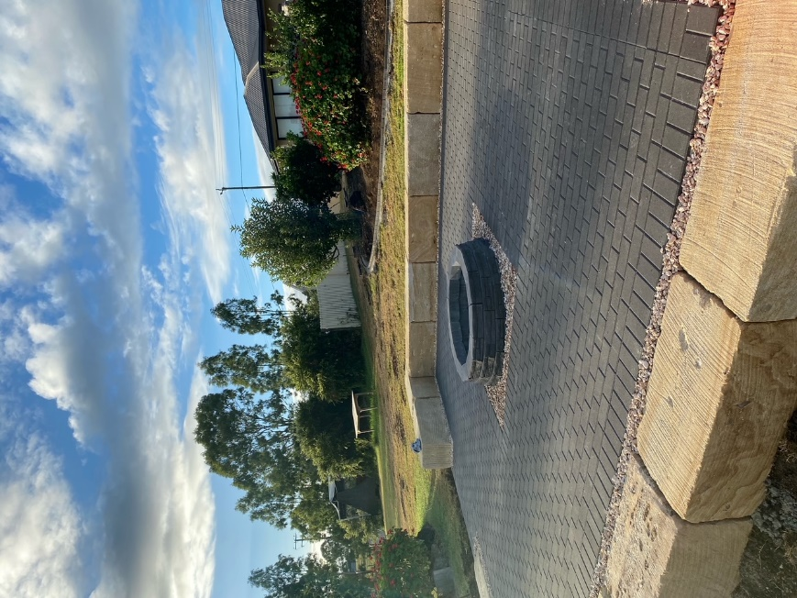  Complete sandstone firepit area after concrete, paving and filling with decorative gravel.
C | 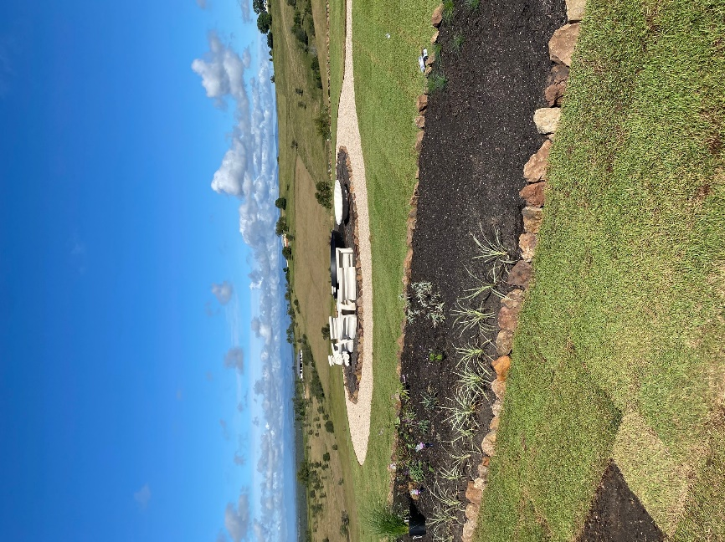  Multiple garden beds with stone edges I hand stacked on a deco base after marking out with a measuring tape and paint, also using stringlines to get perfect circles such as the centre garden.
D | 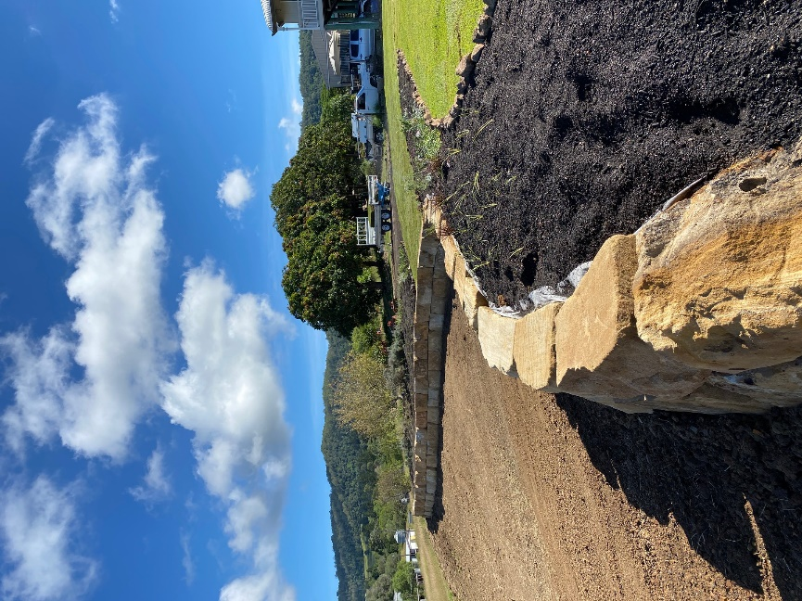  B grade sandstone wall built with the uncut face out to make a more rough, natural face. Built on a screeded base of 10mm drainage gravel and backfilled with the same gravel with landscape fabric against the rock.
E | 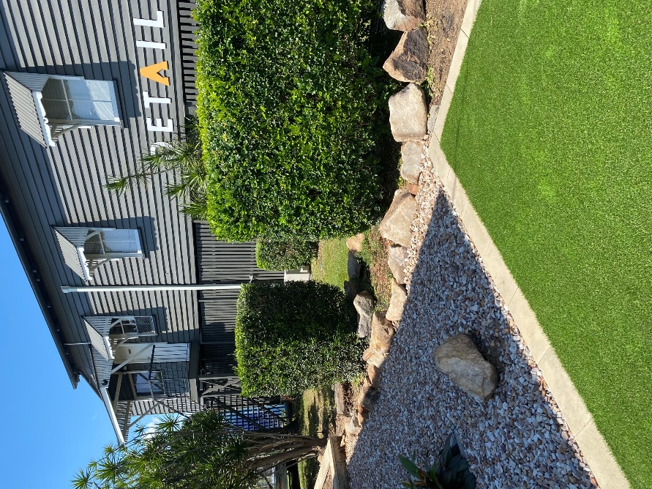  Medium sized rock acting as the border between two property’s while also retaining the sandstone gravel on one side.
F | 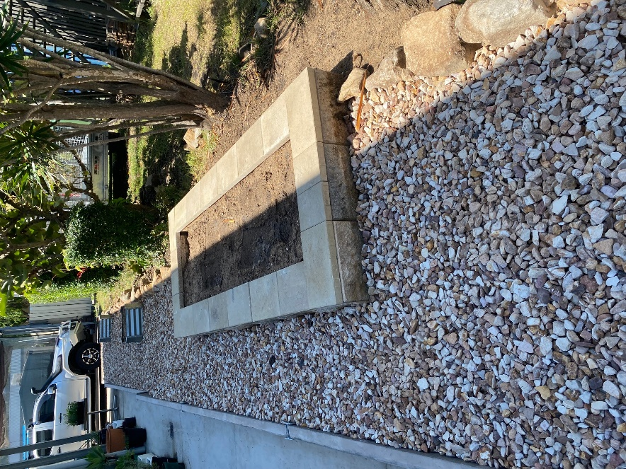  Stone border from previous photo continuing down the property boundary.
G | 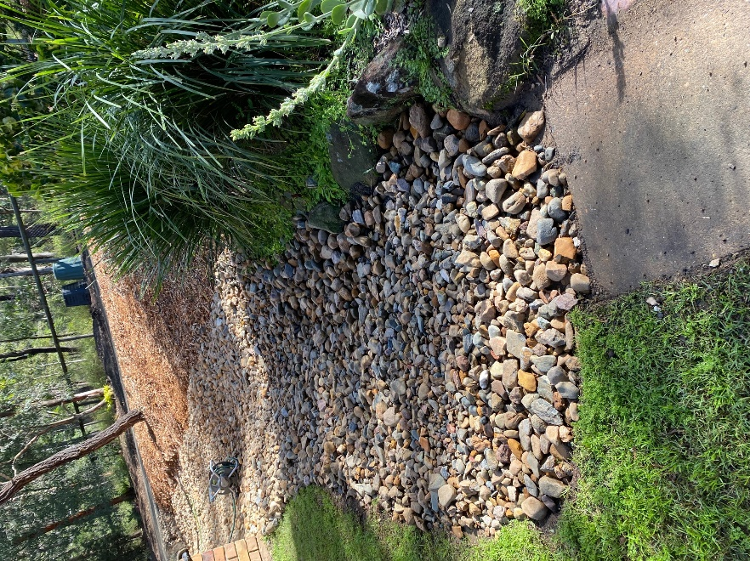  Dry creek bed using 40-75mm river stone to help with drainage issues property owner was experiencing. The new creek runs approximately 150m from the top of the property under an internal driveway and out to the nature strip where it runs off into a drain along the road.
H
I
J
K
L
M
N
O
P
Q
R
S
T
U
V
W
X
Y
Z

Outcome for Activity 13 | ☐ Satisfactory  ☐ Not satisfactory
Trainer/Assessor comments

