



CPCCBC6001
Apply building codes and standards to the construction process for large building projects

LEARNER GUIDE
Version Control
Unit code | Document version | Release date | Comments/actions
CPCCBC6001 | 10.1 | 09.02.2022 | First edition
CPCCBC6001 | 10.2 | 14.02.2023 | Added section relating to Government contracts pg. 4  Added to structural design pg. 81

Copyright
Copyright ©2020 by CAQA Resources.
Copyright protects this material. No part of this publication may be reproduced, distributed, or transmitted in any form or by any means, including photocopying, recording, or other electronic or mechanical methods, without the prior written permission of the publisher, except in the case of brief quotations embodied in critical reviews and certain other non-commercial uses permitted by Copyright Act 1968 (Cth). For permission requests, write to the publisher, addressed “Attention: Permissions Coordinator,” at the address below.
Inquiries should be addressed to:
CAQA Resources
2/10 Lawn, CT
Craigieburn, Victoria – 3064
Australia
www.caqaresources.com.au
Disclaimer
Although the author and publisher have made every effort to ensure that the information in this book was correct at press time, the author and publisher do not assume and hereby disclaim any liability to any party for any direct, indirect, incidental, or consequential loss, damage, or disruption caused by errors or omissions, whether such errors or omissions result from negligence, accident, or any other cause. Data and case study examples are intended to be fictional. Any resemblance to real persons or organisations is coincidental.
If you believe that information of any kind in this publication is an infringement of copyright, in material in which you either own copyright or are authorised to exercise the rights of a copyright owner, and then please advise us by contacting CAQA Resources, 2/10 Lawn Ct, Craigieburn, Victoria - 3064 or email copyright@careercalling.com.au.
Acknowledgement
This remains the property of CAQA Resources, a Career Calling initiative.


Table of Contents
Table of Contents 2
Introduction 4
CHAPTER 1: INTERPRET RELEVANT CODES AND STANDARDS REQUIREMENTS. 6
1.1 Identify relevant clauses from the NCC that apply to individual open classification projects. 8
1.2 Determine scope of works and prescriptive requirements relevant to the NCC. 12
1.3 Access and interpret requirements of relevant Australian Standards referenced in the NCC. 15
CHAPTER 2: CLASSIFY BUILDINGS. 18
2.1 Determine the nature of buildings according to use and arrangement. 20
2.2 Apply NCC criteria to determine the defined classification. 22
2.3 Identify and interpret NCC requirements for multiple classifications. 24
CHAPTER 3: APPLY SOLUTIONS TO CONSTRUCTION PROBLEMS 27
3.1 Determine the range of NCC criteria required to ensure project compliance. 29
3.2 Identify alternative, compliant solutions for construction problems to comply with NCC Performance Requirements. 33
3.3 Meet the Performance Requirement of the NCC by applying a Performance Solution supported by one or a combination of the Assessment Methods. 35
3.4 Use a Deem-to-Satisfy (DTS) solution supported by one or a combination of Assessment Methods to meet NCC compliance. 38
3.5 Use a combination of Performance Solutions and DTS solutions to comply with the Performance Requirements of the NCC. 40
3.6 Identify and complete relevant documentation to meet Performance Requirements of the NCC. 42
3.7 Discuss compliance options with relevant construction personnel to ensure compliance with NCC Performance Requirements. 43
CHAPTER 4: APPLY FIRE PROTECTION REQUIREMENTS. 46
4.1 Determine fire resistance required for the construction of all classes and types of buildings. 48
4.2 Identify and apply NCC requirements with respect to passive and active fire protection to all classes and types of buildings. 51
4.3 Check existing buildings for compliance with passive and active fire protection requirements according to NCC requirements. 54
CHAPTER 5: IMPLEMENT STRATEGY TO MANAGE CONSTRUCTION COMPLIANCE 57
5.1 Establish strategies to manage construction compliance of large, complex and high-rise buildings with the NCC. 59
5.2 Implement and coordinate the work of professionals involved in the development and management of the building process. 61
5.3 Seek effective design solutions for buildings of more than three storeys to meet the needs of clients and ensure compliance with the NCC. 63
5.4 Design and implement quality assurance processes to ensure effective and compliant management of the construction process. 64
5.5 Detect non-conforming building materials and products and manage the evidence of suitability as required in the NCC. 66
CHAPTER 6: ADDITIONAL INFORMATION 68
References 93

Introduction
Building Codes
The set of guidelines defined by the governing body to attain minimum standards of safety and welfare of a masses of a building is termed as building codes.
The main goal of building codes is to secure public well-being, safety and general welfare as they are related to the construction and inheritance of buildings and structures. The building code becomes the law of a specific jurisdiction when officially instituted by the proper legislative or private power.
The National construction code, which provides a set of technical provisions for the design, construction, and performance of buildings, plumbing, and drainage systems throughout Australia, is used according to Australian legislation.
In partnership with the Australian Government and each State and Territory Government, the Australian Building Codes Board publishes and maintains it.
Government building and construction legislation:
Building regulatory building standards and codes law in each State and Territory give legal effect to the BCA. This legislation comprises an Act of Parliament and subordinate legislation that gives the Government the authority to regulate certain features of buildings and structures and provides the administrative requirements needed to carry out the legislation.
State or Territory legislation may override or apply to any provision of the BCA. As a result, the BCA must be interpreted in light of that Act. Any questions about these issues should be directed to the State or Territory authority responsible for building regulations.
Working on Government buildings:
Federal, state and local governments make tender requests to the private sector for the supply of goods and services. Government agencies advertise tenders through their own websites, for example, The federal government publishes all business opportunities, annual procurement plans, multi-use lists and contracts on its centralised AusTender website.The Queensland Government advertises tender opportunities on the QTenders website. You can register on the website to receive email alerts for government tenders that are relevant to your business. If you are interested in Tendering for government building work, you must:
- Register your interest at the relevant website
- Attend any tender information sessions offered.
  - These are valuable opportunities to ask questions and make contact with the agency. They may also give you a chance to meet potential subcontractors or make contacts that could participate in a consortium.
- Develop your tender proposal
  - Follow all recommentations for assessing and developing your bid
  - Locate and make use of networks and referees
- Submit and present your bid.

The Australian Building Codes Board

The ABCB is governed by an agreement between the Commonwealth and each state and territory government.It’s a partnership between the signatories, the local Government, and the construction sector.
Its purpose is to develop nationally consistent performance-based building regulatory systems that are efficient, cost-effective, and meet community and industry needs. It reports to the Ministerial Council for Planning, Housing, and Local Government.
The Board is made up of
- The chief executive officer of each state and territory's administration is in charge of building regulations.
- A commonwealth representative; and
- An Australian local government association (ALGA) representative; and
- Business representatives.
The Building Codes Committee (BCC) is the ABCB's highest technical advisory body, responsible for technical issues relating to the BCA.
The BCC is made up of:
- The ABCB's Executive Director.
- One nomination from each of the ABCB's Commonwealth, State, Territory, and ALGA members; and
- Industry members nominated by the ABCB.



CHAPTER 1: INTERPRET RELEVANT CODES AND STANDARDS REQUIREMENTS.

Introduction
This chapter deals with the detailed information regarding interpreting relevant codes and standard’s requirements. Identifying important NCC provisions related to individual open categorisation projects, determining the scope of work and prescriptive requirements relevant to the NCC, and finally, accessing and interpreting applicable Australian Standards cited in the NCC.


What will I learn?

In this chapter,you will learn about the following:
- Identify relevant clauses from the NCC that apply to individual open classification projects.
- Determine scope of works and prescriptive requirements relevant to the NCC.
- Access and interpret requirements of relevant Australian Standards referenced in the NCC.

Identify relevant clauses from the NCC that apply to individual open classification projects.

Building or plumbing law enacted by your state or territory government, or other statutory authority, gives legal effect to the NCC. These Acts and Regulations establish the legislative foundation and administrative processes for the NCC to support building design and construction and plumbing and drainage systems.
This section provides information regarding identifying relevant clauses from the National construction code that apply to individual open classification projects. An individual open categorisation project encompasses all building classes and kinds within the NCC, focusing on the construction of structures with more than three stories.
Relevant clauses from the NCC that apply to individual open classification projects
Following are the clauses of NCC that are applied to individual open classification projects such as:
- NCC vol.1 J5.5 Ductwork insulation
- NCC vol.1, 3.9 Car park
- NCC vol.1, CP1 structural stability during a fire
- NCC vol.1, CP2 Spread of fire
- NCC vol.1, C1.2 Calculation of rising in storeys
- NCC vol.1, C1.3 Buildings of multiple classifications
- NCC vol.1, D1.2 Number of exits required
- NCC vol.1, D2.22 Re-entry from fire-isolated exits
- NCC vol.1, E1.5 Sprinklers
- NCC vol.2, Clause: 3.8.2 Room heights
- NCC vol.2, clause: 3.3, masonry
The NCC assigns a categorisation to each form of building or structure based on the purpose for which they are planned, constructed, or converted to be employed, rather than the function or use they are put to. This section discusses how the NCC defines and uses each building classification.
"Class 1" through "Class 10" are the different building classifications. Sub-classes, denoted by a letter after the number, exist in several classifications (e.g. Class 1a).
Volume One of the NCC covers most of the technical building requirements for Class 2 to 9 buildings, whereas Volume Two of the NCC covers most of the criteria for Class 1 and 10 buildings.
The clauses are discussed below:
A6.0 Determining the classification of a structure
- The function for which a structure or component of a building is planned, constructed, or converted to be utilised determines its categorisation.
- Each structure component must be classified according to its intended use and must meet all classification standards.
- A room containing a mechanical, thermal, or electrical facility or the like that serves the building must be classified in the same way as the primary component or main use of the building or fire compartment where it is located.
- An occupiable outdoor area must have the same classification as the component of the building to which it is connected unless another classification is more appropriate.
A6.1 Class 1 structure
One or more of the following sub-classifications are included in a Class 1 structure:
- A single dwelling is defined as one or more buildings that together form a single dwelling and include the following:
- A single-family residence.
- A row home, terrace house, town house, or villa unit is one of a group of two or more attached houses, each of which is a building separated by a fire-resistant wall.
A building in Class 1b is one or more structures that together form—

- A boarding house, guest house, hostel, or similar establishment that—
- Has a maximum capacity of 12 people, and (ii) has 12 people.
- Have a total floor space of not more than 300 m2 (measured across the building or buildings' surrounding walls); or
- Four or more single residences on one allotment are used for short-term vacation rentals.
A6.2 Class 2 structures
- A Class 2 structure is one with two or more sole-occupancy apartments.
- In a Class 2 building, each sole-occupancy unit must be a distinct home.
Buildings in Class 3 (A6.3)
A Class 3 building is a residential structure that provides long-term or transient housing for a group of unrelated people, such as:
- A boarding house, a guest house, a hostel, a lodging house, or a hostel for backpackers.
- A hotel or motel's residential area.
- A school's residential area.
- Facilities for the elderly, children, and individuals with disabilities.
- A residential section of a healthcare facility that houses employees.
- A detention centre's residential section.
- A facility for long-term care.
Buildings in Class 4 (A6.4)
Part of a building that is a dwelling or residence within a non-residential building (Class 5 to 9), such as a caretaker’s residence in a hospital.
Buildings classified as A6.5, Class 5
A Class 5 structure is an office building utilised for business or professional purposes.
Class 6 structures (A6.6)
A Class 6 building is a shop or other structure used for the retail sale of goods or the direct provision of services to the general public, such as—
- A restaurant, café, milk or soft-drink bar; or (2) an eating room, café, restaurant, milk or soft-drink bar; or (3) milk or soft-drink
- A dining room or bar area that is not part of a hotel or motel's assembly building, store, or kiosk; or
- A barbershop, a public laundromat, or an undertaker's establishment; or
- A market, a showroom, or a service station.
Buildings classified as A6.7 Class 7
A Class 7 structure is a storage structure that comprises one or more of the following sub-categories:
- A car park (Class 7a).
- Class 7b – a structure used for storing or displaying products or produce for wholesale sale.
A6.8 Class 8 structures
A Class 8 structure is a process-oriented structure that includes the following features:
- A structure where items or products for sale are manufactured, assembled, altered, repaired, packed, finished, or cleaned.
A6.9 Class 9 structures
A Class 9 structure is a public structure that comprises one or more of the following sub-categories:
- A health-care facility, including any building areas set aside as labs, and a health-care building used as a residential care building, is classified as Class 9a.
- Class 9b — an assembly building in a primary or secondary school that includes a trade workshop or laboratory.
- Class 9c – Aged care facility
A6.10 Structures and buildings in Class 10
One or more of the following sub-classifications are included in a Class 10 structure:
- A non-habitable structure includes a private garage, carport, shed, or similar structures.
- A structure that is a fence, tower, antenna, retaining wall or free-standing wall, swimming pool, or the like is classified as Class 10b.
- A private wildfire shelter is classified as Class 10c.
Multiple classes (A6.11)
A building (or a portion of a building) can be designed, built, or altered for various functions and be classified in more than one way.

Determine scope of works and prescriptive requirements relevant to the NCC.

The National Construction Code (NCC) is a performance-based code that contains all of the Performance Requirements for building construction.
It's organised into a hierarchy of advice and code compliance levels, with the Performance Requirements serving as the minimum standard for all buildings, building elements, and plumbing and drainage systems. The Performance Requirements, which are the NCC's mandatory requirements, determine if a building, plumbing, or drainage system complies with the NCC.
General Requirements help to support Performance Requirements. These cover a variety of other features of using the NCC, such as:
- It is interpreted
- Documents of reference
- The acceptance of the design and construction, as well as any supporting evidence
- Adequacy/documentation, and
- The NCC's classification system for buildings.
The key to the performance-based NCC is that no specific material, component, design factor, or building approach is required. This allows for a variety of compliance options.

A Performance Solution (Alternative Solution) or a Deemed-to-Satisfy (DTS) Solution can be used to meet the Performance Requirements.
This section provides information regarding determining the scope of works and perspective requirements relevant to the NCC. The scope of work generally requires the timelines to complete the project, and prescriptive requirements include ‘what to do’ and ‘how to do’ statements.
The scope of works and prescriptive requirements include the following terms such as:
- Characteristics: The distinguishing quality of the component or product is known as characteristics. The NCC includes the characteristics of every component, e.g. For a fast response sprinkler; it includes different discharge characteristics.
- Compatibility: Scope of work of NCC also includes the prescriptive requirements of compatibility of two components so that they can exist or work together. For example, The NCC is responsible for specifying fire performance for fire window that makes compatibility with fore walls in which it is located.
- Dimensions: All the dimensions of components of buildings are specified by NCC. The minimum and maximum dimensions requirements are specified in its base upon different design approaches.
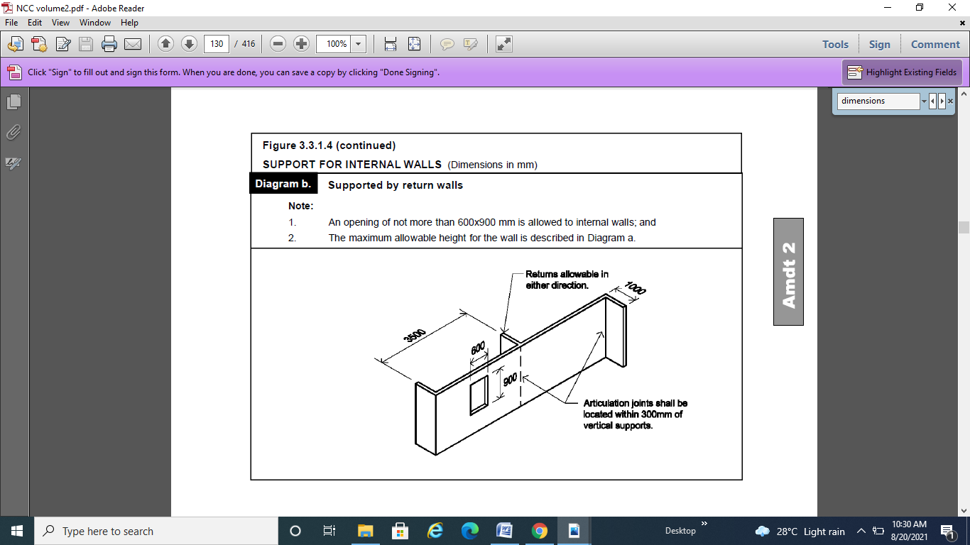
- Location: It also includes different parts of the building and signs.
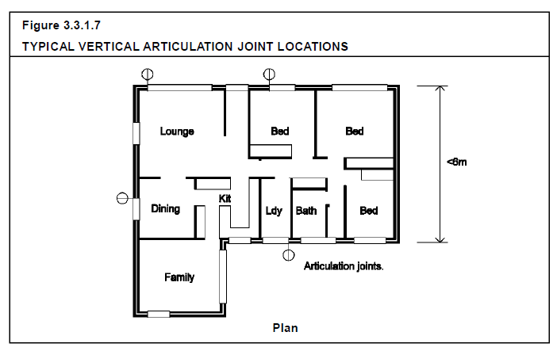
- Patterns: The NCC defines different patterns or shapes for components. The NCC volume three includes the drainage system that describes the different pipe patterns according to the building requirements.
- Quantities: The scope of work specifies the different quantity requirements for the material according to the type of work.
- Sizes: It also describes the size of different areas, such as the size of the compartment for fire hydrants. Moreover, it includes the size of different components, for example;
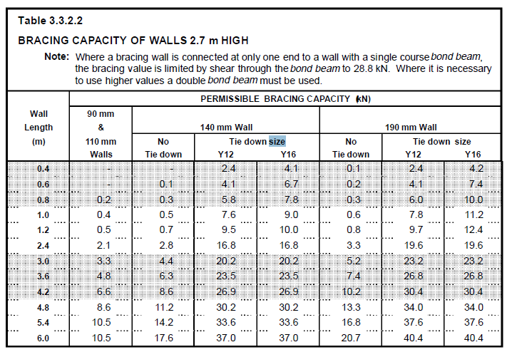
- Surfaces: Information related to surfaces is specified by NCC's scope of work.
- Type of product or service. This includes the type of product and service required according to the type of job.

Access and interpret requirements of relevant Australian Standards referenced in the NCC.

Before initiating the construction work, you need to ensure that you have accessed and interpreted the requirements of relevant Australian Standards referenced in the NCC. This will help you do your work safely and ensure all work is compliant.
The National Construction Code (NCC) is a set of technical standards that apply across Australia for the design, construction, and performance of buildings and plumbing and drainage systems. The Australian Building Codes Board publishes and maintains it on behalf of and in conjunction with the Australian Government and each State and Territory Government.
Relevant Australian standards referenced in NCC:
- Volumes One and Two of the Building Code of Australia (BCA) (given effect through the Environmental Planning and Assessment Act 1979)
- Volume Three of the Australian Plumbing Code (given effect through the Plumbing and Drainage Act 2011).
Requirements
The NCC is a performance-based code that sets the minimum requirements concerning structure, fire safety, access and egress, accessibility, health and amenity, and sustainability.
All new buildings, new building work, and new plumbing and drainage systems must comply with the NCC.
Compliance with the NCC is achieved by meeting the relevant Performance Requirements.
This can be done by:
- Complying with the prescriptive Deemed-to-Satisfy Provisions,
- The development of a Performance Solution or
- A combination of both.
Designers can choose between DTS and Australian Standards as Performance Hierarchy.
On the other hand, this compliance process may necessitate expert judgment and further verification.
When a Deemed-to-Satisfy Provision adopts a Standard, rule, specification, or provision found in any document produced by Standards Australia or another authority, that adoption does not contain a provision-specific standard, rule, specification, or provision-
- Stating or clarifying any manufacturer's, supplier's, or purchaser's respective rights, responsibilities, or obligations; or
- Defining the roles and responsibilities of any tradesperson or other construction worker, architect, engineer, authority, or other person or body; or
- Requiring the submission of any material, building component, form, or technique of construction for approval to any person, authority, or entity other than one authorised to do so by state or territory legislation.; or
- Requiring the submission of material, building component, form, or method of construction to standards Australia or a standards Australia committee for expression of opinion; or
- Allowing the manufacturer or purchaser to deviate from the code, rule, specification, or provision at their sole discretion or by arrangement or agreement between them.


Self-check assessment

QUESTION 1
List any two relevant clauses that relevant clauses from the NCC that apply to individual open classification projects.
- NCC vol.1 J5.5 Ductwork insulation
- NCC vol.1, 3.9 Car park
QUESTION 2
Explain any one relevant Australian standard in detail which is referenced in NCC.
- ______________________________________________________________ NCC Volume One primarily covers the design and construction of multi-residential, commercial, industrial and public assembly buildings and some associated structures.
- AS3600 concrete structures
QUESTION 3
Discuss any five prescriptive requirements relevant to the NCC.
- Characteristics: The distinguishing quality of the component or product is known as characteristics. The NCC includes the characteristics of every component, e.g. For a fast response sprinkler; it includes different discharge characteristics.
- Quantities: The scope of work specifies the different quantity requirements for the material according to the type of work.
- Surfaces: Information related to surfaces is specified by NCC's scope of work.
- Dimensions: All the dimensions of components of buildings are specified by NCC. The minimum and maximum dimensions requirements are specified in its base upon different design approaches.
- Location: It also includes different parts of the building and signs.

CHAPTER 2: CLASSIFY BUILDINGS.
Introduction
This chapter deals with the information regarding the classification of buildings that includes determining the nature of buildings as per their usage and arrangements, moreover, applying NCC criteria to find the defined classification, in the end, identify and interpret NCC requirements for multiple classifications.
What will I learn?
In this chapter, you will learn about the following:
- Determine the nature of buildings according to use and arrangement
- Apply NCC criteria to determine the defined classification.
- Identify and interpret NCC requirements for multiple classifications.

Determine the nature of buildings according to use and arrangement.

The NCC assigns a categorisation to each form of building or structure based on the purpose for which they are planned, constructed, or converted to be utilised, rather than the function or use to which they are placed.
This section discusses how the NCC defines and uses each building classification. "Class 1" through "Class 10" are the different building classifications. Sub-classes, denoted by a letter after the number, exist in several classifications.
Following are the nature of buildings according to use and arrangement such as:
Class 1 buildings include houses, i.e., stand-alone single dwellings of a domestic or residential nature. These houses may also combine horizontally with other class 1 buildings, for instance, terrace houses and city houses. In that condition, their houses are separated by a wall that is fire resistant and a sound insulator. The class 1 buildings are further classified as Class 1a and Class 1b.
A Class 1a building is a single dwelling, a disengaged house; or a gathering of joined dwellings being a townhouse, row house, or something like that.
A Class 1b structure is a lodging, visitor house, or inn with a floor region under 300 m2 and commonly has under 12 individuals. It can likewise be at least four single homes situated on one designation, which are utilised for momentary occasion convenience.
Class 2 buildings: Apartment buildings come under Class 2 buildings. These are commonly multi-unit residential buildings where masses live above and below each other. These buildings contain single storey attached dwellings with a common space beneath them. For instance, a common car park under two dwellings.
Class 3 buildings: The residential buildings other than class 1 and class 2 buildings come under the class 3 buildings category. These buildings are utilised as a commonplace for unrelated masses. To exemplify, guest house, hostel, workers’ quarters and care-type for children, the elderly or masses with disability.
Class 4 part of a building: The residence present in the building of non-residential nature comes under class 4 part of a building, for instance, caretakers’ dwelling in the storage facility.
Class 5 Buildings: Commercial structures, such as offices, are designated as Class 5 structures. Offices for lawyers, accountants, general medical practitioners, government agencies, and architects are examples of Class 5 structures.
Class 6 buildings: The places utilise for the sale of goods and supply of services to the masses comes under class 6 buildings such as shops, restaurants and cafés.
Class 7 buildings: These are classified under two categories;
Class 7a buildings include car parks.
Warehouses, storage facilities, and buildings for the exhibition of goods (or produce) for wholesale are all examples of Class 7b structures.
Class 8 buildings: An industrial facility is the most widely recognised approach to depicting a Class 8 structure. It is a structure where a cycle (or craftsmanship) is completed for exchange, deal, or gain. The structure can be utilised for creation, gathering, modifying, fixing, getting done with, pressing, or cleaning of merchandise or produce. It incorporates structures like a specialist's studio. It might likewise be a structure for food fabricate, like an abattoir. A research centre is likewise a Class 8 structure, even though it very well might be little in size. This is because of their high potential for fire risk.
CLASS 9 buildings: The buildings utilised for public purposes come under Class 9 buildings. Class 9 buildings consist of three sub-classifications: Class 9a, Class 9b and Class 9c.
Class 9a buildings are commonly hospitals known as health-care buildings by NCC.
Class 9b buildings include schools, colleges, sporting facilities and public transport buildings in which masses are gathered for political, social and religious purposes.
Class 9c buildings include aged cares defined as accommodation locations for elderly masses.
Class 10 buildings: It includes non-habitable structures subdivided into three categories: Class 10a, Class 10b and Class 10c.
Sheds, carports, and private garages are examples of Class 10a structures.
Class 10b structures include fences, masts, antennas, retaining walls, swimming pools, and similar structures.
A private wildfire shelter is a Class 10c structure. A private bushfire shelter is a structure that is connected to a Class 1a building but not attached to it.

Apply NCC criteria to determine the defined classification.
This section provides information regarding applying NCC criteria to determine the defined classification. Volume One of the NCC covers most of the technical building requirements for Class 2 to 9 buildings, whereas Volume Two of the NCC covers most of the criteria for Class 1 and 10 buildings. The plumbing and drainage standards for all building categories are covered in Volume Three of the NCC.
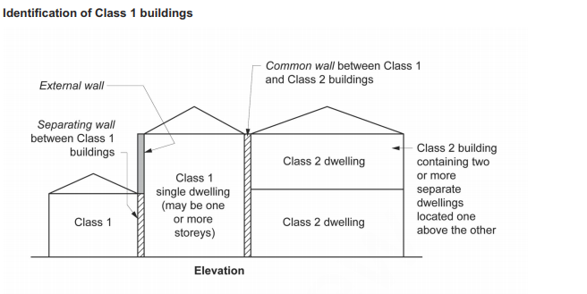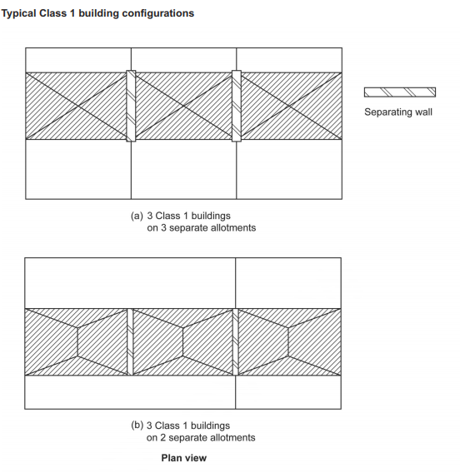
Applying NCC criteria
Classification is a method of determining the risks associated with a structure or component based on its intended usage. It must be done correctly to accomplish NCC goals appropriate for each building in each situation.
It is conceivable for portions of a single building to be classified differently. A building's components can also be classified in more than one way. If there is a disagreement between the part's standards, the more stringent requirement takes precedence.
When it's unclear which categorisation should be used, the proper authorities have the last say. They make their selection based on a review of the construction proposal.
They'll determine which categorisation the structure most closely resembles. They will also consider the expected fire load and the likely repercussions of any dangers to the building's safety, health, and amenity. The appropriate authorities will also consider any relevant court rulings or determinations of the State or Territory body responsible for handling building classification appeals. It's worth noting that rulings by appeals bodies and certain court decisions are rarely precedent-setting in some states and territories. These kinds of decisions are made on a case-by-case basis.
It's also worth noting that building regulatory bodies in each state and territory may have offered guidance, interpretations, or recommendations to help practitioners apply the correct classification to a structure or part. The appropriate authority should be consulted on such problems.
If the storey has a large floor area, the 10% or less concession area may be considered, even if the rest is classified as a building with lower risk potential. The following is an example of how this area concession could be used:
- If a single-story factory has an office that occupies 8% of the total floor area, the entire structure (including the office) can be categorised as Class 8.
- However, if the office area occupies 12 per cent of the floor area of the storey, that portion must be categorised as Class 5, while the rest of the building must be classified as Class 8.

Identify and interpret NCC requirements for multiple classifications.

This section provides information regarding identifying and interpreting NCC requirements for multiple classifications.
According to NCC, A building that serves more than one purpose and classification come under multiple classifications.
As per NCC, one can combine class6/7 or class 5/6 under multiple classifications according to the flexible utilisation of the building. To exemplify, if a building requires an office, shop and storage, it will be designed as a Class5/6/7.
To design these types of buildings, they must be meet the minimum requirements of all classifications, then they can be used for their appropriate purpose.
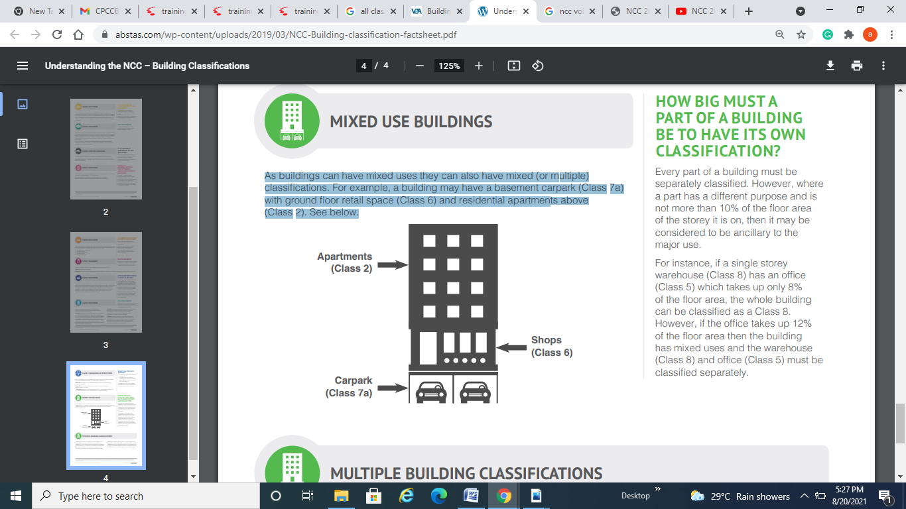
As NCC volume 1, clause C1.3, the Following is the procedure to determine the type of construction for a building that contains more than one class.
The following figure is used to a shown method for finding the type of construction required for multiple classifications.
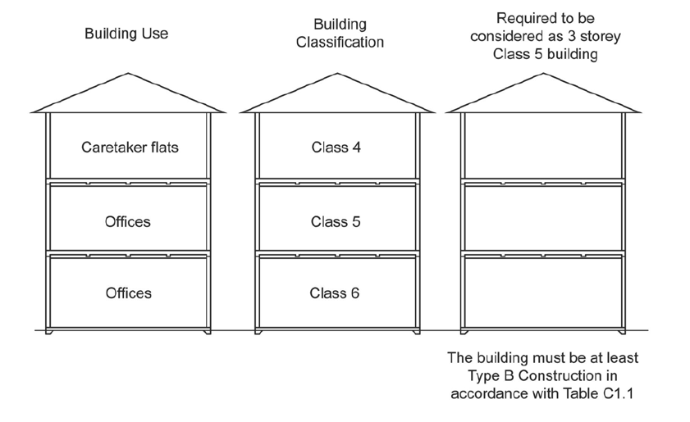
Further explanation is provided in 2.1.
Self-check assessment

QUESTION 1
What is determining the nature of buildings so important?
To be able to design buildings, they must be meet the minimum requirements of a classification, then they can be used for their appropriate purpose.
QUESTION 2
How do we identify and comprehend NCC requirements for multiple classifications?
Clause C1.3, the Following is the procedure to determine the type of construction for a building that contains more than one class. Apply the building use to be able to work out the classification.
QUESTION 3
What are the procedures involved in determining the defined classification using NCC criteria?
Classification is a method of determining the risks associated with a structure or component based on its intended usage. It must be done correctly to accomplish NCC goals appropriate for each building in each situation.
It is conceivable for portions of a single building to be classified differently. A building's components can also be classified in more than one way. If there is a disagreement between the part's standards, the more stringent requirement takes precedence.
One procedure is As NCC volume 1, clause C1.3, the Following is the procedure to determine the type of construction for a building that contains more than one class.

CHAPTER 3: APPLY SOLUTIONS TO CONSTRUCTION PROBLEMS

This chapter deals with the information regarding applying solutions to the construction problems that include determining the range of NCC criteria required for guaranteeing project compliance. Moreover, identification of compliant solutions then apply them by using assessment methods. Furthermore, use a Deem-to-Satisfy solution to comply with the performance requirements of the NCC. In the end, after completion of relevant documents, discuss compliance options with relevant construction personnel.

What will I learn?
In this chapter, you will learn about the following:
- Determine the range of NCC criteria required to ensure project compliance.
- Identify alternative, compliant solutions for construction problems to comply with NCC Performance Requirements.
- Meet the Performance Requirement of the NCC by applying a Performance Solution supported by one or a combination of the Assessment Methods.
- Use a Deem-to-Satisfy (DTS) solution supported by one or a combination of Assessment Methods to meet NCC compliance.
- Use a combination of Performance Solutions and DTS solutions to comply with the Performance Requirements of the NCC.
- Identify and complete relevant documentation to meet Performance Requirements of the NCC.
- Discuss compliance options with relevant construction personnel to ensure compliance with NCC Performance Requirements.

Determine the range of NCC criteria required to ensure project compliance.

This section explains about to determine the range of NCC criteria essential for ensuring project compliance.
If a Building Solution meets the Performance Requirements, it will comply with the BCA.
Meeting the Performance Requirements Only by— will you meet the Performance Requirements.
- Complying with the Deemed-to-Satisfy Provisions, or
- Developing an Alternative Solution that—
- Meets or exceeds the Performance Requirements; or
- Can be shown to be at least as good as the Deemed-to-Satisfy Provisions;
- Or a combination of (a) and (b).
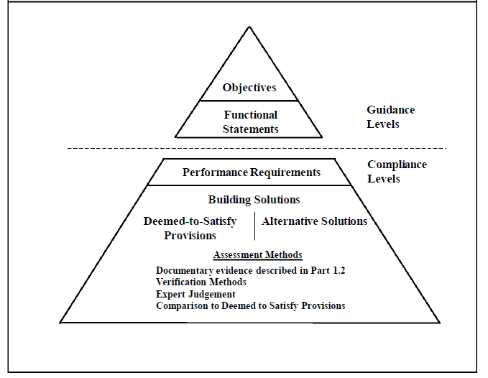
Objectives and Functional Statements: The Objectives and Functional Statements can be utilised as a tool for interpretation.
Provisions Deemed to Satisfy: The Performance Requirements are judged to be met if a Building Solution meets the Deemed-to-Satisfy Provisions.
Alternative Approaches
- An Alternative Solution must be evaluated using one or more assessment methods.
- If the Assessment Methods used to determine compliance with the Performance Requirements are met, an Alternative Solution will comply with the BCA.
- Assessment Methods must be used to identify the Performance Requirements that apply to an Alternative Solution.
To determine whether a Building Solution meets the Performance Requirements, one or more of the following Assessment Methods, or a combination of them, can be used:
- Proof that a material, building method, or design satisfies a Performance Requirement or a Deemed-to-Satisfy Provision.
- Verification Methods, such as
- the BCA's Verification Methods, or
- any other Verification Methods that the competent authority accepts for assessing performance requirements compliance.
- The Deemed-to-Satisfy Provisions are compared.
Expert opinion.
Compliance requirements:
A solution must meet the Governing Requirements and the Performance Requirements to comply with the NCC. The Governing Requirements specify how the Performance Requirements must be fulfilled.
Performance Requirements define the minimum requirements that various buildings or building parts must meet. The only NCC technical provisions that must be met are the Performance Requirements.
State and Territory modifications and additions may be relevant to certain Performance Requirements in some cases.
A solution can be a Performance Solution and a Deemed-to-Satisfy Solution simultaneously. Regardless of the approach used, building proponents must always adhere to the NCC's Performance Requirements.
The use of Verification Methods that are not included in the NCC is allowed under A2.2(2)(b)(ii). The following are examples of verification methods:
- A computation based on mathematical models or analytical procedures; or
- A test that uses a technical process to directly quantify the amount to which the performance requirements have been met, either on-site or in a laboratory; or
- An inspection (and a report on the inspection); or
- Any other form of certification that is appropriate.
The relevant authority must approve any verification method employed.
A Performance Solution must meet all applicable NCC Performance Requirements. A Performance Solution is a customised solution that meets the Performance Requirements' intended goal. A Performance Solution must meet all applicable Performance Requirements and be confirmed using one or more of the Assessment Methods listed below:
- Suitability evidence.
- Method of Verification
- Expert opinion.
- The Deemed-to-Satisfy Provisions are compared.
A Deemed-to-Satisfy Solution is achieved by following the necessary Deemed-to-Satisfy Provisions in the NCC. The Deemed-to-Satisfy Provisions are a set of rules that must be met to be satisfied (i.e. like a recipe book, they tell you how, what and in which location things must be done). The term "Deemed-to-Satisfy" refers to materials, components, design considerations, and construction processes that, if employed, are deemed to meet the Performance Requirements.
One or more of the following Assessment Methods can be used to verify a Deemed-to-Satisfy Solution:
- Suitability evidence
- Expert opinion.
There is no such thing as a stand-alone NCC provision. Any deviation from the Deemed-to-Satisfy Provisions for a Performance Solution must be evaluated in light of the relevant Performance Requirements in the relevant NCC Section or Part. Furthermore, the proposed Performance Solution may impact other Performance Requirements in different Sections or Parts. As a result, these extra Performance Requirements must be examined in conjunction with the Performance Solution in question. The procedures for identifying which Performance Requirements are relevant are described in A2.2(3) and A2.4(3).

Identify alternative, compliant solutions for construction problems to comply with NCC Performance Requirements.

The NCC defines an alternative solution as follows:
"Alternative Solution" refers to a construction solution that meets the Performance Requirements without satisfying the Deemed-to-Satisfy Provisions.
This section discusses alternative solutions to a construction problem that will comply with NCC performance requirements . Alternative Solution refers to a Building Solution that meets the Performance Requirements without being deemed to satisfy the Deemed-to-Satisfy Provisions.
The process of developing an Alternative Solution
When the design has evolved to the stage where the Building Certifier / Surveyor determines if the building conforms with the NCC's Deemed-to-Satisfy Provisions, the Alternative Solution procedure begins.
Alternative Solutions are necessary when the building design does not meet the Deemed-to-Satisfy Provisions. The Australian Building Codes Board published the International Fire Engineering Guidelines (IFEG), which provide a recommended approach for completing fire safety engineering solutions for an Alternative Solution to ensure consistency in the methodology of formulating fire safety engineering solutions.
A two-stage reporting method, consisting of a Fire Engineering Brief (FEB) and a Fire Engineering Report, is commonly used (FER). This includes key stakeholders such as the fire department, local council, insurance, and other interested parties, in addition to the design team, client, and building certifier.
Fire Engineering Brief
The construction of a Fire Engineering Brief is the initial step. The goal of the Fire Engineering Brief is to communicate the objectives and basic approach for completing the fire safety engineering analysis to relevant stakeholders and approval authorities. The Fire Engineering Brief's goal is to write out the suggested Alternative Solutions, including acceptance criteria and any input parameters that will be used in each one.
The Fire Engineering Brief includes the following information:
- A trial fire safety technique for the facility,
- Stakeholder objectives,
- Possible deviations from the deemed-to-satisfy provisions in the trial fire safety approach,
- Appropriate performance criteria,
- Adopted engineering/assessment technique,
- If necessary, fire scenarios will be evaluated. And
- The requirements for acceptance.
Stakeholders, such as the Building Certifier/Surveyor and the Fire Brigade, are given the Fire Engineering Brief to comment on and approve. The Fire Engineering Report can be created once the Fire Engineering Brief has been agreed upon.
Fire Engineering Report
The Fire Engineering Report, which outlines the formulation and analysis of fire safety design solutions against the fire safety objectives produced during the Fire Engineering Brief process, is the second stage. Fire Engineering Reports are typically prepared by registered/accredited Fire Safety Engineers using the approach and process defined in the International Fire Engineering Guidelines.
The Fire Engineering Report includes the necessary calculations, test evidence analysis, and fire modelling to back up the building's established fire safety design solution recommendations. Frequently, Fire Engineering Reports specify performance levels for timber products in fire testing, in which case further paperwork must be given to the regulatory authorities.

Meet the Performance Requirement of the NCC by applying a Performance Solution supported by one or a combination of the Assessment Methods.

This section contains information on achieving the NCC's performance requirements by implementing a performance solution supported by one or more assessment methods.
Performance requirements
The National Construction Code is, also known as the NCC, contains mandatory requirements called "Performance Requirements" that set the minimum level that buildings, building elements and plumbing systems must achieve.
Generally, performance requirements include:

Assessment methods:
- Comparison with DTS provisions: The proposed performance solution is compared to the deemed-to-satisfy provisions in this method. The performance solution will be deemed to meet the relevant performance criterion if it can be proven to an approval authority that it conforms in a comparable or superior manner to a deemed-to-satisfy provision. The applicable deemed-to-satisfy provision and performance solution must both be subjected to the same level of analysis using the same technique to make this comparison.
- Evidence of suitability: While the requirements for each volume vary significantly, evidence of suitability (which may be subject to limitations) can typically be given in support of a proposition that a material, product, method of construction, or design meets a performance requirement deemed-to-satisfy provision.
- Expert judgment: When Calculation cannot test or simulate physical criteria, a technical expert's opinion may be accepted. This is known as the application of expert judgement. This decision is frequently made when performance criteria are difficult to measure and is based on an expert's knowledge with reference material and papers to support a conclusion.
- Verification method: Verification methods prescribe alternative ways in which a solution complies with performance requirements and can include the following:
Calculations: Alternative approaches for a solution to meet performance requirements are prescribed by verification methods, which can include the following:
Tests: employing a technological procedure to directly test one or more performance criteria of a particular solution, either on-site or in a laboratory; and/or
Inspections: to verify that a product or system is built and installed properly to reach a certain degree of performance.
Examples of NCC verification methods include:
- BV1 in NCC Volume One for structural reliability.
- DV1 in NCC Volume One for wire barriers.
Any assessment above methods may be used to assess compliance if a performance solution is adopted. Still, the building proponent must ensure that the assessment method(s) chosen sufficiently shows that the performance solution will meet the BCA's performance standards. Depending on the intricacy of the performance solution, the assessment methodologies will differ.
Example 1: Automatic Sprinkler System
Performance requirement
An automatic fire suppression system must be installed to the extent necessary to control the development and spread of fire, taking into account:
- The size of the fire compartment.
- The building's function or use;
- The fire hazard; and
- The building's height.
Performance solution
- Data centre room storing patient medical records in a hospital (Class 9a building)
- Fire sprinklers are required across the building
- Fire sprinklers are unwanted due to contents
Proposed Performance Solution – Clean Agent System
Performance solution – clean agent system
- Examine performance needs
- Consider the influence on other areas of the code
- Create documentation
- Performance Requirements in Detail
- Assessments Method
- Expert Opinion
- Testing and Calculations
- Details of Standard or Other Evidence Considered
- Obtain Authority acceptance

Use a Deem-to-Satisfy (DTS) solution supported by one or a combination of Assessment Methods to meet NCC compliance.

This section explains how to meet NCC compliance by implementing a Deem-to-satisfy solution backed up by one or more Assessment procedures.
A Deemed-to-Satisfy Solution is achieved by following the necessary Deemed-to-Satisfy Provisions in the NCC. The Deemed-to-Satisfy Provisions are prescriptive (in the sense that, like a recipe book, they tell you how what, and where you must accomplish things). They comprise materials, components, design considerations, and construction methods deemed to satisfy the Performance Requirements if employed, thus the phrase "Deemed-to-Satisfy."
A Deemed-to-Satisfy Solution must meet the relevant Performance Requirements and be confirmed using one or more of the Assessment Methods listed below:
- Proof of appropriateness
- Expert Determination
Deemed-to-satisfy solutions specify numerous design and construction approaches, such as materials, components, design considerations, and construction, that are deemed to meet the performance requirements if employed.
- ‘Ceiling heights in a habitable room must be not less than 2.4 metres';
- ‘When available, a livable room must have an average daylight factor of not less than 2%. and
- Examples of deemed-to-satisfy rules include: 'A stairway must be designed in line with AS/NZS 1170.1, and each flight must have no more than 18 and no less than 2 risers.
Supporting evidence must be established to indicate that the performance requirements for a deemed-to-satisfy solution have been met. The design shall be deemed to fulfil the BCA if the facts deemed to satisfy provisions are met.
Example 1 – Automatic Sprinkler System
Performance requirement
An automatic fire suppression system must be installed to the extent necessary to control the development and spread of fire, taking into account
- The size of the fire compartment.
- The building's function or use;
- The fire hazard; and
- The building's height.
Deemed-to-satisfy provisions
A sprinkler system must:
- Be placed in a building or portion of a building when Table E1.5 requires it, and
- Meet Specification E1.5's requirements.
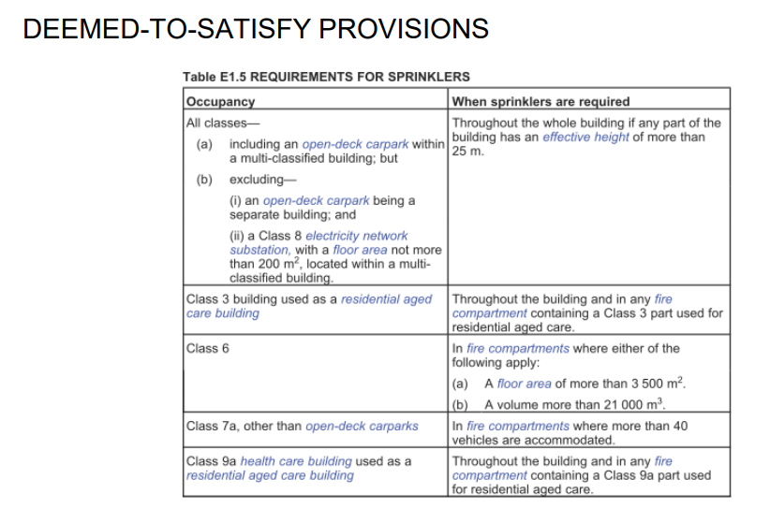

Use a combination of Performance Solutions and DTS solutions to comply with the Performance Requirements of the NCC.
This section provides information regarding the combination of performance solutions and DTS solutions to comply with the performance requirements of the NCC.
A mix of Performance Solutions and Deemed-to-Satisfy Solutions can be used to meet performance requirements.
Compliance can be demonstrated in the following ways when using a combination of solutions:
- A2.2, which will be evaluated against the appropriate Performance Requirements.
- A2.3 for evaluation against the Deemed-to-Satisfy Provisions.
When a Performance Solution is used in conjunction with a Deemed-to-Satisfy Solution to satisfy a Performance Requirement, the following technique must be utilised to establish the Performance Requirement or Requirements relevant to the Performance Solution:
- Determine which Deemed-to-Satisfy Provisions of each Section or Part will be the focus of the Performance Solution.
- Identify the Performance Requirements relevant to the indicated Deemed-to-Satisfy Provisions from the same Sections or Parts.
- Identify Performance Requirements from other Sections or Parts that apply to any components of the proposed Performance Solution or are impacted by the implementation of the Deemed-to-Satisfy Provisions that are the focus of the Performance Solution.
Both Performance Solutions and Deemed-to-Satisfy Solutions can be utilised to ensure compliance with Performance Requirements when designing a building, plumbing, or drainage system. A mix of solutions may be used to meet a single Performance Requirement. This could include situations where a single Performance Requirement applies to many building elements, such as plumbing or drainage.
There is no such thing as a stand-alone NCC provision. Any deviation from the Deemed-to-Satisfy Provisions for a Performance Solution must be evaluated in light of the relevant Performance Requirements in the relevant NCC Section or Part. Further, the proposed Performance Solution may impact other Performance Requirements in different Sections or Parts. As a result, these extra Performance Requirements must be examined in conjunction with the Performance Solution in question. The procedures for identifying which Performance Requirements are relevant are described in A2.2(3) and A2.4(3).
A2.4(2)(a) mentions A2.2. As a result, when combining Performance Solutions and Deemed-to-Satisfy Solutions, A2.2(4) must be followed when a Performance Requirement is suggested to be satisfied by a Performance Solution.

Using combination of solutions:
Both Performance Solutions and Deemed-to-Satisfy Solutions can be utilised to meet Performance Requirements while developing a building. A mix of solutions may be used to meet a single Performance Requirement. This could include situations where a single Performance Requirement applies to many elements within a structure.
The necessary Performance Requirements must be defined when using a combination of solutions by reviewing the:
- Each Section/Deemed-to-Satisfy Part's Provisions for the solution, as well as Performance Requirements from these Sections/Parts; and
- Other sections/parts' performance requirements related to or affected by the proposed solution.
The right Assessment Methods must be employed when implementing a combination of compliance solutions. That is, if a Performance Solution meets a Performance Requirement, proof of suitability, a Verification Method, Expert Judgment, and/or comparison with the Deemed-to-Satisfy Provisions must all be used. This section of the design must likewise follow the Performance Solution approach. Evidence of Suitability and/or Expert Judgement must be used if a Deemed-to-Satisfy Solution is utilised to meet the Performance Requirement.

Identify and complete relevant documentation to meet Performance Requirements of the NCC.

This section deals with information regarding the identification and completes relevant documentation to meet the performance requirements of the NCC.
All BCA decisions should be completely documented, and copies of all relevant documents should be kept.
The following are some examples of the types of documentation that should be prepared and kept:
- The Building Solution in detail, including all pertinent plans and supporting paperwork.
- If an Alternative Solution is proposed–
- The applicable Performance Requirements in detail, and
- The approach or methods used to determine whether or not the relevant Performance Requirements were met.
- Information about any Expert Judgement that was used, including the amount to which the judgement was used, as well as the expert's qualifications and experience;
- A list of any tests or calculations performed to establish if the applicable Performance Requirements were met; and
- Details of any Standards or other information relied upon.

Discuss compliance options with relevant construction personnel to ensure compliance with NCC Performance Requirements.

This section discusses compliance options with relevant construction personnel to ensure compliance with NCC Performance Requirements. If the paperwork proves conformance, a person designing or constructing following the DTS Provisions is considered to be complying with the Performance Requirement.
Relevant construction personnel in the decision-making process:

Ensuring compliance
To ensure compliance with NCC Performance Requirements, consultation with an authorised authority should begin as soon as possible.
However, the stage at which consultation begins is a decision made by the person in charge of managing the brief process, and the project's complexity may influence it. Legislation may also specify when this must take place.
The project's complexity will influence
- The need for, and breadth of, stakeholder input; and/or
- The suitability of skilled and experienced persons.
A major advantage of discussion is that it allows stakeholders who will be needed to participate in decision-making processes throughout the project to express their needs.
Self-check assessment

QUESTION 1
How can we figure out how many NCC criteria we'll need to assure project compliance?
Meeting the performance requirements for NCC Criteria compliance
- Complying with the Deemed-to-Satisfy Provisions, or
- Developing an Alternative Solution that—
- Meets or exceeds the Performance Requirements; or
- Can be shown to be at least as good as the Deemed-to-Satisfy Provisions;
- Or a combination of (a) and (b).

QUESTION 2
Explain DTS solution in detail.
Deemed to Satisfy solutions prescribe various methods of design and construction including materials, components, design factors, and construction which, if used, are deemed to meet the performance requirements
QUESTION 3
What processes are required in ensuring that NCC Performance Requirements are met?
To ensure compliance with NCC Performance Requirements, consultation with an authorised authority should begin as soon as possible.
However, the stage at which consultation begins is a decision made by the person in charge of managing the brief process, and the project's complexity may influence it. Legislation may also specify when this must take place.
The project's complexity will influence
- The need for, and breadth of, stakeholder input; and/or
- The suitability of skilled and experienced persons.
A major advantage of discussion is that it allows stakeholders who will be needed to participate in decision-making processes throughout the project to express their needs.

CHAPTER 4: APPLY FIRE PROTECTION REQUIREMENTS.

This chapter covers fire protection requirements, such as determining the fire resistance needed for all classes and types of buildings, identifying and applying NCC requirements for passive and active fire protection to all classes and types of buildings, and checking existing buildings for compliance with passive and active fire protection requirements according to NCC requirements.
What will I learn?

In this chapter, you will learn about the following:
- Determine fire resistance required for the construction of all classes and types of buildings.
- Identify and apply NCC requirements with respect to passive and active fire protection to all classes and types of buildings.
- Check existing buildings for compliance with passive and active fire protection requirements according to NCC requirements.

Determine fire resistance required for the construction of all classes and types of buildings.
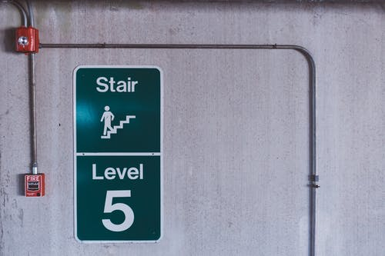
This section provides information regarding determining the fire resistance required to construct all classes and types of buildings.
Fire Resistance – the building's fire resistance criteria. This is to ensure that not only does fire travel from one structure to another but that a building's structural stability is maintained during a fire, allowing residents to flee and the fire department to combat the fire. This is accomplished by using separation distances between buildings, fire protection for external walls (including any openings such as windows), and the division of the building's internal spaces into compartments. About this section, it is critical to comprehend the following terminology:
- Not to be confused with building class, the type of construction specifies the amount of fire resistance that specific building elements must attain. The three types of construction, A, B, and C, are determined by the building's class and the number of storeys. Type A buildings are the most fire-resistant because they have a greater danger of fire, such as high rise, high occupant buildings. Type C buildings have a lower danger of fire and are thus the least fire-resistant.
- The fire source feature depicts the possibility of a fire spreading from or to a specific location. It's usually the exterior wall of another structure on the same property, a side or back border, or the distant road boundary that runs alongside the property. Because the owner of one lot has no control over what is erected on adjoining lots, and there is the potential for a building to be put up to the boundary on the adjoining lot, boundaries are considered fire source features.
- The resistance against the passage of fire achieved by an element of a building is measured in minutes. The structural adequacy, integrity, and insulation criteria make up this list. A 90/30/60 FRL, for example, denotes a component that must withstand fire for 90 minutes for structural adequacy, 30 minutes for integrity, and 60 minutes for insulation.
- A 90/30/60 FRL, for example, represents a fire resistance rating of 90 minutes for structural adequacy, 30 minutes for integrity, and 60 minutes for insulation.
- A sole occupancy unit is a room or portion of a building reserved for the exclusive use of one resident.
Defend against the spread of fire:
- A Class 1 building must be safeguarded against fire spread from another building that is not an attached Class 10 building; and the allotment border next to a road or public area. (See Figure 2.3.1 for further information.)
- A Class 10a structure must not pose a significant risk of fire spread between Class 2 and 9.
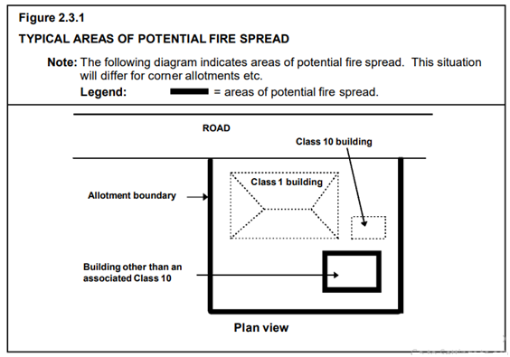
Buildings of multiple classifications
- In a building with several categories, the type of construction required is the most fire-resistant type determined by applying Table C1.1 to the top level, which applies to all storeys.
- In a building with a Class 4 portion on the top storey, the classification that applies to the top storey for (a) must be—
- when the Class 4 part occupies the entire top storey, the classification that applies to the next highest floor; or
- The classification applies to the adjacent section when the Class 4 part occupies the top storey. C1.4 construction with a variety of materials A building may be of mixed Types of construction, with the type of construction selected by C1.1 or C1.3 and the separation determined by C2.7.
Two storey Class 2, 3 or 9c buildings
A building with a two-story rise in storeys may be of Type C construction if:
- It is a Class 2 or 3 building, or a combination of these classes, and each sole-occupancy unit has:
- access to at least two exits; or
- direct access to a highway or open area; or
- It is a Class 9c structure with a sprinkler system that meets Specification E1.5 throu5ghout and meets the maximum compartment size specified in Table C2.2 for Type C construction.

Identify and apply NCC requirements with respect to passive and active fire protection to all classes and types of buildings.

This section provides information regarding identifying and applying NCC requirements concerning passive and active fire protection to all classes and types of buildings.
Fire hydrants
- A fire hydrant system must be installed to serve a building that is
- larger than 500 m2 in total floor area and
- where a fire department is present to respond to a building fire.
- The system of fire hydrants must be installed in conformity with AS 2419.1, with the exception that a Class 8 electricity network substation is exempt from AS 2419.1 clause 4.2 if—
- It is not possible to link it to the town's main water supply; and
- water storage for fire-fighting is supplied for one hour.
- Internal fire hydrants must only serve the storey on which they are located, with the exception that a sole-occupancy unit in Class 2 or 3 building or Class 4 part of a building may be served by a single fire hydrant located at the level of egress from that sole-occupancy unit; or a building of not more than 2 storeys in Class 5, 6, 7, 8, or 9 building may be served by a single fire hydrant located at the level of.
Fire hose reels
- E1.4 does not apply to—
- A building classified as a Class 2 or 3 structure, or a component of a building classified as a Class 4 structure;
- A Class 8 electrical network substation;
- A Class 9c building; or
- Primary or secondary school classrooms and accompanying corridors.
- There must be a fire hose reel system available.—
- To service the entire building if one or more internal fire hydrants are installed; or
- To serve any fire compartment having a floor area of more than 500 m2 if internal fire hydrants are not installed.
- The fire hose reel system must—
- Have fire hose reels installed following AS 2441; and
- Provide fire hose reels to serve only the storey on which they are located, with the exception that a single fire hose reel located at the level of egress from a sole-occupancy unit of not more than 2 storeys in Class 5, 6, 7, 8, or 9 buildings may serve that sole-occupancy unit if the fire hose reel can provide coverage to the warehouse.
- To achieve the system coverage specified in AS 2441, fire hose reels must be positioned internally, externally, or combined.
- One or more of the following requirements for individual internally situated fire hose reels must be met in defining the layout of any fire hose reel system to achieve system coverage:
- Fire hose reels must be situated adjacent to an internal fire hydrant (other than one within a fire-isolated exit). Still, they do not have to be adjacent to every fire hydrant if system coverage can be accomplished.
- Fire hose reels must be within 4 metres of an exit, except they do not have to be adjacent to every exit if system coverage can be accomplished.
- In compliance with (i) and (ii) not providing system coverage, extra fire hose reels may be placed in courses of travel to an exit to obtain the required coverage.
- Fire hose reels must be placed so that the fire hose does not have to pass through fire or smoke doors, except for:
- Wall doorways described in C2.5(a)(v) in a Class 9a building and C2.5(b)(iv) in a Class 9c structure, separating supplementary use zones with a high potential fire hazard; and
- Wall doorways mentioned in C2.12 or C2.13
- C3.13 refers to entryway openings to shafts.
- Where the regular water supply cannot or is unreliable,
- A pump;
- A water storage facility; or
- A pump and a water storage facility must be constructed to deliver the minimum flow and pressures required by clause 6.1 of AS 2441.
Sprinklers: A sprinkler system must:
- Be placed in a building or part of a building when Table E1.5 requires it; and
- Meet Specification E1.5's requirements.
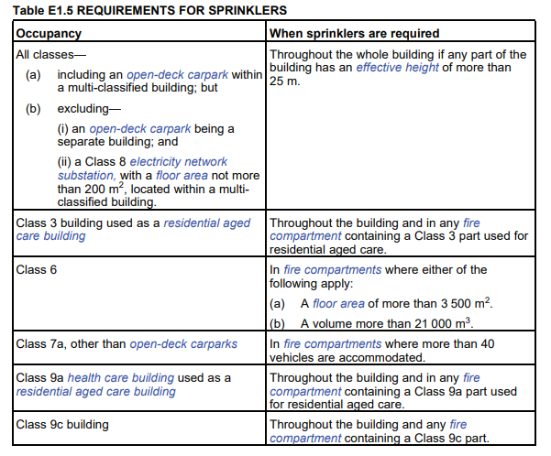
Portable fire extinguishers
Portable fire extinguishers must be—
- Provided as listed in Table E1.6; and
- For a Class 2 or 3 building or Class 4 part of a building, provided—
- To service any fire compartment with a floor area greater than 100 square feet where internal fire hydrants are not placed, or (B) to serve the complete Class 2 or 3 building or Class 4 component when one or more internal fire hydrants are installed.
Portable fire extinguishers provided in Class 2 or 3 building or Class 4 part of a building must be—
- An ABE type fire extinguisher; and
- Minimum size of 2.5 kg; and
- Distributed outside a sole-occupancy unit—
  - They are only to serve the storey in which they are situated; and
  - Ensure that the distance between the entrance doorway of any sole-occupancy unit and the nearest fire extinguisher is no more than 10 metres.

Check existing buildings for compliance with passive and active fire protection requirements according to NCC requirements.
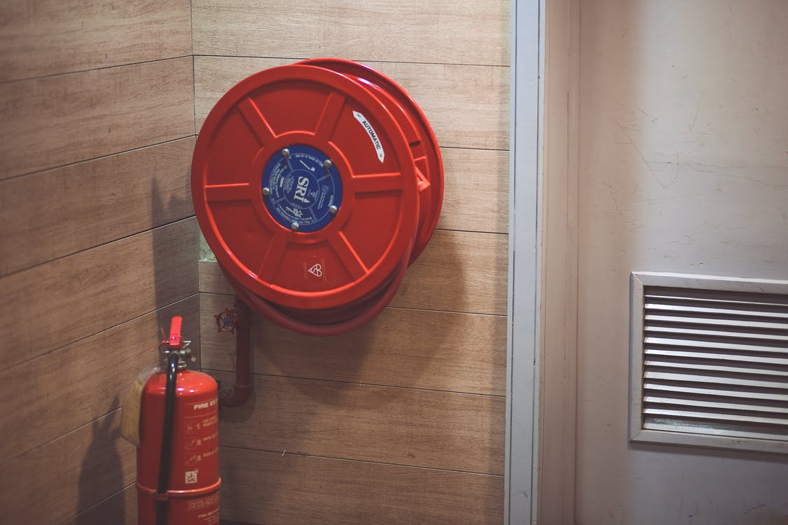
Existing buildings must be checked for compliance with passive and active fire protection measures according to NCC criteria for the safety of workers.
A building must be equipped with fire-fighting equipment to prevent fire spread—
- To allow occupants time to safely evacuate without being overcome by the effects of the fire; and
- To allow occupants to conduct an initial attack on fire; and
- To supply the required equipment for search, rescue, and firefighting operations to the fire department; and
- To provide other parts of the building with fire-fighting equipment.
A fire hose reel system must be installed to the extent necessary to allow occupants to safely attack a fire in the first few minutes, taking into account:
- The size of the fire compartment;
- The building's function or use;
- Any other fire-fighting systems in the building; and
- The danger of a fire.
Fire extinguishers shall be provided to the extent necessary to allow inhabitants to attack a fire in the first few minutes, taking into account:
- The building's function or use;
- Any other fire safety devices installed in the building; and
- The fire hazard.
A fire hydrant system must be supplied to the extent necessary to meet the needs of the fire department, taking into account
- Firefighting operations;
- The building's floor area; and
- The fire hazard.
An automatic fire suppression system must be installed to the extent necessary to control the development and spread of fire, taking into account:
- The size of the fire compartment;
- The building's function or use;
- The fire hazard; and
- The building's height.
In a building, adequate facilities must be provided to the extent necessary to coordinate fire brigade action during an emergency, taking into account:
- The function or use of the building;
- The floor area of the building; and
- The building's height.
Self-check assessment

QUESTION 1
List any four firefighting equipment and their uses.
______________________________________________________________ A fire hose reel system must be installed to the extent necessary to allow occupants to safely attack a fire in the first few minutes.
Fire extinguishers shall be provided to the extent necessary to allow inhabitants to attack a fire in the first few minutes.
A fire hydrant system must be supplied to the extent necessary to meet the needs of the fire department.
An automatic fire suppression system must be installed to the extent necessary to control the development and spread of fire.
QUESTION 2
How to determine fire resistance required for the construction of all classes and types of building?
The type of construction specifies the amount of fire resistance that specific building elements must attain. The three types of construction, A, B, and C, are determined by the building's class and the number of storeys. Type A buildings are the most fire-resistant because they have a greater danger of fire, such as high rise, high occupant buildings. Type C buildings have a lower danger of fire and are thus the least fire-resistant.

QUESTION 3
Give three reasons why firefighting apparatus is required in the building.
____ A building must be equipped with fire-fighting equipment to prevent fire spread—
- To allow occupants time to safely evacuate without being overcome by the effects of the fire; and
- To allow occupants to conduct an initial attack on fire; and
- To supply the required equipment for search, rescue, and firefighting operations to the fire department; and
- To provide other parts of the building with fire-fighting equipment.
________________________________________________________________________________________________________________________________________________________________________________________________________________________________________________________________________________________________________________________________________________________________________________

CHAPTER 5: IMPLEMENT STRATEGY TO MANAGE CONSTRUCTION COMPLIANCE

Introduction
This chapter contains information on how to implement construction compliance strategies, such as establishing strategies to manage construction compliance of large, complex, and high-rise buildings with the NCC, as well as implementing and coordinating the work of professionals involved in the development and management of the building process, and seeking effective design solutions for buildings with more than three storeys to meet the needs of clients.

What will I learn?

In this chapter, you will learn about the following:
- Establish strategies to manage construction compliance of large, complex and high-rise buildings with the NCC.
- Implement and coordinate the work of professionals involved in the development and management of the building process.
- Seek effective design solutions for buildings of more than three storeys to meet the needs of clients and ensure compliance with the NCC.
- Design and implement quality assurance processes to ensure effective and compliant management of the construction process.
- Detect non-conforming building materials and products and manage the evidence of suitability as required in the NCC.

Establish strategies to manage construction compliance of large, complex and high-rise buildings with the NCC.

This section details the strategy established to manage construction compliance of large, complex and high-rise buildings with the NCC. The buildings whose height is greater than 25 m come under large, complex and high-rise buildings.
Before both instances, and from its creation, the Building Code of Australia (as part of the NCC) has required that most multi-story buildings' external walls be non-combustible. According to the performance criteria, they must avoid the spread of fire both within and between buildings.
Given this and other NCC elements, a new building constructed in Australia that adheres to the NCC will give extraordinarily high levels of safety. Furthermore, based on what we know about the Grenfell Tower disaster, such a structure built today would not meet the NCC's requirements.
This includes safeguards that minimise fire spread, alert occupants when smoke is detected, make evacuation easier, and allow fire departments to operate.
Specific criteria vary depending on the scale of the building, but rules in the NCC for a typical high-rise residential complex include:
- Detection and warning systems for smoke and occupants.
- Fire-resistant exits, such as stairwells.
- Multiple exits for each storey to provide an alternate egress route if one exit becomes inoperable.
- Smoke is kept out of the exit stairwell.
- Sprinklers in the event of a fire.
- Fire-resistant architecture to prevent fires from spreading between units and levels.
- External walls that are not flammable.
- The ability to withstand a collapse as a result of the fire.
- Fire hydrants and other features that aid fire-fighting operations.
Example: The structure in question is a high-rise office skyscraper in the heart of the city. It's next to other comparable structures and on the street alignment. In this case, the spread of a fire must be avoided because:
- the occupants will take some time to evacuate the building, so the escape routes must be protected;
- the spread of fire between each storey must be prevented, including the risk of fire spreading through the building's external walls where each storey is a separate fire compartment; and
- Because the buildings are so close together, a fire might readily spread. In this case, under CP2(a), building elements may require a high level of protection against fire spread.
When examining the ramifications of satisfying CP2(a), the ability of the fire department to contain a fire would also need to be evaluated in both circumstances.
If a Performance Solution is adopted, it may be appropriate to evaluate it using the Section C Deemed-to-Satisfy Provisions as a guide. However, if alternative means can be discovered to satisfy the relevant authority that the Performance Requirements will be met, compliance with the Deemed-to-Satisfy Provisions is not required. For information on approved assessment methodologies for determining compliance with the Performance Requirements, the building proponent should refer to A2.2.
If a solution based on the Deemed-to-Satisfy Provisions is being considered, the Deemed-to-Satisfy Provisions contain precise requirements for the fire protection of building elements.


Implement and coordinate the work of professionals involved in the development and management of the building process.

For the effective building process, it is mandatory to implement and coordinate the work of professionals involved in the development and management of the building process.
The various professionals that are involved in the building process are:

The following strategy must be used to implement and coordinate the work of professionals such as:
- Establish a project road map to start the work so that manager can find the building process is on schedule or off schedule.
- Define the roles and responsibilities of each professional so that they can improve themselves in certain circumstances according to their roles and responsibilities.
- Schedule a meeting of all professionals before commencing the process to establish subgroups for effective teamwork.
- Set out the scope of work in writing so that everyone clear the project's goal.
- Develop quality control and quality assurance plan that stops errors before they happen.
- Also, develop a communication plan that will help define the construction process for better understanding among professionals.

Seek effective design solutions for buildings of more than three storeys to meet the needs of clients and ensure compliance with the NCC.
This section contains information on how to create successful design solutions for buildings with more than three stories to suit clients' needs and comply with the NCC.
Things to keep in mind while seeking an effective design solution:
- First, double-check that all of the options you're considering are valid design solutions for your project, which you can sell to your stakeholders and get their approval. Solutions that violate the corporate law policy, or have a significant negative impact on customers, for example, would be removed from the list.
- Ensure that all remaining options can meet the project's requirements: they must be able to satisfy the needed output levels of quality, performance, and dependability while remaining within a fair timeframe and cost to the organisation.
- Evaluate the relative importance of the basic weighing factors: Time Impact, Cost Impact, and Other Impact for each of the following alternatives.
- Conduct a sanity check to ensure that the solution(s) offered by the solution selection matrix is reasonable.
The following steps are utilised to design solutions that will meet clients' needs and ensure compliance with the NCC.
- A certified principle design expert prepares a concept report.
- A design team led by a certified main design professional prepares the design.
- Where needed, coordination and verification with other design professionals, owners, and contractors.
- Provide the code official with the plans and supporting papers.
- The code official conducts a plan evaluation.
- Verifies that the code official satisfies applicable prescriptive code provisions and performance-based objectives.
- Plans are approved, and a code official issues a permit.
- The permit holder builds according to approved plans and paperwork.
- Officials in charge of codes ensure that qualified inspection services are given and documented as needed.
- Issue an Occupancy Certificate.

Design and implement quality assurance processes to ensure effective and compliant management of the construction process.

The identification of quality requirements for a project is known as Quality Assurance. Furthermore, it includes identifying existing documents related to the project's quality requirements to make them available for their effective use. It is the process of identifying or deciding on all the quality requirements for a project. The overall success of a construction project depends upon the quality assurance processes.
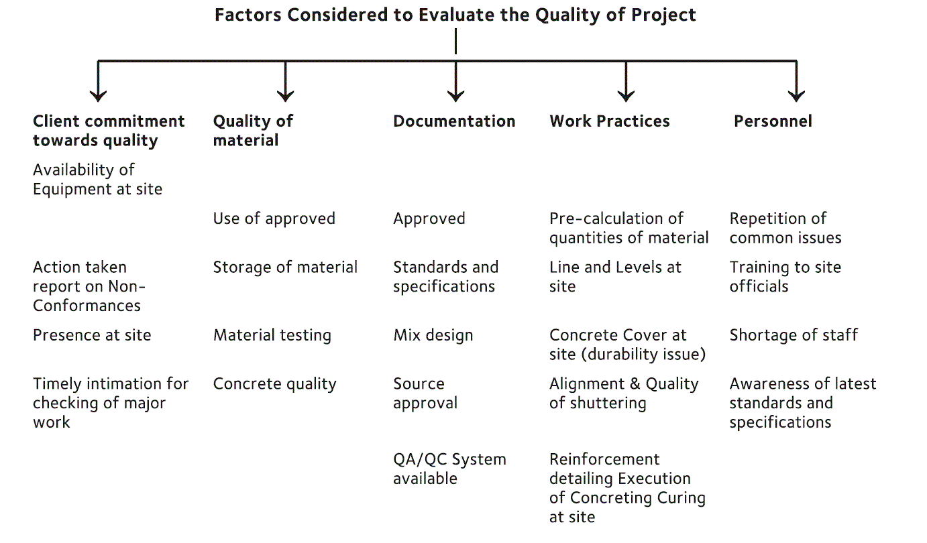
Importance of Quality Assurance processes:
There is in every case some risks implied in any construction task, and Quality Assurance is fundamental in forestalling issues with a form and diminishing danger. On the off chance that quality issues are just distinguished after an action has been finished, the outcome is re-work and program delays. When quality issues aren't recognised at all during the form, it can prompt agonising deformity responsibility periods or structures that bomb a long time after pragmatic consummation.
QA centres around the techniques that the development organisation has executed to guarantee that the plan fulfils quality guidelines and guarantee the most elevated industry standards are applied consistently.
Following activities are involved in the design and implementation of Quality Assurance processes to ensure effective and compliant management of construction:
- Assessing the performance of processes and work products against process descriptions, principles and methods impartially.
- Non-compliance issues are identified and raised.
- After giving feedback to staff, report management about the consequences of quality assurance activities; and
- Ensure any non-compliance issues are tended to.

Detect non-conforming building materials and products and manage the evidence of suitability as required in the NCC.
This section provides information regarding non-conforming building materials and products and manages the evidence of suitability as required in the NCC.
Identifying non-conforming building materials and products
NCBPs are products and materials that:
- Pretend to be something they aren’t.
- Fail to fulfil needed criteria for their intended use.
- Are sold or provided with the intent to deceive those who use them.
An NCBP is a building product labelled or described as non-combustible but combustible.
NCPs (non-complying building products) are items and materials used when they do not meet the National Construction Code's criteria (NCC). This could include products that have passed applicable testing and/or marking requirements but have been utilised in a location or scenario. The NCC has stated they are unsuitable.
An NCP is a combustible construction product labelled as such but is utilised in situations where the NCC requires a non-combustible product. It is therefore unfit for purpose and consequently non-compliant. As a result, a building product or material might be non-conforming and non-compliant.
When a worry or a problem with a construction product or material is initially discovered, determining if it is a non-conforming product or has been used wrongly and outside of NCC regulations can be challenging (and is thus an NCP).
In many circumstances, the same inquiry or testing method will be required to determine whether the product or material is non-conforming or non-compliant.
NCBP-related risks and issues (including those relating to health, cost remediation, safety, and legal issues) can thus affect everyone and anyone involved in building and construction, including those involved in designing and engineering, assessment and approvals, manufacturing or importing, buying and selling, building or occupying.
The general provisions for design and construction acceptance can be found in Part A2 of Volumes One and Three and Part 1.2 of Volume Two of the NCC.
Manage the evidence of suitability:
To verify that a product conforms and/or complies with the NCC, five different types of proof can be used. These include the following:
- A CodeMark or Watermark Certificate of Conformity;
- A certificate from a suitably qualified person, such as an engineer.
- A certificate from a product certification body accredited by the Joint Accreditation Scheme of Australia and New Zealand (JAS-ANZ)
- A report issued by a registered testing authority; and
- The relevant delegate (s) deemed other suitable documentary evidence (acceptable).
Self-check assessment

QUESTION 1
What are the various strategies for managing construction compliance with the NCC for large, complicated, and high-rise buildings?
Specific criteria vary depending on the scale of the building, but rules in the NCC for a typical high-rise residential complex include:
- Detection and warning systems for smoke and occupants.
- Fire-resistant exits, such as stairwells.
- Multiple exits for each storey to provide an alternate egress route if one exit becomes inoperable.
- Smoke is kept out of the exit stairwell.
- Sprinklers in the event of a fire.
- Fire-resistant architecture to prevent fires from spreading between units and levels.
- External walls that are not flammable.
- The ability to withstand a collapse as a result of the fire.
- Fire hydrants and other features that aid fire-fighting operations.

QUESTION 2
What exactly are non-conforming building materials and products, and how may they be identified?
________________________________________________________________
NCPs (non-complying building products) are items and materials used when they do not meet the National Construction Code's criteria (NCC). This could include products that have passed applicable testing and/or marking requirements but have been utilised in a location or scenario. The NCC has stated they are unsuitable.

QUESTION 3
Elucidate the significance of quality assurance procedures.
______________________________________________________________
QA centres around the techniques that the development organisation has executed to guarantee that the plan fulfils quality guidelines and guarantee the most elevated industry standards are applied consistently.
______________________________________________________________________________________________________________________________________________________________________________________________________________________________________________________________________________________________________________________

CHAPTER 6: ADDITIONAL INFORMATION

Working drawings and specifications
Working drawings contain dimensioned, graphical information that a contractor can utilise to construct the works or suppliers to fabricate, assemble, and install instalments. Architectural, structural, civil, mechanical, electrical, and so on are examples of these types of drawings.
Working drawings, such as plans, sections, and elevations, are two-dimensional orthogonal projections of the building or component described.
Types of Building Plan Drawings
Different types of drawings are given by an architect based on the detailing and complexity of a project to understand and smooth the operation of the construction process.
Site Plan
A site plan is a detailed design of a building or apartment that depicts the entire layout of the structure. It depicts the site’s boundaries, access points, and surrounding structures significant to the design.
All utility connections, such as drainage and sewer lines, water supply, electricity and communications cables, and outdoor lighting, must be shown on the site plan for a construction project.
Floor Plan
A plan is a top-down view of a structure or thing. The most basic architectural diagram is a floor plan, a perspective from above that shows the layout of spaces in a building in the same way as a map does, but at a specific building level. A floor plan view is a vertical orthographic projection of an object onto a horizontal plane cutting across the building.
Cross Section
A cross-section is a geometric projection of a building’s horizontal orthographic projection onto a vertical plane cutting across the building. A cross-section is a vertical cut section of a building that reveals the dimensions and thickness of any structure component. It also depicts a structure’s sill height, lintel height, floor height, and other minor features.
Elevation
A projection drawing that depicts one side of the home in orthographic projection is known as an elevation drawing. An elevation drawing's goal is to show the finished appearance of a certain side of the house and offer vertical height information.
Quality assurance, policies, procedures, and workplace safety standards are part of an organisation's quality management system.
The organisational quality insurance is discussed in the previous section 5.4. In this section, we will be discussing policies, procedures and workplace requirements.
Quality requirements include: manufacturer specifications, relevant regulations, including Australian standards workplace requirements, all of these are explained in this section as below:
Compliance documentation
On every job site, compliance documentation is critical to all elements of operations. From the work instructions to quality and environmental requirements, documentation sets out the type of work, the timeframe for construction and the procedures for completing the task.
Statements including the words "must," "must," or "will" are frequently used in these texts to imply that there are legal requirements that must be followed. Each project site will have its own set of compliance documents that must be consulted.
These documents require that the tasks be undertaken so that it meets the required standards.
It is significant to know your obligations under the compliance documents such as:

Worksites are required to meet a range of compliance documents. These include:

Each state uses different OHS/WHS legislation. They all have the same requirements. In case of any questions regarding the safety rules, you must contact your supervisor.
Other compliance documents include:
Before starting your work, ensure that you have access to all the operation documents for the job. This will help you do your work safely and ensure all work complies. The operation documents include:
- Work Method Statement
- Safety Data Sheets (SDS)
- Project Quality requirements
Work Method Statement: A Safe Work Method Statement (SWMS) is a document that defines the high-risk construction work activities that will be performed at a workplace, the hazards that may develop as a result of these activities, and the controls that will be implemented to mitigate the risks.
SWMS are required for high-risk construction work activities, as defined in the WHS Regulations. A generic SWMS may be prepared for works carried out regularly and can be used for those work activities. The content of the SWMS can be refined over time and include consultation with workers and other persons conducting a business or undertaking.
Work method statements must be completed before initiating the work. The work methods statements provide details on the steps to complete the job. These include details of any hazards that you might face while completing the job and the safety measures to be implemented to control these hazards.
These statements can also be known as:
- Safe Work Method Statement (SWMS)
- Job Safety Analysis (JSA)
- Job Hazard Analysis (JHA)
- Standard Operating Procedure (SOP)
These statements are also used to organise work activities and ensure that everything is completed based on the job requirements. You must ensure that these required documents are available before initiating the task.
Safety Data Sheet: The schedule for the amount of work to be carried out varies depending on location.
A Safety Data Sheet (SDS) is a document that contains health and safety information on hazardous substances or dangerous goods products, compounds, or chemicals. If you acquire one of these items, it should come with a safety data sheet (SDS).
The SDSs inform you.
- The product (its name, contents, and properties), who made or imported it, how the product may influence your health, and how to securely use and store it
- Who made it or imported it?
- The potential for the product to harm your health
- How to safely use and store it
Health and safety
Risks linked with high-risk construction work must be managed by anyone operating a business or endeavour.
Further guidance on the duties related to high-risk construction work and SWMS is available in the Code of Practice: Construction Work.
Operations Documentation
Before initiating your work, you must ensure that you access the required operational documents. This will ensure that the work is completed safely and complies with the legislative requirements. These documents include:

How to ensure everyone is safe?
OHS/WHS laws ensure that employers comply with their duty of care to keep employees and other people safe at work.
Who does the duty of care apply to:
- Persons conducting a business or undertaking (PCBU)
- Managers
- Suppliers
- Designers
- Employees
- Contractors and sub-contractors
- Volunteers
Worker’s duty of care
The workers must ensure that they take care of their health and safety and the safety of others in the workplace. The workers must ensure that they do not put their own and others’ health and safety at risk with their actions.

PCBU’s duty of care
The person conducting a business undertaking (PCBU) must:
- Ensure that a safe workplace is provided to the employees and others.
- Ensure that the workers are trained and are familiar with the job tasks to be completed.
- Eliminate or minimise risks.
- Notify workers of any present and potential hazards and risks.
- Ensure the workers are familiar with the emergency procedures.
- Ensure the worksites have a safety plan in place.
WHS laws
Safe Work Australia created a unified set of WHS laws adopted across the country. These are referred to as 'model' legislation.
You must follow the following at the civil construction worksite:

If you identify any hazard or potential risk, you must tell the supervisor as soon as possible.
Your civil construction worksite also has the work instructions for working safely, including:
- Emergency procedures (using fire fighting equipment, first aid and evacuation)
- Handling hazardous materials
- Safe operating procedures
- Personal protective clothing and equipment
- Safe use of tools and equipment
National Construction Code (NCC) or building code of Australia
The National Construction Code (NCC) provides the minimum requirements applicable to new buildings throughout Australia.
Performance requirements under the NCC must be satisfied through either:
- Performance Solutions;
- Deemed-To-Satisfy (DTS) Solutions; or
- A combination of the two.
There are numerous ways to achieve compliance. The most typical conservative ways of achieving DTS solutions are by following:
- Acceptable Construction Practices; or
- Australian Standards referenced within the NCC.
Designers can choose to follow Australian Standards as Performance Solutions over DTS solutions. However, this compliance process may require expert judgment and additional verification.
This flyer indicates the important changes toDTS requirements surrounding masonry and differences compared with relevant industry-approved Australian Standards.
Environmental requirements
When we use the timber material, then it does not have so much impact on the environment, But some points must be considered while working on a construction site:
- Water quality
- Air levels
- Waste management
- Hazardous chemicals
- Lighting.

Table: Environmental requirements
Element |  | Description
Water Quality | Waterways should be free from pollution. As a construction worker, it is your responsibility to ensure that any material residue should not enter waterways.
Air Quality | Air quality is ensured by dust control and management. During windy days, water sprays must prevent dust from rising.
Noise Levels | Noise should be maintained to the optimum level. This is considered important during night operations, especially in residential sectors.
Waste Management | Waste management is an important factor in maintaining a clean and safe environment. Waste problems can be reduced by acting on the following priorities:  - Avoidance  - recycling  - re-use  - Disposal.
Hazardous Chemicals | A construction worker must know about the storage, use and disposal of hazardous chemicals. You should seek advice from your supervisor.
Lighting | The lighting of construction sites close to residential areas can cause serious environmental concerns. Whenever possible, all lighting should be fixed away from populated areas.

Environmental Hazards
Objectives
- Recognise environmental hazards.
- Acknowledge treatment and first aid for exposure to environmental hazards.
- All employees of Australia are committed to observant and active environmental administration in every aspect of their field and undertaking activities with the consent of all regulatory provisions and other legal demands.

Environmental protection of the building site
Environmental protection starts at the development site with the air workers need to breathe.
The workers should be saved from any fumes from construction machinery and building waste or materials; moreover, these materials should be altered carefully and then recycled or disposed off after completing work. At last, the soil is also a valuable asset; therefore, it should not be polluted by disposing of this type of material.
Environmental protection
What is the necessity of environmental controls?
We must protect the environment on a tiny scale and on a global scale.
Several types of structures or monitoring systems are installed on the worksites to protect the environment and reduce construction activities’ impacts.
Deciding which controls to use depends on why controls may be needed.
- Waste control
- Hazardous materials
- Water quality (erosion and sediment control)
- Cultural heritage management issues
- Air quality
- Noise
- Flora and fauna
What the law says
You must follow several legal necessities to proceed construction process without causing harm to the environment. The legislation includes Acts and Regulations, which are mandatory, codes of Practice, Advisory Standards, and Guidelines, which are non-mandatory but may be cited in mandatory Acts and Regulations.
The tiers of Government are:
- Federal or Commonwealth Legislation (the Environmental Protection &Biodiversity Conservation Act 1999)
- State & Territory Legislation (Environmental Protection Act 1994 and Water Act 2000)
- Local Government Legislation (Development Approvals, Material Change of Use, Environmentally Relevant Activities)
Common law is where a precedent has been set in a Court of Law, not through an Act of Parliament (also known as Case Law). Two examples of Common Law are:
- Rights of neighbours – causing undue interference with land use or damage.
- Rights of Protection – requires obligations to be met to provide adequate safety standards.
Most recent legislation updates relating to the environment Aboriginal Cultural Heritage Act 2003:
New legislation includes changes to regulate impacts and disturbances to significant Aboriginal areas or objects.
It includes the following new provisions:
- Duty of Care (section 23) carries a penalty for Individuals of $7500 and Corporations of $75000.
- Unlawful Harm (section 24) is punishable by a fine of $7500 or two years in jail.
- Excavation, relocation, and removal are prohibited (section 25).
- Possession of Aboriginal Cultural Heritage without Permission (section 26).
Water Regulation 2002:
For any development that affects water access or influences water, permits and approvals are required (e.g. canal developments). The Environmental Protection Act of 1994 and the Integrated Planning Act of 1997 specifies the ERA and Development Approvals that must be obtained. Obligations under the Common Law to Prevent Vandalism, Fire, or Flooding:
A duty of care exists for managing land to prevent foreseeable events from providing Due Diligence for the public and your employee’s safety. By adopting proactive measures to cope with predicted acts of vandalism or natural disasters, the contractor must avoid consequence air pollution, water pollution, unlawful sewage discharges, noise pollution, and other environmental offences. For example, any liquid storage tanks or other plant and equipment exposed to the elements or vandalism should be adequately maintained and protected through fencing, roofing, contouring, fire breaks, lockable gates, and other means.
Details from the environmental protection act, 1994
Due Diligence
Due diligence is:
- A defence under the Environmental Protection (EP) Act safeguards employees and the companies with whom they work.
- Individuals and businesses have a responsibility to prevent or mitigate environmental harm.
- "By creating and maintaining a system to assure compliance with the EP Act, taking all reasonable and practical actions to prevent or minimise environmental impact."
- There is a legal need to offer a certain level of care through expected standards (e.g., record-keeping to demonstrate compliance with legal obligations, contractor responsibilities include acquiring an Environmentally Relevant Activity (ERA) permit to carry out an activity).
General environmental duty
Every individual has a responsibility to refrain from engaging in any activity that may cause or is likely to cause environmental harm unless all reasonable and feasible precautions have been taken to avoid or mitigate the risk. It is important to understand that a person can be found guilty of an offence before this Act causes any actual harm.
Duty to Notify Environmental Harm
Any person who becomes aware that serious or material environmental harm will be caused or is likely to occur (unless it is authorised or in an emergency direction) must notify their employer or the relevant authority as soon as possible (S37). The highest fine for failing to report environmental harm is $6,000. If project staff have any issues, they should contact their supervisor as soon as feasible.
Environmental protection policies
Under the EP Act, air, water, noise, and waste management policies have been established. Here are a few examples:
Air – failure to comply with an air quality abatement notice (S19 Air Policy). The penalty is $2500.
Water-
- Rubbish, wastewater, concrete, pesticides, oil, etc., cannot be released into a roadside gutter, drain or body of water or be placed in a position where it could be released (S31 of136). The penalty varies between $1200 and $1500.
- This may include an unprotected topsoil stockpile or mulch close to a creek.
- Stormwater results in a buildup of mud or silt in drains. Sand, silt, or mud may not be deposited or placed where it could wash into a gutter or drain (S32 Water Policy). The penalty is $1200. This may include washing a vehicle on the roadside or in a driveway.
Noise
Failure to comply with a noise abatement notice (S23 Noise Policy), the penalty is $2500.Under the new Noise Policy, any audible noise outside normal working hours is a nuisance and is an offence under the EP Act. This means a contractor cannot work on Sunday or a public holiday at any time or any weekday, such as Saturday before 6.30 am or after 6.30 pm, without pre-approval of a government authority.
Land Administration-
The EP (Waste Management) Law 2000 obtrudes fines for littering and garbage disposal. Fines range up to Fifteen hundred dollars for littering, then from around three thousand dollars (less than 200 litres) to up to twelve thousand three hundred seventy-five dollars if more than two hundred litres for illegally disposing of rubbish. The offence described above is an indication only and may change according to conditions.
Damage to the natural environment
There are fines quoted for persons, but it is five to ten times greater than others for industry workers.
- Illegal environmental danger – any kind of Act or omission that generates material or serious environmental danger or a nuisance is indictable unless it is authorised or an emergency (S119).
- Environmental annoyance –In unruly conditions (S123), the fine is $10,000 or $50 000. To exemplify: if noise, dust and odour cross the limits.
- Substances environmental danger – the highest fine is $50,000. If the damage is unruly, the penalty is $100,000 and up to two years imprisonment (S120).
- Extreme environmental danger – the maximum fine is $100 000. If the damage is willful, the penalty is $250 000 and less than five years imprisonment (S120). For instance: the largest oil spill in water sources and/or disposed of toxic substances.
- Delinquency against environmental safety policies – an individual who willfully contravene this environmental policy should be penalised up to $100,000 (S124).
- Prescribed Pollutants – The pollutants prescribed by an environmental policy should be avoided in places where they could cause severe or environmental nuisance (S126). The maximum fine is $10,000 for this offence.
Environmental Management System.
Several companies in the construction industry implement and maintain Environmental Management systems following the requirements of AS/NZ ISO 14001 (International Standard Quality Assurance for the Environment).
These provide guidelines specific to:
- Organisation’s environmental policy
- Environmental management plan.
Environmental protection Acts and Regulations
- Environmental Protection Act 1994
- Environmental Protection Regulation 1998
- Environmental Protection (Waste) Policy and Regulation 2000
- Environmental Protection (Water) Policy 1997
- Environmental Protection (Noise) Policy 1997
- Environmental Protection (Air) Policy 1997
Manufacturer's specifications: Manufacturers Specifications are written instructions, specifications and recommendations that the manufacturer gives. Moreover, it outlines how a product can be used, installed, examined, operated, stopped and stored. For safe work practices, it is crucial to follow the manufacturer's specifications during the construction work.
Establish Work requirements
Your work requirements must be clarified, interpreted and confirmed correctly. Clarifying these instructions means asking questions until you understand what’s required from you.
Interpreting the instructions means drawing out the knowledge from the instructions to finish the assigned tasks successfully.
Confirming work requirements is often achieved through:
- Speaking together with your supervisor or other personnel involved in the planning process.
- Gaining knowledge of and conversing with the documents commonly found on a worksite.
- Interpreting drawings and sketches correctly, as these are commonly used.
- Understanding the task requirements will allow you to organise your work tasks and manage some time more effectively.
To try to do this, you’ll wish to make a to-do list or task sheet for yourself.
Definitions and technical building terms.
- Nosing closed String: The inclined part of the stairs which supports tread and rise is called Nosing closed string.
- Tread: It is the horizontal part of a step on which the footrests.
- Riser: The vertical part of the step is called the riser.
- Newel: The vertical posts are fixed at both ends of stairs and help to connect handrails and a string.
- Handrails: A rail that is fixed above and parallel to string to provide support while climbing and descending stairs is called a handrail.
- Balusters: The vertical members fixed between strings and handrails are called balusters.
- Landing: A platform constructed at the end of stairs or between two flights of stairs is called a landing.
- Nosing: The front edge of the tread, which is shaped, is called nosing.
- As-builts: This is the record of total drawings, including specifications.
- Computer-Aided Design: It is the software used to model 2d and 3d drawings related to construction work.
- Daily Report: It includes the detail of job site activities that the foreman writes at the end of the day.
- Fieldwork order: A document that contains work instructions and is given to a subcontractor by a contractor.
- Job costing: It is the cost accounting method to track the completion of a task and measure the task cost aligned to the budget.
- Specifications: Detail of material and quality of the design of the building.
- Absorption: The weight of water absorbed by bricks when placed in water for a specific time is absorption.
- Admixture: A material added to mortar to provide special properties is called admixture.
- Brick: A rectangular prism made of clay and burned in a kiln is called a brick.
- Efflorescence: A white colour powder seen on the surface of bricks is called efflorescence.
- Header: It is the full length of brick that is placed perpendicular to the face of the wall.
- Stretcher: It is a full length of brick placed parallel to the face of the wall.
- Bond: The pattern of bricks in which these are laid is called a bond.
- Course: A horizontal layer of bricks is called a course.
- Bed: A lower surface of bricks is called a bed.
- Perpend: A vertical joint on the face of the wall laid over vertical joints of alternate course is called perpend.
- Sill: A horizontal member of brick used to support the opening is called a sill.
- Lintel: A load-bearing structure placed above the openings of the wall is called a lintel.
- DPC: The layer of water-resistant course provided at the bottom of the wall is called a damp proof course.
- Mortar: The mixture of cement, sand and water is called mortar,
- Wythe: The vertical section of the masonry is called wythe.
- Pavers: Pavers are the types of bricks manufactured without a central hole. The size of pavers varies dramatically.
- Solid and hollow blocks: Solid blocks are made without holes, while hollow blocks are made with holes to increase insulation.

Design principles and the behaviour of structures under stress, strain, compression, bending or combined actions.
Structural design is the discipline of calculating the various load requirements of various structures and designing a structure capable of withstanding worst-case scenarios, such as a 100-year storm. A building must be designed to provide strength, stability, serviceability and durability and must be able to withstand loads efficiently. Loads include: environmental loads, live loads, and dead loads. Structural design gives all the vital information regarding foundations, floors, walls, beams, roof types and the quality of materials to ensure that any of the structures built meet all the safety requirement. The design principles of any structure that is under the influence of stress, strain, compression, bending, or combined actions mainly depend upon three factors such as:
- Structural safety: Follow those design methods during the construction of a building that prevents collapsing of building.
- Serviceability: Design a structure so that the masses can use them in a certain time or period.
- Value engineering: Use material and methods at affordable cost.
The behaviour of structures under stress, strain, compression, bending or combined actions:
There are mainly four stages during the stress-strain behaviour of the structure, i.e. firstly, it goes under the proportional limit in which stress is proportional to strain. Secondly, the structure begins to go under the plastic stage but can regain its shape after unloading, it is known as an elastic limit. In the third stage, the structure reaches to their ultimate stress and in the last stage, stress decreases while strain increases in such a manner that the structure collapse; this point is known as a fracture point.
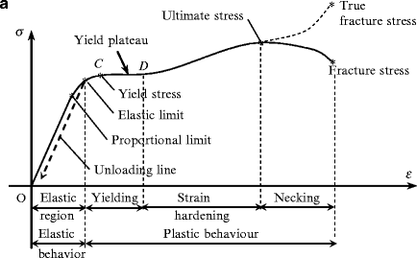
Compression is a force that pushes the particles of a material closer together. For example, when a column supports a load, it is under compression and its height shortens, albeit often imperceivably. The opposite is tensile force which tends to elongate a material. When a building comes under the influence of any type of loading, it sometimes goes to compression or bending according to the type of loading. Due to compressive loading, a structure is compressed and has shortened length. In the bending condition, a structure is squashed and bent from some points, like the middle and end.
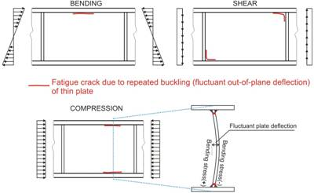
Properties, characteristics and limitations of building materials, products and components.
Several materials, products and components are used in the construction of the building. According to the type of building, different materials are available. The following is the example of some materials, products and components along with their properties, characteristics and limitations that are used in building, such as:
Materials:
Characteristics of clay bricks: It should be strong, durable, dimensional stable, longevity, fire- and weather resistant.
Application of clay bricks: It makes walls, floors, arches and cornices. Besides this, it is also used for making sure that it is used in lime and plaster for aesthetic view.
Limitations of clay bricks: It is heavier than other masonry materials, and its main ingredient is soil that is harmful to the environment. The sound quality of clay bricks is very poor.
Characteristics of solid and hollow blocks:
- Highly durable
- Low maintenance
- Fire resistant
- Thermal and sound insulation
- Environment friendly
Application of solid and hollow blocks: These are used to build large structures as they are light weight and easy to lift. Moreover, solid blocks are used to build both load-bearing and non-load-bearing wall.
Limitations of solid and hollow blocks: These are not cost-effective as they are too expensive and do not provide a good aesthetic view.
Characteristics of Pavers:
- Compressive and tensile splitting strength
- Water absorption
- Abrasion resistance
- Slip or skid resistance
Pavers are used to build roads, patios, walkways, and other outdoor platforms.
Limitations of pavers: These are uneven and unstable, needing a proper drainage system. Moreover, over time pavers are sinking, and their colour is also fading.
Refractory bricks and mortar:
Characteristics of refractory bricks: Refractory bricks have strong strength as they can easily resist shear stress and bending stress. Besides this, these have good porosity and abrasion resistance property. Also, they have higher thermal conductivity.
Application of Refractory bricks: Generally, these are built to stand at higher temperatures. Therefore, these are used in kilns, fireboxes and fireplaces.
Limitation of refractory bricks: They are very heavy in weight and are not environment friendly.
Characteristics of mortar:
Workability: It should be easy to place, mix and transport.
Bond: It should have a proper bond with bricks, stones or concrete blocks.
Compressive strength: The compressive strength of mortar should not be less than its permissible value.
Application of mortar: It is used to develop a soft layer between bricks and stone in masonry work. Moreover, It works as the load-bearing that distributes the load uniformly over the lower brick or stone. It is used to prevent water enters into the joints of bricks or stones.
Mortar limitations: delayed hardening, low tensile strength, shrinkage by drying, and low chemical resistance.
Characteristics of various natural and manufactured stones:
- Density
- Porosity
- Permeability
- Absorption
Applications of various natural and manufactured stones are used to the built floor, wall cladding, bullnose, and steps.
Limitations of various natural and manufactured stones: It is heavier in weight; therefore, the construction with stone is time-consuming. It is more prone to weather changes as develops cracks and mildew as passes time.
Characteristics of aggregates:
- Grading
- Durability
- Particle shape and surface texture
- Abrasion and skid resistance
- Unit weights and voids
- Absorption and surface moisture
Application: It is used to construct pavements, roads, and foundations. Besides this, it is also used to construct slabs, columns and other building elements in concrete.
Limitations: The strength and workability of concrete depend upon the stone's surface. A smooth surface increases the workability of concrete. Still, it decreases the strength of concrete, while the rough surface is responsible for increasing the strength of concrete, but it decreases the workability of concrete. This is the biggest drawback of aggregates.
Characteristics of cement:
- The fineness of the cement.
- Soundness.
- Consistency.
- Strength.
- Setting time.
- The heat of hydration.
- Loss of ignition.
- Bulk density.
Application of cement: Cement is used in mortar for plastering, masonry work, pointing, etcetera. Moreover, It is used to make joints in drains and pipes to prevent water tightness of the structure. It is the main ingredient of concrete used to construct floors, roofs and lintels, beams etc.
Limitation of cement: The tensile strength of cement is very low. It develops more cracks on the surface than other binders.
8)Characteristics of lime:
- Good plasticity
- Easy to work
- Stiffens
- Resistance to moisture
- Cementitious property
- Low to shrinkage
Application of lime: It is used as a binding material in construction such as agriculture, construction and industry.
Limitation of lime: It is not hard as cement and its setting time is also fast. No time is left to check the mortar.
Characteristics of Mortar additives: waterproofing, water-repellency, efflorescence control, air entrainment using plasticisers to increase workability, accelerating and retarding setting times etc.
Applications of Mortar additives: Mortar additives are used in mortar to increase its strength and workability.
Limitations of Mortar additives: This increase the chance of shrinkage in the mortar.
Products:
Abrasives: The type of hard product that is used to smooth rough or irregular substrates. It is available in a sheet of cloth coated with an abrasive material. The utilisation of abrasives is always known as ‘sanding’ or ‘rubbing down’.

Cutting & polishing compounds: These are applied to the coating to remove dust and polish the surface.

Chemicals: It is the most common product that is rapidly used nowadays even before.
Generally, these are of two types such as acid and alkaline. It is necessary to neutralise the surface by using these chemicals during surface preparation.
Sugar Soap: To clean grease, oil and other contaminants, these products are utilised. These are alkaline.
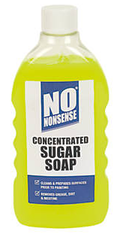
Sodium Hypochlorite: It is a household bleach used to remove mould growth.
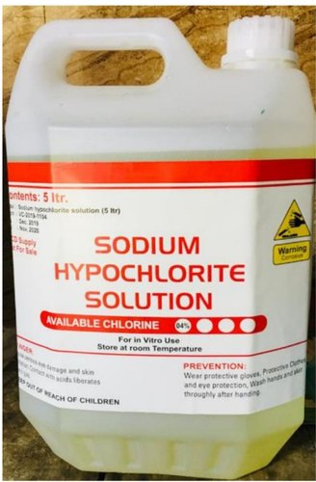
Sodium Hydroxide: It is known as caustic soda to remove old alkaline paint. Use this product carefully as it is a very harmful and hazardous substance.
Some common acids:
Hydrochloric acid: This is used to neutralise the surface of masonry and concretes. During the etching of concrete, this product is commonly used.
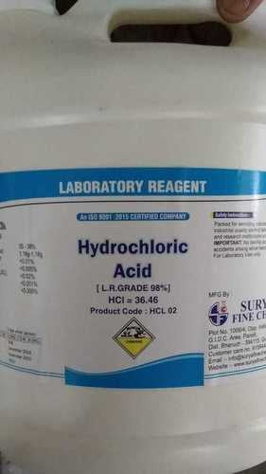
Phosphoric acid: This is used to remove old paint from metals.

Solvents: these are used to clean tools and equipment. These are made of hydrocarbons, kerosene and mentholated spirits.

Stoppers and fillers: Stoppers are used for patching the deep holes and cracks, while the filler is used to fill fine cracks of the surface.
Examples of stopping materials are putty, plaster, plastic wood, caulking compound, etc.
Examples of fillers are water-mixed cellulose fillers, ready-mixed oil-based fillers and gap fillers.

The main components of building their properties and characteristics mainly depend upon their material explained above.
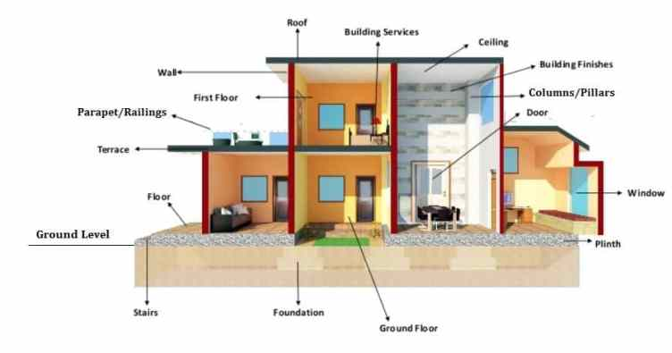
Below ground construction:
Methods:
- Cut and cover method: In this method, the first trench is excavated and then covered by some support for increased bearing capacity.
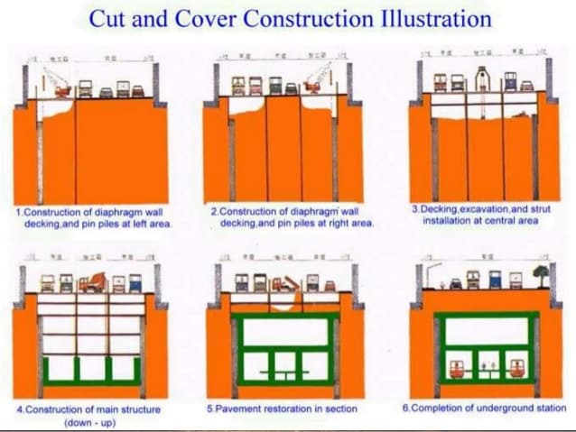
- Top to the bottom method: Construction starts from the top and ends at the bottom.
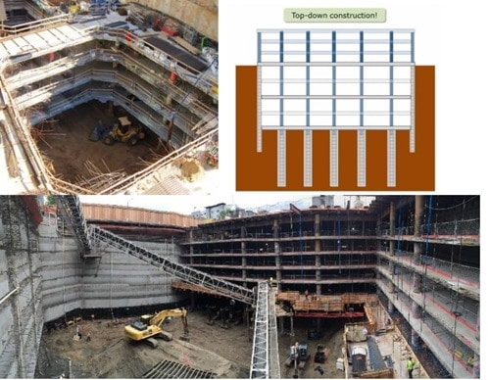
- Structural sufficiency: A retaining wall is constructed to support underground material.
- Water ingress: The prevention must be arranged for water ingress in below ground construction. Sometimes, due to cracks present in the structural elements, water makes its way to enter the building.
- Waterproofing: The elements of the below-ground construction must be waterproofing so that if water ingress into construction, it does not affect the components of the building.
- Work health and safety (WHS): It is mandatory to follow the WHS Legislation during underground construction for workers and masses present during work. The WHS laws are established to prevent any type of risk during work, and it also provides control measures for some conditions that are pre-inspected.
NCC performance hierarchy:
The NCC performance hierarchy now consists of the elements shown in the diagram below adapted from NCC Clause A0.3.
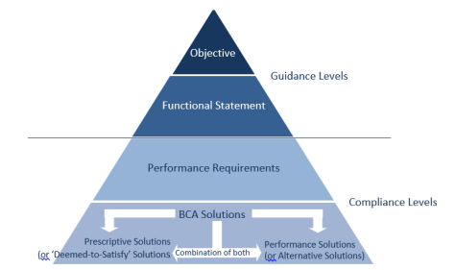
Describe the community's expectations for buildings under the objectives section.
Functional Statements — explain how the buildings will meet the goals.
Performance Requirements – define the minimum level of performance that a building must achieve to accomplish the Objectives and Functional Statements.
BCA – Building Solutions The first volume deals with commercial buildings, is a performance-based document with mandated 'Performance Requirements.' The BCA allows for three compliance options to meet the 'Performance Requirements':
- By complying with the prescriptive requirements (also known as the 'Deemed-to-Satisfy' provisions), which specify how to attain compliance; or
- By assessing a 'Performance Solution (also known as a 'Alternative Solution') by satisfying the applicable 'Performance Requirement' utilising the 'Verification Methods' defined within the BCA.
- A hybrid of the two approaches.


References

- Anatomy - Coyne Stair. https://www.coynestair.com/faq/
- Model WHS Laws - Australian Safety and Compliance. https://australiansafetyandcompliance.com.au/model-whs-laws/
- Safety data sheets - WorkSafe - WorkSafe Victoria. https://www.worksafe.vic.gov.au/safety-data-sheets
- WORK SAFELY AT HEIGHTS LEARNER GUIDE - ceg.net.au. https://www.ceg.net.au/wp-content/uploads/2021/09/TR-WAH-522-RIIWHS204E-Learner-Guide-1.pdf
- Elevation Plan | EdrawMax Template. https://www.edrawmax.com/templates/1004904/
- Design Approach for Performance- Based Building Codes. http://www.cscos.com/wp-content/uploads/FireProtection3_SBeverly.pdf
- Non-conforming building products | Department of Mines .... https://www.commerce.wa.gov.au/building-and-energy/non-conforming-building-products-1
- Non-conforming building products - NSW Fair Trading. https://www.fairtrading.nsw.gov.au/trades-and-businesses/construction-and-trade-essentials/building-products/non-conforming-building-products
- BCA 96 Guide to the BCA Volume One - Amendment 7. https://ncc.abcb.gov.au/sites/default/files/ncc/BCA_96_Guide_Amdt_07.pdf
- Public Comment Draft NCC 2019 Volume Three ... - manualzz. https://manualzz.com/doc/48120703/public-comment-draft-ncc-2019-volume-three-plumbing-code-of
- Fire Regulation Compliance through ... - WoodSolutions. https://www.woodsolutions.com.au/fire-regulation-compliance-through-alternative-solutions
- Building Code of Australia (BCA) 2010 - Volume One. https://ncc.abcb.gov.au/sites/default/files/ncc/BCA_2010_Volume_One.pdf
- Understanding Building Classifications | ABEL Building .... https://www.abelinspections.com.au/blog/2019/11/18/understanding-building-classifications/
- Menu. https://www.planning.nsw.gov.au/Policy-and-Legislation/Buildings/National-Construction-Code

