
AHCLSC306
Implement a paving project

Copyright © 2021 CSTC Pty Ltd

All rights reserved. No part of the contents of this publication may be reproduced or used in any form or by any means – graphic, electronic, or mechanical including photocopying, digitising, recording, or information storage-and-retrieval systems – without the written permission of CSTC Pty Ltd.
ASSESSMENT FOR AHCLSC306

Student name | Morgan Anstee
Date of assessment submission | 15/03/2021

Trainer/Assessor’s name
Date of assessment marking | Click here to enter a date.
Outcome for unit | ☐ Competent  ☐ Not Yet Competent

TASK INSTRUCTIONS

- As part of the assessment for this unit of competency, you are required to complete a series of activities.
  - Some of these activities will require you to provide a response within this document, others will require you to gather evidence to demonstrate your knowledge and skills.
- At all times, the responses in your assessment must reference Australian (Queensland or Federal) documentation, including legislation, regulations, codes of practice, standards and guidance publications.

ACTIVITIES

Identify/list the scope of the work to be carried out from the concept plan shown.

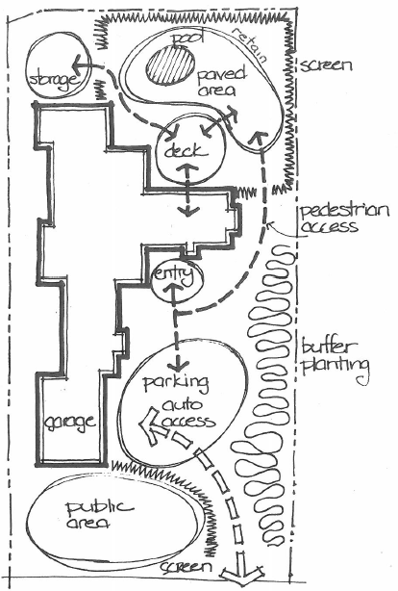

Response
Paving around pool area
- Prepare paving area and ground
- Locate services
- Make provision for irrigation line to cross paved ares
- Mark out area and paving pattern according to plans ( peg reduced levels)
- Excavate area to sub base level
- Place sub base material in evenly over the area and compact with mechanical plate compactor
- Place bedding layer, spread evenly over area. Install screed rails and screed bedding layer
- Start laying pavers
- Install edging restraints
- Sweep through gap filling sand
- Run back over finished pavers with a plate compactor using something in between the plate and the pavers to avoid damage ie carpet
- Lightly mist pavers with water

Outcome for Activity 1 | ☐ Satisfactory  ☐ Not satisfactory
Trainer/Assessor comments

Identify/list the detail on the landscape plan shown.

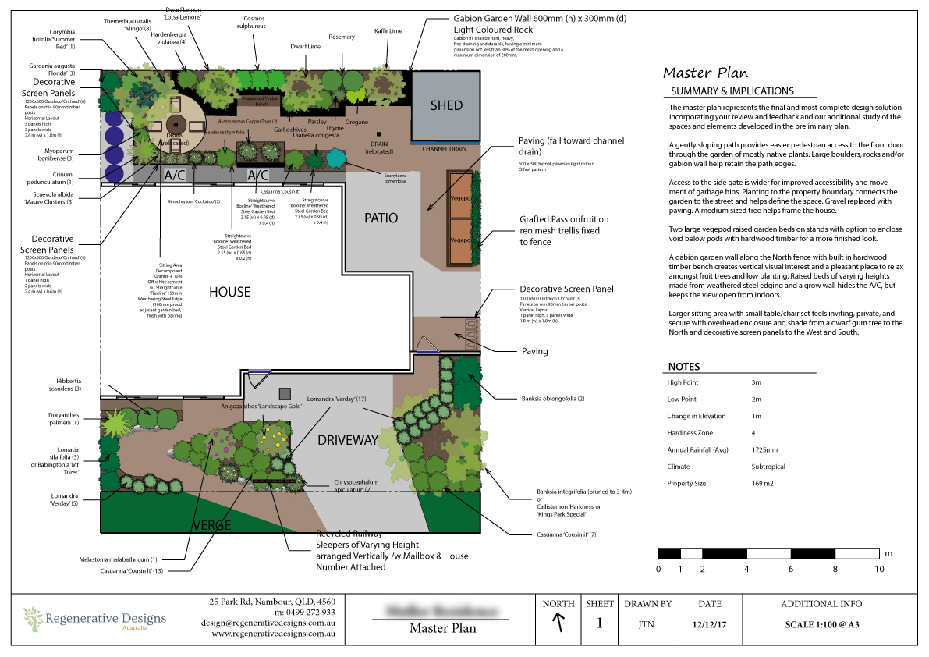

Response
Paving to be installed in the back yard and the behind the gate with a fall towards the drain using 600 x 300 format pavers in light Cobar offset pattern

Outcome for Activity 2 | ☐ Satisfactory  ☐ Not satisfactory
Trainer/Assessor comments

Using the graphics shown, create a simple plan that details a paved path through a garden with grass, trees, shrubs, rocks and steps.

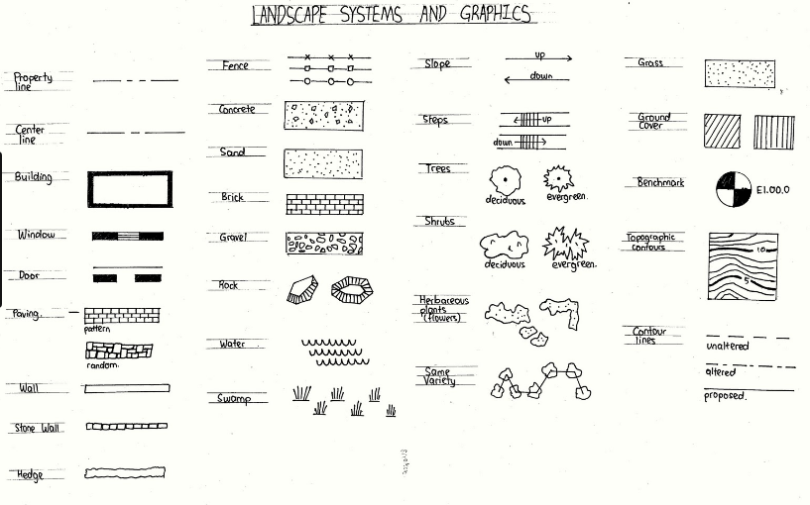

Response
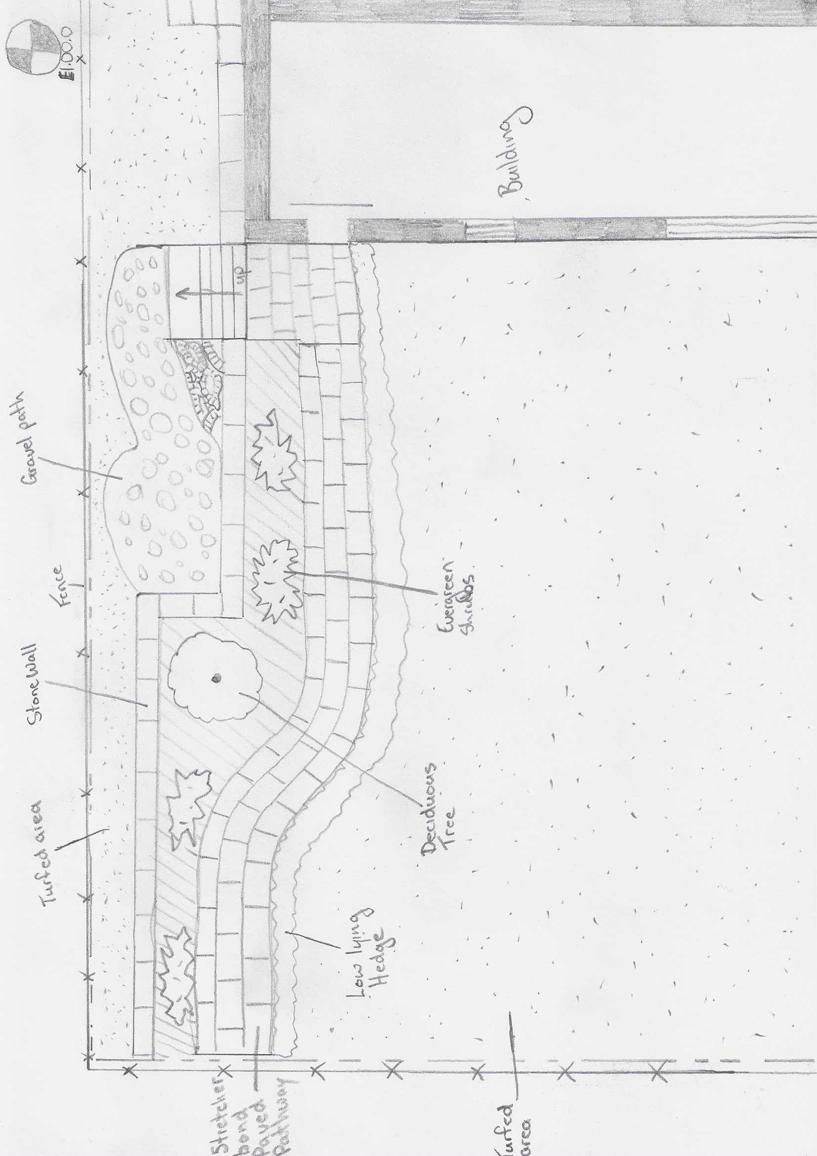

Outcome for Activity 3 | ☐ Satisfactory  ☐ Not satisfactory
Trainer/Assessor comments

Research the advantages and disadvantages of concrete, clay and stone pavers.

For each material, provide one (1) example of a project where it would be most appropriate to use the material and one (1) example of a project where it would not be appropriate to use the material. Explain your responses.

Concrete pavers
Appropriate
Cost affective as it is cheaper to make concrete pavers, options there are a lot of options with concrete style pavers
Not appropriate
Colour, the colouring options are limited and also the way the pavers are manufactured could have imperfections in the colouring and when exposed to long durations of UV this could effect the colour and also the structure of the paver causing it to erode

Clay pavers
Appropriate
Clay bricks hold colouring longer as they are naturally coloured, so they retain colour when exposed to UV rays
Not appropriate
Clay bricks are more costly and have limited colour options

Stone pavers
Appropriate
Stone pavers are low maintenance, has a larger assortment of colours, they are low maintenance
Not appropriate
Much more expensive, tends to absorb moisture much more easily

Outcome for Activity 4 | ☐ Satisfactory  ☐ Not satisfactory
Trainer/Assessor comments

Obtain photographs of common landscaping materials and finished landscapes (both soft and hard).

Explain the differences between your emotions/feelings when you see each photograph in black and white and in colour.

Photograph 1
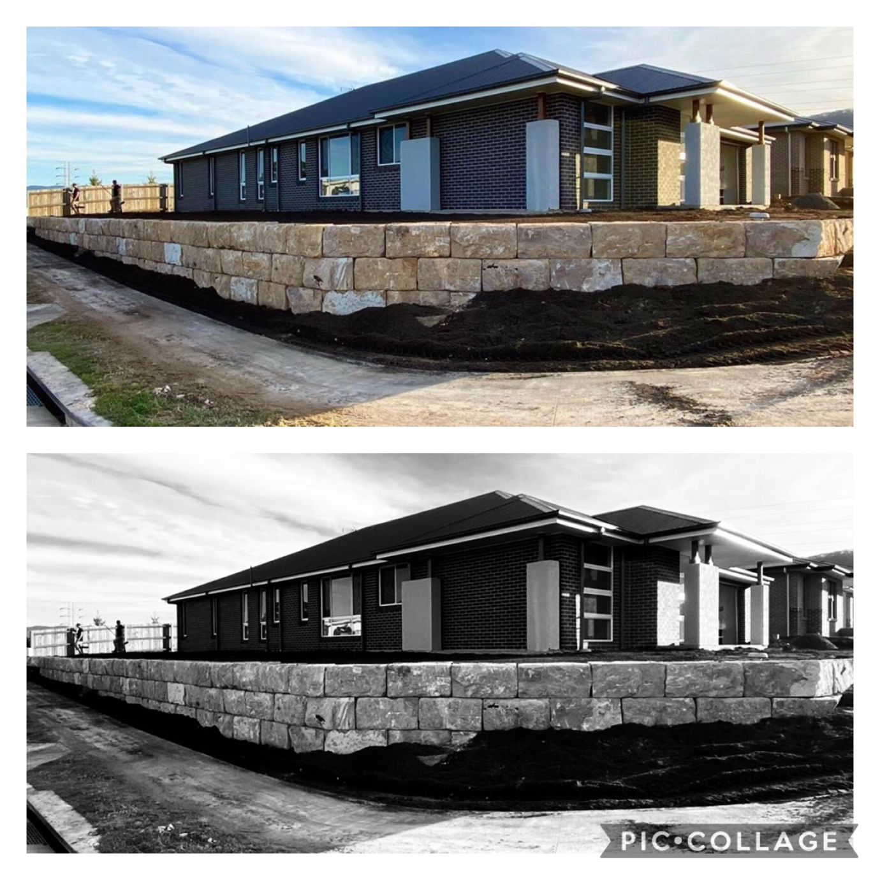

Black and white: Emotions and feelings
The white./grey wall makes me feel a strong sense of boundary with its hard and sharp faces/edges. I have a feeling of dislike as it seems like the house has been built on top of the wall.
Colour: Emotions and feelings
The orange tones give me a sense of warmth, welcomeness and satisfaction. The colour creates a sense of depth allowing me to feel the distance between the wall and house.

Photograph 2
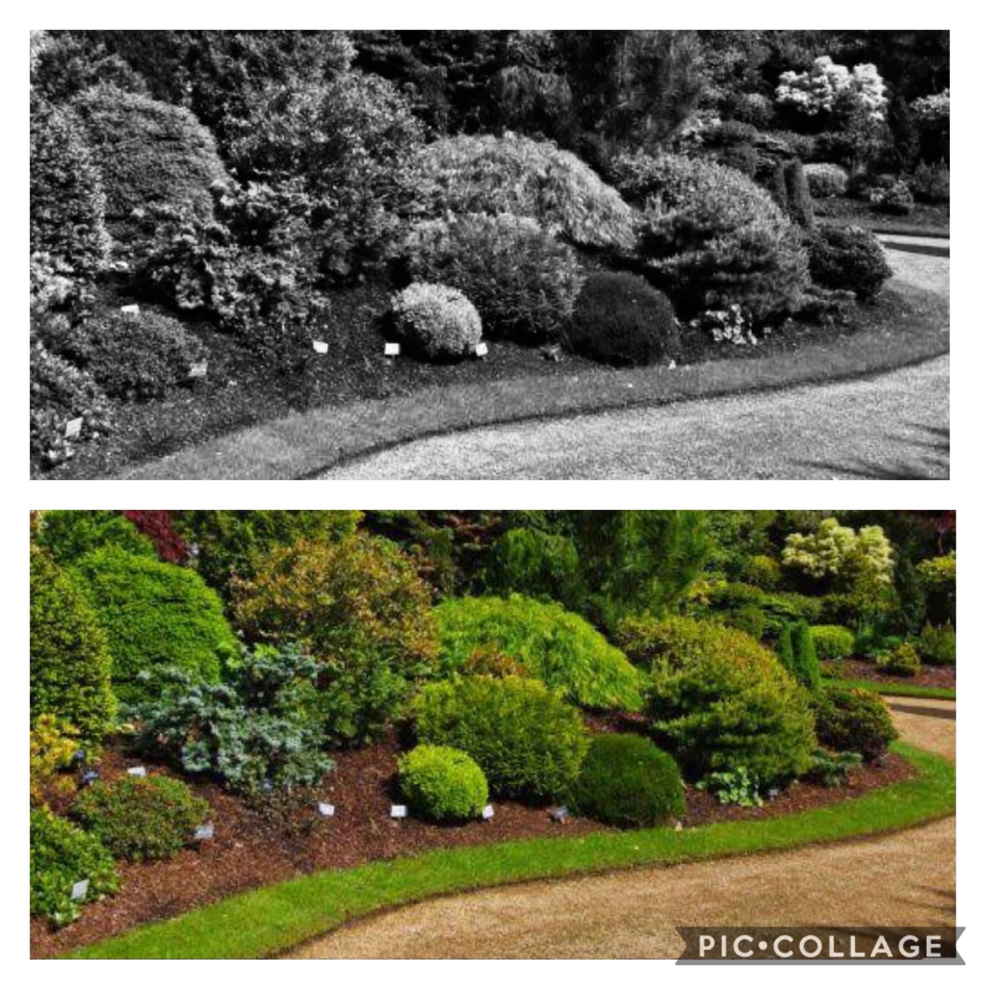

Black and white: Emotions and feelings
This photo provides me with a sense of heaviness, claustrophobia and avoidance. It is difficult to differentiate between the plants, mulch, grass and path which makes me feel stuck.
Colour: Emotions and feelings
The green provides me with thoughts of life, growth, hope and harmony. I feel a sense of calmness and appreciation of nature.

Photograph 3
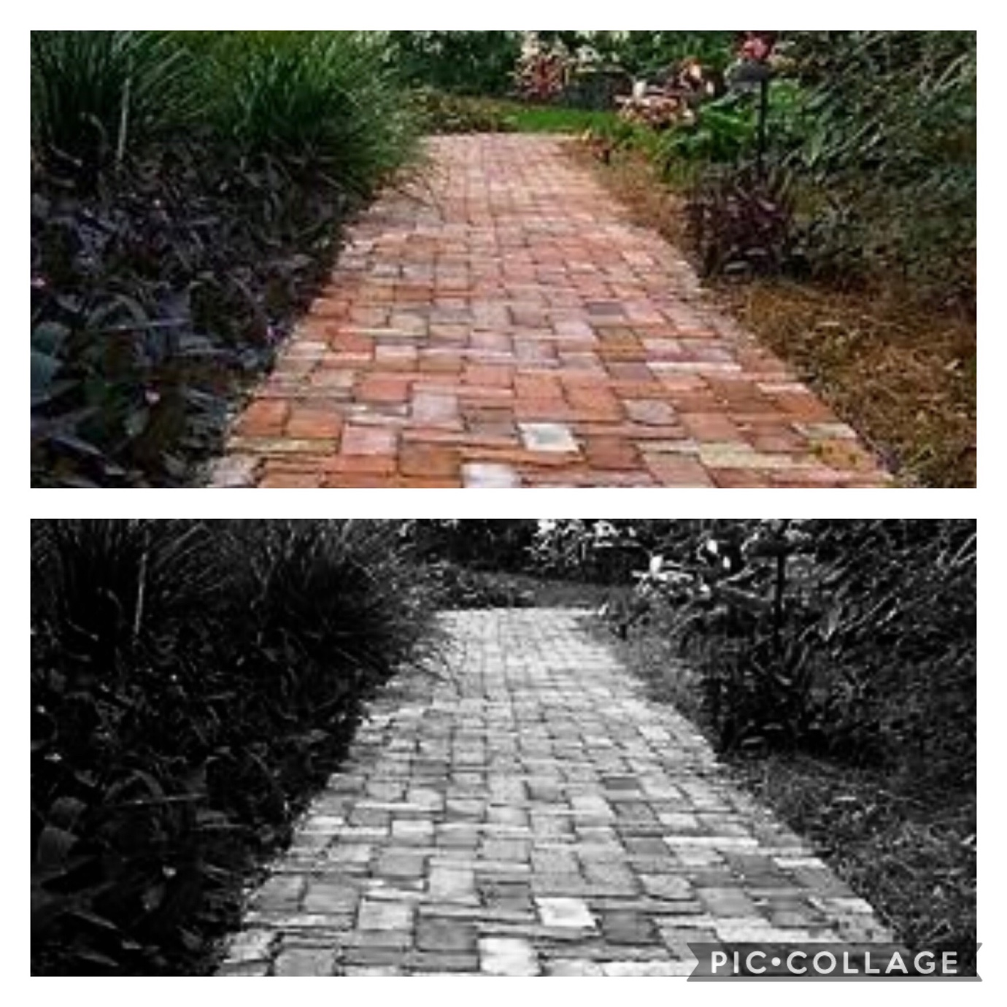

Black and white: Emotions and feelings
This photo initially provides me with a dark and eerie sense that as I continue to explore the depths, it leads me to an area of openness and opportunity.
Colour: Emotions and feelings
This photo provides me with a sense of peacefulness, tranquillity, and focus. The colour/tones lead me to feel like I am walking towards a quiet place listening to nature.

Photograph 4
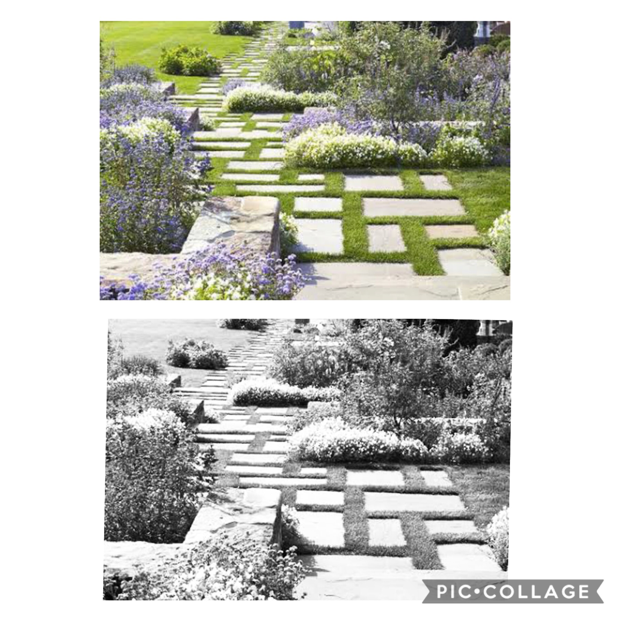

Black and white: Emotions and feelings
I feel a sense of being overwhelmed, cluttered, distracted and scattered. The grey tones are making the whiteness feel hard and unavoidable.
Colour: Emotions and feelings
I still feel a sense of distraction and being overwhelmed, however this has been softened by the green grass in between. I feel like I can smell Lavender and sense of enjoyment as I make my way down the path.

Outcome for Activity 5 | ☐ Satisfactory  ☐ Not satisfactory
Trainer/Assessor comments

Research and identify eight (8) different paving patterns, including the common usage, advantages and disadvantages for each pattern.

Pattern 1 name | 90 degree Herringbone
Common usage
Driveways and pathways
Advantages
It is the strongest pattern and is laid at a 45 or 90 degree angle. Because the pattern interlocks so tightly it can handle significant weight. It has a strong visual effect
Disadvantages
More expensive, more complex to lay, lots of cuts

Pattern 2 name | Stretcher Bond
Common usage
Pathways and entertaining areas
Advantages
Easy and fast to install, least amount of waste, Requires least amount of cutting
Disadvantages
Mostly suited to small area.
Has a short service life span.
Prone to rutting and fatigue, does not tolerate frequent trafficked areas, in particular vehicle turning, accelerating, turning

Pattern 3 name | Basket weave
Common usage
Patio and entertaining area, gives a vintage look and Is eye catching
Advantages
Very eye catching and can be appealing and a feature of its own, easy to install . Requires minimal cutting
Disadvantages
Not as strong as herringbone and not recommended for areas with heavy traffic. good for straight runs, does not curve well

Pattern 4 name | Stack bond
Common usage
Patios, court yards and entertaining areas
Advantages
Simplest of all patterns, requires minimal cuts, ideal for large format pavers and making smaller layouts look larger, strong lines great for pointing towards views
Disadvantages
Not suited to heavy traffic areas, can be fiddly to lay as you must lay each paver down by one corner, making sure that all four corners align for a straight stack look, non structural

Pattern 5 name | Ashlar pattern
Common usage
Residential and heavy traffic area
Advantages
Provides a more contemporary look
Great for breaking up monotony of large paving projects
Disadvantages
More complex to install, more cuts, time consuming

Pattern 6 name | Staggered
Common usage
Patios, pools and pathways
Advantages
Easy and quick to install, requires minimal cutting and less wastage
Disadvantages
No good for heavy traffic areas

Pattern 7 name | Boxed basket weave
Common usage
Patios and entertaining areas, footpaths
Advantages
Very eye catching and can be appealing and a feature of its own, easy to install, requires minimal cutting
Disadvantages
Not as strong as herringbone and not recommended for areas with heavy traffic. Good for straight runs and does not curve well

Pattern 8 name | Zig Zag Brick Bond
Common usage
Driveways, pathways
Advantages
This type of bond is very similar to herring-bone only difference is that in this case the bricks are laid in a zig-zag pattern. It is mostly adopted in brick paved flooring
Disadvantages
Pattern can sink if not laid correctly, lots of cuts

Outcome for Activity 6 | ☐ Satisfactory  ☐ Not satisfactory
Trainer/Assessor comments

Select a paver type (with known specifications) and calculate the material costs for a straight path that measures 6m long by 900mm wide.

Response
Convict Sandstone Bush Hammered Tumbled Paver
Pavers per sqm: 22.22
Price per sqm: $40
Area in sqm: 5.40
Pavers per Width: 3.00
Pavers per length: 40.00
Pavers per area: 120.00
Pavers price per area: $216
Pavers cubic metres: 0.16
Pavers weight kg: 388.80

Outcome for Activity 7 | ☐ Satisfactory  ☐ Not satisfactory
Trainer/Assessor comments

Research the advantages and disadvantages of installing edging before and after laying pavers.

Installing edging before laying pavers
Advantages
- Helps define the outline of the job on irregular shaped jobs in a bounded area
- Allows the shape to be checked for accuracy both in alignment and level before pacing the body
- Can be used as a level guide
- Edging first means you can put all cuts to one side depending on paving pattern

Disadvantages
- Requires more cuts as the body blocks have to suite the soldiers course
- Never lay this course on bedding material

Installing edging after laying pavers
Advantages
- On loosely or undefined pavement, edge course can be positioned to minimise cuts
- Neatest method, concrete haunch can be hidden under surrounding grass, pebble or mulch

Disadvantages
- Possibility of dislodging the pavers while digging channel for haunching

Outcome for Activity 8 | ☐ Satisfactory  ☐ Not satisfactory
Trainer/Assessor comments

List environmentally safe products for cleaning.

Response
- White Vinegar
- Baking soda
- Guardit solutions paving and concrete cleaner

Outcome for Activity 9 | ☐ Satisfactory  ☐ Not satisfactory
Trainer/Assessor comments

Have team members take photos and videos of your involvement with paving projects.

Identify each photo / video with a letter label and describe each photo / video in the table below. Submit the photo / video files along with this workbook.

Advantages
A
B
C
D
E
F
G
H
I
J
K
L
M
N
O
P
Q
R
S
T
U
V
W
X
Y
Z

Outcome for Activity 10 | ☐ Satisfactory  ☐ Not satisfactory
Trainer/Assessor comments

