Workplace Assessment 3 – Assessor’s Checklist
(This form is for the assessor’s use only)

Purpose
This Assessor’s Checklist lists the specific criteria that the candidate’s submission for Workplace Assessment 3 must satisfactorily meet.
This form is to be completed by the candidate’s assessor to document their assessment of the candidate’s submission in Workplace Assessment 3.

Task Overview
For this task, the candidate is required to record the sizes, thickness, and quantity of the materials from the detail drawings used on the building and construction project by completing the Material Quantity Takeoff Form they obtained from the assessor.
In this task, the candidate will be assessed in their:
- Practical knowledge of the sizes, thickness and quantity of construction items.
- Practical skills relevant to examining detail drawings to determine sizes and thickness
- Practical skills relevant to interpreting two-dimensional and three-dimensional drawings and applying to estimation

Instructions to the Assessor

After the assessment
- Complete all parts of the Assessor’s Checklist, including the Assessor Declaration on the last page of this form.

Candidate Details
Candidate name | Dawei Yang

Assessor Details
Candidate is assessed by | Steve Zhu

Context of the Assessment
Workplace/organisation | Dawn construction
Resources required for the assessment | - Building and construction project  - Opportunities to examine detail drawings to determine sizes, thickness and quantity of materials  - Detail drawings  - Material Quantity Takeoff Form

Assessor’s Checklist
The candidate’s Material Quantity Takeoff Form submission: | YES/NO | Assessor’s comments
- Specifies the height of the corresponding items
- Item 1 | YES NO
- Item 2 | YES NO
- Item 3 | YES NO
- Specifies the width of the corresponding items
- Item 1 | YES NO
- Item 2 | YES NO
- Item 3 | YES NO
- Specifies the thickness of the corresponding items
- Item 1 | YES NO
- Item 2 | YES NO
- Item 3 | YES NO
- Specifies the quantity of the corresponding items
- Item 1 | YES NO
- Item 2 | YES NO
- Item 3 | YES NO

Assessor Declaration
By signing here, I confirm that I have thoroughly reviewed the candidate’s Material Quantity Takeoff Form submission for this workplace assessment task.
I confirm that the information recorded on this Assessor’s Checklist is true and accurately reflects the candidate’s submission for this workplace task.
Assessor’s signature | 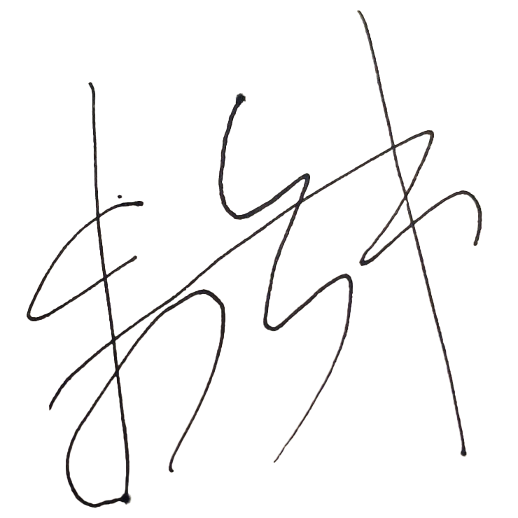
Assessor’s name | Steve Zhu
Date signed | 06/11/2022

End of Workplace Assessment - Assessor’s Checklist

