SAFE WORK METHOD STATEMENT
Pelican Formwork Pty Ltd, 17 Burke Street Coorparoo, (07) 3288 2198 |  | Principal contractor (PC) | Bigtime Builders
Work activity | Use of Power tools (nail guns, power saws, drills) | Work location | Midtown apartments  154 Charlotte Street  Brisbane 3000
High risk construction work |  | Work location | Midtown apartments  154 Charlotte Street  Brisbane 3000
High risk construction work |  | Date | 1/11/2019
Have workers been consulted about the SWMS? | All workers are required to be consulted with regards to the SWMS and control measures contained in the SWMS.

Person responsible for ensuring compliance with SWMS | Matt Cumiskey (Site supervisor) | Date SWMS provided to PC | 10/11/2019
Person(s) responsible for reviewing the SWMS | Matt Cumiskey (Site supervisor) | Last SWMS review date | 07/01/2020
Date received | 17/11/2019 | Signature | 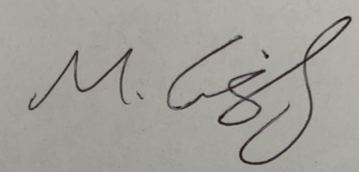

Workers name | Jim Jones | Date received | 09/01/2020
Workers signature | 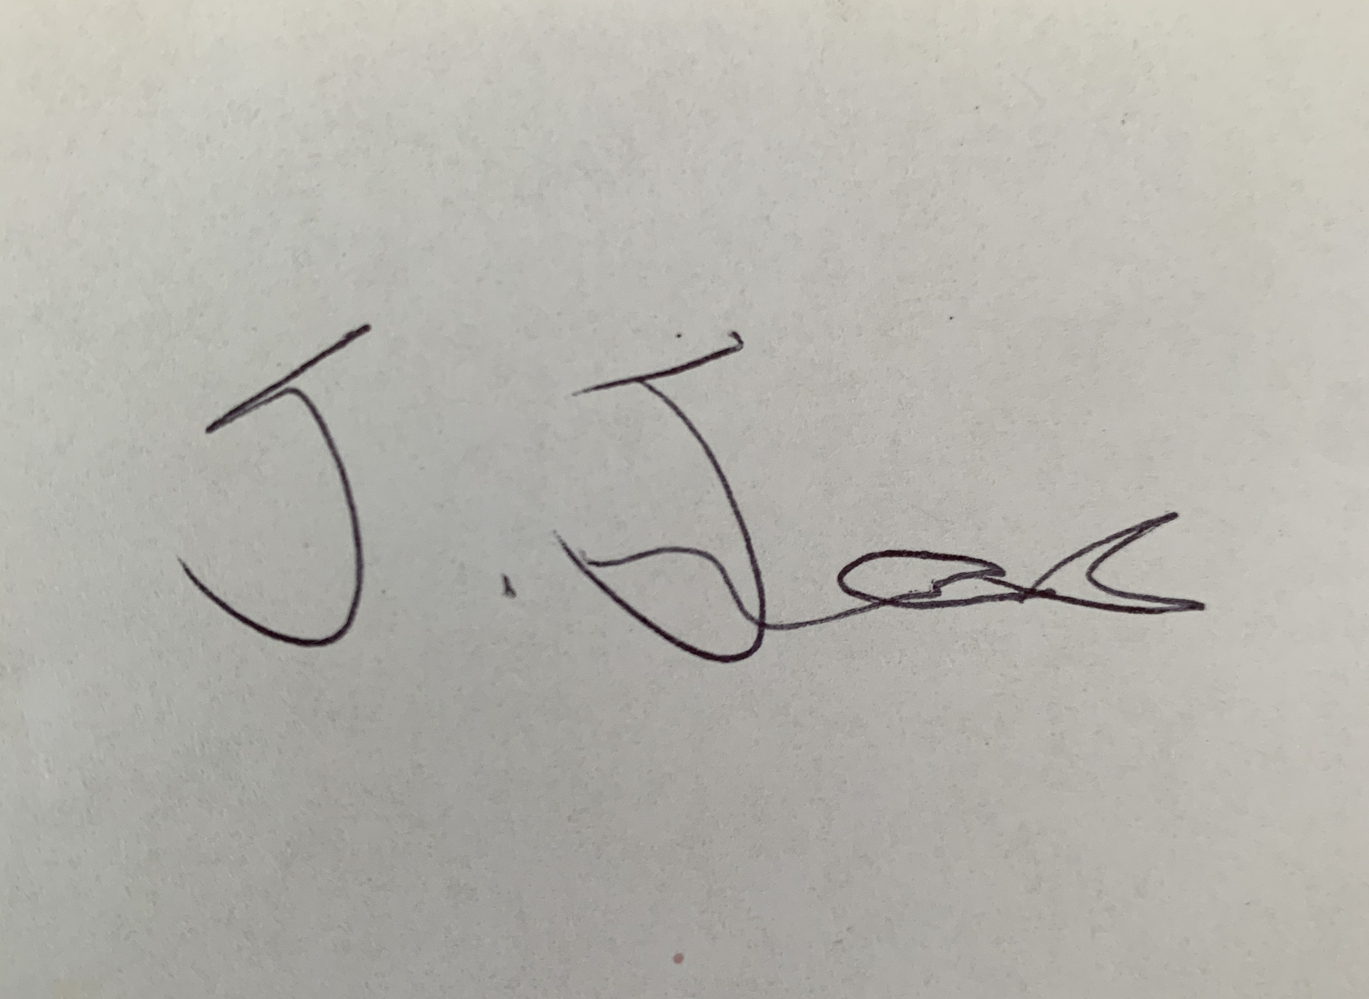

What are the tasks involved? | Tools | What are the hazards and risks? | What are the control measures?
 | Tools used for task | Identify the hazards and risks that may cause harm to workers or the public. | Describe what will be done to control the risk. What will you do to make the activity as safe as possible?
Cutting | Power saw | Noise, eye damage and falling off cuts | Use PPE including eye protection, ear protection and steel cap boots
 |  | Flying obstacles from rotating blade | Before activating the tool ensure that you are standing to one side of the rotating blade, be ready to drop the tool. When satisfied that the blade is clear to run without problems, start the tool.
 |  | Hands being close to blade, jamming of the blade, item moving during cutting, sever cuts, loss of fingers | Ensure that all pencil markings are done away from the blade and not during operations. Pre-mark item to be cut & cease use if re-marking is required.  Secure item to be cut or prevent slippage by placing on a firm flat surface & secure.  Consider if the off-cut needs to be supported Make sure your hand is no closer than 150mm from the blade and hold the largest part of the work firmly on the bench or supporting surface.
 |  | Cuts, loss of fingers, eye injuries during the cutting of work | Make sure your hand is no closer than 150mm from the blade and hold the largest part of the work firmly on the bench or supporting surface.  Stance should be relaxed but alert and to one side of the cutting blade.  Operate the saw with firm steady pressure, speed should not be fast.  When cutting has been completed it has to be brought back to the resting position.  Be aware of what has happened to the off-cut.  Keep one hand holding the work until the cutting blade stops running.  Do not pass hands under the blade while it is running.
Using Power Drills | Drill | Tripping, cuts, eye injuries, hair & clothing caught in drill mechanism | Ensure area is clear of rubbish and obstacles prior to setting up.  Keep hands clear of drill bit at all times Tie or secure long hair.  Secure loose clothing to prevent it being caught by the drilling bit.  Wear appropriate safety goggles/glasses where there is a risk of foreign objects entering the eye.
Using nail gun | Gas nail gun | Misfire | Ensure all nail gun safety devices are operable.  Never dislodged jammed nails or components whilst the compressed source is connected to the nail gun. Never tamper or modify a safety device fitted to the nail gun.  Always use the correct air pressure or gas volume as specified in the operating manual.  Ensure all hose pipes and couplings are in serviceable condition.  Never change position or carry the nail gun with your finger depressing the trigger.
 |  | Persons below operating area, nails passing through timber | Ensure the area around or below the work site is clear of personnel.  Do not point the tool towards yourself or others, no matter how far away they are.
 |  | Projectile hazard | Maintain a safe, well balanced position to prevent misalignment of the nail gun during use.  Ensure hands and fingers are not in the firing path.  Be aware of the airline so that it does not become a trip hazard to you or others.  Always wear safety glasses when using a nail gun Inspect the timber that the nail is being fired into for knots or metal backing as this may cause the nail to ricochet.  Be wary of gang nails and speed bracing that may cause the nail to skew out of the timber or break. Apprentices are not to use nail guns in bump fire mode.
Using electrical hand tools | Any electrical hand tool | Electrocution | All electrical leads should be intact with no damage to insulation.  All leads should be tested & tagged in accordance with legislation.  Locate excess electrical cord away from work area.  Leads should be running to a tested RCD device either at the switchboard or a portable device.

