Practical Task 1 (2X)
Description of task:
On two (2) occasions, a suitable observer is to verify the participant’s ability to process client requirements in relation to contract documentation. The participant is to obtain client information, accurately convey that information to those developing contract documentation (including drawings and specifications) and complete the administration of the contract documentation process.
- Occasion 1: Residential construction project
- Occasion 2: Commercial construction project

The participant is to gather evidence of how they have completed each component of the Practical Task, which is to be submitted with this Practical Assessment sheet. Evidence to be submitted may include:
- RFI sent to client and proof of correspondence
- Variation sent to client and proof of correspondence and acceptance

Occasion 1: Residential construction project

For this task I have provided evidence of progress claims and RFI’s completed and sent through to the builder on a monthly basis. This outlines my ability to process client requirements in relation to contract documentation. The information provided is directly related to our contract and contractual agreements. The process of creating the claims involves reviewing the current variations, reviewing how much work has been done on site, how much costs have occurred and assessing the amount needed to cover those costs.

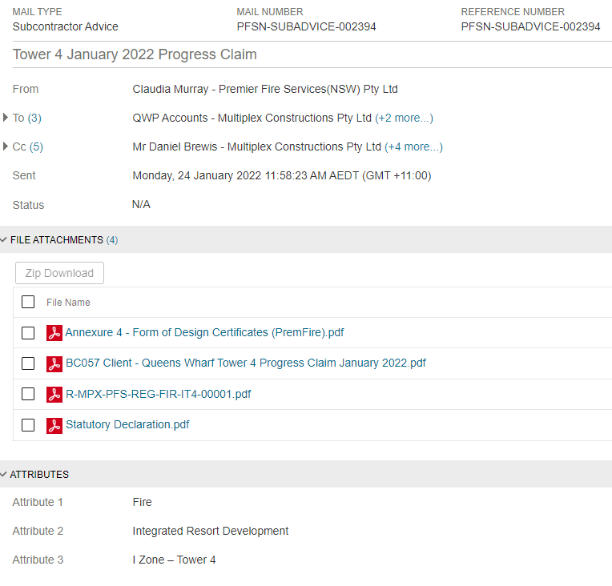

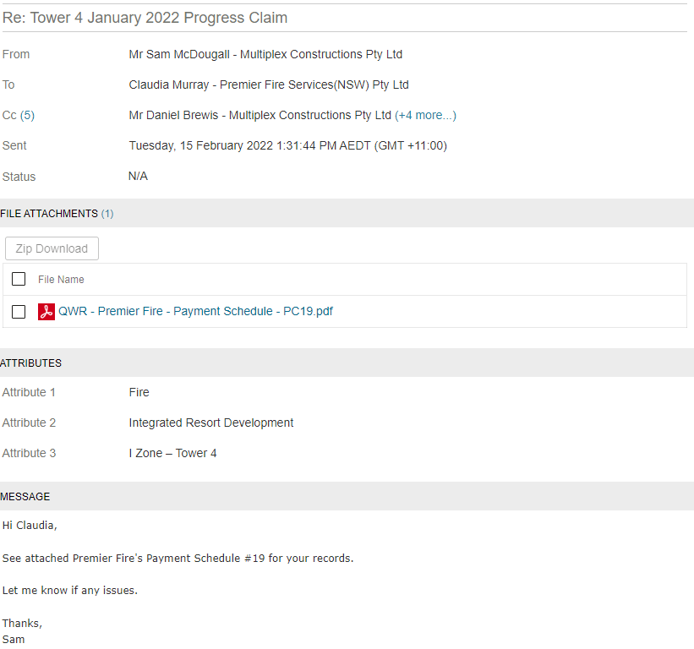

Occasion 2: Commercial construction project

For this task I have provided evidence of RFI’s being sent to me to prepare reports and send back to the client as part of a monthly submission for training hours. As part of our contract, we must provide 5% of the total contract value in training hours. In which 60% of those hours must be conducted by Apprentices and 40% conducted by other workforce.

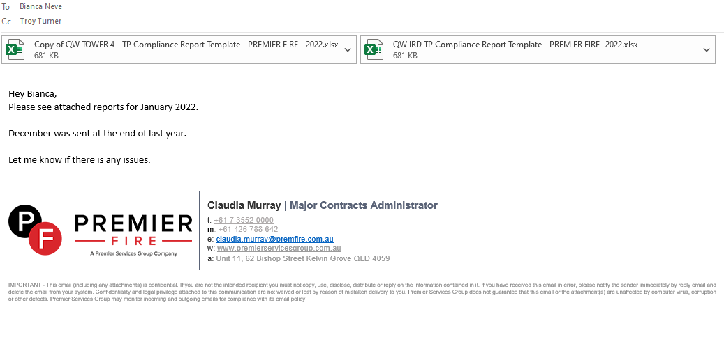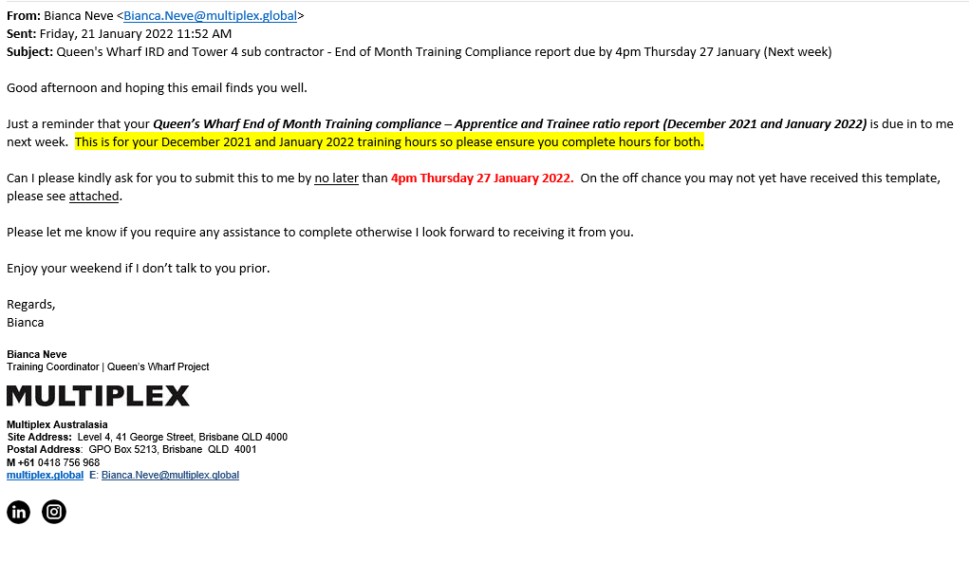

Practical Task 2 (2X)
Description of task:
On two (2) occasions, a suitable observer is to verify the participant’s ability to plan, prepare and lodge a building application. The participant is required to evaluate and review the outcome of the application.
- Occasion 1: Development approval
- Occasion 2: Building approval

The participant is to gather evidence of how they have completed each component of the Practical Task, which is to be submitted with this Practical Assessment sheet. Evidence to be submitted may include:
- Council approvals.
- Traffic control plan submissions and approval by city councils.
- Crane base drawings and approval by engineer (if you have them).
- QFES approvals.

The observer is to provide detailed comments on the tasks completed by the participant. The assessor is to verify the observer’s comments in the Assessor Comments section, and provide the Practical Assessment outcome on the front cover of this document.

Occasion 1: Development approval

Working in a Fire Company that get subcontracted onto these jobs the development approval is well and truly conducted by the time we get onboard. However, we do have a process in which we need to follow to gain seismic approval by the seismic engineer. Our drawings will go through the approval process with the builder and our peers, including the architect and the structural engineer and get to a stage where it is ‘Approved for Construction’ status. These drawings will then be sent to the Seismic engineer, in this instance Kusch, for review on where to place appropriate hanging restraints to ensure our materials don’t shift in the case of seismic activity. Installation must then follow these approved drawings. Kusch will supply a Form 15 and 16 to ensure the design and installation complies with the Seismic approved drawings. (see drawings and forms attached)

Occasion 2: Building Approval

QFES approval happens at the very start of a project, often we are contracted and given a number of weeks to create our initial design for this to go to QFES. We are required to either give a design or often due to the short time period given to provide the design they will accept a hatched drawing with the Australian Standard references relating to the hatches. This will identify where we intend to have protection throughout the building. We will also hatch in different formats areas that will not be protected or issue a list of items to them for example, we would not install sprinkler heads in electrical/communications cupboards as these are filled with electrical equipment, we would remove the sprinkler and add a detector instead, this is just better practice.
QFES design will usually happen at BA approval stage. QFES will also then do a site visit at the end of the project to check pump rooms etc to ensure space requirements in there have been met & stair landings have enough space for them to work on Part 6 valves.
Drawings then are subject to change as building goes up. Our drawings go through a peer review process with the structural company and he architect to give advice on the design as it happens. (see BA approval drawings and Form 15 below)

As a fire company it is in our best interest when designing pipe we design around the cranes where possible as this allows for us to potentially finish install in an area there are cranes still up onsite. We use the structural GA drawings & models to ensure we avoid the area but ensure coverage is still achieved. Sometimes if the crane penetration is too big for sprinkler heads to protect the area then we will leave a plugged feed so that we can test the area and leave it pressurised even with the crane still installed, then when it is removed it will only take 1 sprinkler fitter a short amount of time to finish off the area by draining the system & completing the install. (See structural drawings below)

