CPCCBC6018
Manage processes for complying with legal obligations of a building and construction contractor

ASSESSMENT SUMMARY

The assessment activities for CPCCBC6018 Manage processes for complying with legal obligations of a building and construction contractor cover all aspects of the unit of competency. For Apprentices/Trainees, this includes supervisor completion of the Apprentice/Trainee Record (ATR).

Participants must read all the information given before starting any assessment task. The assessment tasks are intended to be fair, flexible, valid and reliable. If a Participant has any questions or requires alternative arrangements to be made such requests should be directed to their Trainer/Assessor, who should note such arrangements in the ‘Assessor Comments’ on the affected assessment. If a Participant feels they are not yet ready to be assessed, they should discuss their options with their Trainer/Assessor.

To satisfactorily complete the assessment, the Participant is required to answer all questions correctly and demonstrate their skills to industry standards. If a Participant does not answer all questions or perform all tasks, they will be deemed ‘Not Satisfactory’ for the task and ‘Not Yet Competent’ for the unit of competency.

The Trainer/Assessor can provide the Participant with additional information on interpreting the assessment outcomes and guide the Participant’s options. If a Participant is still deemed ‘Not Satisfactory’ they will have the opportunity to undertake a supplementary assessment or appeal the result as per the process in the Student Handbook.

By signing below, the Participant acknowledges:
- They understand the assessment instructions and requirements, and consent to being assessed.
- The work submitted is to be their own work – with the work of/with others needing to be clearly acknowledged and documented.
- They consent to any photo/video recording of their work that occurs during assessment.

Participant name | Ethan Wilson
Participant signature | 

Pre-requisite unit(s) to be achieved and authenticated prior to undertaking assessment
Not applicable

Task | Date completed | Assessment Results
Theory Exam | Select Date. | Satisfactory | Not Satisfactory
Workbook | Select Date. | Satisfactory | Not Satisfactory
Practical Assessment | Select Date. | Satisfactory | Not Satisfactory
Outcome for CPCCBC6018 | Select Date. | Competent | Not Yet Competent

Evidence requirements checklist (ticked by assessor and evidence supplied to RTO)
Theory Exam  Workbook  Practical Assessment  Copy of contract reviewed  Screenshot/ doc. of management system introduced and managed | 1 x ea. Policy & procedure - record & legal documents storage  Screenshot/ doc. system managed re: insurance and taxation  1 x ea. Policy & procedure re: payments  Code of conduct developed  Screenshot / copy of EMP compliance actions.

Assessor name
Assessor signature

CPCCBC6018
Manage processes for complying with legal obligations of a building and construction contractor

THEORY EXAM

Participant name | Ethan Wilson

FOR THE PARTICIPANT
Instructions
- You will complete written questions as outlined on the following pages. You must attempt all questions and provide enough detail in your responses to demonstrate your knowledge.
- It is anticipated that you should complete this assessment within two (2) hours, but additional time may be allowed upon negotiation with the Assessor.
- You must complete all questions unassisted by the Assessor or other personnel but may refer to reference material as needed. All questions must be answered correctly for a ‘Satisfactory’ assessment outcome to be awarded.
  - An oral examination may be allowed under certain circumstances, whereby your answers will be documented by another party.
  - Any written questions that are incomplete, or not answered satisfactorily will need to be completed again after further training support.
    - If you answer a question incorrectly but modify your response, put your initials next to the written change (or the Assessor must initial a verbal change).
Resources required
Pen

FOR THE ASSESSOR
Instructions
- Where oral examination has occurred, ensure that this is acknowledged in writing (e.g. FT001 and Assessor Comments)
- All questions must be satisfactorily demonstrated by the Participant for a Satisfactory determination (indicated by an Assessor tick to the right of the question).
- Assessors are to complete marking in pen of a different colour to the Participant.
- If the Participant verbally modifies their response, write in the modified response verbatim and put your initials next to the written change.

ASSESSOR COMMENTS
As necessary, outline:
- Details on reattempts, alternative arrangements or reasonable adjustments made.
- Where a Participant is deemed ‘Not Satisfactory’, provide recommendations for future training.

- Discuss the following types of building contract and identify provisions relating to these in the State/Territory you are working.

 | State/Territory: QLD
Answer | Contracts | Purpose/requirement
 | Commercial contract | A commercial contract is used exclusively for the construction of commercial buildings. These structures are not for residential use. Building office spaces, stores, hotels, and other enterprises that may require space for a private business are examples of this. Commercial contracts are similar to residential contracts in most cases. Depending on the applicable zoning and other construction rules, additional permissions and paperwork may be required.
 | Residential contract | When constructing a home, a residential contract is required. The Home Building Act governs this form of arrangement. The NSW Home Building Act 1989 lays out the bare minimum of rights for homeowners, builders, and contractors. This includes warranties, payments, deposits, insurance, and other home construction-related issues. This includes the ability to transact with licensed builders, have insurance, and have the requisite warranties in a construction defect. Failure to comply with these has legal ramifications.
 | Lump Sum contract | On a lump sum contract, the customer and the contractor agree on a "fixed fee" for the work to be done before work begins. This contract can be used to build both residential and commercial buildings. A lump sum construction contract is risky because the contractor has fewer options for modifying their price.
 | Sub-contract agreement | A subcontractor agreement between the main contractor and a subcontractor relates to expert work performed on behalf of the main contractor on a construction project.
 | Cost-plus contract | A cost-plus contract specifies that a client agrees to reimburse a construction business for building expenses such as labour, materials, and other costs, as well as an additional payment, commonly expressed as a percentage of the total contract price. Alternatives to lump-sum agreements include this form of a building contract. It allows for flexibility and transparency and lowers a contractor's risk by ensuring a profit. This applies to both residential and business contracts. In a cost-plus arrangement, the customer has the right to see the contractor's expenses in detail. A guaranteed maximum price is also included in some cost-plus contracts.

- Discuss contract terms, conditions, and inclusions you are likely to encounter.

Answer | Contract conditions define the main legal relationship between the parties involved in a building project, influencing risk allocation and, as a result, price. The construction industry has a wide selection of standard contract forms to balance the parties' risks and provide certainty of meaning via extensive and recurrent use.

- Discuss the importance of adding variation clause to the contract and what you may need to include in the contract documents.

Answer | A Variation clause is added to have a chance to charge to any deviation or alteration to original scope. Its important to add the clause in and clearly state what your scope is in the contract for protection and so you add or remove items from your scope with cost implications to the client.

- Discuss why builders should keep and maintain records of subcontractors, site supervisors and managers qualifications, competencies, and licences.

Answer | Builders should maintain records of subcontractors' and site personnel's qualifications, competencies, and licenses to ensure regulatory compliance, safety, quality, efficiency, and effective risk management while supporting training, reputation, and comprehensive project documentation

- Why would you access the Australian Business Licence and Information Service (ABLIS)?

Answer | Accessing ABLIS helps businesses navigate regulatory requirements, apply for necessary licenses and permits, and ensure compliance with federal, state, and local laws.

- How can you ensure you respond to changes to licensing arrangements in a timely manner?

Answer | To ensure timely responses to changes in licensing arrangements, you should regularly monitor updates from relevant regulatory bodies, subscribe to notifications or newsletters, implement a system for tracking licensing status, and review your compliance processes periodically.

- Discuss areas of a building contract that may require you to organise professional legal advice.

Answer | Professional legal advice is essential for navigating complex areas of a building contract, including terms and conditions, risk allocation, dispute resolution, compliance, and payment issues to ensure clarity, fairness, and legal protection.

- What processes can you introduce and manage to enable the organisation to obtain effective legal advice relating to contract law?

Answer | To obtain effective legal advice on contract law, establish relationships with legal professionals, implement a structured contract review process, maintain organized documentation, schedule regular reviews, create internal protocols, train staff, utilize legal tools, and stay updated on legal developments.

- Discuss the benefits of having a contract management system in place.

Answer | a contract management system enhances efficiency, compliance, and visibility, while improving risk management, collaboration, and accuracy, ultimately leading to cost savings and better strategic outcomes.

- What mechanisms can you put in place to improve communication and dialogue with the client?

Answer | To improve client communication, implement regular updates, assign dedicated contacts, establish feedback channels, schedule meetings, ensure clear documentation, use communication tools, provide actionable reports, conduct client surveys, offer training, and maintain responsive service.

- Describe what happens in conciliation.

Answer | In conciliation, a neutral conciliator helps disputing parties communicate, identify issues, and explore potential solutions to reach a mutually acceptable agreement. The process is voluntary and non-binding, focusing on facilitating dialogue and negotiation to resolve disputes informally.

- Why would the builder change/adapt workplace procedures and workplace safety requirements at a new site?

Answer | A builder would change or adapt workplace procedures and safety requirements at a new site to address site-specific conditions, comply with local regulations, manage unique hazards, and ensure the safety and efficiency of operations tailored to the particular environment and project needs.

- Discuss strategies you can apply that ensure all workers are inducted, informed, and regularly updated of their on-site safety responsibilities.

Answer | To ensure all workers are properly inducted, informed, and updated on safety responsibilities, implement comprehensive induction programs, conduct regular safety training, and establish clear communication channels. Use visual aids, hold regular briefings, appoint safety personnel, and provide accessible safety documentation. Additionally, conduct safety audits, incorporate feedback mechanisms, and recognize adherence to safety protocols to reinforce and maintain safety practices on-site.

- A worker you have employed on the site has been injured and has lodged a request for workers compensation to reimburse their medical expenses. Explain the process you must follow in your State or Territory for claiming on behalf of the worker.

Answer | the process in Queensland involves immediate medical care, reporting the injury, assisting with the claim form, submitting required documents, and maintaining communication with both the insurer and the injured worker.

- What is inherent risk in construction? Discuss the factors to be considered in assessing risks inherent in building and construction projects.

Answer | Inherent risk in construction involves potential hazards intrinsic to the industry, influenced by factors such as site conditions, project complexity, workforce skills, regulatory compliance, material handling, contractor management, design flaws, health and safety, environmental impact, and financial factors. Assessing these risks helps in identifying, managing, and mitigating potential issues to ensure project safety and success.

Read the scenario below to respond to Q16. and Q17.

The subcontractor (first-tier subcontractor) you hired for this project is carrying on a business that is primarily in the building and construction industry. He has engaged another subcontractor (second-tier subcontractor) to assist with their current workload.

- What subcontractor payments are you required to report to the Australian Taxation Office (ATO)?

Answer | Any payments made to the first-tier subcontractor for building and construction services.

- Will the first-tier subcontractor also be required to report to the Australian Taxation Office (ATO)? Explain your answer.

Answer | you are not directly responsible for reporting payments made by the first-tier subcontractor to the second-tier subcontractor, you must ensure that the first-tier subcontractor is aware of their own reporting obligations

- As the principal contractor, you will be withholding tax from the payments you make to your workers and contractors through PAYG withholding. Provide the four (4) activities that you must complete in compliance with the Australian Taxation Office’s (ATO) requirements for those who make payments subject to withholding.

Answer  1.  2.  3.  4. | • Register for PAYG Withholding: Ensure you are registered with the ATO for PAYG withholding. This registration is necessary for legally withholding and remitting tax from payments made to employees and contractors.  • Withhold the Correct Amount: Accurately calculate and withhold the appropriate amount of tax from payments to employees and contractors, based on the relevant tax tables and withholding rates provided by the ATO.  • Provide Payment Summaries: Issue Payment Summaries (or income statements for the Single Touch Payroll system) to employees and contractors at the end of the financial year, summarizing the total amounts paid and tax withheld.  • Lodge Activity Statements: Submit regular Business Activity Statements (BAS) or Instalment Activity Statements (IAS) to the ATO, reporting the amount of tax withheld and paying the withheld amounts by the due date.

- Discuss the following types of insurance and the purpose that builders or building companies need to organise them.

Answer | Insurance | Purpose/requirement
 | Workers compensation | Workers' compensation insurance is a mandatory form of insurance that provides financial and medical support to employees who are injured or become ill due to their work.
 | Contract/Construction Works insurance | Contract/Construction Works insurance is designed to cover various risks associated with construction projects. This type of insurance is essential for builders and building companies to manage the financial risks that arise during the construction process.
 | Public liability | Public Liability Insurance is a type of insurance that protects builders and building companies from financial losses resulting from claims made by third parties for injury or property damage caused by their operations.
 | Professional indemnity | Professional Indemnity Insurance is a type of insurance that provides coverage for professionals against claims of negligence, errors, or omissions in their professional services.
 | Commercial Motor Vehicle | Commercial Motor Vehicle Insurance is vital for builders and building companies as it covers damage to vehicles, liability for third-party property, injuries, theft, and loss of equipment. It ensures legal compliance, supports business continuity, and helps manage risks associated with operating commercial vehicles, thereby safeguarding the company’s assets and operations.

- Discuss how you can improve the organisational industrial relations climate while enforcing the company codes of conduct for employees and subcontractors.

Answer | Improving the organizational industrial relations climate while enforcing company codes of conduct involves clear communication, fairness, and transparency, involving employees and subcontractors, providing support, leading by example, and monitoring compliance. By fostering a positive work environment and addressing issues effectively, you can enhance adherence to company policies and maintain a harmonious industrial relations climate.

- What do the basic rights known as ‘consumers’ guarantees’ cover?

Answer | consumer guarantees are fundamental rights under Australian consumer law, specifically outlined in the Australian Consumer Law (ACL), which is part of the Competition and Consumer Act 2010. These guarantees ensure that consumers receive products and services that meet certain standards.

Read the scenario below to respond to Q22.

A Brisbane consumer hires a builder to undertake repairs on an outdoor patio. The consumer and the builder agree on a cost of $4,200 but don't discuss the completion date. The builder starts the repairs but doesn’t return for a month. The consumer claims that the service hasn’t been supplied within a reasonable time even though heavy rain occurred during one (1) week of the month.

- Discuss the compliance issues related to this activity and how this can be rectified.

Answer | In this scenario, the key compliance issue is the builder’s failure to complete the repairs within a reasonable time frame. To rectify this, the builder should assess the reasonableness of the delay, communicate effectively with the consumer, expedite the completion of work, and address any inconvenience caused. Proper documentation and understanding of consumer rights are essential for resolving disputes and ensuring compliance with Australian Consumer Law.

- Discuss how waste avoidance actions can be encouraged and monitored on-site.

Answer | To encourage and monitor waste avoidance on-site, implement training and efficient planning, promote recycling and reuse, ensure proper material handling, and regularly track and review waste metrics to continuously improve practices.

CPCCBC6018
Manage processes for complying with legal obligations of a building and construction contractor

WORKBOOK

Participant name | Ethan Wilson

FOR THE PARTICIPANT
Instructions
- You will complete written activities as outlined on the following pages. You must attempt all questions and provide enough detail in your responses to demonstrate your knowledge.
- The timeframe for these tasks will be established by your Assessor or Training Plan, but additional time may be allowed upon negotiation with the Assessor.
- You must complete all questions unassisted by the Assessor or other personnel but may refer to reference material as needed. All questions must be answered correctly for a ‘Satisfactory’ assessment outcome to be awarded.
  - An oral examination may be allowed under certain circumstances, whereby your answers will be documented by another party.
  - Any written questions that are incomplete, or not answered satisfactorily will need to be completed again after further training support.
    - If you answer a question incorrectly but modify your response, put your initials next to the written change (or the Assessor must initial a verbal change).
Resources required
Pen

FOR THE ASSESSOR
Instructions
- Where oral examination has occurred, ensure that this is acknowledged in writing (e.g. FT001 and Assessor Comments)
- All questions must be satisfactorily demonstrated by the Participant for a Satisfactory determination (indicated by an Assessor tick to the right of the question).
- Assessors are to complete marking in pen of a different colour to the Participant.
- If the Participant verbally modifies their response, write in the modified response verbatim and put your initials next to the written change.

ASSESSOR COMMENTS
As necessary, outline:
- Details on reattempts, alternative arrangements or reasonable adjustments made.
- Where a Participant is deemed ‘Not Satisfactory’, provide recommendations for future training.

NOTE

At times, you will be provided with a specific business context to which you must respond, otherwise it is anticipated that you will use a workplace of your choosing (your own, or hypothetical) to provide the context to the task.

At all times, the responses in your assessment must reference Australian (Queensland or Federal) documentation, including legislation, regulations, codes of practice, standards and guidance publications.

Access the Queensland Building and Construction Commission to respond to the following questions.
- What is required to gain a Builder - medium rise licence?
- What is required to gain a Builder - low rise licence?
- Describe the scope of work for a Builder restricted to special structures (shade sails).

- What is required to gain a Builder - medium rise licence?
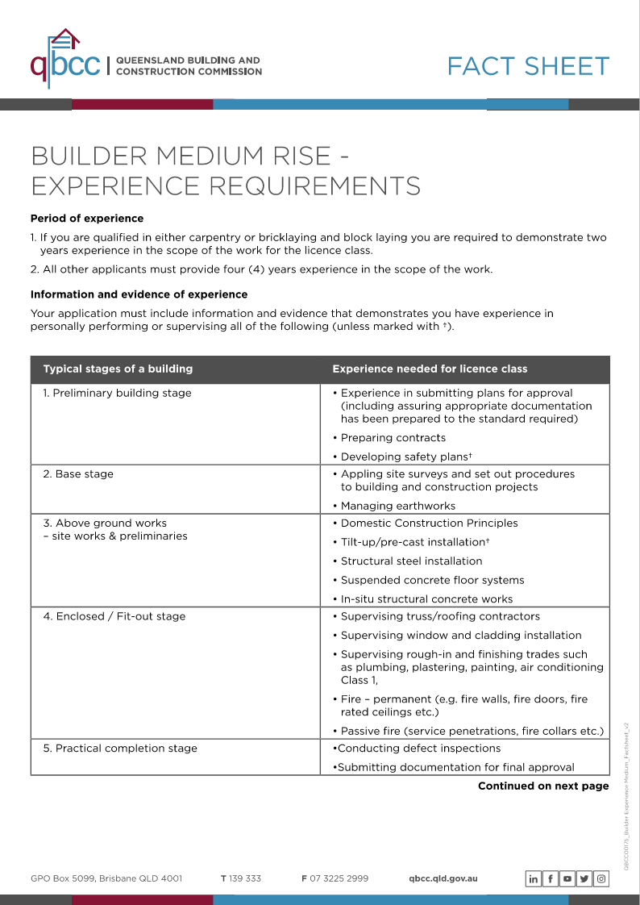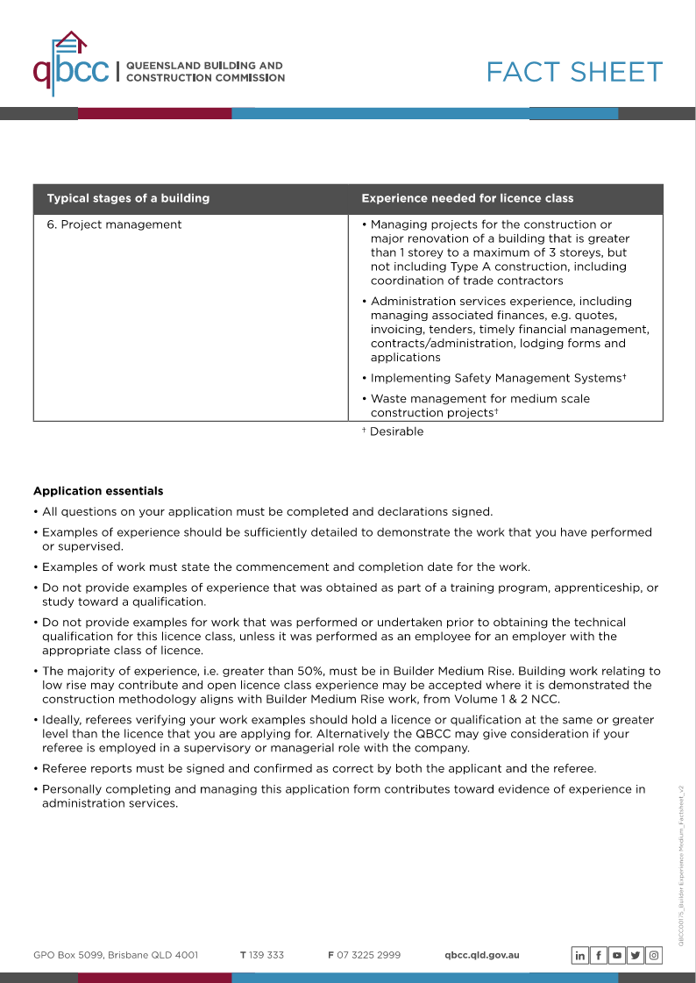
- What is required to gain a Builder - low rise licence?
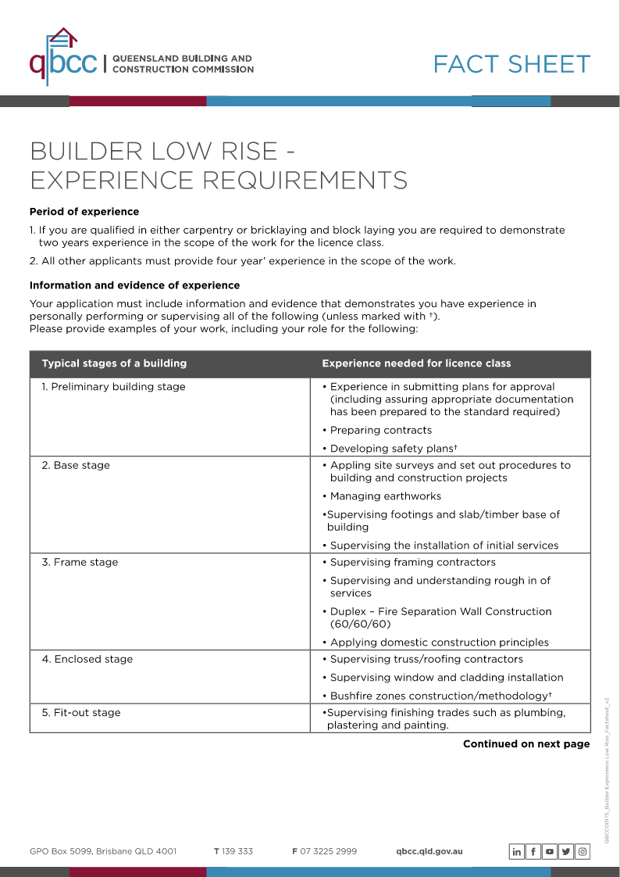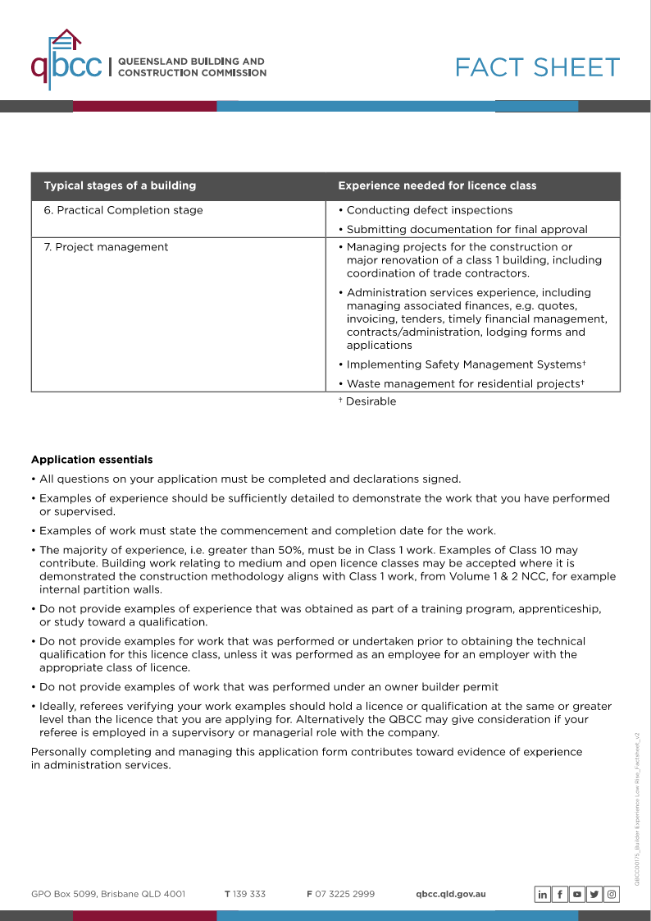
- Describe the scope of work for a Builder restricted to special structures (shade sails).
- Construction, installation, maintenance or repair of membrane shade structures including metal brackets, cables and structural members for the structures.
- Concreting work for footings for the structures, and
- Prepare plans and specifications for membrane shade structures that are:
  - for the licensee's personal use, or
  - for use in building work to be performed by the licensee personally.
- Incidental work of another class.

Satisfactory Outcome

Access the Fair Work Ombudsman website at https://www.fairwork.gov.au/about-us/legislation#fair-work-legislation and respond to the following questions.
- What is the purpose for the Fair Work Act 2009 and the Fair Work Regulations 2009?
- What actions are taken by the Fair Work Ombudsman in relation to compliance and enforcement?
- Describe the type of issues workers may contact the Fair Work Ombudsman about.

- What is the purpose of the Fair Work Act 2009 and the Fair Work Regulations 2009?
- Regulate Employment Conditions: Sets minimum standards for employment, including fair wages, regulated working hours, mandated leave entitlements, and clear procedures for termination, ensuring consistent and equitable conditions across workplaces.
- Promote Fair Work Practices: Defines the rights and responsibilities of employers, employees, and unions to ensure that workplace practices are fair and equitable, fostering respectful and balanced work relationships.
- Establish Fair Work Commission: Creates an independent body to manage workplace disputes, approve and review enterprise agreements, and enforce compliance with workplace laws, ensuring fair resolution of employment issues.
- Ensure Workplace Flexibility: Provides frameworks for flexible working arrangements and effective dispute resolution, enabling a balanced approach that accommodates both employer and employee needs while maintaining productivity.

- What actions are taken by the Fair Work Ombudsman in relation to compliance and enforcement?
• Investigate Complaints: The FWO investigates complaints from employees and employers about potential breaches of workplace laws, such as unpaid wages, incorrect classification, or unfair treatment.
• Conduct Audits and Inspections: Regularly conducts audits and site inspections of businesses to ensure compliance with Fair Work regulations, including checking records and practices related to wages, working hours, and entitlements.
• Provide Guidance and Education: Offers resources, advice, and training to employers and employees to help them understand their rights and obligations under workplace laws, and to prevent non-compliance.
• Enforce Penalties and Take Legal Action: Imposes penalties for breaches of the Fair Work Act, which may include fines or orders for compensation. The FWO can also take legal action in the Fair Work Commission or courts to address serious or repeated non-compliance.
• Promote Awareness: Runs campaigns and publishes information to raise awareness about workers' rights and employer responsibilities, helping to prevent violations and promote fair workplace practices.

- Describe the type of issues workers may contact the Fair Work Ombudsman about.
Workers contact the Fair Work Ombudsman about issues such as unpaid wages, incorrect classification, unfair dismissal, workplace bullying, underpayment, breaches of employment conditions, unlawful redundancy, and general compliance with workplace laws.

Satisfactory Outcome

Provide information that you would include in an email or memo to communicate to company employees and contractors:
- licencing and contract requirements for your State or Territory
- the consequences of non-compliance with relevant legal obligations and licensing requirements.

Answer:
I would start by outlining the requirements for the specific task and the associated licence for the work being performed.
When communicating to employees always remember to give them time to provide feedback or comment.
QBCC licencing checks can be used to see if individuals or company are current.
When Companies or individuals are performing unlicenced work this can result in fines being issued up to $3,096 or prosecuted in court. Repeat offending can lead to imprisonment for up to a year.
Contact QBCC if you are unsure.

Also the use of the below can be used.
Australian Business Licence and Information Service (ABLIS)
It is a resource for existing businesses and those considering launching. ABLIS can help you find applicable state, territory, local, and Australian government licenses, permits, approvals, rules, and codes of practice, so you can get precise information and stay on top of your compliance duties.

Satisfactory Outcome

Search the internet to locate information and training that you can organise that provide human resources administration staff information to assist them in understanding their responsibilities in relation to:
- insurance
- taxation matters.

- Insurance
For workplace insurance I would initially look into worksafe.qld.gov.au, On here you can find relevant insurance on what policy you are required to take out and what you should be covering your business with.
These policies might include:
- Work cover
- Accident insurance
- House hold work insurance
- Workplace injury insurance

- Taxation matters
For taxation matters you can find this information on ato.gov.au.
The ato website covers everything you need to know starting with registering a business to how to pay you workers and information.
Online service agents can be used to help navigate the site to find what you are looking for.

Satisfactory Outcome

Write a Code of Conduct for all employees and subcontractors engaged in a building and construction company that outlines specific principles and standards of behaviour that underpin best practice and co-operation. Use the following headings for your Code of Conduct.
- Objectives
- Responsibilities
- Ethical principles
- Continuous improvement
- Project planning and contract documentation
- Management and administration of contracts
- Environmental management
- Security of payments
- Training and development
- Work health and safety
- Compliance

- Objectives
The purpose of this Code of Conduct is to provide a framework of principles and standards for builders operating in the construction industry in Queensland. The objectives include:
- Establishing a culture of integrity, professionalism, and respect within our organization and with our clients and partners.
- Promoting safety, quality, and sustainability in all construction activities.
- Ensuring compliance with all relevant laws, regulations, and industry standards.
- Fostering continuous improvement in our practices, processes, and relationships.

- Responsibilities
All builders, employees, and subcontractors are responsible for:
- Upholding the standards set out in this Code of Conduct in all aspects of their work.
- Acting with honesty, transparency, and professionalism in all business dealings.
- Reporting any breaches of this Code or unethical behavior to management or designated personnel.
- Protecting the company’s assets and confidential information.
- Collaborating effectively with team members, clients, and stakeholders to achieve project goals.

- Ethical principals
The ethical principles guiding our conduct include:
- Integrity: We commit to honesty and transparency in all interactions and decision-making processes.
- Respect: We treat all individuals fairly and with dignity, valuing diversity and inclusion within our workforce and with our clients.
- Accountability: We take responsibility for our actions, ensuring that we meet our obligations to clients, subcontractors, and the community.
- Fairness: We engage in equitable and fair dealings with clients, suppliers, and subcontractors, ensuring that all parties are treated justly.
- Professionalism: We maintain high standards of conduct and competence, continually striving for excellence in our work.

- Continuous improvement
We are dedicated to the principle of continuous improvement through:
- Regularly evaluating and enhancing our processes, practices, and systems to improve efficiency and effectiveness.
- Encouraging feedback and suggestions from employees and subcontractors to identify areas for improvement.
- Staying updated with industry advancements, technologies, and best practices that can enhance our operations.
- Promoting a culture of innovation, where new ideas and methodologies are welcomed and explored.

- Project planning and contract documentation
To ensure effective project outcomes, builders must:
- Prepare clear, comprehensive, and accurate project plans and contract documents, outlining scope, timelines, and budgets.
- Conduct thorough risk assessments and develop mitigation strategies during the planning phase.
- Engage stakeholders in the planning process to ensure alignment and clarity of expectations.
- Maintain transparency in communication and documentation throughout the project lifecycle.

- Management and administration of contracts
To effectively manage contracts, builders are required to:
- Understand and adhere to the terms and conditions of all contracts entered into.
- Keep detailed records of contract performance, including communications, changes, and compliance with specifications.
- Address any issues or disputes that arise promptly and professionally, using established processes for resolution.
- Ensure that all stakeholders are kept informed of contract status and any changes that may affect them.

- Environmental management
Environmental stewardship is a priority in our operations. Builders must:
- Comply with all relevant environmental laws and regulations in Queensland.
- Implement sustainable construction practices that minimize waste and conserve resources.
- Promote awareness of environmental issues among employees, subcontractors, and clients.
- Report any environmental incidents or concerns immediately to management, ensuring swift action is taken.

- Security of payment
To maintain financial integrity in projects, builders must:
- Understand and comply with the payment terms specified in contracts.
- Ensure timely invoicing and follow-up on payments due for completed work.
- Maintain transparency in financial transactions and communications with clients and subcontractors.
- Address any payment disputes promptly, seeking resolution through appropriate channels.

- Training and development
We believe in the ongoing development of our workforce. Builders are encouraged to:
- Participate in training programs and professional development opportunities to enhance skills and knowledge.
- Stay informed about current trends, technologies, and best practices within the construction industry.
- Share expertise and knowledge with colleagues to foster a culture of learning and collaboration.
- Seek constructive feedback on performance to identify areas for personal and professional growth.

- Work health and safety
The health and safety of our employees and subcontractors are paramount. Builders must:
- Comply with all relevant health and safety legislation, regulations, and codes of practice in Queensland.
- Complete required safety training prior to commencing work on-site.
- Identify potential hazards and implement appropriate measures to mitigate risks.
- Report all incidents, accidents, and near misses immediately to management, ensuring thorough investigation and corrective actions are taken.

- Compliance
All builders and subcontractors must:
- Adhere to this Code of Conduct and any additional policies, procedures, or guidelines established by the company.
- Stay informed about applicable laws, regulations, and industry standards that affect their work.
- Report any violations of this Code, unethical behavior, or non-compliance with laws and regulations to management.
- Participate in compliance training and audits as required to uphold the highest standards of integrity and accountability.

Satisfactory Outcome

Access the website for your State or Territory environmental regulator and respond to the following questions:
- What environmental authority conditions apply in relation to noise or dust at a sensitive place?
- Discuss guidelines regarding waste and waste avoidance that you can include in the site Environmental Management Plan (EMP).

- What environmental authority conditions apply in relation to noise or dust odour, at a sensitive place?
Environmental authority conditions require companies to not cause environmental nuisance from noise at a sensitive receptor (a place where noise is measured to investigate whether impacts are occurring) or from dust, odour, light or smoke at a sensitive place (including for example a dwelling, library, childcare centre, medical centre, or a public park).
- Discuss guidelines regarding waste and waste avoidance that you can include in the site Environmental Management Plan (EMP).
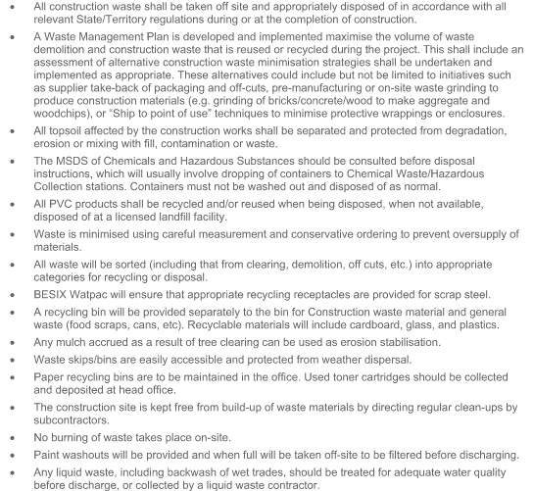

Satisfactory Outcome

CPCCBC6018
Manage processes for complying with legal obligations of a building and construction contractor

PRACTICAL ASSESSMENT

Participant name | Ethan Wilson

FOR THE PARTICIPANT
Instructions
- The tasks outlined on the following pages will require performance of normal workplace activities, as a result of a structured activity set by an Observer in the workplace or a simulated activity set by your Assessor/Observer.
- The timeframe for these tasks will be established by your Assessor/Observer, in consideration of location conditions and industry requirements.
- You must complete all tasks unassisted by the Assessor or other personnel unless the steps note this assistance.
- You must attempt all tasks (and itemised steps) for a ‘Satisfactory’ assessment outcome to be awarded.
  - For any observation conducted that is incomplete, or without satisfactory performance, the observation will need to be completed again after further training support.

FOR THE ASSESSOR/OBSERVER
Instructions
- The following observation record should be used to judge and record your observations of the Participant as they complete the task(s) set. You must record your observations of the Participant’s performance.
  - For each occasion, indicate the task performed and whether it was a simulation or workplace-based task.
    - Any simulated assessment must ensure the Participant still performs under workplace conditions which reflect industry standards.
  - In the comments, provide clear detail regarding the task that the Participant was required to do (e.g. PPE used, materials handled, attachments connected, plant types).
- All steps must be satisfactorily demonstrated by the Participant for a ‘Satisfactory’ determination (indicated by an Assessor tick to the right of each itemised step, or an Observer tick to the right of each itemised step, and confirmation by an Assessor in the Assessor Comments).
  - Where you have determined that one or more task steps have not been satisfactorily demonstrated, provide the Participant with additional support and outline details of such assistance in the Assessor/Observer Comments. Allow the Participant two (2) further opportunities to demonstrate the task again to allow an opportunity for a ‘Satisfactory’ assessment outcome to be achieved.
  - If after three (3) attempts the Assessor determines that the Participant cannot demonstrate the required steps, a ‘Not Satisfactory’ outcome is to be determined.

TASK OUTCOME
Task | Date | Task Type (Tick) | Location | Task outcome (Tick)
 |  |  |  | Satisfactory | Not Satisfactory
Task 1 | 4/11/2024 | Workplace  Simulation | TUH EXP (Townsville)/ JCU TIC

ASSESSOR COMMENTS: GENERAL
As necessary, outline:
- Details on reattempts, alternative arrangements or reasonable adjustments made.
- Where a Participant is deemed ‘Not Satisfactory’, provide recommendations for future training.

ASSESSOR COMMENTS: PRACTICAL TASK 1
Individual student (as named on cover page)
Multiple students [ All from Attendance Report, Specific students involved – identify students]
Task | Provide detail
1.1A. | Specify type of building contract reviewed where provisions of the contract, terms, conditions, inclusions and variations were correctly identified:
1.1B. 1.1E. | Specify how building contractor licencing and contract requirements were reviewed for compliance:
1.1C. | Specify how contractor licensing and contract requirements and non-compliance were communicated to workplace employees and others:
1.1F. | Specify where the application for necessary building or construction licenses was made:
1.2A. | Specify which areas of the contract reviewed required professional legal advice.
1.2B. | Specify processes managed to enable the workplace to obtain such legal advice.
1.2C. | Specify contracts management system introduced and managed:
1.2D. | Specify how the efficiency and performance of the contract management systems and users was maintained:
1.2E. | Specify mechanisms applied and maintained to facilitate improved communications and dialogue with client:
1.3A. | Specify administration systems developed and managed that facilitate conforming with workplace WHS responsibilities:
1.3A. 1.3B. 1.6A. | Specify administration systems developed and managed that facilitate conforming with workplace Environmental responsibilities:
1.4A. 1.4B. | Specify systems introduced and managed to ensure insurance and taxation requirements are met:
1.4C. | Specify problems, symptoms and causes of non-compliance recognised and solutions generated:
1.5C. | Specify remedial action undertaken where evidence of non-compliance with consumer protection principles is identified:
1.6B. | Specify how supply and removal of subcontract works and materials are monitored for compliance with EMP:
1.6C. | Specify changes to legislation or environmental requirements recorded and relevant organisational activities and systems altered to ensure ongoing compliance:

CPCCBC6018
Manage processes for complying with legal obligations of a building and construction contractor

Practical Task 1
Description of task:
The participant must demonstrate and provide evidence to demonstrate the skills and ability to ensure the compliance of contactor’s legal obligations for one building and construction project including:

- Determine contract compliance and licensing requirements
  - Read the building contract, confirm the type of contract and identify provisions of the contract, terms, conditions, inclusions and variations.(attach copy of contract reviewed)
  - Review and confirm whether building contractor licensing and contract requirements are current and suitable to the work.
  - Communicate contractor licensing and contract requirements to company employees to ensure contract and licensing requirements are met.
  - Inform employees of the consequences of non-compliance with licence and contract requirements.
  - Recognise changes to licensing arrangements in a timely manner.
  - Appy for and take necessary steps to obtain the necessary building or construction licenses.
- Manage relationships on legal matters
  - Determine the areas of the contract requiring professional legal advice.
  - Organise and manage processes to enable workplace to obtain legal advice in relation to contract..
  - Introduce and manage a contracts management system through which legal interpretations of contract or tender documents may be obtained before submission.(screenshot or documentation of management system introduced and managed)
  - Manage the efficiency and performance of the contract management systems and individuals involved in the process
  - Apply and maintain mechanisms to improve communications and dialogue between the workplace and the client to facilitate conciliation.
- Administer organisation’s obligations.
  - Develop and manage administration systems that facilitate conforming with organisation’s obligations and meeting WHS and welfare, workers' compensation, noise abatement and working hours’ regulations.
  - Maintain and manage records demonstrating organisational compliance with legal obligations.
  - Develop and maintain policies, procedures and facilities for the proper and secure storage of organisational legal documentation. .(attach copy of policy and procedure developed)
- Manage compliance with government legislation.
  - Introduce and manage systems that support and maintain organisational capacity to meet legal obligations with regard to insurance and taxation. .(screenshot or documentation of system introduced and managed)
  - Organise training and instruction for relevant personnel regarding insurance and taxation responsibilities.
  - Investigate problems, symptoms and causes of non-compliance and recognise key issues and synthesise information to generate solutions
- Apply and manage consumer protection practices.
  - Develop and implement practices and policies which facilitate the organisation meeting its obligations to its clients, subcontractors and employees. (attach copy of 1 policy and 1 procedure developed)
  - Establish and enforce codes of conduct for all employees and subcontractors. (attach copy of code of conduct developed)
  - Take remedial action where evidence of non-compliance with consumer protection principles is identified.
- Manage compliance with environmental legislation.
  - Develop and manage systems to gather information in relation to the organisational environmental management plan.
  - Manage the supply and removal of subcontract works and materials and constantly scrutinise to ensure compliance with environmental standards.
  - Record relevant changes to legislation or environmental requirements and alter organisational activities and systems to ensure ongoing compliance.
These tasks may be simulated or real. The Participant is to gather evidence of how they have completed each component of the Practical Task, which is to be submitted with this Practical Assessment sheet. The Observer is to provide detailed comments on the tasks completed by the Participant (on the Observer Comments, overleaf). The Assessor is to verify the Observer’s comments, noting their findings in the Assessor Comments (on the back of the Practical Assessment cover page) and provide the assessment outcome.
Resources required:
Residential or commercial worksite; Access to legislation and regulations relating to building and construction contractors; workplace policies, procedures and quality documentation, building and construction contract for project, EMP; business equipment, technology, applications and software systems.
Observer details
Name of observer: | Katie Garay
Role of observer  (Confirm suitability to sign) | Project Engineer
Email address of observer | Kgaray@Besixwatpac.com
Signature of observer: | 
Date: | 4/11/2024

When completing the task, did the Participant: | Tick if satisfactorily completed.  Provide comments if left unticked.
1 Determine contract compliance and licensing requirements.
- Read the building contract, confirm the type of contract and identify provisions of the contract, terms, conditions, inclusions and variations.(attach copy of contract reviewed)
- Review and confirm whether building contractor licensing and contract requirements are current and suitable to the work.
- Communicate contractor licensing and contract requirements to company employees to ensure contract and licensing requirements are met.
- Inform employees of the consequences of non-compliance with licence and contract requirements.
- Recognise changes to licensing arrangements in a timely manner.
- Appy for and take necessary steps to obtain the necessary building or construction licenses.
2 Manage relationships on legal matters.
- Determine the areas of the contract requiring professional legal advice.
- Organise and manage processes to enable workplace to obtain legal advice in relation to contract.
- Introduce and manage a contracts management system through which legal interpretations of contract or tender documents may be obtained before submission.(attach screenshot or documentation of management system introduced and managed)
- Manage the efficiency and performance of the contract management systems and individuals involved in the process
- Apply and maintain mechanisms to improve communications and dialogue between the workplace and the client to facilitate conciliation.
3 Administer organisation’s obligations.
- Develop and manage administration systems that facilitate conforming with organisation’s obligations and meeting WHS and welfare, workers' compensation, noise abatement and working hours’ regulations.
- Maintain and manage records demonstrating organisational compliance with legal obligations.
- Develop and maintain policies, procedures and facilities for the proper and secure storage of organisational legal documentation.(attach 1 copy of policy and procedure developed)
4 Manage compliance with government legislation.
- Introduce and manage systems that support and maintain organisational capacity to meet legal obligations with regard to insurance and taxation. .(screenshot or documentation of system introduced and managed)
- Organise training and instruction for relevant personnel regarding insurance and taxation responsibilities.
- Investigate problems, symptoms and causes of non-compliance and recognise key issues and synthesise information to generate solutions.
5. Apply and manage consumer protection practices.
- Develop and implement practices and policies which facilitate the organisation meeting its obligations to its clients, subcontractors and employees. (attach copy of 1 policy and 1 procedures re payments and confidentiality developed)
- Establish and enforce codes of conduct for all employees and subcontractors. (attach copy of code of conduct developed)
- Take remedial action where evidence of non-compliance with consumer protection principles is identified.
6. Manage compliance with environmental legislation
- Develop and manage systems to gather information in relation to the organisational environmental management plan. (attach screenshot / copy of EMP compliance)
- Manage the supply and removal of subcontract works and materials and constantly scrutinise to ensure compliance with environmental standards.
- Record relevant changes to legislation or environmental requirements and alter organisational activities and systems to ensure ongoing compliance.

Observer comments:
- Determine contract compliance and licensing requirements
Ethan reviewed the subcontract for our hydraulics package and confirmed that the company and their representatives are corrected licensed. He seeks relevant approvals for after-hours works as required.

- Manage relationships on legal matters
Ethan has demonstrated his ability to understand legal matters within contracts by reading the T&Cs presented by a fencing supplier and raising further questions to clarify their purpose.

- Administer organisation’s obligations
Ethan will ensure new workers are inducted onto the project and has submitted their SWMS prior to commencing works. He contributes to the site diary and daily coordination meeting, which are both methods of maintaining records of subcontractor consultation/compliance. Ethan contributed to the development of a helicopter downwash safe operating procedure and manages the implementation of this policy on a daily basis.

- Manage compliance with government legislation
Ethan works closely with the contract administrators (CAs) to ensure subcontractors have provided copies of their latest insurance certificates. The company is set up so that without copies of the latest certificates, subcontractors cannot be paid through the finance system. Ethan is often the conduit between the CAs and the subbies to chase up expired certificates. He has coordinated instruction sessions between subbies and the CAs when there the subbies are unsure what is required from them.

- Apply and manage consumer protection practices
Ethan ensured high quality standards for the client were met by managing the defects process at the JCU TIC project. Ethan was responsible for ensuring subcontractors completed work in a safe manner, within a specified timeframe and to the quality required. This included raising and closing out non-conformances.

- Manage compliance with environmental legislation
Ethan is familiar with the project’s Environmental Management Plan including the erosion and sediment control plan. He raises issues relevant to the appropriate management of these systems, including instructing subcontractors on when erosion control measures need to be maintained.

