CPCCBC4004A
Identify and produce estimated costs for building and construction projects

THEORY EXAM INSTRUCTIONS

- This exam will occur under standard assessment conditions.
  - An oral examination may be allowed under certain circumstances.
Answers will be documented and FT003 (Oral examination declaration form) must be completed.
- Participants must provide enough detail in their responses to demonstrate their knowledge and skills.
- Please fill in the details below, providing your name, signature and date of assessment.
  - Your signature acknowledges that this is your own work.
- If a participant initially answers a question incorrectly but modifies their response, they must follow the instructions below:
  - If a participant changes their response in writing, they must put their initials next to the written change.
  - If a participant changes their response verbally, this must be noted on the exam paper by the assessor.

Participant name | Angelo Navarro Tolentino
Participant signature | 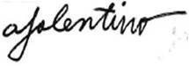

Assessor name
Assessor signature | 

Date | 23/04/2018

Number of questions | Number of questions answered correctly | Satisfactory?
24 |  | Yes | No

Assessor Comments
- What is the critical aspect of identifying and interpreting plans, drawings and specifications for a building project?

Answer | The critical aspect of identifying and interpreting plans, drawing and specifications is to be able to show all parties involved in a building project the proposed structure and what the end product will look like when completed.

- What is the purpose for date stamping of plans, drawings and specifications?

Answer | The purpose of date stamping is to mark pertinent documents relevant to construction bringing emphasis on dates, marked changes, and or amendments. Date stamping also makes the documents authentic.

- Nominate at least six (6) people and/or entities that would use plans drawings and specifications on a building project.

Answer | Plans are used by the following parties:  1. Engineers  2. The client and the lending body  3. Carpenters  4. Bricklayers  5. Concreters  6. Real Estates Agents

- Plans and drawings usually hold many and varied features.
Name some of the types of drawings and details you would expect to see on plans and drawings for a building project.

Answer | The types of drawings and details you would expect to see on plans and drawings for a building project are the location plans, site or block plans, floor plans, elevation plans and sectional plans.

- It is necessary to acquire all building plans and specifications at the beginning of the negotiation period so we know all building project details prior to commencing work (including dimensions, construction materials, door and window schedules, masonry control joint locations and smoke alarm locations).
What else would be expected to be provided?

Answer | On top of the building plans and specification, one may also need to provide the following project plans and specifications:  - Architectural plans and elevations  - Building Specification  - Footing construction report and foundation soil assessment  - Framing Plans  - Roof Truss Computations  - Energy Efficiency Report  - Other details as required such as if the building is in a bush fire zone or, if you are adding a swimming pool.

- Drawings are usually arranged in the approximate order of construction. What might a set of drawings consist of?

Answer | A set of drawings consists of:  1. Civil  2. Structural  3. Architectural  4. Electrical  5. Mechanical  6. Plumbing

- Explain how to access the Building Code of Australia (BCA) and its relevance to estimating costs for building and construction projects.

Answer | One can access the BCA by simply obtaining information depending on the classification of your project. It directly affects estimating costs because the end product, the project, should follow performance requirements. Builders work around the requirements by providing materials that will be suitable. These materials are all essential to getting the estimate.

- Explain how to access the Plumbing Code of Australia (BCA) and its relevance to estimating costs for building and construction projects.

Answer | The Plumbing Code of Australia can be accessed by looking into the BCA’s third volume. It is highly relevant to estimation costs because it requires the builder to provide nationally consistent minimum standards of relevant safety and so on. The incorporation of plumbing and or drainage materials, labour, maintenance all affect the estimates.

- Explain how to access Australian Standards and their relevance to estimating costs for building and construction projects.

Answer | You can access Australian Standards by looking through published documents setting out specification and procedures designed to ensure products, services and systems are safe, reliable and perform according to their intent. They are relevant to estimating costs because just like the BCA, and Plumbing Codes, they require builders to follow a norm which translates to expenditure.

- Identify two (2) standards that would be relevant to the industry sector.

Answer | Two other standards that would be relevant are:  1. Fire Safety Standard  2. Energy Efficiency Standards

- Explain the impact of WorkCover requirements on costs to the project.

Answer | WorkCover requirements impact the costs of the project because it is necessary that the builder ensure the safety of the workplace. That being said the builder will need to incorporate the costs of educating workers, providing protective equipment, and medical services during the whole duration of the project.

- Explain the impact of Environmental Protection Agency requirements on costs to the project.

Answer | Environmental Protection Agency (EPA) requirements has an impact on project cost because there is a need for builders to abide by the Government’s local regulations for environmental preservation and sustainability. This is considered and overhead cost because it will definitely result to variation in the plans and drawings.

- Calculate and cost the lineal timber order for 93 x 19 DAR Meranti and allow 5% wastage. The cost per lineal metre is $6.40.
The requirements are: 22 @ 2400; 30 @ 3600; 10 @ 4800; 12 @ 1880
Show your calculations.

Answer | Given:  1. 93 x 19 DAR Meranti Timber  2. Wastage = 5% or 0.05  3. Cost per lineal metre = $6.40  4. 22@2400; 30@3600; 10@4800; 12@1880  Solution:  22*2.4m = 52.80m  30*3.6m = 108m  10*4.8m = 48m  12*1.88m = 22.56m  Total length = (52.8+108+48+22.56)m = 231.36m  Total length with 5% wastage = (231.36m)(1.05) = 242.928 or 243m  Total cost of order = (243)($6.40/m) = $1555.20 ANS.

- A building floor plan measures 24000 x 14000 and the specification states the sheet flooring is 3.6 x 0.9 x 19mm Yellow TERMIFLOR T&G H2 at $58.38 per sheet.
Calculate the area of floor sheeting required when an allowance of 2% is made for waste and cutting. Determine the number of sheets to order to the nearest whole sheet and calculate the cost for the flooring.
Show your calculations.

Answer | Given:  - Building Floor plan measure: 24m x 14m  - Sheet Flooring: 3.6 x 0.9 x 19mm or 3.6m x 0.9m x 0.019m  - Allowance = 2% or 0.02  - $58.38 per sheet  Solution:  Area of sheet flooring required = (24m)(14m) = 336m^2  Area of sheet flooring required with allowance = (336m^2) (1.02) = 342.72 m^2 ANS.  Number of sheet to be ordered = (342.72m^2/ (3.6m) (0.9m)) = 105.78 = 106 sheets ANS.  Cos of flooring = (106sheets)($58.38/sheet) = $6188.28 ANS

- If a solid cavity brick wall is to be built 23000mm long and 2400mm high (no windows and no doors), how many bricks would be required if the number of bricks per square metre is 50? Show your calculations.

Answer | Given:  Brickwall area : 23000mm x 2400mm  Brick per sqm = 50  Solution:  Area of brick wall = (23m)(2.4m) = 55.2m^2  Required no. of bricks = (55.2sqm)(50/sqm) = 2760 bricks ANS.

- You are a QBCC licensed plasterer and a client (Owner Builder) Davey Jones-Locker of 100 Reef Avenue, Brisbane, Queensland wants you to quote for plastering an internal wall of his house build and has described to you the following information over the phone:
The Client tells you the Council approved plans and drawings state the finished ceiling height from the top of slab floor is 2400mm. There is one external solid timber door (D4) is 2340 x 870 x 35 in this wall and no other openings. The length of this house end wall is 11 metres.

The house is of brick veneer construction and includes a 50mm cavity and the load bearing external framing is 70 x 45 MGP12 (a Boral product “Pineguard Blue”). The bricks are standard bricks 230 x 76 x 100mm. (L x H x W).

The Client tells you that the door is positioned 2100mm from an internal corner (RHS in aerial view) and as seen from inside the house looking out. The specification and drawings state 10mm regular internal plasterboard. You know from experience regular plasterboard is supplied in the following sizes lengths 6M, 4.8M, 4.2M, 3.6M, 3M, 2.7M and 2.4M with recessed edge and widths of 1200mm and 1350mm.

The Client wants a quote to fix and finish this internal wall with plasterboard.

Your labour and on-costs are charged at $51.50 an hour per tradesman plus materials including sheets, fixing, finishing and sanding. You estimate ancillaries including stud glue, screws, base coat, top and finish coats at $315.00 and that there is two (2) days’ work.
Your business works a 38 hour week you allow workers a 15 minute morning tea break and half hour for lunch. You will need two (2) tradesmen first day and one (1) tradesman second day including materials and equipment supply, fixing, finishing and sanding.
You are to research or acquire plasterboard sheet prices and attach this price list to your email. You are not required to supply or fix cornice.
Sketch the wall in Plan View (not to scale), dimension it with relevant measurements, and position the door on the right side of your plan view sketch and then calculate the plasterboard required and approximate waste expressed as a percentage (%) for internally lining this wall.
Estimate the cost of the job, including supplying plasterboard materials fixing setting, finishing and sanding plus labour. Then write a covering email to be sent to the client. You must show your methods for calculating cost of sheets, waste, plus fixing, setting, finishing and sanding.
Attach your quote, sketch, calculations and pricing list and email this to your Trainer/Assessor (details provided by them).

DRAFT AREA

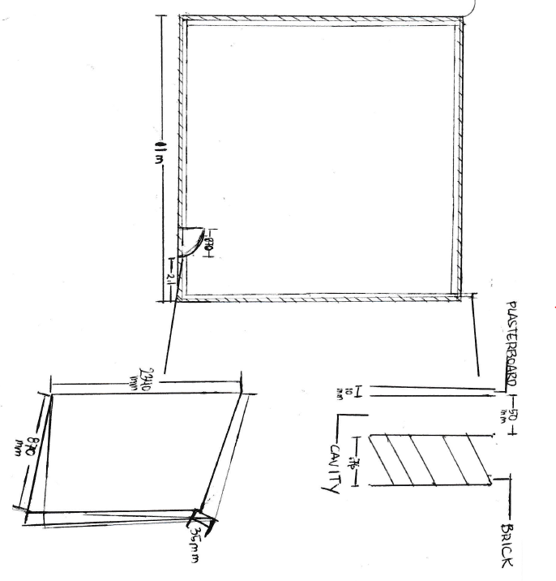
Given:

Finished ceiling height from top of slab floor = 2400mm or 2.4m
Solid Timber Door (D4): 2340 x 870 x 35 mm or 2.34 x 0.87 x 0.035m
Length of house end wall = 11m
Brick Veneer construction: 50mm cavity; load bearing external framing is 70 x 45 MGP12;
230 x 76 x 100mm Standard Bricks
Door is positioned 2100mm or 2.1m from an internal corner
10mm regular internal plasterboard; recessed edge; 1200mm or 1350mm widths

Labour Rates:
Hourly labour cost per tradesman = $51.50 (total package)
Ancillary cost for 2 days = $315.00
Two days of work
38 hours a week: 15 morning tea break: 30minute lunchbreak
Manpower:
Day 1: 2 tradesmen
Day 2: 1 tradesman

Calculation/quote:
Number of working hours per tradesman per day= 38hours/5days = 7.6 hours/day
Cost per tradesman per day = 7.6 hours * $51.50 = $391.40/day
Cost for Day 1 on Labour= 2*391.40 = $782.80
Cost for Day 2 on Labour= 1*391.40 = $391.40
Total Cost on Labour = $782.80 + $391.40 = $1174.20

DRAFT AREA

Required plasterboard:
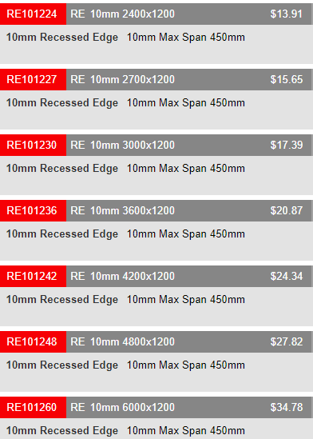

Based on one side of the wall, the most economical plasterboard dimension to use are the 6m and 2.7m lengths.

Wastage for 1 side of the wall = (6m+2*2.7m) – 11m = 0.4m
Total wastage = 0.4m * 4 = 1.6m
Percent waste = (1.6m/(11m*4)) = 0.0364 or 3.64%

One side of the wall needs 2 pcs of 6m length and 4 pcs of the 2.7m length
The entire interior plastering of the house would need: 8 pcs of 6m length and 16 pcs of 2.7m length
Total Cost of plasterboard materials = 8($34.78) + 16($15.65) = $528.64

Total quote = Total cost of Labour + Total cost of plasterboard materials + Ancillary cost
= $1174.20 + $528.64 + $315.00 = $2017.84

Please feel free to contact me if you have any questions regarding the quote.

Regards,

Angelo Navarro Tolentino
QBCC Licenced Plasterer

Answer

- There are many different ways of estimating project costs. You can use your past experience, or ‘square metre’ rates but if you are unfamiliar with estimating and pricing then you should resort to the materials and labour method of costing using an item-by-item approach which is considered as the best industry approach to estimating.
What are at least three of the nominated methods for estimating?

Answer | The three nominated methods for estimating are the following:  1. Costing by area  2. Costing by material and labour  3. Costing by a costing guide or estimating manual

- Name some of the circumstances to consider in relation to labour adjustment factors when estimating a project for construction.

Answer | Some of the circumstances to consider in relation to labour adjustment factors are the following:  1. Temperature  2. Congestion or accessibility of workplace  3. Lighting of work area and openness  4. Productive Labour  5. Lifted Materials  6. Adjustment for tradesmen with below average skills  7. Deduction of costs for highly skilled tradesmen  8. Deduction of costs for identical tasks  9. Costs for material protection, matching and fitting of materials  10. Adjustment of cost for work done after natural calamities  11. Adjustment of cost for unreliable parties that may affect the project’s total cost

- If a bricklayer lays 600 bricks in an eight (8) hour day, what is the average number of bricks laid per hour by the bricklayer?
Tick your response.

Answer | Choice | Possible Answers
 | ☐ | 65
 | ☐ | 70
 | ☐ | 55
 | ☐ | 90
 | ☒ | 75
 | ☐ | 105
 | ☐ | 85

- What and where are some of the potential sources you could go to in choosing your suppliers for goods and services?

Answer | Online is the best way to locate suppliers such as manufacturers and wholesalers. Access to the Queensland Government Business and industry portal website will provide information about choosing suppliers. Other potential sources are the ones advertised in the Yellow pages. Attending industry events and exhibitions in another good way to find suppliers and expanding your network.

- What are some of the primary (key) factors for choosing your suppliers?

Answer | The primary factors for choosing a supplier are ones that can provide the most suitable goods or services, most economical or suitable price and timely delivery with respect to the project’s needs and schedule.

- What are some of the ways you could communicate with your suppliers for gaining quotes?

Answer | One could communicate with suppliers for gaining quotes using the following options:  1. Written request  2. Email request  3. Faxed request  4. Telephone request  5. Verbal request

- Explain the concept of a ‘Labour Only’ quote?

Answer | The concept of a ‘Labour Only’ quote is to provide a realistic estimate using three different ways. Namely the ‘per unit’, ‘per lineal metre’ and per square metre method. These ways of quoting involves labour costs translating from certain measures. Materials used to satisfy a job is not included in the quotes.

You will be provided an allocated period by your instructor to complete this task.
You may use appropriate costing software programs in completing this task.

- Referring to the supplied set of house plans, you must do the following scheduling and costing:

- Identify and nominate a supplier/s and schedule the materials and cost the internal and external timber wall framing.
- Identify and nominate a supplier/s and schedule the materials and cost the foundations and lower floor concrete slab including the schedule and costing for reinforcement.
- Identify and nominate a supplier/s and schedule the materials and cost for the sub floor framing and the flooring for the upper floor plan.
- Calculate the architrave and skirting required for the fit out of the upper floor only in lineal metres.
- Calculate the wet area tiles for the upper floor only which are client chosen for both floors and walls with the wall tiles 250 x 100 and floor tiles 300 x 300.
- Estimate the labour only cost to tile all the wet areas only in the home. The tiler charges labour only $44.00 per square metre.
- Determine the roofing material and number of square metres of it that are required.
- Complete the aluminium windows and doors schedule and other external doors schedule for the lower floor only.
- Complete a full internal doors schedule for the lower floor only.
N.B. Assume all doors are flush panel 2040mm in height and 35mm thick.
- Estimate the labour only cost for hanging all doors on the lower floor – if a tradesman takes 2 hours to jamb an opening, hang the door, fit the door furniture, door stops, architrave and fit a door-open-restraint. The hourly rate is $27.80 plus 20% on costs.

Answer

Answer | Find cost of internal and external timber wall framing  Find the cost of the foundations and lower floor concrete slab  Find the cost of the sub floor framing and the flooring for the upper floor plan  Calculation of the architrave and skirting required for the fit out of the upper floor  Calculation of the wet area tiles for the upper floor:  Wall tiles = 250 x 100  Floor Tiles = 300 x 300mm  Estimation of labour cost to tile all wet areas of the home:  Tiler Labour Charge = $44.00 per square metre  Total Wet Area = (Area of Laundry)(Area of all bathrooms) (44)  Determining of the roofing material to be to be used:  0.42 BM KLIP Lok Roofing Sheeting  H= 2040mm  T= 35mm  Aluminum windows and doors schedule and other external doors for the lower floor  Time it takes for tradesman to do door job = 2 hours  Hourly rate of tradesman = $27.80  Added cost on labour = 20%  No of Doors on lower floor = 3doors  Labour cost = 2(3)(1.20)(27.80*2) = $400.32

