
AHCLSC306
Implement a paving project

Copyright © 2022 CSTC Pty Ltd

All rights reserved. No part of the contents of this publication may be reproduced or used in any form or by any means – graphic, electronic, or mechanical including photocopying, digitising, recording, or information storage-and-retrieval systems – without the written permission of CSTC Pty Ltd.
ASSESSMENT FOR AHCLSC306

Student name
Date of assessment submission | Click here to enter a date.

Trainer/Assessor’s name
Date of assessment marking | Click here to enter a date.
Outcome for unit | ☐ Competent  ☐ Not Yet Competent

TASK INSTRUCTIONS

- As part of the assessment for this unit of competency, you are required to complete a series of activities.
  - Some of these activities will require you to provide a response within this document, others will require you to gather evidence to demonstrate your knowledge and skills.
- At all times, the responses in your assessment must reference Australian (Queensland or Federal) documentation, including legislation, regulations, codes of practice, standards and guidance publications.

ACTIVITIES

Identify/list the scope of the work to be carried out from the concept plan shown.

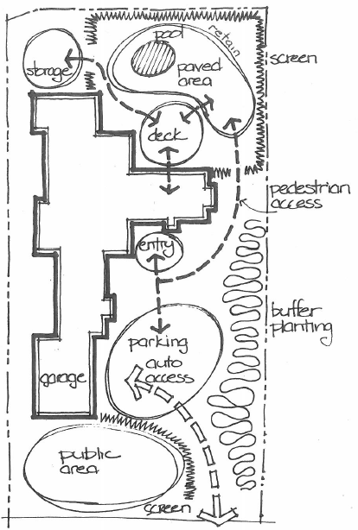

Response
Paved outdoor area around a pool

Outcome for Activity 1 | ☐ Satisfactory  ☐ Not satisfactory
Trainer/Assessor comments

Identify/list the detail on the landscape plan shown.

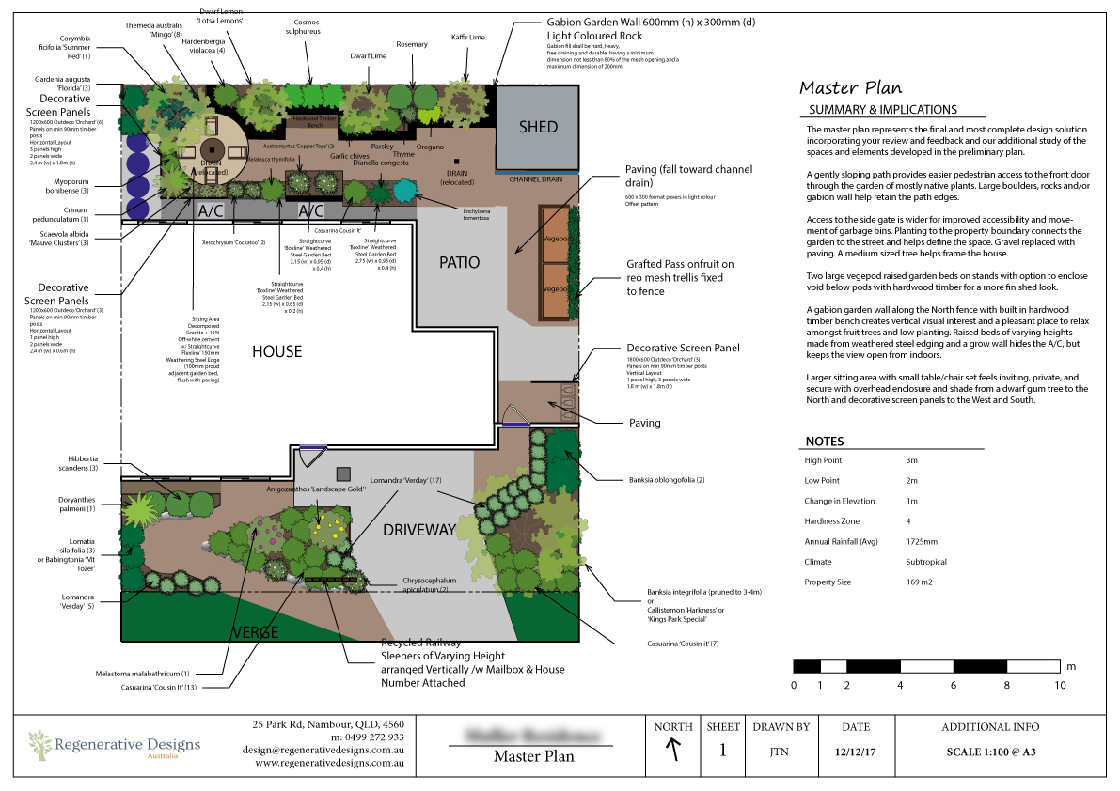

Response
Location and description of everything on plans, elevation levels, summary of process and plans, plant names

Outcome for Activity 2 | ☐ Satisfactory  ☐ Not satisfactory
Trainer/Assessor comments

Using the graphics shown, create a simple plan that details a paved path through a garden with grass, trees, shrubs, rocks and steps.

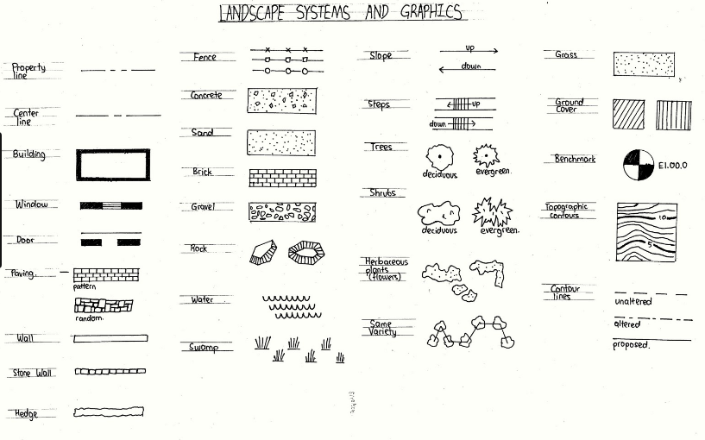

Response
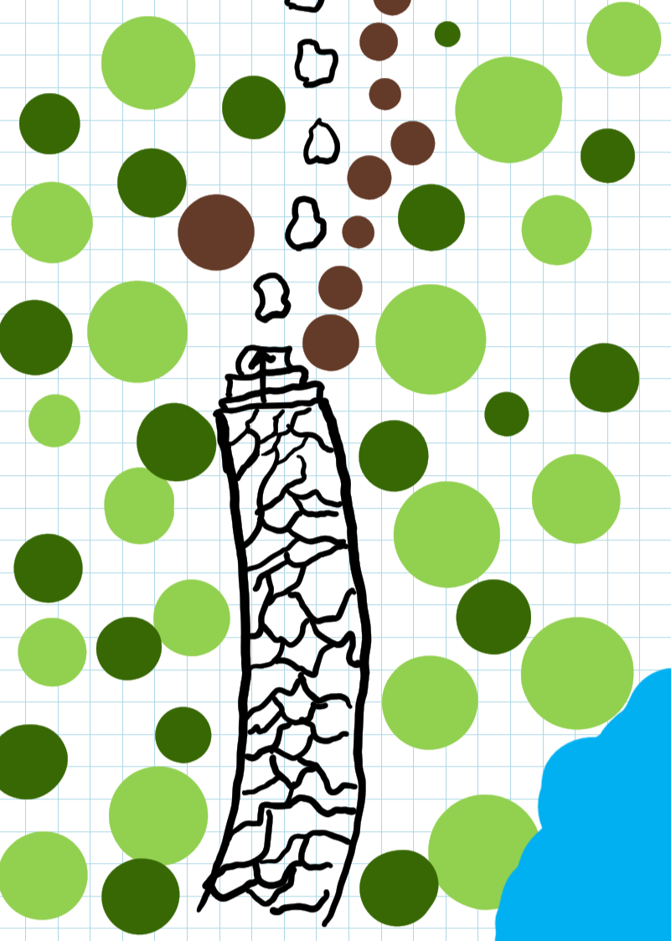

Outcome for Activity 3 | ☐ Satisfactory  ☐ Not satisfactory
Trainer/Assessor comments

Research the advantages and disadvantages of concrete, clay and stone pavers.

For each material, provide one (1) example of a project where it would be most appropriate to use the material and one (1) example of a project where it would not be appropriate to use the material. Explain your responses.

Concrete pavers
Appropriate
New modern house
Not appropriate
I believe can work with almost any landscape if done correctly

Clay pavers
Appropriate
Old renovated house
Not appropriate
New modern house

Stone pavers
Appropriate
New modern house
Not appropriate
I believe can work with almost any landscape if done correctly

Outcome for Activity 4 | ☐ Satisfactory  ☐ Not satisfactory
Trainer/Assessor comments

Obtain photographs of common landscaping materials and finished landscapes (both soft and hard).

Explain the differences between your emotions/feelings when you see each photograph in black and white and in colour.

Photograph 1
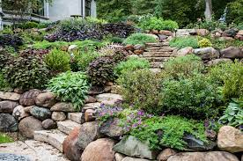

Black and white: Emotions and feelings
Dull, boring, uninteresting
Colour: Emotions and feelings
Colourful, intriguing, classy, peaceful

Photograph 2
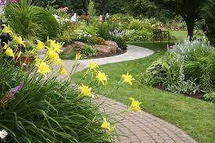

Black and white: Emotions and feelings
Dull, boring, uninteresting
Colour: Emotions and feelings
Colourful, intriguing, classy, peaceful

Photograph 3
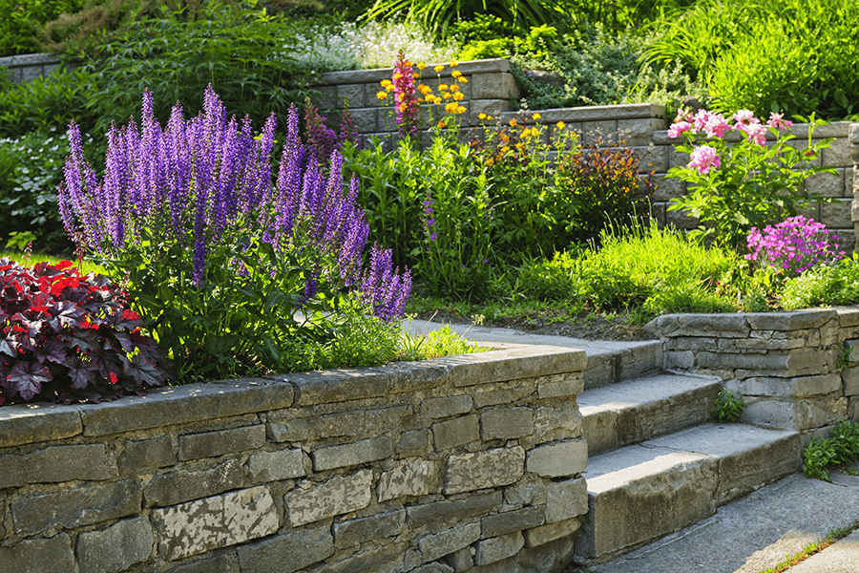

Black and white: Emotions and feelings
Dull, boring, uninteresting
Colour: Emotions and feelings
Colourful, intriguing, classy, peaceful

Photograph 4
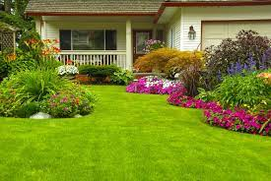

Black and white: Emotions and feelings
Dull, boring, uninteresting
Colour: Emotions and feelings
Colourful, intriguing, classy, peaceful

Outcome for Activity 5 | ☐ Satisfactory  ☐ Not satisfactory
Trainer/Assessor comments

Research and identify eight (8) different paving patterns, including the common usage, advantages and disadvantages for each pattern.

Pattern 1 name | Stack bond
Common usage
Path ways
Advantages
Minimal cuts
Disadvantages
basic

Pattern 2 name | Basketweave
Common usage
pathways
Advantages
Simple, minimal cuts
Disadvantages
Out of fashion, simple

Pattern 3 name | Running bond
Common usage
driveways
Advantages
Structural, tidy
Disadvantages
Cuts every row

Pattern 4 name | herringbond
Common usage
Patios, footpaths, driveways
Advantages
No cuts, easy to lay
Disadvantages
Not structual

Pattern 5 name | fivestone
Common usage
patios
Advantages
Good tidy finishes
Disadvantages
Complicated pattern

Pattern 6 name | Fivestone random
Common usage
patios
Advantages
Good finishing look, modern
Disadvantages
Complicated, cuts

Pattern 7 name | Muster K
Common usage
patios
Advantages
Tidy, modern
Disadvantages
Not structural

Pattern 8 name | Three stone pattern
Common usage
Foot paths
Advantages
Straight forward, no cuts
Disadvantages
Not structual

Outcome for Activity 6 | ☐ Satisfactory  ☐ Not satisfactory
Trainer/Assessor comments

Select a paver type (with known specifications) and calculate the material costs for a straight path that measures 6m long by 900mm wide.

Response
Bluestone 600 x 400 $88sm

6 x 0.9 = 5.4
5.4 x 88 = $475

Outcome for Activity 7 | ☐ Satisfactory  ☐ Not satisfactory
Trainer/Assessor comments

Research the advantages and disadvantages of installing edging before and after laying pavers.

Installing edging before laying pavers
Advantages
Allows for set perimeter, doesn’t allow pavers to move during laying
Disadvantages
If done incorrectly process is much harder

Installing edging after laying pavers
Advantages
Gives more freedom for error
Disadvantages
Pavers may move once placed before edging is in

Outcome for Activity 8 | ☐ Satisfactory  ☐ Not satisfactory
Trainer/Assessor comments

List environmentally safe products for cleaning.

Response
Organic soap, organic spray and cleaner.

Outcome for Activity 9 | ☐ Satisfactory  ☐ Not satisfactory
Trainer/Assessor comments

Have team members take photos and videos of your involvement with paving projects.

Identify each photo / video with a letter label and describe each photo / video in the table below. Submit the photo / video files along with this workbook.

Advantages
A
B
C
D
E
F
G
H
I
J
K
L
M
N
O
P
Q
R
S
T
U
V
W
X
Y
Z

Outcome for Activity 10 | ☐ Satisfactory  ☐ Not satisfactory
Trainer/Assessor comments

