Health and Safety Committee
This site has a Health and Safety Committee. Each subcontractor may have one (1) representative. The Committee meets the First and Third Wednesday of each Month. If you have any safety issues you would like to raise, please see your representative or the McNab Foreman.
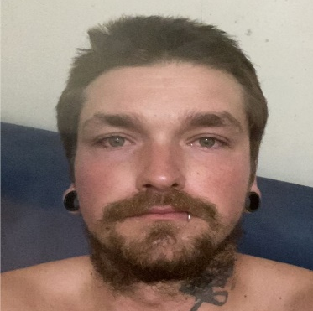 |  | 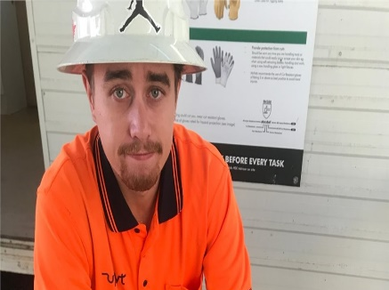 |  | 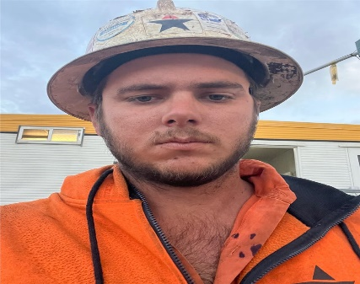
Name: | Matt Hendricks | Name: | Bryce Graham | Name: | Jordan Buck
Company: | TK Formbuild | Company: | AR Coastal Scaffold | Company: | C&S Steel Fixing
Mobile: | 0423 356 867 | Mobile: | 0435 312 617 | Mobile: | 0408 419 940
Role: | Chair  Minutes  HSR  Member | Role: | Chair  Minutes  HSR  Member | Role: | Chair  Minutes  HSR  Member

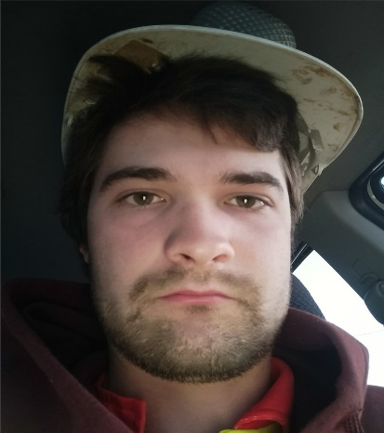 |  | 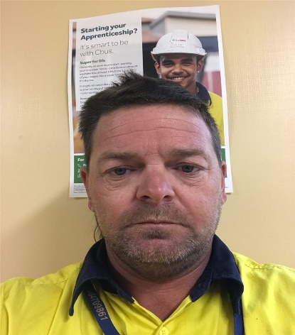 |  | 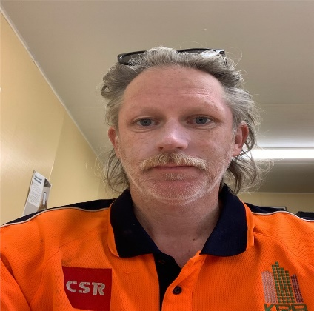
Name: | Robbie Joanne | Name: | Steven Ludbey | Name: | Dan Hill
Company: | MG Brick & Block | Company: | Aspire Tower Crane | Company: | KRB Group
Mobile: | 0409 475 223 | Mobile: | 0416 525 035 | Mobile: | 0403 187 355
Role: | Chair  Minutes  HSR  Member | Role: | Chair  Minutes  HSR  Member | Role: | Chair  Minutes  HSR  Member

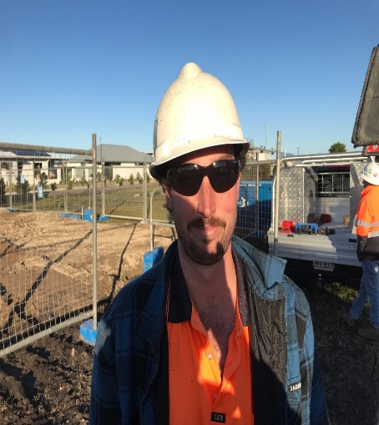 |  | 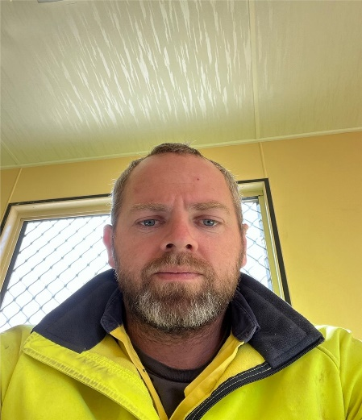
Name: | Josh Hall | Name: | Jason Morris
Company: | Monteur Electrical | Company: | DYFA Plumbing
Mobile: | 0403 875 752 | Mobile: | 0415 913 230
Role: | Chair  Minutes  HSR  Member | Role: | Chair  Minutes  HSR  Member

