CPCCBC4004A
Identify and produce estimated costs for building and construction projects

THEORY EXAM INSTRUCTIONS

- This exam will occur under standard assessment conditions.
  - An oral examination may be allowed under certain circumstances.
Answers will be documented and FT003 (Oral examination declaration form) must be completed.
- Participants must provide enough detail in their responses to demonstrate their knowledge and skills.
- Please fill in the details below, providing your name, signature and date of assessment.
  - Your signature acknowledges that this is your own work.
- If a participant initially answers a question incorrectly but modifies their response, they must follow the instructions below:
  - If a participant changes their response in writing, they must put their initials next to the written change.
  - If a participant changes their response verbally, this must be noted on the exam paper by the assessor.

Participant name | Justin Skehan
Participant signature | 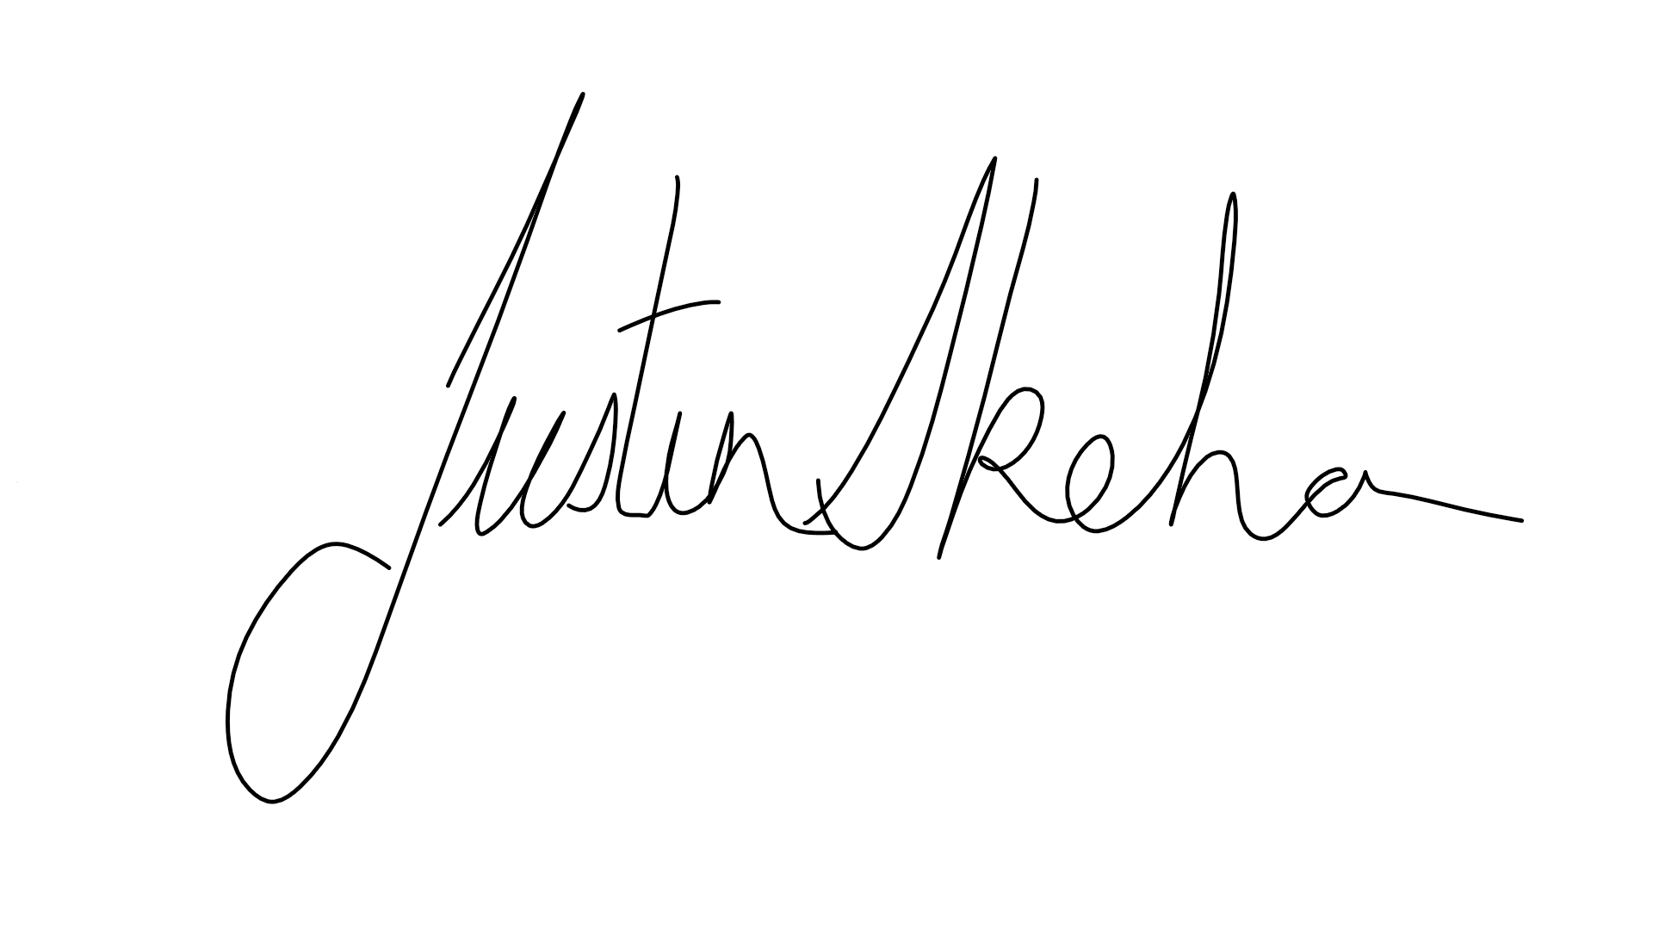

Assessor name
Assessor signature | 

Date | 16/08/2018

Number of questions | Number of questions answered correctly | Satisfactory?
24 |  | Yes | No

Assessor Comments
- What is the critical aspect of identifying and interpreting plans, drawings and specifications for a building project?

Answer | The critical aspect of identifying and interpreting plans and drawings is to show all parties involved in a building project the proposed structure, how it is to be built, the materials to be used, and what it will look like when completed.

- What is the purpose for date stamping of plans, drawings and specifications?

Answer | The purpose of date stamping is to ensure all parties can identify they have and or are working of the current plans and not a superseded set

- Nominate at least six (6) people and/or entities that would use plans drawings and specifications on a building project.

Answer | Other parties that will need to you plans and specifications would be  - Local Councils  - Engineers  - Utility Companies supplying Gas and Electricity  - Carpenters  - Kitchen Manufacturers  - Concreters  - Client  - Finance Providers  - Plumbers

- Plans and drawings usually hold many and varied features.
Name some of the types of drawings and details you would expect to see on plans and drawings for a building project.

Answer | Construction drawing will contain site plans, floor plans, slab and footing plans, elevations and section drawings. These plans will show details such as the building location on the block and setback measurements, wall dimensions, connection details, building heights, client name, project address, scale, reference numbers and dates

- It is necessary to acquire all building plans and specifications at the beginning of the negotiation period so we know all building project details prior to commencing work (including dimensions, construction materials, door and window schedules, masonry control joint locations and smoke alarm locations).
What else would be expected to be provided?

Answer | You would also expect to be provided with  - Soils Test Report  - Engineering  - Energy Efficiency Report  - Bushfire Zoning  - Roof Truss reactions and layout  - Building Specifications  - Schedule of finishes  - Framing and Bracing Plans  - Footing Construction details  - Electrical Plans  - Service Plans  - Site Plan

- Drawings are usually arranged in the approximate order of construction. What might a set of drawings consist of?

Answer | Civil Drawing these are often labelled C‐1, C‐2, etc and include plot or site plans, utilities, easements, grading and landscaping  Structural Drawing these are often labelled S‐1, S‐2, etc and will include foundation, structural steel, building support system, roof framing  Architectural Drawing are often labelled A‐1, A‐2, etc and will include floor plans, elevations, building sections, door and window schedules and room finishes  Electrical Drawings are often labelled E‐1, E‐2, and will include electrical wiring, lighting plan, reflected ceiling plan, panel schedules  Mechanical Drawings are often labelled M‐1, M‐2, etc): include heating, ventilating, sprinkler systems and air conditioning plans  Plumbing Drawings are often labelled P‐1, P‐2, and will include hot and cold-water system layout and sewage disposal systems

- Explain how to access the Building Code of Australia (BCA) and its relevance to estimating costs for building and construction projects.

Answer | The BCA or NCC is available free of charge from the Australian Building Codes Board www.abcb.gov.au you will need to refer to the code to ensure your estimate is in accordance with the construction methods and principles outlined In the code

- Explain how to access the Plumbing Code of Australia (BCA) and its relevance to estimating costs for building and construction projects.

Answer | The Plumbing Code of Australia is available free of charge from the Australian Building Codes Board www.abcb.gov.au you will need to refer to the code to ensure your estimate is in accordance with the plumbing methods and principles outlined in the code

- Explain how to access Australian Standards and their relevance to estimating costs for building and construction projects.

Answer | Australian Standards are available for purchase from SAI Global https://infostore.saiglobal.com au you will need to refer to the relevant Australian Standard to ensure your estimate is in accordance with the construction methods and principles outlined in the standard

- Identify two (2) standards that would be relevant to the industry sector.

Answer | Two relevant standards would be  - AS 1684.3 2010 Residential Timber Framed Construction (Cyclonic Areas)  - AS 4440 2004 Installation of Nail Plated Timber Roof Trusses  )

- Explain the impact of WorkCover requirements on costs to the project.

Answer | It is compulsory in Queensland to insure workers against workplace accidents by taking out an accident insurance policy with WorkCover Queensland. These costs should be included into the cost of a project, so that the company recovers overheads. WorkCover is considered a direct job cost (labour), which are costs that are incurred/involved with the actual construction.

- Explain the impact of Environmental Protection Agency requirements on costs to the project.

Answer | Several environmental related costs will be incurred, such as seeking approvals and waste management site fees. Estimators must also consider environmental management tasks such as third-party water quality monitoring costs, contractors implementation of management controls and so on.

- Calculate and cost the lineal timber order for 93 x 19 DAR Meranti and allow 5% wastage. The cost per lineal metre is $6.40.
The requirements are: 22 @ 2400; 30 @ 3600; 10 @ 4800; 12 @ 1880
Show your calculations.

Answer | 22 x 2.400 = 52.800 Lm  30 x 3.600 = 108.000 Lm.  10 x 4.800 = 48.000 Lm.  12 x 1.880 = 22.560 Lm.  52.8 + 108 + 48 + 22.56 = 231.36 Lm.  231.36 x 1.05 = 242.928 Lm.  242.93 x $6.40 = $1554.75  Or rounded to the metre  243 x $6.40 = $1555.20

- A building floor plan measures 24000 x 14000 and the specification states the sheet flooring is 3.6 x 0.9 x 19mm Yellow TERMIFLOR T&G H2 at $58.38 per sheet.
Calculate the area of floor sheeting required when an allowance of 2% is made for waste and cutting. Determine the number of sheets to order to the nearest whole sheet and calculate the cost for the flooring.
Show your calculations.

Answer | 3.6 x 0.9 = 3.24 Sheet  24 x 14 = 336M2  336 x 1.02 = 342.72M2  342.72 / 3.24 = 105.77 Sheets  106 x 58.38 = $6188.28

- If a solid cavity brick wall is to be built 23000mm long and 2400mm high (no windows and no doors), how many bricks would be required if the number of bricks per square metre is 50? Show your calculations.

Answer | 23 x 2.4 = 55.2M2  55.2 x 50 =2760 Bricks

- You are a QBCC licensed plasterer and a client (Owner Builder) Davey Jones-Locker of 100 Reef Avenue, Brisbane, Queensland wants you to quote for plastering an internal wall of his house build and has described to you the following information over the phone:
The Client tells you the Council approved plans and drawings state the finished ceiling height from the top of slab floor is 2400mm. There is one external solid timber door (D4) is 2340 x 870 x 35 in this wall and no other openings. The length of this house end wall is 11 metres.

The house is of brick veneer construction and includes a 50mm cavity and the load bearing external framing is 70 x 45 MGP12 (a Boral product “Pineguard Blue”). The bricks are standard bricks 230 x 76 x 100mm. (L x H x W).

The Client tells you that the door is positioned 2100mm from an internal corner (RHS in aerial view) and as seen from inside the house looking out. The specification and drawings state 10mm regular internal plasterboard. You know from experience regular plasterboard is supplied in the following sizes lengths 6M, 4.8M, 4.2M, 3.6M, 3M, 2.7M and 2.4M with recessed edge and widths of 1200mm and 1350mm.

The Client wants a quote to fix and finish this internal wall with plasterboard.

Your labour and on-costs are charged at $51.50 an hour per tradesman plus materials including sheets, fixing, finishing and sanding. You estimate ancillaries including stud glue, screws, base coat, top and finish coats at $315.00 and that there is two (2) days’ work.
Your business works a 38 hour week you allow workers a 15 minute morning tea break and half hour for lunch. You will need two (2) tradesmen first day and one (1) tradesman second day including materials and equipment supply, fixing, finishing and sanding.
You are to research or acquire plasterboard sheet prices and attach this price list to your email. You are not required to supply or fix cornice.
Sketch the wall in Plan View (not to scale), dimension it with relevant measurements, and position the door on the right side of your plan view sketch and then calculate the plasterboard required and approximate waste expressed as a percentage (%) for internally lining this wall.
Estimate the cost of the job, including supplying plasterboard materials fixing setting, finishing and sanding plus labour. Then write a covering email to be sent to the client. You must show your methods for calculating cost of sheets, waste, plus fixing, setting, finishing and sanding.
Attach your quote, sketch, calculations and pricing list and email this to your Trainer/Assessor (details provided by them).

DRAFT AREA

DRAFT AREA

Answer

- There are many different ways of estimating project costs. You can use your past experience, or ‘square metre’ rates but if you are unfamiliar with estimating and pricing then you should resort to the materials and labour method of costing using an item-by-item approach which is considered as the best industry approach to estimating.
What are at least three of the nominated methods for estimating?

Answer | - Estimating by area  - Estimating by material and labour  - Estimating by a Costing Guide or Estimating Manual

- Name some of the circumstances to consider in relation to labour adjustment factors when estimating a project for construction.

Answer | some of the circumstances to consider in relation to labour adjustment factors when estimating a project for construction are  - Deduct 10% when the work is in a large open area with excellent access and good light.  - Add 1% for each 10 feet that materials must be lifted above ground level.  - Add 15% to 25% for work on a ladder or a scaffold, in a crawl space, in a congested area or remote from  - the material storage point.  - Add 10% to 15% when working temperatures are below 40 degrees or above 95 degrees.  - Add 10% to 35% for demanding specs, rigid inspections, unreliable suppliers, a difficult owner or an  - inexperienced architect.  - Add 30% to 50% on small jobs where fitting and matching of materials is required, adjacent surfaces have  - to be protected and the job site is occupied during construction.

- If a bricklayer lays 600 bricks in an eight (8) hour day, what is the average number of bricks laid per hour by the bricklayer?
Tick your response.

Answer | Choice | Possible Answers
 | ☐ | 65
 | ☐ | 70
 | ☐ | 55
 | ☐ | 90
 | ☒ | 75
 | ☐ | 105
 | ☐ | 85

- What and where are some of the potential sources you could go to in choosing your suppliers for goods and services?

Answer | There are a number of methods you can use to source potential suppliers from  - searching online  - Publication like the Yellow Page and Local Directory  - Industry Events  - Business Networks

- What are some of the primary (key) factors for choosing your suppliers?

Answer | Once you have a list of potential suppliers some key factors are to, ask them for written quotations, where needed a sample of the items you need, range and products on offer you can then compare their services to see which suppliers are the best fit for your business

- What are some of the ways you could communicate with your suppliers for gaining quotes?

Answer | The methods of communicating with your suppliers are as follows  - written request  - email request  - faxed request  - telephone request  - verbal request  - instore visit

- Explain the concept of a ‘Labour Only’ quote?

Answer | A labour only quote is a price for solely the labour component of a job. This means no other job component is included i.e.. Materials, permits  Labour can be charged out using 3 standard methods  - Per unit: installation of set items like doors are usually quoted per unit  - Per lineal metre: the cost of building walls to a specified height and type may be quoted per lineal metre of wall length  - Per square metre: the cost of plasterboard, decking or cladding may be quoted in square metres

You will be provided an allocated period by your instructor to complete this task.
You may use appropriate costing software programs in completing this task.

- Referring to the supplied set of house plans, you must do the following scheduling and costing:

- Identify and nominate a supplier/s and schedule the materials and cost the internal and external timber wall framing.
- Identify and nominate a supplier/s and schedule the materials and cost the foundations and lower floor concrete slab including the schedule and costing for reinforcement.
- Identify and nominate a supplier/s and schedule the materials and cost for the sub floor framing and the flooring for the upper floor plan.
- Calculate the architrave and skirting required for the fit out of the upper floor only in lineal metres.
- Calculate the wet area tiles for the upper floor only which are client chosen for both floors and walls with the wall tiles 250 x 100 and floor tiles 300 x 300.
- Estimate the labour only cost to tile all the wet areas only in the home. The tiler charges labour only $44.00 per square metre.
- Determine the roofing material and number of square metres of it that are required.
- Complete the aluminium windows and doors schedule and other external doors schedule for the lower floor only.
- Complete a full internal doors schedule for the lower floor only.
N.B. Assume all doors are flush panel 2040mm in height and 35mm thick.
- Estimate the labour only cost for hanging all doors on the lower floor – if a tradesman takes 2 hours to jamb an opening, hang the door, fit the door furniture, door stops, architrave and fit a door-open-restraint. The hourly rate is $27.80 plus 20% on costs.

Answer | a. Attached  b. Attached  c. Attached  d. – upper floor Skirting 103 Lm  - upper floor Architrave 207Lm  e. - Floor Tiles 300 x 300mm 17m2  - Wall Tiles 250 x 100m 52 Sqm  f. - 69m2 x $44.00 = $3036.00  g. - Garage Roof .42Bmt Kliplok Zinc 55m2  - Lower Roof .42Bmt Colorbond Trimdek 49m2  - Upper Roof .42Bmt Zinc Trimdek 175Sqm  h. Attached  I. – Redicote Doors 204 x 820 x 35mm 1/870 3/820 1/770 3/720 1/620  j. 9 Doors x (2x $27.80) + 20% = $600.48

Answer

