BSBLDR414
Lead team effectiveness

ASSESSMENT SUMMARY

The assessment activities for BSBLDR414 Lead team effectiveness cover all aspects of the unit of competency. For Apprentices/Trainees, this includes supervisor completion of the Apprentice/Trainee Record (ATR).

Participants must read all the information given before starting any assessment task. The assessment tasks are intended to be fair, flexible, valid and reliable. If a Participant has any questions or requires alternative arrangements to be made such requests should be directed to their Trainer/Assessor, who should note such arrangements in the ‘Assessor Comments’ on the affected assessment. If a Participant feels they are not yet ready to be assessed, they should discuss their options with their Trainer/Assessor.

To satisfactorily complete the assessment, the Participant is required to answer all questions correctly and demonstrate their skills to industry standards. If a Participant does not answer all questions or perform all tasks, they will be deemed ‘Not Satisfactory’ for the task and ‘Not Yet Competent’ for the unit of competency.

The Trainer/Assessor can provide the Participant with additional information on interpreting the assessment outcomes and guide the Participant’s options. If a Participant is still deemed ‘Not Satisfactory’ they will have the opportunity to undertake a supplementary assessment or appeal the result as per the process in the Student Handbook.

By signing below, the Participant acknowledges:
- They understand the assessment instructions and requirements, and consent to being assessed.
- The work submitted is to be their own work – with the work of/with others needing to be clearly acknowledged and documented.
- They consent to any photo/video recording of their work that occurs during assessment.

Participant name | RHYS HOLMES - YASSO
Participant signature | 

Pre-requisite unit(s) to be achieved and authenticated prior to undertaking assessment
Not applicable

Task | Date completed | Assessment Results
Theory Exam | Select Date. | Satisfactory | Not Satisfactory
Practical Assessment | Select Date. | Satisfactory | Not Satisfactory
Outcome for BSBLDR414 | Select Date. | Competent | Not Yet Competent

Evidence requirements checklist (ticked by assessor and evidence supplied to RTO)
Theory Exam | Practical Assessment  Team development plan

Assessor Name
Assessor Signature | 

BSBLDR414
Lead team effectiveness

THEORY EXAM

Participant name | RHYS HOLMES - YASSO

FOR THE PARTICIPANT
Instructions
- You will complete written questions as outlined on the following pages. You must attempt all questions and provide enough detail in your responses to demonstrate your knowledge.
- It is anticipated that you should complete this assessment within two (2) hours, but additional time may be allowed upon negotiation with the Assessor.
- You must complete all questions unassisted by the Assessor or other personnel but may refer to reference material as needed. All questions must be answered correctly for a ‘Satisfactory’ assessment outcome to be awarded.
  - An oral examination may be allowed under certain circumstances, whereby your answers will be documented by another party.
  - Any written questions that are incomplete, or not answered satisfactorily will need to be completed again after further training support.
    - If you answer a question incorrectly but modify your response, put your initials next to the written change (or the Assessor must initial a verbal change).
Resources required
Pen

FOR THE ASSESSOR
Instructions
- Where oral examination has occurred, ensure that this is acknowledged in writing (e.g. FT001 and Assessor Comments)
- All questions must be satisfactorily demonstrated by the Participant for a Satisfactory determination (indicated by an Assessor tick to the right of the question).
- Assessors are to complete marking in pen of a different colour to the Participant.
- If the Participant verbally modifies their response, write in the modified response verbatim and put your initials next to the written change.

ASSESSOR COMMENTS
As necessary, outline:
- Details on reattempts, alternative arrangements or reasonable adjustments made.
- Where a Participant is deemed ‘Not Satisfactory’, provide recommendations for future training.

- Identify a team that may exist in the workplace. Consider the purpose of the team, its goals and objectives. Name and describe the roles and responsibilities for at least three (3) team members. Finally, identify at least one (1) method that will assist with monitoring progress towards the team goals.

Answer | Point | Detail
 | Team purpose | A Workplace Health and Safety committee that inspects any risks/hazards or any positive and negative observations made within the construction site.
 | Goals and objectives | Short term | Each month conduct and facilitate a WHS Site walk within the construction site to discuss, record and document any hazards or risks found.
 | Goals and objectives | Long term | To complete the project with no on site reported injuries and improve our WHS inspections.
 | Team members | Role | Description | Responsibilities
 | Team members | 1 | Team WHS Committee Lead | Facilitating the WHS Committee site walks and initiating a discussion within the team on issues or problems that have been seen within the site.
 | Team members | 2 | WHS Committee documenter | Documenting and constructing a meeting minutes to distribute to other worksite personnel after the discussions and walks have been completed.
 | Team members | 3 | WHS Committee member | Monitor and measure any risks/hazards found on site and address the findings and engage with the team in a general discussion of preventatives, to ensure we meet our long-term goal.
 | Progress monitoring | Weekly WHS Team Co-Ordination meetings to ensure all goals and objectives are on track, and that any issues and queries that any worksite personnel have raised on site or within the office are addressed.

- True or False (Tick your response): A team leader is more of a mentor than overseer who checks work.

Answer |  | True
 |  | False

- Match the leadership styles and definitions by writing the appropriate letter next to each number in the centre column.

Answer | Style |  |  | Definition
 | 1 | Authoritarian | 1 - B | A | Leaders who let the team function without much interference
 | 2 | Democratic | 2 - C | B | Leaders who fully control their team
 | 3 | Laissiz-Faire | 3 - A | C | Leaders who try to include everyone in the decision-making process

- Identify two (2) benefits and two (2) drawbacks of transactional leadership.

Answer | Benefits | Drawbacks
 | Value organisation and well-controlled practises. | Not well fitted for workplaces where ingenuity and innovative ideas are appreciated
 | Work best with employees who follow structured policies and procedures. | They can tend to focus on rewards to encourage employees and enhance self-interest satisfaction, instead of building a solid professional relationship.

- Which of the following are characteristics of transformational leaderships? Tick all that apply.

Answer | Choice | Possible Answers
 |  | The leader acts as a role model to employees
 |  | Close, consistent focus on the company vision
 |  | A high value on interpersonal relationships
 |  | Inspiration as a tool to motivate employees

- Why is it important for team leaders to include team members in the planning process?

Answer | It is important for leaders to include team members in the planning process to ensure that all personnel are working towards the same specific goal or desired target. Team members should have a thorough understanding of the works they are aiming to deliver and the steps that are involved, to reach a high standard of completion. This is to avoid poor quality of works, decrease any miscommunication and minimise the chance hazards/risks.  This also creates the opportunity for everyone to share valuable insights, knowledge, and alternative ideas/methods/solutions with the team. Processes and systems can be made more efficient, incidents/hazards that were overlooked previously could be identified, and any questions or doubts can be answered.  Knowing the strengths and weakness of those who are part of the construction process will enable the team leader to plan a more practical, safe, and efficient path to success.

- For each of the listed activities in the table below, identify two (2) methods that team leaders can use to involve team members.

Answer | Activity | Method/s to involve team members
 | Goal setting | - Team leaders could conduct performance reviews where team members are encouraged to set goals and take on further upskilling or development, in a desired field.  - Team leaders could share their own personal experience on how they earnt an important role in the company. They could also share who they went to for assistance and how they overcame any obstructions on their journey to success.
 | Decision making | - Team leaders can encourage decision making by giving others the authority to make choices on their own or when working individually.  - Team leaders can provide support and additional information to instil confidence in team members when making decisions for themselves.
 | Work allocation | Facilitating a toolbox/pre-start meeting, to help determine the confidence within the team member’s strength and weaknesses for work allocation.  Team leaders to consider the work’s priority to establish the importance in allocating which job’s first within the team.

- True or False (Tick your response): Diverse teams produce more creative results than teams in which members are less diverse.

Answer |  | True
 |  | False

- Provide two (2) examples of how the knowledge, skills and background of team members can enhance team practices.

Answer | Not every team member will have the same skillset, background and knowledge as the other. As such, having variety and diversity within a team can introduce newer and more efficient ways to complete/approach a task.  When knowledge is shared it can also provide opportunities for others to upskill or make changes to their own personal practices so that they can advance their own skillset and better assist the work of others.

- Provide two (2) reasons that responsibilities must be carefully delegated within the work team.

Answer | A team leader should avoid delegating responsibilities that are not complimentary to the member’s skillset to prevent any delays, obstacles and issues while trying to accomplish the team’s goal.  Giving a member too much responsibility could have a negative effect. Overloading a member of the team could cause stress, fatigue, and mental instability from too much pressure, especially if they lack confidence and don’t have the capacity to take on more tasks. Responsibilities should be evenly and fairly distributed amongst the entire team.

- Describe what innovation brings to the workplace. Provide one (1) example of innovative practice.

Answer | Innovation can reduce costs, new partnerships and relationships, inspire more initiative, and most of all, improves productivity.  An example of an innovative practice within the workplace is substituting paperwork documentation into digital. This would include permits to work, checklists, and building documentation and utilising a digital tool such as an iPad, which would speed up productivity and make documentation more accessible.

- Describe (3) methods that may be used to measure a team’s innovation.

Answer | Utilising innovation metrics within the workplace: -  Revenue stake of innovations / Total revenue = Innovation Rate.  Quantity of innovations / Number of products = Innovation Ratio.  Utilise a KPI system to record innovation performances.  Team leaders tracking profits and costs after innovations have been used within the workplace.

- Explain how encouraging team members to assist each other in undertaking their roles and responsibilities can improve productivity.

Answer | Positive encouragement to a team member can boost morale and improve teamwork within the workplace. Implementing teamwork can be more efficient in reaching the teams goals as each member can contribute different thoughts, initiatives and suggestions. It also gives a member additional experience in dealing with issues or solving problems in a role outside of their usual scope of work. Positive assistance with each other within the team presents a high standard of cohesion.

- Describe (3) methods that may be used to measure a team’s productivity.

Answer | Programme meetings to discuss within the team any setback’s, positives, or issues raised. This will give leaders and members an overview on how many remaining items, estimated hours, outstanding jobs that are waiting, in progress or completed.  Implementing agile metrics within the project would help the team set targets, measures against goals, and evaluate performance. Applying these graphs can show team leaders how well their team is dealing with the set deadlines.  Implement the productivity output formula strategy. This can be used on any jobs or tasks completed. Simply choose the output the leaders will measure; understand you’re input figure (Typically the hours of labour put into production) and proceed to divide the output by the input. Adding a dollar value to the result can be measured for your cost-benefit ratio.  (e.g) Productivity = $\frac{OUTPUT}{INPUT}$

- Which of the following are likely outcomes from involving team members in all aspects of a job? Tick all that apply.

Answer | Choice | Possible Answers
 |  | Causes members to resent the team
 |  | Makes the work more meaningful
 |  | Improves self-esteem of team members
 |  | Improves team morale
 |  | Team members take more responsibility for their individual work

- Explain how providing feedback to team members can encourage and motivate team members – building trust and positive working relationships.

Answer | Providing feedback to members of the team can be valuable and constructive if delivered positively. Constructive criticism helps the member understand areas he/she could improve in, or areas where they are excelling (strengths and weaknesses). Having these conversations from a leader can encourage them to complete work/personal goals and objectives. Positive and negative feedback can help team members approach tasks/situations with a different perspective, and aid in the development of a trusting relationship between the team leader and member. Having trust and positivity in a working relationship can create a collaborative environment. It allows team members/leaders to be more comfortable asking questions to gain clarity, and it also creates opportunities for team members to ask for more responsibility knowing their leader is comfortable with them accepting the task and willing to support them.

- Identify one (1) issue, concern or problem that may be identified by team members. Describe the signs that you would recognise to identify the issue and how the matter could be resolved by internal team negotiation.

Answer |  | Response
 | Issue, problem, or concern | Lack of communication and cohesion within the project team.
 | Signs | Productivity breakdowns, Negative environment around the team, members unsure with approaching tasks or responsibilities.
 | Solution via negotiation | Planned meeting to review every members responsibilities, tasks/jobs approaching, discuss any topics of issues within the workplace and ask around the room how the team could approve in working together more positively

- Identify one (1) issue, concern or problem that would need to be resolved by an external party. Describe the signs that you would recognise to identify the issue and who the matter should be referred to.

Answer |  | Response
 | Issue, problem, or concern | Excavation material compaction test failed due to a subsoil drainage collision under pavement works, this finding would have to be immediately notified to the external subcontractor operator.
 | Signs | Uneven ground, Ability of failure for a proof roll, this finding is to be notified to the external subcontractor engineer.
 | Solution via negotiation | Liaise with the subcontractor to remove the wet material and repair with certified material and place geofabric to prevent any further issues.

- Identify three (3) ways that the team leader can serve as a role model to, and motivate, the team.

Answer | - A leader displaying a high standard example of positivity – having this trait within the workplace encourages members of the team to be alike and set’s a comfortable and encouraging environment. Positivity boosts productivity, increases the team’s energy levels and aids them to think more clearly to enhance their focus
- A leader demonstrating integrity in the workplace creates a comfortable involvement of trustworthiness and incorruptibility. Having both qualities within a team and demonstrated by a leader, means that others will also aspire to conduct themselves in the same/similar manner.
- A leader possessing the trait of being observant. Having this quality can make things efficient, comfortable and acceptable. A leader being observant in the workplace can prevent problems before they commence, ensure members of the team are performing correctly, and an overall view on the performance of the project/job.

- For each of the following areas, provide one (1) example of how the team leader’s contributions to the work team can enhance the organisation’s image:
- Internally, within the work team and the organisation
- Externally, with clients/customers

Answer | Question | Response
 | Within the work team and organisation | Team leaders can come together with the team and create collaborative goals to help reach their final objective to show the importance of completion.
 | With clients and customers | Leaders can foster open and trustworthy communication between themselves and with clients and customers, displaying how the organisation is operated and giving people an understanding of the organisation values and practises.

- Provide three (3) communication methods that a team leader may encourage the team to use, and situations that each communication method would be suitable for.

Answer | Method | Suitability
 | Email | Emails would be suitable for team members to reach out to other members, external subcontractors, or other relevant personnel to the project. It’s an effective and productive application to use by sending notifications or various messages towards a group(s) or one person.
 | Team Meetings | Team meetings would be a great opportunity to discuss any open queries or issues around the room, or for members to share insights and strategies. One on one communication in person adds great value and gives a person more opportunity to discuss problems solving and be more open in communication comfortability.
 | Visual Presentations | Visual Presentations can add value by retaining information at a more productive rate, and gives attendee’s clarity over jobs, or important information by watching videos, photographs, or even performance graphs relevant to progress tracking.

- Identify two (2) ways that the team leader can establish open communication with management.

Answer | A team leader can arrange to introduce staff directly to management / people of authority, so that they seem more approachable, and members feel more comfortable speaking with them. An open-door policy for meetings also reinforces open communication.  Establish a healthy relationship with a member of management to get to know them on a more personal level. Developing a professional personal relationship can help break down some walls, and an encourages each other to communicate more openly. Encouraging staff entertainment or regular informal get-togethers creates a more open environment for members to express themselves and any concerns.

- Identify two (2) issues, concerns and problems that may be raised by the team to management.

Answer | Company to assist in funding for training to help upskill personnel and meet identified skills needed to create a safe and professional workplace.  Negotiation of relocation for the next project (Cost of expenses to move Town/Cities, opportunity for paid travel)

- Identify two (2) issues, concerns and problems related to the team that may be raised by management back to the team.

Answer | Project targets / Objectives are not being completed on time. Management would be inclined to approach team leaders to review the performance within the team and ensure that any delays or obstacles are being resolved.  Current working hours from members of team are exceeded workers fatigue hours or are not meeting the requirements of the ‘Work Health and Safety Act 2011’

- Describe one (1) situation where the team leader may have to negotiate with management on behalf of the team.

Answer | If Project targets / objectives were unrealistic or impossible to accomplish without the right amount resource.

Refer to the extract below from an Escalation Policy and Procedure to respond to Q26. to Q28.

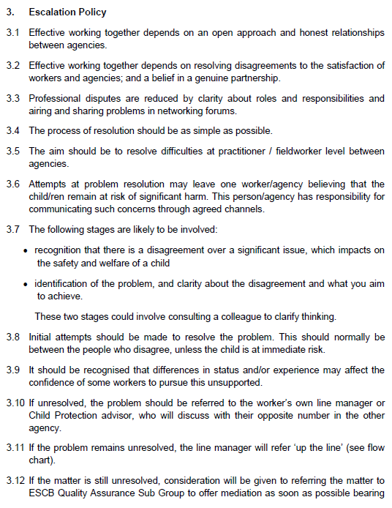
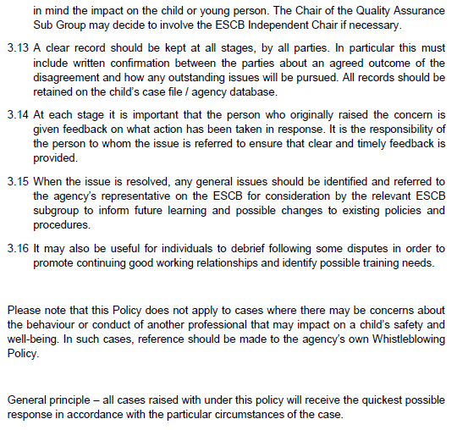
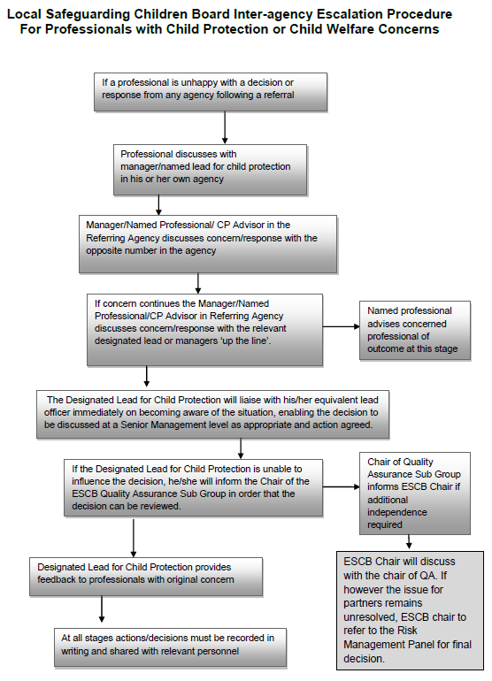

- Order the following steps from 1 to 5 to identify the correct order of issue escalation where a problem is unresolved.

Answer | Step Number | Steps
 | 1 | The people who disagree should make the initial attempts to resolve the problem
 | 5 | When the issue is resolved, any general issues should be identified and referred back to the agency’s representative to inform future learning and possible changes to existing policies and procedures
 | 3 | If the problem remains unresolved, line manager will refer ‘up the line’
 | 4 | If the matter is still unresolved, the matter may be referred to the Quality Assurance Sub Group to offer mediation
 | 2 | If unresolved, the problem should be referred to the worker’s own line manager

- True or False (Tick your response): It is the goal for all cases raised under this policy to receive the quickest possible response.

Answer |  | True
 |  | False

- If the ESCB Chair cannot resolve the issue, which body can make the final decision?

Answer | Risk Management Panel

BSBLDR414
Lead team effectiveness

PRACTICAL ASSESSMENT

Participant name | RHYS HOLMES - YASSO

FOR THE PARTICIPANT
Instructions
- The tasks outlined on the following pages will require performance of normal workplace activities, as a result of a structured activity set by an Observer in the workplace or a simulated activity set by your Assessor/Observer.
- The timeframe for these tasks will be established by your Assessor/Observer, in consideration of location conditions and industry requirements.
- You must complete all tasks unassisted by the Assessor or other personnel, unless the steps note this assistance.
- You must attempt all tasks (and itemised steps) for a ‘Satisfactory’ assessment outcome to be awarded.
  - For any observation conducted that is incomplete, or without satisfactory performance, the observation will need to be completed again after further training support.

FOR THE ASSESSOR/OBSERVER
Instructions
- The following observation record should be used to judge and record your observations of the Participant as they complete the task(s) set. You must record your observations of the Participant’s performance.
  - For each occasion, indicate the task performed and whether it was a simulation or workplace-based task.
    - Any simulated assessment must ensure the Participant still performs under workplace conditions which reflect industry standards.
  - In the comments, provide clear detail regarding the task that the Participant was required to do (e.g. PPE used, materials handled, attachments connected, plant types).
- All steps must be satisfactorily demonstrated by the Participant for a ‘Satisfactory’ determination (indicated by an Assessor tick to the right of each itemised step, or an Observer tick to the right of each itemised step, and confirmation by an Assessor in the Assessor Comments).
  - Where you have determined that one or more task steps have not been satisfactorily demonstrated, provide the Participant with additional support and outline details of such assistance in the Assessor/Observer Comments. Allow the Participant two (2) further opportunities to demonstrate the task again to allow an opportunity for a ‘Satisfactory’ assessment outcome to be achieved.
  - If after three (3) attempts the Assessor determines that the Participant cannot demonstrate the required steps, a ‘Not Satisfactory’ outcome is to be determined.

TASK OUTCOME
Task | Date | Task Type (Tick) | Location | Task outcome (Tick)
 |  |  |  | Satisfactory | Not Satisfactory
Task 1 | Select Date. | Workplace  Simulation | ASMTI – Project  Laing O’Rourke

ASSESSOR COMMENTS
As necessary, outline:
- Details on reattempts, alternative arrangements or reasonable adjustments made.
- Where a Participant is deemed ‘Not Satisfactory’, provide recommendations for future training.
N/A with any additionalcomments due to Rhys completing his lead team effectiveness to a very satisfactory standard.

ASSESSOR COMMENTS: PRACTICAL TASK 1
Individual student (as named on cover page)
Multiple students [ All from Attendance Report, Specific students involved – identify students]
Task | Provide detail
1.B. | Feedback provided to team members:  I observed Rhys on a daily basis participate with morning pre-starts to the group and capturing within the discussions and open communication between the team and providing the team members feedback from what he had observed from the previous day as well as recognition to the team for their efforts.
1.C. | Support offered to identify and resolve problems, issues and concerns:  Again observing the way Rhys spoke to the work crew he continued to have open communication that was 2 -way at all times, this felt the workcrew could discuss openly anything that was troublesome for them and with this he provided some important information to prevent this occurring again.
1.D. | Issues passed from management to the team and vice versa:  Rhys is seen as the staff member that guides/direct the direct labour force each day to their critical tasks to allow the site, Rhys informs all of the labour the upcoming works that are planned through the information that is gathered through the daily co-ordination meeting with site supercvsion so that they are fully aware and work efficiently to ensure that targets for upcoming works are met.

BSBLDR414
Lead team effectiveness

Practical Task 1
Description of task:
A suitable observer is to verify the participant’s ability to lead team effectiveness, including:
- Leading and consulting with the team to develop a team development plan that addresses –
  - Team cohesion
  - Innovation and productivity measures
  - Issues management and actions
- Communicating with team members and management to –
  - Consult, encourage, support and provide feedback to the team
  - Model team leadership behaviours and approaches
  - Resolve problems

The Observer is to provide detailed comments on the tasks completed by the Participant (on the Observer Comments, overleaf). The Assessor is to verify the Observer’s comments, noting their findings in the Assessor Comments (on the back of the Practical Assessment cover page) and provide the assessment outcome.
Resources required:
Team Development Plan Template
Observer details
Name of observer: | Brendan Butler
Role of observer  (Confirm suitability to sign) | Site Manager
Email address of observer | bbutler@laingorourke.com.au
Signature of observer:
Date: | 7/02/2023

When completing the task, did the Participant: | Tick if satisfactorily completed.  Provide comments if left unticked.
- Lead and consult with the team to establish and document a team development plan, incorporating:
- Team purpose, roles, responsibilities, goals, objectives and plans
- Consideration of organisational goals, objectives and plans
- Team cohesion
- Innovation and productivity measures
- Issues management and actions
- Lead team to develop cohesion, including:
- Providing opportunities for input of team members into planning, decision making and operational aspects
- Encouraging and supporting team members to take responsibility for own work and to assist each other
- Providing feedback to team members to encourage, value and reward individual and team efforts and contributions
- Participate in and facilitate work team, including:
- Leading and supporting team members in meeting expected outcomes
- Actively encouraging team members to participate in and take responsibility for team activities and communication processes
- Giving the team support to identify and resolve problems, issues and concerns
- Acting as a role model to enhance the organisation’s image for work team, clients and customers
- In line with organisational escalation policies and procedures, maintain open communication by passing information from management to the team and vice versa (including issues, concerns and problems).

OBSERVER COMMENTS

TEAM DEVELOPMENT PLAN

DATE OF EFFECT
Start | 22/11/2022 |  | End |  | 21/12/2022
GOALS, PLANS AND OBJECTIVES
Outline the team’s purpose, goals, and objectives. Identify how this fits within the organisation’s goals, objectives and plans.
This team is to help all sub-contractors on site with labour and operating duties. The team consists of two telehandler operators who are present on site for a 12-hour shifts. During daily pre-starts each operator has a list of tasks to assist with material relocations and unloading of material deliveries for various contractors. Within the team also consists of two labourers who assist in day to day who perform tasks such as industrial cleaning within the construction, assisting in manual labour duties to help install materials, and supporting project with personnel with water each morning.
OBJECTIVES FOR TEAM
Objective |  | Work process |  | Responsible employee |  | Start date | End date
Team cohesion |  | Having delegated lift plans relevant to two telehandler operations. (each morning delegating Dallas and himself to certain lifts to aid cohesion and continuity). |  | Daniel Watson |  | 8/11/2022 | 5/03/2023
Innovation |  | Presenting the idea of hiring a rotator attachment for on site telehandler to help with unloading of waste materials within large skip bins for site clean-ups / waste disposal. |  | Dallas Parry |  | 8/11/2022 | 5/03/2023
Productivity |  | Providing Water to all personnel to ensure hydration is kept to a high standard to support the productivity of the project. |  | Darrius Mann |  | 8/11/2022 | 5/03/2023
Issues management |  | Enrolling within the health and safety representative course and participating in H&S committee walks to assist in any site issues |  | Jennifer Ryberzech |  | 8/11/2022 | 5/03/2023
REVIEWING AND ASSESSMENT METHODS
How will you track the plan’s implementation, the team’s progress (e.g. through team meetings, reports)?
I will conduct weekly progress meeting to give the opportunity to address any on site issues, innovative ideas, or any queries that the team might have. I will conduct progress reports individually on each member of the team to report back to management.

ADDITIONAL SUPPORT
Is there any additional support needed to reach the desired goals (e.g. courses, classes, resources).
Each operator will have the opportunity to apply/enrol for additional machinery classes/courses to be able to be competent on more machinery on site to operate. Depending on the response for the team, possibly employing an additional member to ensure the team are not being overworked
EXPECTED OUTCOME
Team leader’s expectations on the outcome based on the data.
Completion of the project by the correct date. The team to have hit all their goals, objectives and self-aspirations while enjoying working on the project
OUTCOME IF GOALS AND OBJECTIVES ARE NOT MET
Identify the consequences and further steps if the team fails to satisfy the standards set by the plan.
Facilitate individual team member meetings to help understand where these failed objectives are being formed. If standards are not continuously met, there will be the potential idea of termination of employment

