CPCCBC4007A
Plan building or construction work

THEORY EXAM INSTRUCTIONS

- This exam will occur under standard assessment conditions.
  - An oral examination may be allowed under certain circumstances.
Answers will be documented and FT003 (Oral examination declaration form) must be completed.
- Participants must provide enough detail in their responses to demonstrate their knowledge and skills.
- Please fill in the details below, providing your name, signature and date of assessment.
  - Your signature acknowledges that this is your own work.
- If a participant initially answers a question incorrectly but modifies their response, they must follow the instructions below:
  - If a participant changes their response in writing, they must put their initials next to the written change.
  - If a participant changes their response verbally, this must be noted on the exam paper by the assessor.

Participant name | Justin Skehan
Participant signature | 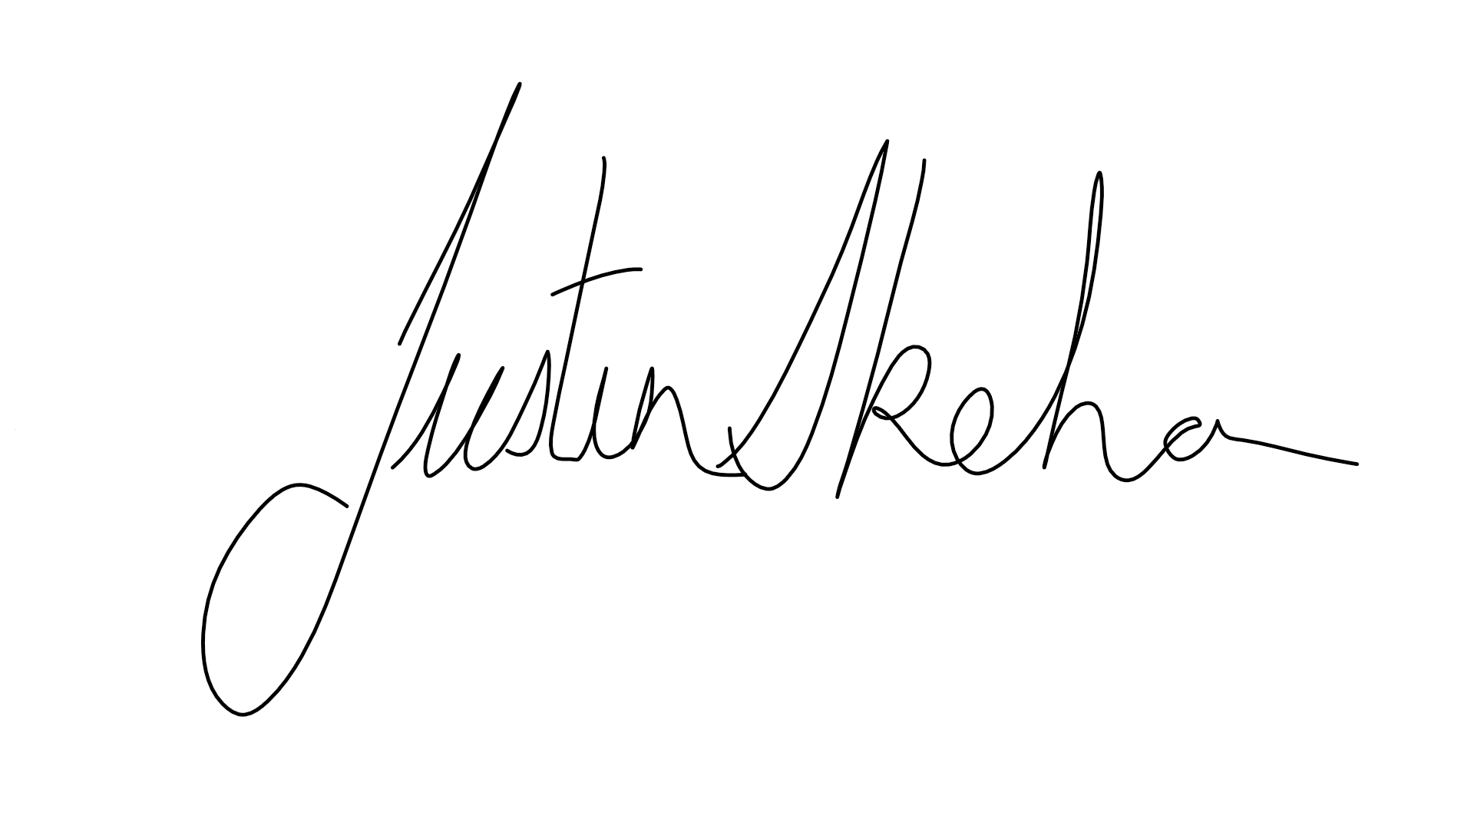

Assessor name
Assessor signature | 

Date | 7/09/2018

Number of questions | Number of questions answered correctly | Satisfactory?
29 |  | Yes | No
Assessor Comments
- Who is responsible for supervision on a building construction site?

Answer | Under the Queensland Building and Construction Commission Act 1991 (QBCC Act), a licensed contractor must ensure that building work done under their licence is adequately supervised

- Who is responsible for supervision when a Builder has a Construction Manager on site?

Answer | As a construction manager, your obligations are the same as for a licensed contractor. You must make sure that any work carried out by licensed contractors for a principal (under construction management trade contracts) is supervised by an appropriately licensed person.

- Who is responsible to supervise and coordinate tradespeople working on site?

Answer | It is your responsibility to supervise and coordinate tradesmen working on site, and this includes any defects in subcontractors’ work.  If you are a nominee or site supervisor, you must ensure the work done is supervised by an appropriately licensed person.

- Is it likely that particular requirements for quality and finish would be included in the contract (e.g. the type, style and number of coats of paint to be applied or the quality of bricklaying and finish to be achieved or the style of cladding or lining to be applied etc.)?
How should the builder encourage the client with checking the implementation of such details?

Answer | The builder could encourage the client to attend site when inspections occur at each stage of the job

- What might the client do if the client is unsure about conducting on-site inspections of work in progress or completed?

Answer | If the client is unsure about attending site they could ask for a copy of the inspection reports, photo evidence of the work completed is correct

- Explain the role of the Building Certifier.

Answer | The Building Certifier is a highly qualified building industry professional whose role is to check that the builder has complied with the approved building plans and appropriate building standards. Certifiers can work for local government, or in a private practice as a private certifier  Some of the of the tasks a Building Certifier completes are,  - assess and approve plans relating to new or altered buildings  - inspect construction work at mandatory stages  - provide certificates of inspection to the homeowner, the builder and the local Authority  - issue enforcement notices where required  - give final approval for a building to be occupied

- Explain what a Building Certifier is not responsible for.

Answer | Building certifiers are not responsible for the quality of workmanship within the construction process as this responsibility is that of the builder to the client.

- Name at least eight (8) things you can do to help avoid problems escalating into dispute.

Answer | Eight things you may do to help avoid problems escalating into dispute.  Are,  - discuss upfront and listen carefully to your client’s concerns  - speak about the problem calmly and patiently  - check the relevant documentation to verify if the complaint is warranted/correct or fair  - As the primary contractor deal with the matter in person to give the client reassurance the matter is important and is being dealt with accordingly  - Clarify with your client all the details to avoid any misunderstanding  - Actively work towards solving the problem and maintaining a healthy working relationship with your client  - Discuss with the client what their expected outcomes might be, so you can determine the required actions to be taken  - comply with the correct procedure quickly and fairly

- What is the Building Code of Australia (BCA)?

Answer | The NCC is a performance-based code containing all Performance Requirements for the construction of buildings. It is built around a hierarchy of guidance and code compliance levels, with the Performance Requirements being the minimum level that buildings, building elements, and plumbing and drainage systems must meet. A building, plumbing or drainage solution will comply with the NCC if it satisfies the Performance Requirements, which are the mandatory requirements of the NCC.  The Performance Requirements are also supported by General Requirements, which cover other aspects of applying the NCC including its interpretation, reference documents, the acceptance of design and construction (including related evidence of suitability/documentation) and the classification of buildings within the NCC.  The key to the performance-based NCC is that there is no obligation to adopt any material, component, design factor or construction method. This provides for a choice of compliance pathways. The Performance Requirements can be met using either a Performance Solution (Alternative Solution) or using a Deemed-to-Satisfy (DTS) Solution.

- List the number and name and descriptions of the Building Code of Australia (BCA).

Answer | There are 3 volumes with amendments there are listed below  - NCC 2016 Guide Amendment 1  - Provides guidance to NCC 2016 Vol.1 Amendment 1 for multi-res, commercial, industrial and public buildings and structures.  - NCC 2016 Volume One Amendment 1  - Vol.1 Amendment 1 contains the requirements for multi-res, commercial, industrial and public buildings and structures.  - NCC 2016 Volume Two  - Contains the requirements for residential and non-habitable buildings and structures.  - NCC 2016 Volume Three  - Contains the requirements for plumbing and drainage for all classes of buildings.  - NCC 2016 Consolidated Performance Requirements Amendment 1  - Contains all the Performance Requirements and supporting General Requirements as extracted from NCC 2016 Volume One Amendment 1, Volume Two and Volume Three.

- What are the key sections of the structure of the Building Code of Australia (BCA)?

Answer | The key structure of the BCA comprises:  Objectives:  - The need to regulate and safeguard people  Functional statements  - Explains how a building is to meet community expectations  Performance requirements (core of the BCA):  - These outline a suitable level of performance for building materials, components, design factors, and construction methods in order for a building to meet the relevant functional statements and, in turn, the relevant objectives.  Building solutions  - There are two methods that set out the means of achieving compliance with the performance requirements (deemed-to-satisfy provisions and alternative solutions)

- Explain the term ‘Deemed to Satisfy’ with respect to the provisions in the BCA.

Answer | The deemed-to-satisfy building solution establishes a clear and concise process for compliance.  Builders, Building Surveyors or other people who want to develop a new means of achieving performance requirements may choose to adopt the deemed-to-satisfy building solution as outlined in the BCA. This essentially means that the building solution complies in an equivalent or superior way to a deemed-to-satisfy provision

- What is a Standard?

Answer | Australian Standards are published documents that set out specifications and procedures that are designed to ensure products, services and systems are safe, reliable and consistently perform the way they were intended to.  They establish a common language and standard which define quality and safety criteria.”

- Describe the purpose of the following Australian Standards.

Answer | Standard | Purpose
 | AS1684 | AS 1684 Residential Timber Framed Construction is a four-part Australian Standard covering design criteria, building practices, tie-downs, bracing and span tables for timber framing members. It is also referred to as the Timber Framing Code. By complying with this Standard, users are Deemed to Satisfy the requirements of the Building Code of Australia.
 | AS2870 | The purpose of this Standard is to establish performance requirements and specific designs for footing systems for foundation conditions commonly found in Australia and to provide guidance on the design of footing systems by engineering principles
 | AS3000 | Electrical installations, known as the Wiring Rules, are the technical rules that help electricians design, construct and verify electrical installations.
 | AS3500 | Specifies the requirements for the design and installation of sanitary plumbing and drainage from the fixtures to a sewer, common effluent system or an on-site wastewater management system outlines the requirements for the materials, design, installation and testing of roof, surface and subsoil drainage systems to a point of connection
 | AS3600 | The principal objective of the Standard is to provide users with nationally acceptable unified rules for the design and detailing of concrete structures and elements, with or without steel reinforcement or prestressing tendons, based on the principles of structural engineering mechanics. The secondary objective is to provide performance criteria against which the finished structure can be assessed for compliance with the relevant design requirements
 | AS3660 | The objective of this Standard is to provide builders, building designers, regulatory  authorities, termite management system manufacturers and installers, and those people  requiring termite management systems, with methods of termite management for  implementation during construction of new building work.

- What is the difference between the Prime Cost Item Schedule and the Provisional Sum Schedule in a contract? Give one example to help explain your answer.

Answer | A Prime cost is the combination of a manufactured product's costs of direct materials and direct labour. In other words, prime cost refers to the direct production costs. Indirect manufacturing costs are not part of prime cost.  Generally provisional sum is an amount allocated for a specialized work by a specialized firm, for which the details are not available at the time of tender. The provisional sum amount will be a best guess at the time of tender by the employer or contractor depending upon the type of provisional sum

- What does Section 109 of the Queensland Building and Construction Commission Act 1991 provide to the consumer/client?

Answer | 109 Access to building sites  (1) A building contractor must, at the request of a consumer,  allow the consumer reasonable access to a building site at  which building work is being carried out for the consumer.  (2) A contractual provision that is inconsistent with  subsection (1) is void.

- What are some of the preliminary contracts that a builder could ask a client to sign prior to signing the main contract?

Answer | you may ask a client to sign a document before entering into a contract for construction work.  Such a document is often used to obtain a soil report and foundation data, or to develop design, plans and specifications for the construction or renovation of a home.  Sometimes the document is called a pre-construction contract, preparatory work agreement, quote, order, preliminary contract, estimate, provisional quote, authorised tender acceptance, or contract request.

- What is the ‘cooling-off’ period once a contract is signed?

Answer | A cooling off period means that either party can cancel the building contract as long as it is in writing and:  Before 5 business days after making of the contract; or  If relevant provisions of the Act have not been met

- If a client withdraws during the ‘cooling-off’ period how must they present that withdrawal to the builder?

Answer | If an owner chooses to withdraw during the cooling-off period (which is five business days), then they must give you, as the contractor, a written withdrawal notice.

- What are liquidated damages in terms of a signed building contract?

Answer | Contracts generally include a clause making provision for the contractor to pay liquidated damages to the client in the event that the contract is breached. In building contracts, liquidated damages usually relate to the contractor failing to achieve practical completion (i.e. completing the works so they can handover the site to the client) by the completion date set out in the contract. They are often calculated on a daily or weekly rate.  Liquidated damages are not penalties, they are pre-determined damages set at the time that a contract is entered into, based on a calculation of the actual loss the client is likely to incur if the contractor fails to meet the completion date

- What is the maximum deposit allowed for the total contract price under $20,000? Tick your response.

Answer | Choice | Possible Answers
 |  | 5%
 |  | 15%
 |  | 12%
 |  | 10%

- What is the maximum allowable deposit when the contract price is $20,000 or more? Tick your response.

Answer | Choice | Possible Answers
 |  | 15%
 |  | 5%
 |  | 8%
 |  | 10%

- Name the five (5) stages to build a house.

Answer | The five stages are  - Base  - Frame  - Lockup  - Fix out  - Completion

- What contract documentation would you review to identify any unusual aspects for a low rise construction projects related to materials and installations?

Answer | The documentation you may review any unusual aspect related to materials installation would be,  - Manufacturers Installation guides  - National Code of Compliance  - Relevant Australian standards

- If you were looking to identify any possible penalties associated with a build where would you find it?

Answer | Any penalties related to the project should be listed in the Building Contract

- What operational requirements need to be established when planning building/construction work? Consider the supply of labour, materials and relevant documentation for your residential build.

Answer | To identify the operational requirements of a project you will need to have a full understanding of the project requirements some documents you will need  - Titles  - Permits (Applications for permits and service connection)  - Other permits (Asset Protection, Road Opening)  - Building specifications  - Copies of plans, drawings  - Reports (Condition, soil and engineering)  Once you have an understanding of the buildings structure and required finishes you can begin to source the required trades and suppliers you will need for the project

- In what document/s would you find organisational strategies and procedures for applying work health and safety?

Answer | Some documents you could reference to find organisational strategies and procedures for applying work health and safety  - Work Health and Safety Act 2011  - Work Health and Safety Regulations 2011  - Codes of Practice

- How would you prepare your on-site personnel receiving plant, equipment and materials to site for the build? What documentation can be used to identify defective plant, equipment and materials and ensure only non-defective materials are used for all installations of the build?

Answer | You can prepare you site personnel for receiving plant, equipment and materials on site by ensuring all staff have the relevant knowledge and training to deal with the projects requirements some other things you can put in place to help  - Site Inductions  - Ensure staff have the relevant tickets to operate any machinery  - Delivery Checklists  - Damaged Good Reports to document any damage  - Machinery Inspection Checklists  - Machinery Pre-Start Checklists  - Delivery Schedules  - Supplier Contact Details  - Designated delivery and storage areas

- You are to sequence the construction operations for the residential construction project shown below and outlined overleaf. Operational details are to be entered into a manually prepared project schedule or computer-based software program and the critical path of the project is to be defined and revised as required.
Your project timeframes are to allow for adjustments to account for time of year, anticipated delays, inclement weather and the possibility of variations called for by the client.
In further preparation you are to also determine and document the following:
- Installation of temporary services and any site accommodation requirements
- Any plant and other heavy equipment requirements
- The availability of subcontractors and materials, scheduling the on-site labour requirements with reference to the contract documentation
- A site condition report to notify neighbours, authorities and others
- A site delivery checklist
- A facsimile order get a site survey done and to fine accurate heights of house pad above check level
- A communication (e.g. email) with the relevant authorities for serves (i.e. electrical, drainage plumbing, sewerage/septic, gas and telecommunications).

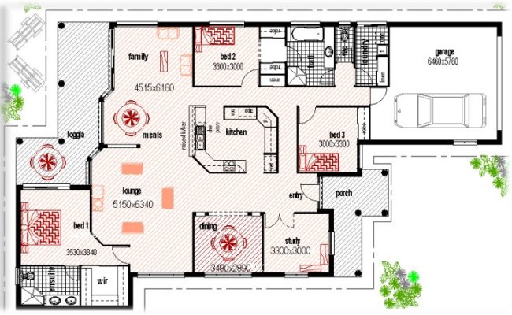
You have been approached as a local builder and have since met on site with Errol and Elizabeth McKendry on their 6 hectares of accessible land at 1416 Chambers Flat Road, Logan Village, Queensland.

They have provided you a sketch floor plan which is for a slab on ground home with pitched roof of three bedrooms and study (see previous page). The home has “Scyon Linea Weatherboard” (James Hardie Product) external cladding with plasterboard internal linings to walls and ceilings with a feature rail at 1100mm on all internal vertical walls and partitions. There is a coloured concrete tile roof over sealed 600mm eaves and a two car garage and attached roofed alfresco (loggia) off internal living areas at the rear. The owners have not chosen any colour schemes nor any electrical/gas appliances or wet area installations at this time. They have requested builder supplied at this stage.

You are provided a geotechnical report and some photos of the property. Nothing untoward is mentioned in the geotechnical report. The block is heavily timbered at the rear and backs on to the Logan River at its rearmost boundary. The owners advise you the location of the house pad is 11 metres above all known flood levels of the past 50 years for the area. There are no trees which are likely to affect the slab on ground location or any work or workers on or around the immediate building to be constructed.

There is a property access gate and approximately 310 metres of 5 metre wide ant bed road into the property with the block partially fenced with slab posts and four strand barbed wire. The entry gates are solar powered with reinforced concrete block curved feature walls 2.5 metres high and each 5 metres long on either side of the gate with the property title “Little Tuscany” emblazoned on the right hand side concrete block wall. The gate when fully open provides 8 metres wide access with bitumen road from all access routes to the property and up to the boundary at the entry gate. The nearest major community hubs to the location are Logan Village, Loganlea, Loganholme, Beenleigh and Yatala.

Following a site survey you have identified that minimal pad levelling is required other than a general scrape of the area to clean it of grass and other plant matter. Power from the mains is already established on site and there is a property pole established approximately 30 metres from the house slab location. You note the mains power is underground and will need to liaise with the power authority and Council for other possible underground services that may traverse the property. You should also satisfy yourself that the landed property is above the flood plain by gaining access to recent flood reports for the area from the Local Authority.

The nearest neighbours and any other buildings that could be impacted are 800 and 900 metres away respectively to either side boundaries.

Answer

