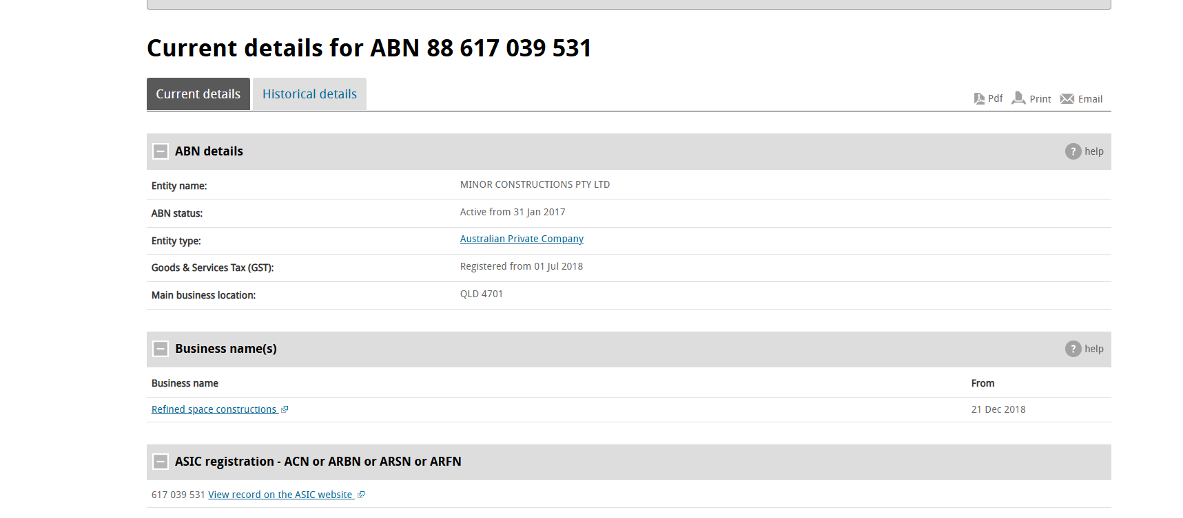

Initial Dispute Information:
- Date of Dispute: The date the problem first arose.
- Description of the Dispute: A clear and concise explanation of the issue.
- Parties Involved: Names and contact information of all parties involved.
- Relevant Documents: Any contracts, agreements, or other documents related to the dispute.
2. Attempts to Resolve the Dispute:
- Date of Attempts: When you tried to resolve the issue (e.g., email, phone call, meeting).
- Method of Communication: How you tried to resolve the dispute (e.g., email, phone call, meeting).
- Summary of Discussions: A brief description of what was discussed during each attempt to resolve the issue.
- Individuals Involved: Names of people who participated in each attempt to resolve the dispute.
- Outcome of Attempts: What happened after each attempt (e.g., agreement, disagreement, further escalation).
3. Formal Dispute Resolution (if applicable):
- Date and Time of Formal Resolution: When the dispute was formally addressed (e.g., mediation, arbitration).
- Method of Resolution: How the dispute was formally resolved (e.g., mediation, arbitration, legal action).
- Participants: Who was involved in the formal resolution (e.g., mediator, arbitrator, lawyers).
- Outcome: The final result of the formal resolution.
4. Final Resolution:
- Date of Final Resolution: When the dispute was finalized.
- Agreement or Decision: The final agreement or court decision, including key terms and conditions.
- Next Steps: Any actions required to implement the final resolution.
5. Additional Notes:
- Any other relevant information: Anything else that might be helpful to understand the dispute and its resolution.
Example Scenario:
Let's say you have a dispute with a contractor about the quality of work done on your home in Berserker. Here's how a dispute resolution record might look:
Dispute Resolution Record
- Date of Dispute: October 1, 2023
- Description of the Dispute: Contractor failed to complete work as agreed upon and did shoddy workmanship.
- Parties Involved: You and the contractor.
- Relevant Documents: Contract, change orders.
Attempts to Resolve the Dispute:
- Date of Attempt: October 15, 2023.
- Method of Communication: Phone call.
- Summary of Discussions: Contractor refused to fix the work.
- Individuals Involved: You and the contractor.
- Outcome of Attempts: No resolution.
- Date of Attempt: October 22, 2023.
- Method of Communication: Email.
- Summary of Discussions: Contractor promised to fix the work, but didn't.
- Individuals Involved: You and the contractor.
- Outcome of Attempts: No resolution.
Formal Dispute Resolution:
- Date and Time of Formal Resolution: November 1, 2023.
- Method of Resolution: Mediation.
- Participants: You, the contractor, a mediator.
- Outcome: Agreement reached to pay for repairs.
Final Resolution:
- Date of Final Resolution: November 15, 2023.
- Agreement or Decision: Contractor paid for repairs to be done by a different contractor.



