Practical Task 1 (2X)
Description of task:
On two (2) occasions, a suitable observer is to verify the participant’s ability to establish the estimated costs associated with the acquisition of materials and labour on building and construction sites, together with the application of relevant overhead costs and margins.

The participant is to gather evidence of how they have completed each component of the Practical Task, which is to be submitted with this Practical Assessment sheet. Evidence to be submitted may include a copy of a Bill of Quantities or similar estimate for a project that shows the following:
- Quantity calculations for material and labour requirements across the trades
- All other associated costs
- Overhead and Profit Margin allowances
- A copy of a quotation
- A copy of the plans and specifications, etc. for the project
- Variation documentation

The observer is to provide detailed comments on the tasks completed by the participant. The assessor is to verify the observer’s comments in the Assessor Comments section, and provide the Practical Assessment outcome on the front cover of this document.
Resources required:
Project plans/drawings/specifications, Computer with costing software.

Below is an estimating sheet I did for a tender to calculate the costs of materials, labour and overheads.
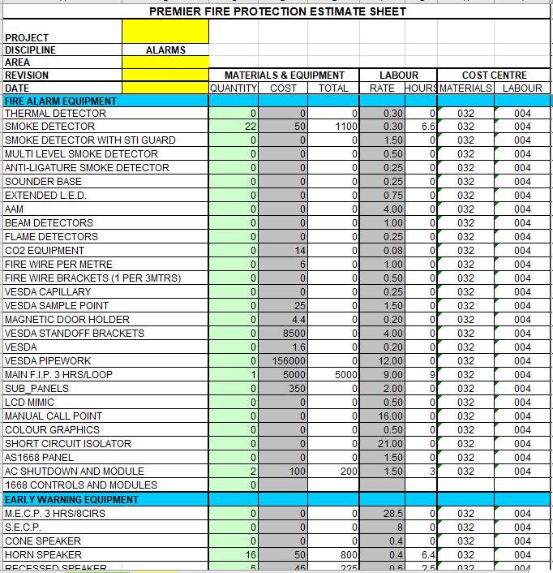
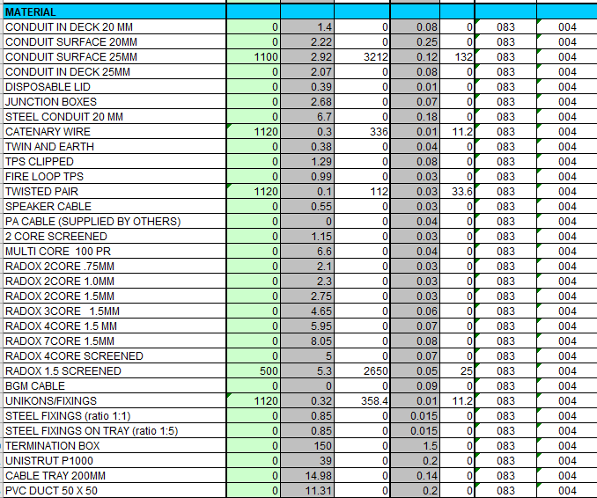

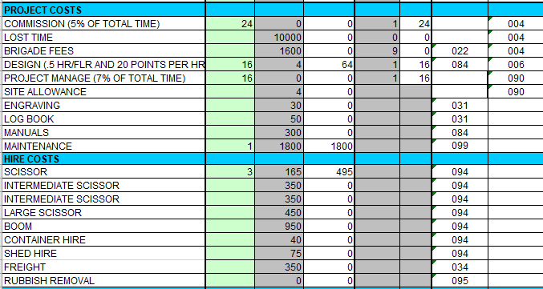

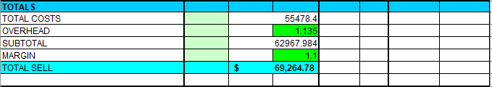

Below is the tender letter/quotation for the job.
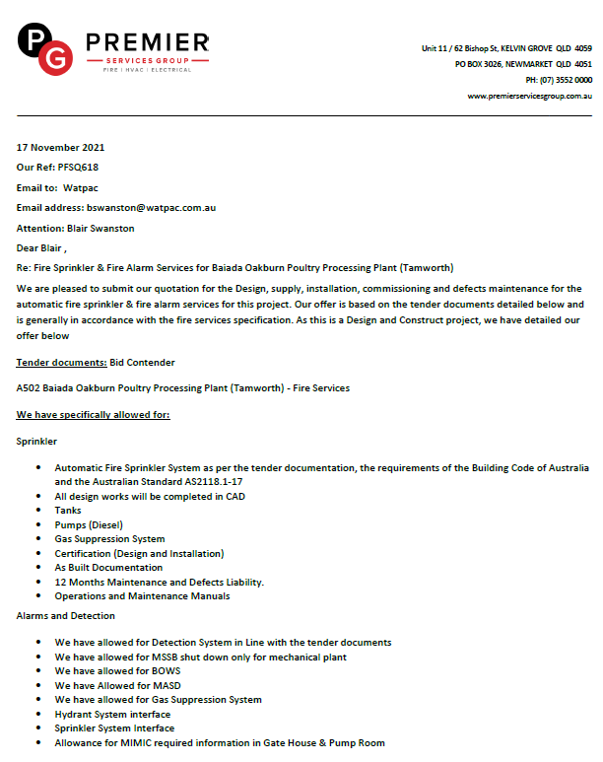

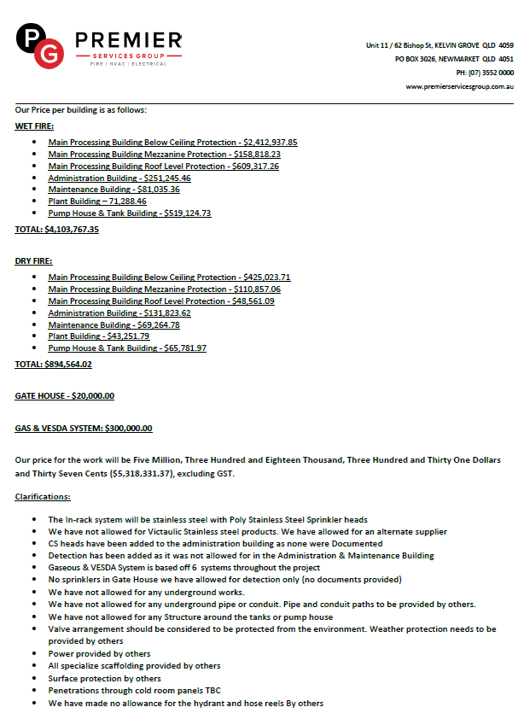

Below are the specs and drawings in which the proposed costs came from:


